Humboldt Current model validation
Field | Entry
Region | Humboldt Current, LME_013; Sea Around Us target boundary includes southern Patagonia. Regional workbook
Catch source | Sea Around Us catch series 1950–2019; reference: 2019 landings. All 218 exact labels, including zero catch and unidentified categories. Catch inputs | Regional catch
Selected article | Neira, Arancibia, Barros, Arriagada, Alarcón & Gatica (2026). Analysing ecosystem and demersal stocks dynamics in the Chilean Patagonia system (41°28.6′S–57°S) from 1980 to 2020 using food web modelling. Progress in Oceanography 241, 103631. Source PDF | DOI
Other known articles | Chiaverano et al. (2018), Large jellyfish and forage fishes as energy pathways in the Northern Humboldt Current System. DOI 10.1016/j.pocean.2018.04.009. Northern 1995–1998 alternatives fail all three saved methods. Other article
Selected model | 13_1_Chilean_Patagonia_(1980); one static 1980 Ecopath model, 15 source ecological groups plus synthetic diet_import. Chilean Patagonia channels, fjords and adjacent open waters, approximately 290,000 km². Canonical JSON | Model folder
Other models from the same article | No other complete static parameterization identified in this article. The 1980–2020 Ecosim series, fishing scenarios and sensitivity runs are dynamic outputs, not additional static input models. Source inventory
Selection rationale | Article - ?  Model - User selected this available non-failing WARN alternative after comparison with Northern Humboldt 1995–1998 (GE, TE and With Egestion FAIL). Spatial suitability remains a serious limitation; model selection does not establish regional applicability.
Model extraction | Partial paper reconstruction. Referenced supplements S1–S7 are absent from the retained source set. Canonical Sea-lion diet sum 1.002 is preserved; accepted runtime normalizes it at tolerance 0.001, infers BA and supplies GS, detritus/routing, missing-catch and import defaults. Printed rounded biomass and undocumented source BA remain distinct from accepted inputs. Extraction report | Source/runtime review
GE diagnostics | WARN: source reconstruction and accepted runtime transformations remain limitations.  No negative SPPR entries across the basal-source columns.  rho_living = 0.3579  b = 0.0210  Detritus (15): SPPR = 1.0453  Strict mass balance passes in the accepted runtime.
TE diagnostics | WARN: source reconstruction and accepted runtime transformations remain limitations.  No negative SPPR entries across the basal-source columns.  rho_living = 0.5423  Detritus (15): SPPR = 0.9937  Strict mass balance passes in the accepted runtime.
SPPR calculation | [MANUAL — Researcher: calculation choices and reasons]  [Excluded groups, scope and relevant values; other adjustments]
Geographic fit | Approximate A. Region covered by study: 7–11%.  Approximate B. Study covered by region: 60–95%. Boundary assessment
Temporal fit | Static 1980 ecosystem applied to catch years 1950–2019; the 2019 reference is 39 years later. Fixed coefficients and composition proxies do not reconstruct annual ecosystem changes. Publication in 2026 does not make the 1980 model contemporary.
Other | With Egestion also retains WARN: rho_living = 0.2863; b = 0.0213; Detritus (15) SPPR = 1.0509. Strict mass balance passes. Skates source EE cannot be interpreted without missing BA. Full matrices and diagnostics
Open issues and next action | [Researcher: open issues and next actions]
Review and reproducibility | Researcher name: [name] | review date: [date]
Taxon mapping and coverage
Reference: 2019 landings; all catch labels, zero catch and unidentified categories; no group filter.
15 source ecological groups (+1 computational import); 218 catch labels.
Simple-chain PPR totals 277,099,551.43 t C in 2019.
34 labels lack a saved classic coefficient/TL; all have zero 2019 landings and therefore zero annual PPR. Unavailable TL remains ?, not zero.
Method: simple trophic chain.
Taxon mapping appendix and descriptive Sources sheet
Overall confidence | Taxa (n) | Catch (%) | Simple-chain PPR (%)
High | 66 | 69.6458% | 12.8861%
Medium | 31 | 13.5477% | 26.8951%
Low | 0 | 0.0000% | 0.0000%
Very low | 121 | 16.8066% | 60.2188%
Unresolved | 0 | 0.0000% | 0.0000%
Overall confidence uses the weaker required membership or allocation component.
Group assignment rules
Plain-language rule | Confidence | PPR percentage
Closest represented taxonomic or ecological analogue; mismatches explicit. | Very low | 55.8164%
Small/medium pelagic ecological extension from named source representatives. | Medium | 18.3892%
Explicit named source membership or combined source stages. | High | 12.8071%
Congeneric or related-source taxonomic extension. | Medium | 8.3729%
Broad-category approximation over compatible represented guilds. | Very low | 4.4024%
Explicit operative Benthos definition and bottom-associated reporting scope. | High | 0.1534%
Broad label with a supported but composition-dependent candidate set. | Medium | 0.0585%
Verified spelling/synonym of a named source taxon. | High | 0.0002%
Membership evidence: source definitions, taxonomy and all 16 candidate decisions
Allocation weight rules
Plain-language rule | Confidence | PPR percentage
One reviewed group; no numerical split. | High | 98.6323%
Missing candidate catches prevent complete catch proxy; complete model biomass fallback. | Medium | 1.2932%
Historical source landings split for Hoki <3/≥3 years. | Medium | 0.0745%
Weights and assumptions: Hoki uses 1980 model landings proportions, transferred to regional catch years. Other split labels use model biomass proportions because source catches are incomplete; composition and catchability are assumed constant across years and catch bases. Weights and evidence
Each percentage is the independent simple-chain PPR associated with taxa using that rule.
Unresolved taxa: none. The 121 Very low decisions account for 16.8066% of landings and 60.2188% of simple-chain PPR. Dosidicus gigas alone contributes 38.8770% of simple-chain PPR. Full mapping coverage does not establish ecological validity. Residual fish candidate sets and their reporting limits are retained in the evidence. Reporting scope evidence

Very low decisions
Affected taxa | Why confidence is very low
Dosidicus gigas | Oceanic predatory squid uses Small pelagic fish as a partial active-nekton analogue. Its large size, feeding level, taxonomy and offshore habitat exceed the forage-fish definition.
Acanthocybium solandri; Allothunnus fallai; Coryphaena; Coryphaena hippurus; Elagatis bipinnulata; Fistularia corneta; Istiompax indica; Istiophoridae; Istiophorus platypterus; Kajikia audax; Katsuwonus pelamis; Scomberomorus sierra; Scombridae; Scombroidei; Tetrapturus; Tetrapturus angustirostris; Thunnus alalunga; Thunnus albacares | Small pelagic fish is the only explicitly pelagic fish pool. Large oceanic predators and broad-family labels extend beyond its small/medium source definition; size, feeding and composition are uncertain.
Thunnus maccoyii; Thunnus obesus; Thunnus orientalis; Xiphias gladius | Small pelagic fish is the only explicitly pelagic fish pool. Large oceanic predators and broad-family labels extend beyond its small/medium source definition; size, feeding and composition are uncertain.
Aplodactylus punctatus; Beryx splendens; Bothidae; Caranx; Caranx lugubris; Caulolatilus; Caulolatilus princeps; Chirodactylus variegatus; Cilus gilberti; Coelorinchus chilensis; Cynoglossidae; Cynoscion analis; Diapterus peruvianus; Diplectrum pacificum; Dissostichus eleginoides; Emmelichthys nitidus; Epinephelus; Graus nigra | Other demersal fish is specifically a Seriolella pool. Unlisted demersal, reef and benthopelagic fish use a weak bottom-associated analogue, with taxonomic, depth, size or habitat mismatch.
Haemulidae; Heteropriacanthus cruentatus; Hippocampus; Hippoglossina macrops; Isacia conceptionis; Labrisomus philippii; Macrouridae; Malacanthidae; Monacanthidae; Mugil cephalus; Nemadactylus; Normanichthys crockeri; Ophichthus; Paralabrax; Paralabrax humeralis; Paralichthyidae; Paralichthys; Paralichthys microps | Other demersal fish is specifically a Seriolella pool. Unlisted demersal, reef and benthopelagic fish use a weak bottom-associated analogue, with taxonomic, depth, size or habitat mismatch.
Paralonchurus peruanus; Parapsettus panamensis; Pinguipes chilensis; Pleuronectiformes; Polydactylus approximans; Prionotus stephanophrys; Prolatilus jugularis; Ruvettus pretiosus; Salilota australis; Sciaenidae; Scorpaena histrio; Sebastidae; Seriola; Seriola lalandi; Seriola rivoliana; Serranidae; Stellifer minor; Stromateus stellatus | Other demersal fish is specifically a Seriolella pool. Unlisted demersal, reef and benthopelagic fish use a weak bottom-associated analogue, with taxonomic, depth, size or habitat mismatch.
Thyrsites atun; Trichiuridae; Trichiurus lepturus | Other demersal fish is specifically a Seriolella pool. Unlisted demersal, reef and benthopelagic fish use a weak bottom-associated analogue, with taxonomic, depth, size or habitat mismatch.
Alopias; Alopias vulpinus; Batoidea; Callorhinchus callorynchus; Carcharhinus falciformis; Carcharhinus longimanus; Chondrichthyes; Deania calceus; Galeorhinus galeus; Hexanchus griseus; Isurus; Isurus oxyrinchus; Lamna nasus; Mobula birostris; Mustelus; Mustelus mento; Mustelus whitneyi; Myliobatidae | Skates contains the named Dipturus/Zearaja chilensis stock. Sharks, other rays and chimaeras share cartilaginous taxonomy but differ in feeding, form and habitat; broad-label composition is unknown.
Prionace glauca; Pseudobatos planiceps; Rhinoptera steindachneri; Sphyrna zygaena; Squalus acanthias | Skates contains the named Dipturus/Zearaja chilensis stock. Sharks, other rays and chimaeras share cartilaginous taxonomy but differ in feeding, form and habitat; broad-label composition is unknown.
Marine fishes not identified | Verified bony-fish reporting scope excludes Skates, but composition across named and pooled fish groups and unrepresented taxa remains unknown. 1980 model biomass proportions replace incomplete source catches, assuming regional composition and catchability across years and catch bases.
Elasmobranchii | The shark/ray/skate reporting category excludes chimaeras. Skates supplies only a weak analogue for its unknown mixture, with feeding, form and habitat differences.
Doryteuthis gahi | Shelf squid uses Small pelagic fish as a partial active-nekton analogue. It is not a source-listed fish; taxonomy, feeding and shelf/demersal movements differ.
Mollusca | Unknown mollusc composition mixes benthic members with pelagic squid, which uses only a weak fish analogue. 1980 model biomass proportions replace incomplete source catches, assuming regional composition and catchability across years and catch bases.
Marine pelagic fishes not identified | The reporting category is bony fish; Small pelagic fish is the only explicitly pelagic pool. Unknown mixture and unrepresented large predators make the assumed composition uncertain.
Hoplostethus atlanticus; Lampris guttatus; Lepidocybium flavobrunneum | Deep-water pelagic fish use Small pelagic fish as the only pelagic fish analogue. Their depth and size are poorly represented by the source pool.
Perciformes | Historical fisheries scope is broader than modern orders. Brama-like pelagic and Seriolella-like demersal pools approximate an unknown mixture. 1980 model biomass proportions replace incomplete source catches, assuming regional composition and catchability across years and catch bases.
Malacostraca | Unknown crustacean composition spans euphausiid Macrozooplankton and Benthos; copepods are excluded. 1980 model biomass proportions replace incomplete source catches, assuming regional composition and catchability across years and catch bases.
Galaxias maculatus | The diadromous and estuarine fish has no freshwater compartment. The Seriolella-defined Other demersal fish pool is only a weak coastal-fish analogue, with size and habitat mismatch.
Actinopterygii | Ray-finned fish have unknown composition across named and pooled bony-fish groups; Skates is excluded. 1980 model biomass proportions replace incomplete source catches, assuming regional composition and catchability across years and catch bases.
Chrysaora plocamia | Macrozooplankton explicitly represents euphausiids. The jellyfish shares a pelagic invertebrate role but differs in body size, gelatinous composition and feeding.
Gadiformes | The broad cod-like label mixes named hoki, whiting and hake with unrepresented grenadiers represented only by a demersal analogue. 1980 model biomass proportions replace incomplete source catches, assuming regional composition and catchability across years and catch bases.
Marine finfishes not identified | Verified bony-fish reporting scope excludes Skates, but composition across named and pooled fish groups and unrepresented taxa remains unknown. 1980 model biomass proportions replace incomplete source catches, assuming regional composition and catchability across years and catch bases.
Marine groundfishes not identified | Bony groundfish have unknown composition across named and pooled demersal groups. Skates and explicitly pelagic Small pelagic fish are excluded. 1980 model biomass proportions replace incomplete source catches, assuming regional composition and catchability across years and catch bases.
Scorpaeniformes | Historical fisheries scope differs from modern orders. Other demersal fish supplies a weak demersal analogue rather than explicit source membership.
Teuthida | The historical squid label has unknown species and size composition. Small pelagic fish is a partial active-nekton surrogate with taxonomic, size and feeding mismatch.

Geographic evidence screenshots
Target R and study S use geographic coordinates. The reviewed source-map reconstruction is distinct from the inherited rectangular article footprint, which conflicts with the stated study bounds and marine domain.

Region area
Humboldt LME_013 target and study location
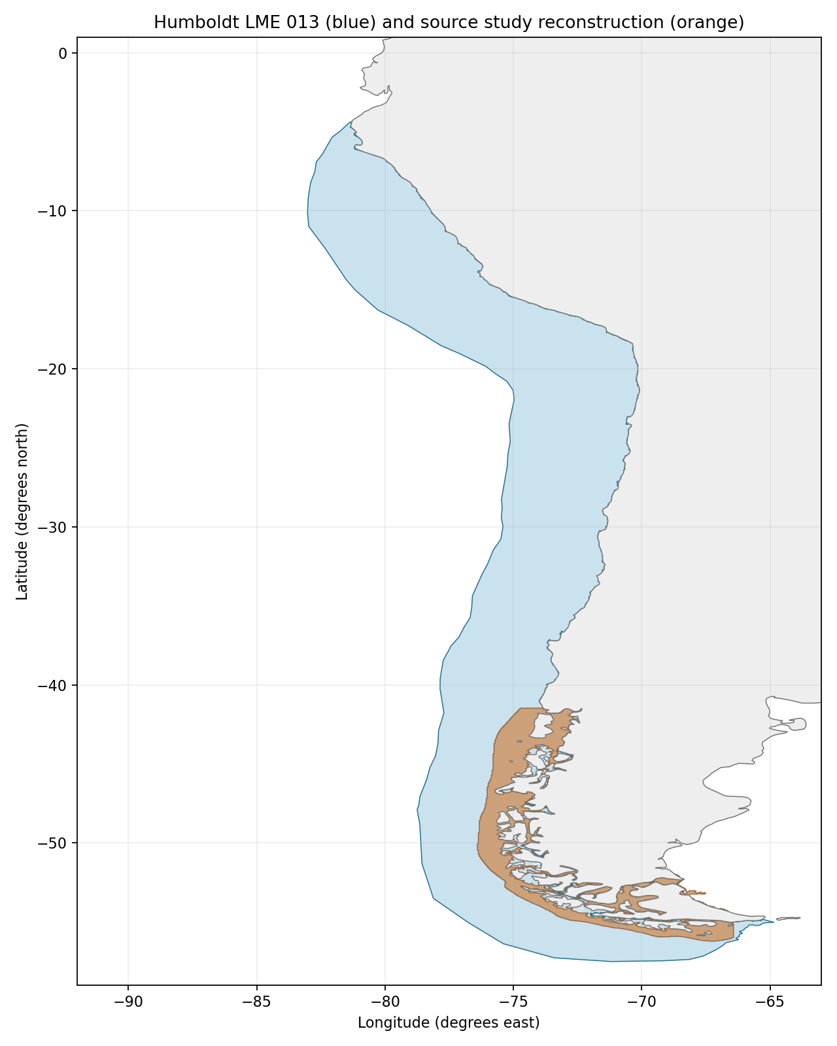
Sea Around Us target R: 2,560,136 km², including southern Patagonia. Blue = R; orange = source reconstruction. Target boundary | Image

Study area in the article
Approximate source-domain reconstruction
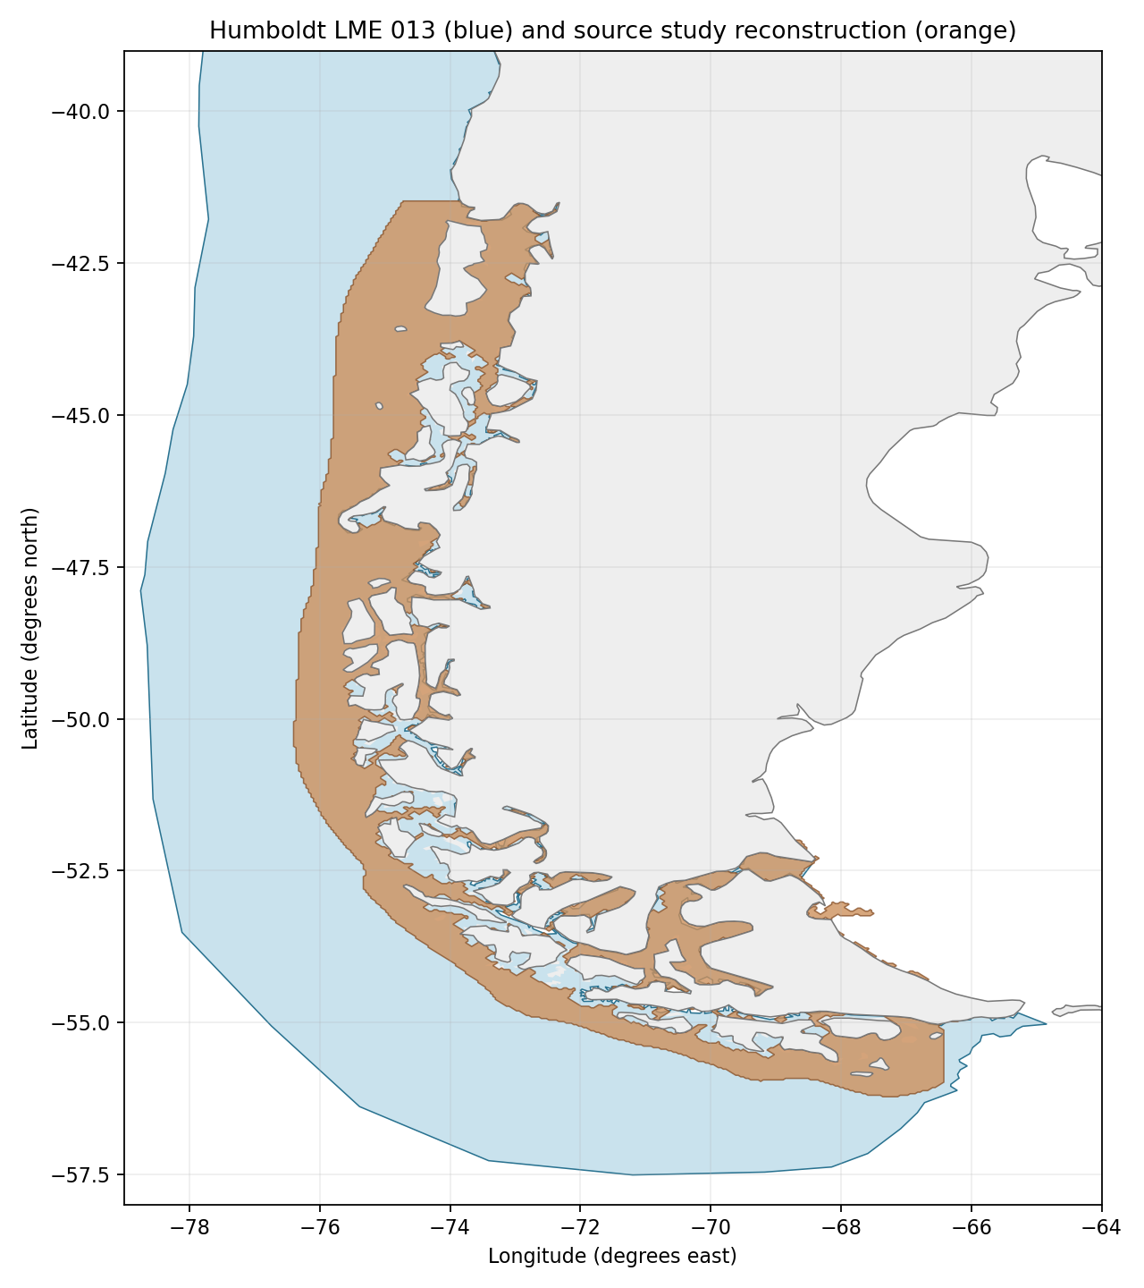
Source S: Methods/PDF4 and Figure 1/PDF2 give 41°28.6′S–57°S, fjords/channels and open water to 35 nautical miles offshore; reported 290,000 km². Image shading trace gives 194,166 km², overlap 183,217 km²; A 7.1565%, B 94.3611% using traced S, B 63.1783% using reported S. Approximate 3–4 km image/coastline resolution and unresolved inner fjords drive the 7–11% / 60–95% sensitivity brackets. The 35-nmi distance is not a fixed longitude offset. Source map | Source bounds | Portable reconstruction
Original source study map: Figure 1 (PDF2), retained below. The abstract/highlights say 55°S, while title, Methods and map indicate 57°S; the latter are used with the discrepancy disclosed. The old −76° to −72°, 41.5°–55°S rectangle includes land and misses the southern/eastern domain.