S1. Time series used for calibration process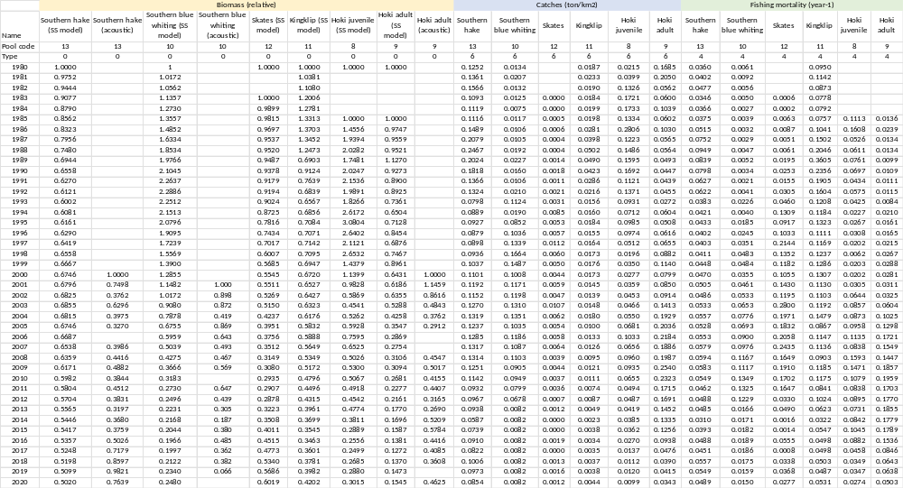

S2. Vulnerabilities estimated in calibration process (yellow values).
Prey \ predator | 2 | 3 | 4 | 5 | 6 | 7 | 8 | 9 | 10 | 11 | 12 | 13 | 14
1. Phytoplankton | 2 | 2 | 2 | 2 | 1 | 2 | 2 | 2 | 2 | 2 | 2 | 2 | 2
2. Microzooplankton | 2 | 2 | 2 | 2 | 2 | 2 | 2 | 2 | 2 | 2 | 2 | 2 | 2
3. Mesozooplankton | 2 | 2 | 2 | 2 | 1.55 | 2 | 2 | 2 | 2 | 2 | 2 | 2 | 2
4. Macrozooplankton | 2 | 2 | 2 | 2 | 2 | 2 | 2 | 2 | 2 | 2 | 2 | 2 | 2
5. Benthos | 2 | 2 | 2 | 2 | 2 | 1 | 2 | 2 | 2 | 2 | 1.19 | 2 | 2
6. Other pelagic fish | 2 | 2 | 2 | 2 | 2 | 2 | 2 | 2 | 2.70E+08 | 2 | 1 | 2 | 2
7. Other demersal fish | 2 | 2 | 2 | 2 | 2 | 2 | 2 | 1 | 2 | 2 | 2 | 2 | 2
8. Hoki (j) | 2 | 2 | 2 | 2 | 2 | 2 | 2 | 1.00E+10 | 2 | 2 | 2 | 2 | 2
9. Hoki (a) | 2 | 2 | 2 | 2 | 2 | 2 | 2 | 2 | 2 | 2 | 1.22 | 2 | 2
10.Southern blue whiting | 2 | 2 | 2 | 2 | 2 | 2 | 2 | 2 | 2 | 2 | 2 | 1 | 2
11. Kingklip | 2 | 2 | 2 | 2 | 2 | 2 | 2 | 2 | 2 | 2 | 1 | 2 | 2
12. Skates | 2 | 2 | 2 | 2 | 2 | 2 | 2 | 2 | 2 | 2 | 2 | 2 | 2
13. Southern hake | 2 | 2 | 2 | 2 | 2 | 2 | 2 | 2 | 2 | 2 | 2 | 2 | 2
14. Sea lions | 2 | 2 | 2 | 2 | 2 | 2 | 2 | 2 | 2 | 2 | 2 | 2 | 2
15. Detritus | 2 | 2 | 2 | 2 | 2 | 2 | 2 | 2 | 2 | 2 | 2 | 2 | 2

