Regional model validation record
Field | Entry
Region | Patagonian Shelf, LME_014; source study is the Falkland shelf subarea. Regional workbook
Catch source | Sea Around Us 1950–2019 series; reference: 2019 landings. All 250 exact labels, including zero catch and unidentified categories. Catch inputs | Regional catch
Selected article | Büring et al. (2024). Unveiling the wasp-waist structure of the Falkland shelf ecosystem: the role of Doryteuthis gahi as a keystone species and its trophic influences. Journal of the Marine Biological Association of the United Kingdom 104, e2. Historical folder PAT-2023. Source PDF | DOI
Other known articles | Ocampo-Reinaldo et al. (2016), San Matías Gulf 1970 reconstruction. It models another subregional area and has source reconstruction/balance limitations. Other retained model
Selected model | PAT2024_FalklandShelf_2020_native; one native 2020 Ecopath model, 36 source groups (+ synthetic diet_import). Falkland shelf to 300 m, approximately 200,000 km²; EwE 6.6.8.18072. Canonical source | Model folder
Other models from the same article | Published-table reconstruction is a different extraction of the same 2020 model, not another final model. S3 initial 45-group parameterization is distinct from the native final 36-group model; dynamic scenarios are not additional static inputs. Model inventory
Selection rationale | User selected the audited native model because it did not FAIL. GE, TE and With Egestion return WARN after coupled completion of source-missing B/EE. Model availability and non-failure do not establish whole-LME suitability.
Model extraction | Main PDF, CSV S1/S2, native database supplement and initial-model DOCX are retained. Source/canonical/accepted computational layers are distinct: coupled missing B/EE, nonconsumer sentinels and native routing are preserved. Native living fate and fleet discards supply Detritus 36 while Discards 35 has consumers; loader negative detritus BA compensation remains a limitation. No scientific parameters rebalanced. Source/runtime review | Source comparison  Retained departures and evidence limits: model notes
SPPR calculation | [MANUAL — Researcher: calculation choices and reasons]  [Excluded groups, scope and relevant values; other adjustments]

Field | Entry
GE diagnostics | No negative/nonfinite entries in all 185 source–recipient values, including unfished groups. rho_living=0.28190653; b=0.03672140; Detritus SPPR=1.08718847; Discards=0. Overall WARN. Strict balance passes.
TE diagnostics | No negative/nonfinite entries in all 185 source–recipient values, including unfished groups. rho_living=0.30979371; b=0.00000000; Detritus SPPR=0.94115749; Discards=0. Overall WARN. Strict balance fails: relative gap 0.00012557; maximum Sharks SPPR 63,225,811.23. Near-zero TE groups 32/26/25 and EE=0 Baleen Whales retained.
Geographic fit | Approximate A: 17.09% of target region covered by study. B: about 100% of study covered by target. Reported 200,000 km² and source subarea statement assumed; no verified study polygon. Boundary assessment
Temporal fit | Static 2020 source applied to 1950–2019 catches; reference is one year earlier. Fixed group coefficients and 2020 composition proxies do not reconstruct historical ecosystem change. Article publication is 2024.
Other | With Egestion: all 185 values finite/nonnegative; rho_living=0.22552522, b=0.04221383, Detritus=1.10650126, Discards=0; balance passes, overall WARN. New TE exposure is 97.07% Prionace glauca, a Very low pelagic analogue using unchanged extreme Sharks coefficient. Routing and subregional transfer concerns remain. Full matrices/settings | Shark exposure
Open issues and next action | [Researcher: open issues and next actions]
Review and reproducibility | Researcher name: [name] | review date: [date]
Taxon mapping and coverage
Reference: 2019 landings; all catch labels, zero and unidentified categories included; no group filter.
36 source groups (+1 computational import); 250 exact catch labels.
Simple-chain PPR totals 142,458,248.78 t C; catch totals 1,497,627.62 t.
55 labels lack a saved classic coefficient/TL; all have zero 2019 landings and zero annual PPR. Unavailable TL remains ?, not zero.
Method: independent simple trophic chain, saved classic wet coefficient × catch / 9 once. Percentages use its full unrounded denominator.
Taxon mapping appendix and descriptive Sources sheet
Overall confidence | Taxa | Catch percentage | PPR percentage
High | 27 | 63.0475% | 91.8375%
Medium | 26 | 4.1639% | 1.6823%
Low | 1 | 0.1117% | 0.2429%
Very low | 196 | 32.6769% | 6.2373%
Unresolved | 0 | 0.0000% | 0.0000%
The summary uses the weaker required membership or allocation confidence. The following tables show each component separately.
Group assignment rules
Plain-language rule | Confidence | PPR percentage
M1: Explicit named final-source member. | High | 92.0523%
M11: Closest meaningful taxonomic or ecological analogue; mismatch retained. | Very low | 5.0878%
M9: Supported broader reporting label or combined named taxa. | Medium | 1.6054%
M10: Broad-category approximation across represented candidates. | Very low | 1.1495%
M4: Supported related-source genus/family/order extension. | Medium | 0.0876%
M3: Explicit bivalve/scallop Small Zoobenthos definition. | High | 0.0174%
Membership evidence: source definitions and all 37 candidate decisions per taxon
Allocation weight rules
Plain-language rule | Confidence | PPR percentage
W1: One reviewed group; no numerical split. | High | 95.9104%
W4: Complete native 2020 catch proxy; D. gahi preserved cohort landings. | Medium | 3.8467%
W5: Identified regional hake donor proportions; reporting-population mismatch. | Low | 0.2429%
W4 uses complete native fleet landings + discards, retaining genuine zero candidates; source mixture is a fixed spatial/temporal assumption. D. gahi cohort landings weights are preserved at 49.237747%/50.762253%. Merluccius Common/Austral weights remain 99.482031%/0.517969%, but W5 is Low because target/donor country, gear and reporting populations differ. Exact weights and evidence
Unresolved: none. Very low: 196 labels represent 32.6769% of landings / 6.2373% of classic PPR. Largest weak PPR exposures: Pomatomus saltatrix 1.4754%; Marine fishes not identified 1.0692%; Cynoscion guatucupa 0.7067%; Micropogonias furnieri 0.6159%. Shrimp uses benthic Munida as a decapod analogue; unlisted demersals use both residual pools because no source size cutoff exists; generic categories retain named and residual candidates. Stage, taxonomy, habitat and geography differ. Coverage does not establish ecological validity. Residual fish reporting uses the verified bony-fish scope: dedicated Dogfish, Sharks and Skates are excluded; source-zero Myctophidae remains eligible. Complete native catch proportions retain Medium allocation confidence. Reporting scope evidence

Geographic evidence screenshots
Target R and study S are separate geographic objects. The reported shelf area/subarea relationship supports approximate overlap assumptions; source sampling maps do not provide a verified 300 m study outline.

Region area
Patagonian Shelf LME_014 target region
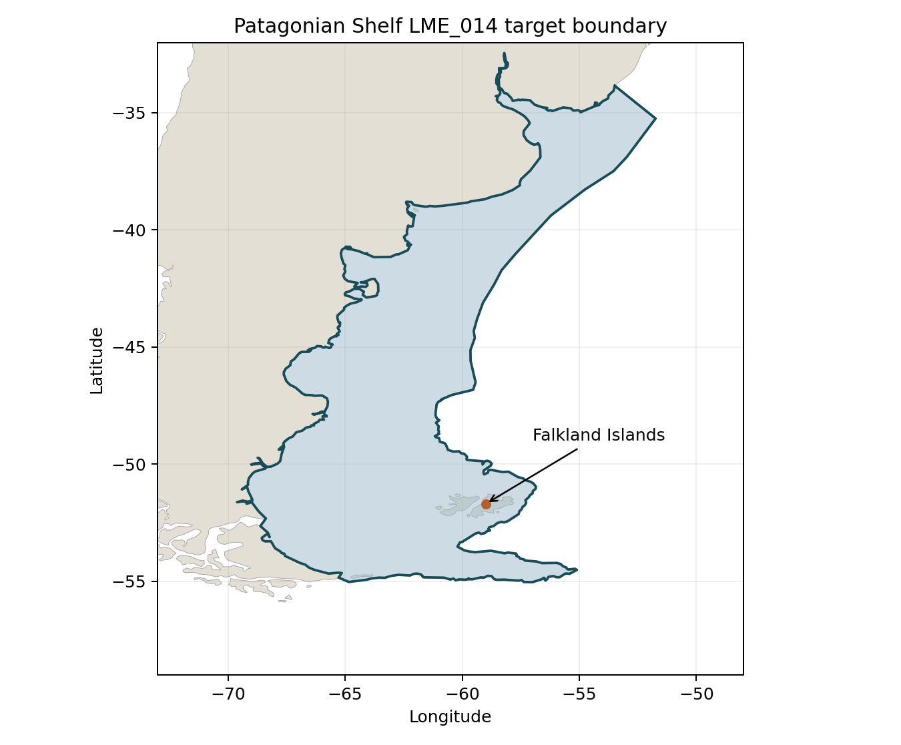
Target R: Sea Around Us Patagonian Shelf boundary, geodesic area 1,170,516 km². Blue = target; point locates Falkland Islands. Target boundary | Image

Study area in the article
Source sampling map — Figure 1
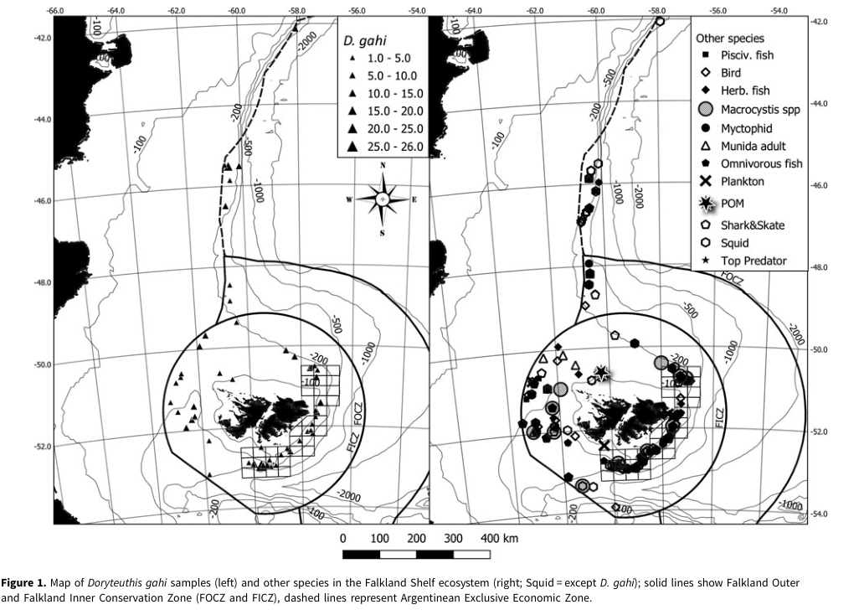
Source S: p.6 reports Falkland shelf to 300 m, about 200,000 km², a subarea of the Patagonian Shelf LME. Assuming nearly all S lies in R: A≈200,000/1,170,516=17.09%; B≈200,000/200,000=100%. These are reported-area assumptions, not measured polygon overlaps or statistical intervals. Figure 1 shows samples/conservation zones and Figure 2 a D. gahi survey area; neither recovers the 300 m model contour. Source map | Source domain | Assessment
The inherited rectangle (64–56°W, 53–48°S) is not the source shelf polygon. Remove its live article display; preserve historical footprint and original source figure. Exact replacement remains unavailable. Target geography is retained. Historical rectangle | Original full map page

