Regional model validation record
Field | Entry
Region | North Sea, LME_022; Sea Around Us marine target region. Regional workbook
Catch source | Sea Around Us series 1950–2019; reference: 2019 total catch (landings plus discards). All 384 exact labels, including zero catch and unidentified categories. Catch inputs | Regional catch
Selected article | Saygu et al. (2025). Historical ecosystem models can serve as a baseline for indicator-based assessment: the North Sea. Frontiers in Marine Science. DOI 10.3389/fmars.2025.1646031. Source PDF | DOI | Four-table supplement
Other known articles | Retained alternatives: Mackinson & Daskalov (2007), whole North Sea 1991; Hill et al. (2021), northern North Sea 1991 static model with 1991–2018 simulations; Pint et al. (2024), southern North Sea bight 1991. NS-2014 has no verified local full text. Alternative material review
Selected model | 22_20251990_East_Coast_of_Scotland_(1991-1995); East Coast of Scotland 1991–1995. 25 source ecological groups plus synthetic diet_import. Historical shelf/fishing grounds extending around Orkney/Shetland; partial North Sea coverage. Canonical JSON | Model folder
Other models from the same article | Same article also presents an 1890–1895 East Coast Scotland static model with identical 25-group topology. It is an extracted unselected candidate, distinct from the selected 1991–1995 parameterization. Historical data do not support multistanza groups. 1890s canonical model | Source review
Selection rationale | User previously preferred this exact model for the least SPPR failures. GE and With Egestion are OK; TE FAIL persists. Model choice remains provisional for whole-region geographic transfer and accepted source/runtime differences.
Model extraction | Main PDF, four-sheet Table S 1–S 4 workbook and methods DOCX are retained. Existing audit matched 97 printed core parameters,232 source diet cells and 775 roundtrip values. Canonical parameters preserved; accepted diet normalization, GS defaults and residual BA completion are documented. Source Turbot/Ling balance is indeterminate without BA; computational balance is a separate finding. Source/runtime audit | Runtime verification | Evidence review
SPPR calculation | [MANUAL — Researcher: calculation choices and reasons]  [Excluded groups, scope and relevant values; other adjustments]

Field | Entry
GE diagnostics | No negative SPPR entries across all 78 basal-source/recipient cells, including unfished groups. rho_living=0.21208967; b=0.06994712; Detritus(25) SPPR=1.08329080. Overall OK.
TE diagnostics | Negative pairings: Detritus(25) → Seabirds(22), −460,709.192379; Phytoplankton(1) → Seabirds(22), −1,916,160.319156. Unfished Seabirds remain in the reviewed configuration. rho_living=1.11277844; Detritus SPPR=0.81044893. Overall FAIL. Full TE matrix
Geographic fit | Approximate A:37–42% of the target region is covered by the study. B:99–100% of the study is inside the region. Different denominators; source-map/land-mask sensitivity brackets, not statistical intervals. Geographic assessment
Temporal fit | Static 1991–1995 ecosystem coefficients are applied across catch years 1950–2019. The 2019 reference is 24–28 years later. Fixed biomass/catch composition proxies do not reconstruct annual ecosystem change; publication 2025 does not make the historical model contemporary.
Other | With Egestion: no negative SPPR entries across all 78 cells; rho_living=0.16967174; b=0.09714913; Detritus SPPR=1.20948850; overall OK. Source excludes discards, whereas regional total catch includes them. Reconstructed/defaulted runtime fidelity and geographic transfer remain limited; no scientific parameter repair made. All matrices and diagnostics
Open issues and next action | [Researcher: open issues and next actions]
Review and reproducibility | Researcher name: [name] | review date: [date]
Taxon mapping and coverage
Reference:2019 total catch; all catch labels, including zero catch and unidentified categories; no group filter.
25 source ecological groups (+1 computational import);384 catch labels.
Independent simple-chain PPR totals 188,909,420.83 t C; total catch 2,717,260.70 t.
72 labels lack a saved classic coefficient/TL; all have zero 2019 total catch and therefore zero annual PPR. Unavailable TL remains ?, not zero.
Method: saved classic wet-weight coefficient × total catch /9 once. Model-mapping coverage and classic-PPR confidence shares are different measures.
Taxon mapping appendix and descriptive Sources sheet
Overall confidence | Taxa | Catch percentage | PPR percentage
High | 99 | 86.0235% | 92.0810%
Medium | 160 | 1.9378% | 4.0424%
Low | 3 | 0.0291% | 0.0250%
Very low | 110 | 12.0072% | 3.8483%
Unresolved | 12 | 0.0023% | 0.0034%
The summary uses the weaker required membership or allocation confidence. The following tables show each component separately.
Group assignment rules
Plain-language rule | Confidence | PPR percentage
Explicit named source membership. | High | 91.5075%
Broad-category approximation over compatible pools. | Very low | 3.6610%
Related taxonomic extension from source representatives. | Medium | 2.0138%
Supported eligible set with inferred reporting composition. | Medium | 1.9563%
Explicit operative source category or complete union. | High | 0.3413%
Verified spelling identity of source taxon. | High | 0.2411%
Closest taxonomic/ecological analogue with stated mismatch. | Very low | 0.1873%
Supported ecological extension. | Medium | 0.0634%
Partial/conflicting source-pool fit. | Low | 0.0250%
No meaningful represented membership established. | Unresolved | 0.0034%
Membership evidence: source definitions, primary taxonomy and complete candidate review Exact residual fish reporting keys use Osteichthyes/ISSC AAP 39; dedicated Sharks & rays is excluded. Reconstructed mixtures remain provisional. SAU/FAO scope bridge
Allocation weight rules
Plain-language rule | Confidence | PPR percentage
Single reviewed group; no numerical split. | High | 96.3707%
Complete historical source-landings proportions. | Medium | 3.6214%
Missing source catches; complete model-biomass fallback. | Medium | 0.0046%
No eligible group; allocation unavailable. | Unresolved | 0.0034%
Each rule table uses the same complete classic-PPR denominator, once per taxon. Multi-group splits use 1991–1995 landings shares only when every candidate has genuine source catch. Missing Infauna/Large zooplankton source catches trigger complete biomass fallback. Historical Scottish composition is assumed for the wider region, all years and total catch including discards. Weights and rejected catch attempts
Very low: 110 labels, 12.0072% of catch and 3.8483% of classic PPR. Broad marine fish/invertebrate labels and unlisted reef, bathyal, diadromous or taxonomically distant forms use explicit approximate pools/analogues. Unresolved:12 freshwater labels, 0.0023% catch and 0.0034% PPR: Carassius carassius, Cyprinidae, Cyprinus carpio, Esox lucius, Hypophthalmichthys nobilis, Leuciscus idus, Lota lota, Perca fluviatilis, Rutilus rutilus, Sander lucioperca, Scardinius erythrophthalmus and Tinca tinca. No meaningful marine analogue was established. Coverage does not establish ecological validity. Separately, Marine fishes not identified contributes 12.49% of GE,12.36% of TE and 12.22% of With Egestion model PPR. These are method-specific shares, not the classic-PPR percentages above. Method contribution review

Geographic evidence screenshots
Target R and study S are distinct geographic objects. The source red-outline trace includes marine historical East Coast Scotland grounds; the inherited rectangular article footprint conflicts with that outline.

Region area
North Sea target and Scotland study location
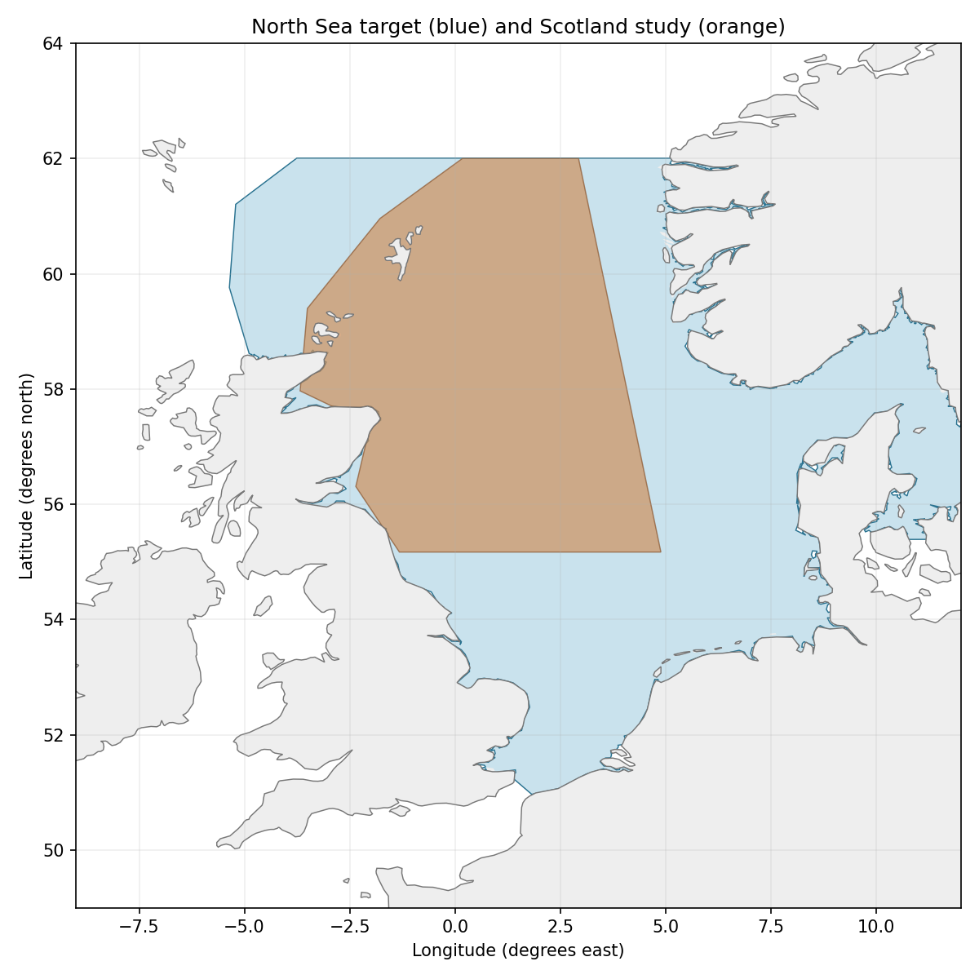
Sea Around Us target R: 699,166 km². Blue=target; orange=source reconstruction. Target boundary | Map image

Study area in the article
Approximate historical Scotland source domain
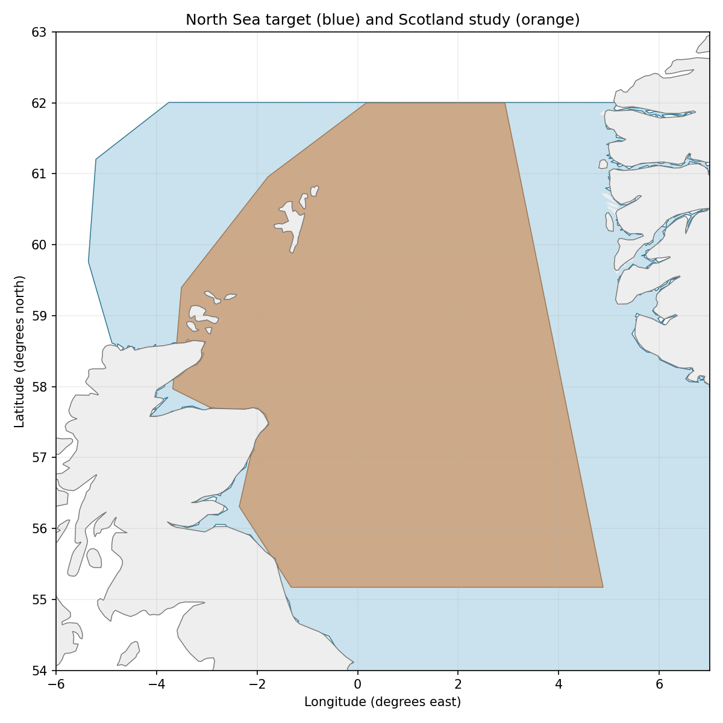
Source Figure 1/PDF 3 and Methods 2.1 describe East Coast Scotland shelf/fleet grounds, including Orkney/Shetland, above the 400 m contour. Trace calibrated to source grid, land excluded consistently: study 276,921 km²; overlap 276,487 km². A=39.55%; B=99.84%. ±0.1° outline sensitivity gives approximate 37–42%/99–100% brackets. The red outline is not an exact bathymetric/fishing-effort mask. Source figure | Portable reconstruction
Original source Figure 1 (PDF 3), red study outline. The inherited −4° to 1°E,55.8°–61°N rectangle misses the northern/eastern source outline and includes land; retained as historical evidence only.