Canary Current model validation
Field | Entry
Region | Northwest African Shelf / Canary Current | LME_027 | Regional workbook
Catch source | Sea Around Us catch series 1950–2019. Reference: 2019 landings; all 512 exact labels, including unidentified and zero-catch records. Catch inputs | Regional catch
Selected article | Morissette, Melgo, Kaschner, Gerber & Bamy (2009). Food web model and data for studying the interactions between marine mammals and fisheries in the Northwest African ecosystem. Fisheries Centre Research Reports 17(2). Exact final report unavailable; retained 2008 preliminary source is distinct. 2008 preliminary PDF | Source identity review
Other known articles | Guénette et al. (2014), Mauritanian Shelf/Banc d’Arguin, DOI 10.1371/journal.pone.0094742: distinct 1991–2006 model family. Villanueva et al. (2004), An Ecopath model of the Sine-Saloum Delta biosphere reserve (Senegal): distinct 38-group estuarine model. 2014 article | Retained alternatives
Selected model | 27_118_Northwest_Africa_(1987); EcoBase accession 118, nominal 1987, 27 ecological groups plus synthetic diet_import. Broad Northwest African offshore ecosystem; reported area 3,561,029 km². Selected JSON | Model folder
Other models from the same article | No additional temporal model from this exact final report is verified. The stored _1883ddd3 candidate is a separately archived identity, not a second source model. Banc d’Arguin/Mauritanian Shelf 1991 belongs to the separate Guénette source. Identity inventory
Selection rationale | Article: ?  Model: user selected this available non-failing 1987 alternative over Banc d’Arguin/Mauritanian Shelf 1991, whose three configurations failed on first try. This does not mean that the article-extracted model will fail after investigation.
Model extraction | The model is the official EcoBase model 118.  However, original diet sums do not sum to 1 (rounding errors are present).  Original BA is 0; however, after DC is normalized, predation values change. We decided to keep EE and M0 flows as in the original JSON and change only BA to keep the model balanced.  The model uses default GS values of 0.2 for consumers.  Groups "Sei whales" and "Brydes whales" route 0% of their flow_to_det to the detritus – we treat their unassimilated consumption and M0 flows as export from the region.  Source/runtime review | Transformation ledger  Retained departures and evidence limits: model notes
GE diagnostics | OK  No negative SPPR entries across the basal-source columns.  rho_living = 0.17  b = 0.37  Detritus (27): SPPR = 2.097498.
TE diagnostics | WARN:  - All whale groups and seabirds have EE=0  - Living groups recycling is very high (rho_living>0.9)  No negative SPPR entries across the basal-source columns, including unfished groups.  rho_living = 0.99.  Detritus (27): SPPR = 1.608032.  Coastal tunas (17) has near-zero efficiency; TE is near singular.
SPPR calculation | Removed groups from calculation due to GE<0.5% (all have EE=0):  - Seabirds (GE=0.1%, TL=3.8, SPPR_GE=19K)  - Killer whales (GE=0.2%, TL=3.9, SPPR_GE=756K)  - Sei whales (GE=0.3%, TL=2.1, SPPR_GE=448)  - Beaked whales (GE=0.4%, TL=4.2, SPPR_GE=15K)  - Dolphins (GE=0.3%, TL=3.5, SPPR_GE=5K)  Removed groups from calculation due to too high SPPR_TE:  - Mesopelagic predators (TE=1.5%, TL=3.9, SPPR_TE=2.75M)  - Coastal tunas (TE=1.5%, TL=3.3, SPPR_TE=86K)  - Sharks  - Dolphins  - Rays  - Crustaceans  - Bathydeersal predators
Geographic fit | Approximate A: 95–100% of the region covered by the study. B: 20–35% of the study inside the region.
Temporal fit | Static 1987 coefficients and group-catch mixture proxies are applied across 1950–2019. The 2019 reference is 32 years later; publication 2009 does not update ecosystem conditions. Annual ecosystem change is not reconstructed.
Other
Open issues and next action | - Check why the extracted model fails, and try to fix it.  - The current model is not good enough
Review and reproducibility | Researcher name: Ido Carmel | review date: 02/10/2026  MODEL DISQUALIFIED  Reason – too strong living compartments recycling due to near-zero EE values (rho_living = 0.99).
Taxon mapping and coverage
Reference: 2019 landings; complete catch-label universe, including unidentified and zero catch; no group filter.
27 source ecological groups (+1 computational import); 512 catch labels.
Simple-chain PPR totals 244,709,206.37 t C in 2019.
100 labels lack a saved classic coefficient/TL; all have zero 2019 landings and therefore zero annual PPR. Unavailable TL remains ?, not zero.
Method: independent classic/simple trophic chain using the saved taxon coefficient.
Full taxon mapping appendix and descriptive Sources sheet
Overall confidence | Taxa (n) | Catch (%) | Simple-chain PPR (%)
High | 0 | 0% | 0%
Medium | 476 | 77% | 89%
Low | 1 | 0.00020% | 0.00020%
Very low | 35 | 23% | 11%
Unresolved | 0 | 0% | 0%
The summary uses the weaker required membership or allocation confidence. The following tables show each component separately.
Group assignment rules
Plain-language rule | Confidence | PPR percentage
Named precursor membership transferred through the verified source-to-model crosswalk; final-source version unverified. | Medium | 66%
Complete taxonomic/reporting candidate union; the caught species mixture is inferred. | Medium | 12%
Taxonomic extension from actual precursor species, genera or family representatives. | Medium | 12%
Broad reporting category approximated over compatible source guilds; composition unknown. | Very low | 11%
Positive taxonomic or habitat analogue with an explicit source-pool mismatch. | Very low | 0.23%
Actual bony members support the placement, but a contradictory source family label limits certainty. | Low | 0.00020%
Membership evidence: precursor members, taxonomy and candidate decisions Bony reporting excludes dedicated Sharks/Rays, while genuine mixed guilds remain eligible. Elasmobranchii excludes chimaeras; sawfish membership in groups 14/15 is retained. Scaridae denotes the historical parrotfish family, now Scarinae within Labridae; the genus-misspelling homonym is excluded. Scaridae rank bridge
Allocation weight rules
Plain-language rule | Confidence | PPR percentage
One reviewed group; no numerical split. | High | 72%
Complete accepted 1987 group-export catch proportions; fixed historical composition assumed. | Medium | 28%
Each rule percentage uses the complete independent simple-chain PPR denominator, once per taxon. Weights and assumptions: all 49 multi-group labels use complete accepted 1987 model-export catches at Medium confidence, fixed across 1950–2019 and all catch bases; native fleet data and modern mixtures are unavailable. Complete allocation evidence
No unresolved taxa remain. Very low: 35 labels, 22.5770% of landings and 11.1850% of classic PPR. Broad fish/invertebrate mixtures and unlisted habitat/taxonomic analogues retain explicit assumptions in the appendix. Centrolophidae is Low: named Schedophilus members support groups 12/18, while its contradictory Sharks-15 label remains unresolved. Separately, Marine fishes not identified contributes 20.47% of GE, 40.70% of TE and 20.58% of With Egestion model PPR. TE totals 1.946 billion t C; its extreme source coefficients are a diagnostic concern, not evidence of reliable food-web demand. Method-specific contribution evidence

Very low decisions
Affected taxa | Why confidence is very low
Actinopterygii; Marine finfishes not identified; Marine fishes not identified | Unknown bony-fish composition is approximated across named coastal/offshore and mixed fish guilds; dedicated Sharks/Rays are excluded. Accepted 1987 model catches proxy the mixture, assumed fixed across 1950–2019 and catch bases.
Scombroidei | Source scombrid members span Large pelagics, Coastal tunas and Other coastal pelagics, but historical Scombroidei reporting breadth and the caught mixture are uncertain. Accepted 1987 catches proxy fixed proportions across years and catch bases.
Anguilla anguilla; Anguilliformes; Branchiostegus; Citharus linguatula; Echelus myrus; Heteropriacanthus cruentatus; Kyphosus sectatrix; Priacanthidae; Priacanthus; Priacanthus arenatus; Psettodes belcheri; Psettodes bennettii; Psettodidae; Sarotherodon melanotheron; Uranoscopus; Uranoscopus scaber | Not listed in the source. Coastal demersal is the mixed-guild analogue through flatfish, reef fishes, catfish and morays; taxonomic, depth and marine/brackish or diadromous differences remain unverified. Assigned wholly to that group.
Epigonus telescopus; Peristediidae; Polymixia nobilis | Not listed in the source. Bathydeersal predators is the habitat analogue through hake, Phycis and macrourids; taxonomic/depth differences remain unverified. Assigned wholly to that group.
Lepas | Crustaceans provides the taxonomic analogue through decapods, but attached epipelagic barnacles differ in habitat/body form. No cirripede compartment exists; Benthos and free Zooplankton are weaker alternatives. Assigned wholly to Crustaceans.
Perciformes | Historical reporting spans heterogeneous percomorphs across five fish guilds; modern order changes and the actual mixture are uncertain. Dedicated clupeids, tunas and cartilage pools are excluded. Accepted 1987 catches proxy fixed proportions across years and catch bases.
Marine pelagic fishes not identified | Unknown pelagic composition spans named pelagic pools and the mixed Coastal demersal guild through its pelagic-associated members. Bathydemersal and dedicated cartilage pools are excluded. Accepted 1987 group-catch proportions remain fixed across years and catch bases.
Miscellaneous marine crustaceans | The broad reported macrocrustacean category fits source decapod shrimps, crabs and lobsters, but its actual species mixture is unknown. Copepod Zooplankton is excluded. Assigned wholly to Crustaceans.
Megalops atlanticus | Not listed in the source. Large pelagics is the mobile-fish analogue through Coryphaena, tunas and billfish; taxonomic and diadromous differences remain unverified. Assigned wholly to that group.
Miscellaneous aquatic invertebrates | Unknown composition spans Cephalopods, Crustaceans, Benthos and Zooplankton, including Hydrozoa/Scyphozoa; fish eggs/larvae and other pooled members cause mismatch. Accepted 1987 group catches proxy a fixed mixture across years and catch bases.
Marine groundfishes not identified | Unknown groundfish composition spans groups 13/14/18, including the source-listed demersal Mora moro. Mixed pelagic and cartilaginous members create pooling mismatch. Accepted 1987 group catches proxy the mixture across all years and catch bases.
Echinoidea; Holothuroidea; Paracentrotus lividus | Echinoderms are absent from the printed members. Benthos is the weak bottom-invertebrate analogue through bivalves, gastropods and Anthozoa; cephalopods and crustaceans are separate pools. Assigned wholly to Benthos.
Alepisaurus ferox | Not listed in the source. Mesopelagic predators is the habitat analogue through Maurolicus, Myctophum and Micromesistius; taxonomic/depth differences are unverified. Assigned wholly to that group.
Inermiidae | Not listed in the source. Other coastal pelagics is the habitat analogue through jacks, mackerels and needlefish; taxonomic/depth differences remain unverified. Assigned wholly to that group.

Geographic evidence screenshots
Target R is the shelf LME; study S is the broader offshore ecosystem. Bounds-based marine reconstructions bracket source-version ambiguity; these are coarse geographic approximations, not exact author polygons or statistical intervals.

Region area
Northwest African Shelf target region
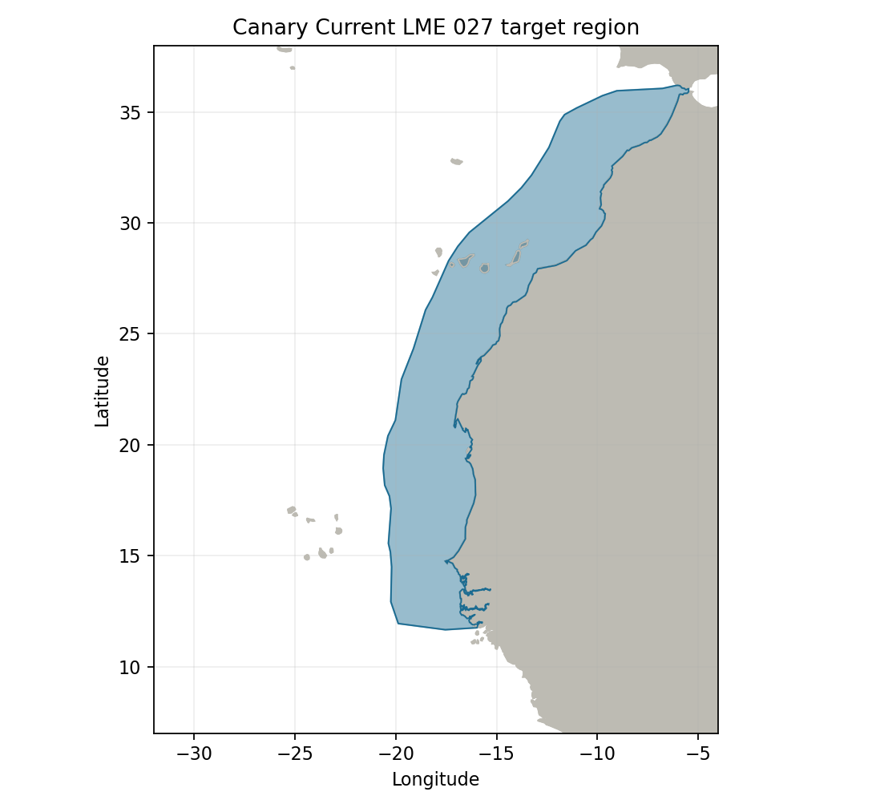
Sea Around Us LME 27 target R: 1,123,612 km². Target boundary | Map image

Study area in the article
Inherited and preliminary source-bound reconstructions
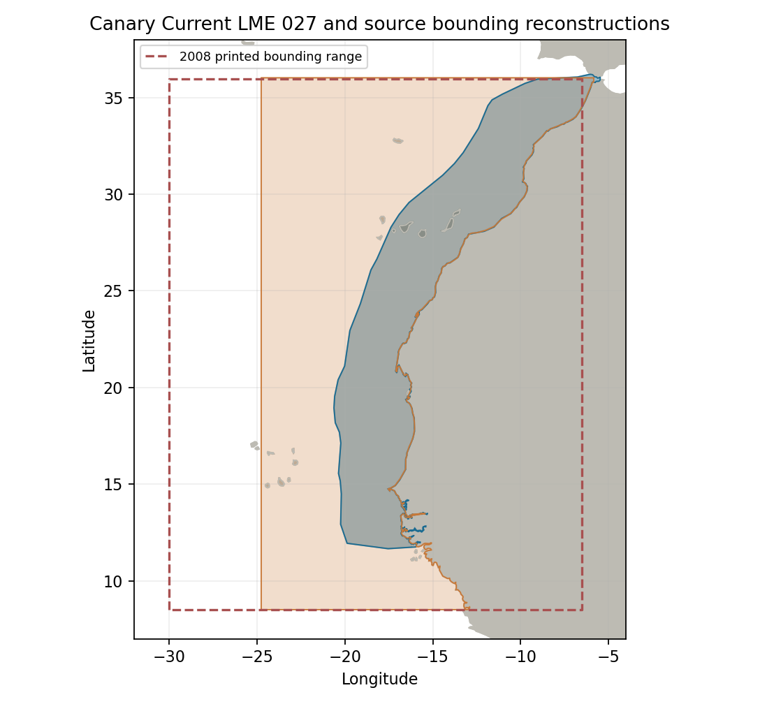
EcoBase 118 extent and 2008 preliminary bounds differ in longitude. Marine reconstructed domains are about 3.43 and 5.08 million km², with A about 99% and B about 22–33%. The reported model area is a separate 3.56 million km² quantity. The broad 95–100% / 20–35% ranges reflect boundary/version uncertainty. Geographic assessment | Portable reconstruction
Original 2008 preliminary Figure 1, PDF 29 (caption PDF 28), rather than the unavailable final-2009 figure. Panel A shows global project areas; panel B shows Northwest African bounds of 8.5–36°N, 30–6.5°W. Preliminary source figure
