Canary Current M30 model validation
Field | Entry
Region | Canary Current (LME 027)  Regional workbook
Catch source | Sea Around Us retained regional dataset, 1950–2019; landings reference year 2019. Provider revision unspecified.  Catch archive | Catch and coefficient context
Selected article | Candidate article: Guénette S, Meissa B, Gascuel D (2014). Assessing the Contribution of Marine Protected Areas to the Trophic Functioning of Ecosystems: A Model for the Banc d’Arguin and the Mauritanian Shelf. PLoS ONE 9(4), e94742.  DOI | Article PDF | Supplement
Other known articles | Morissette, Melgo, Kaschner, Gerber & Bamy (2009): Northwest African food-web model; the currently selected EcoBase 118 version represents 1987.  Villanueva, Tito-de-Morais, Weigel & Moreau (2004): An Ecopath model of the Sine-Saloum Delta biosphere reserve (Senegal).  Central article records | Retained source folders
Selected model | Candidate: Guenette2014_BancArguin_M30_1991. 51 source groups, 47 consumers and 3 reported fleets; Mauritanian shelf to 200 m, approximately 33,224 km². Baseline 1991; Ecosim calibration 1991–2006.  Canonical model JSON | Source extraction
Other models from the same article | Base assumes equal subtidal and intertidal benthos density; P30 raises assumed subtidal density by 30%. The alternatives alter Banc feeding proportions and selected balanced biomasses.  All three share the 1991 shelf domain. EcoBase 689 is a separately deposited numerical version, with material differences from the printed tables.
Selection rationale | Article – ? Candidate review requested; no recorded decision selects this article.  Model – ? No decision selects this variant. Overview retains Northwest Africa 1987 after the earlier comparison recorded failures for the Banc d’Arguin configurations.  Current selection record | Exact recorded rationale
Model extraction | Table 1 and S8 Base conflict; for BA phytoplankton, EE is 0.260 versus 0.40. Both values and their table contexts remain documented.  M30: S8 supplies scenario biomass, EE and aggregate Banc-feeding proportions, but leaves 114 diet cells across 14 consumers unpublished. Complete scenario diet/import matrices were not recovered.  S2 prints Groupers ad → BA L crustaceans as 1.34 (diet sum 2.2006); Coastal birds sum to 0.980331. Four blank cells remain unknown. The source matrix was not repaired.  Multi-stanza Z is distinct from P/B; missing P/B and growth/transition details are retained separately. No discard observations were reported; unknowns remain distinct from zero.  Source conflicts | Diet cell evidence | Online recovery  Retained departures and evidence limits: model notes
GE diagnostics | NOT_RUN. The M30 scenario lacks 114 diet cells across 14 consumers. No scenario-specific coefficient or per-source SPPR matrix is available.  Negative SPPR, rho_living, b and Detritus (51) SPPR: not determined.  Source completeness
TE diagnostics | NOT_RUN. The M30 scenario lacks 114 diet cells across 14 consumers. No scenario-specific coefficient or per-source SPPR matrix is available.  Negative SPPR, rho_living and Detritus (51) SPPR: not determined.  Source completeness
SPPR calculation | [Researcher calculation choices and notes]
Geographic fit | A. Region covered by study: approximately 3.0% (about 2.5–3.5%).  B. Study area covered by region: approximately 95–100%.
Temporal fit | The baseline represents 1991 and calibration spans 1991–2006; the mapping reference is 2019. Transferring fixed coefficients and source catch/biomass proportions across years and across the much larger LME is an explicit approximation.
Other | Base or EcoBase 689 coefficients cannot stand in for this scenario. The independent simple-chain PPR and catch-mapping assessment below do not require scenario SPPR.  The currently selected Northwest Africa 1987 model was disqualified by Ido Carmel on 02/10/2026: “Reason – too strong living compartments recycling due to near-zero EE values (rho_living = 0.99).” This is a separate model’s review.  Regional assessment | Independent native-deposit audit
Open issues and next action
Review and reproducibility | Researcher name: [name] | review date: [dd/mm/yyyy]

Taxon mapping and coverage
Reference: 2019 landings; all retained regional catch labels, including zero landings.
51 source groups; 512 catch taxa. Computational import groups are separate.
Simple-chain PPR totals 244,709,206 t C in 2019.
100 labels lack a saved TL/coefficient. All have zero recorded 2019 landings and contribute zero annual PPR; the annual total is complete.
Method: independent simple trophic chain, using retained taxon coefficients.
Excel taxon appendix and descriptive Sources sheet
Overall confidence | Taxa (n) | Catch (%) | Simple-chain PPR (%)
High | 116 | 49% | 37%
Medium | 283 | 25% | 39%
Low | 45 | 1.7% | 9.8%
Very low | 68 | 24% | 14%
Unresolved | 0 | 0% | 0%
Overall confidence uses the weaker required membership or allocation component.

Group assignment rules
Plain-language rule | Confidence | PPR percentage
Explicit species assignment in the source composition table | High | 37%
Supported extension from listed regional representatives | Medium | 20%
Supported ecological extension to a documented guild | Medium | 14%
Broad reporting category approximated across compatible groups | Very low | 11%
Partial or conflicting ecological fit | Low | 9.8%
Assumed eligible group set supported by source taxonomy and ecology | Medium | 3.1%
Unambiguous fit to the documented residual cephalopod group | High | 2.6%
Closest represented analogue despite habitat or taxonomic mismatch | Very low | 2.1%
Verified synonym of an explicitly listed source species | High | 0.20%
Membership evidence: source Tables S1, S4 and S5, documented guild definitions and regional taxonomic evidence. Source supplement

Allocation weight rules
Plain-language rule | Confidence | PPR percentage
One eligible group; no allocation split needed | High | 83%
Source model 1991 reported catch proportions, assumed across target years and bases | Medium | 17%
Model-biomass proportions when complete candidate catches have zero total | Medium | 0.047%
Weights and assumptions: source 1991 catch proportions; complete model biomass where candidate catch totals are zero. The spatial, temporal and life-stage transfer is assumed. Juvenile source zeros do not show that later catches or discards contain no juveniles. Allocation evidence
Each percentage is the independent simple-chain PPR associated with taxa using that rule.
No unresolved mappings remain. The 68 Very low assignments account for 24% of catch and 14% of simple-chain PPR.

Very low decisions
Affected taxa | Why confidence is very low
Actinopterygii | Broad ray-finned-fish reporting spans named fish, pelagic, coastal and shelf pools. Approximate with source fish pools3–29 except11/20 (selacians), which are taxonomically excluded. Constituent composition is unobserved.
Alepisaurus ferox; Brama brama; Bramidae; Lampris guttatus | Bathypelagic or oceanic midwater fish lack their own depth/feeding compartment. Pelagic L is the closest mobile pelagic-fish analogue, with deep-water/feeding differences retained.
Alopias; Alopias superciliosus; Alopias vulpinus; Carcharhinus falciformis; Carcharhinus galapagensis; Carcharhinus longimanus; Carcharhinus signatus; Carcharodon carcharias; Cetorhinus maximus; Isurus; Isurus oxyrinchus; Isurus paucus; Lamna nasus; Lamnidae; Lamniformes; Mobula birostris; Odontaspis ferox; Prionace glauca | Oceanic, highly migratory or large filter-feeding elasmobranch lacks a matching pool. Shelf selacians is the closest offshore cartilaginous-fish analogue; oceanic/depth or feeding differences (especially basking shark/mobula) are material. Coastal selacians would not resolve those differences.
Antimora rostrata; Mora moro; Trachyrincus scabrus | Deep slope fish exceed the modeled shelf domain. Shelf L includes a deep-associated macrourid and provides a meaningful predatory demersal-fish analogue, with depth/composition mismatch retained.
Aristaeomorpha foliacea; Aristaeopsis edwardsiana; Aristeidae; Aristeus antennatus; Aristeus varidens; Chaceon affinis; Chaceon maritae; Geryon; Paromola cuvieri | Deep/slope large crustaceans extend beyond the modeled <200 m shelf and lack a deep-water pool; shelf large crustaceans are the closest represented benthic decapod analogue. This habitat mismatch is retained.
Carcharhinidae; Carcharhiniformes; Carcharhinus; Squaliformes | Broad shark reporting spans source coastal/shelf habitats and potentially oceanic/deep species. Both selacian pools are a meaningful approximation; no observed species/habitat composition supports stronger containment.

Affected taxa | Why confidence is very low
Centrophorus; Centrophorus granulosus; Centrophorus lusitanicus; Centrophorus squamosus; Centroscyllium fabricii; Centroscymnus coelolepis; Centroselachus crepidater; Dalatias licha; Deania calceus; Echinorhinus brucus; Etmopterus; Etmopterus princeps; Scymnodon ringens; Somniosus rostratus | Deep-water dogfish/shark assemblage extends beyond the modeled shelf. Shelf selacians (including Squalus/Oxynotus/Galeus) is the closest taxonomic/demersal analogue, with depth and unlisted-species mismatch.
Chimaeriformes | Chimaeras have no source group and differ taxonomically from selacians; shelf selacians are the closest cartilaginous demersal-fish analogue, with deep-water and feeding mismatch.
Chondrichthyes | Broad cartilaginous-fish label includes sharks/rays in both source pools and potentially unrepresented chimaeras. Approximate with both meaningful selacian pools; disclose unrepresented component.
Decapoda | Broad decapod reporting can include large harvested shrimps/crabs/lobsters and smaller benthic forms. Use large and small Banc/shelf crustacean pools; cannot infer strict large-only containment from provider commercial tag. Exclude pelagic macrozooplankton because source macro examples are euphausiids/mysids rather than harvested adult Decapoda.
Lepas | Pelagic/rafting goose barnacles are crustaceans without a matching sessile-epifaunal compartment. Small benthic crustacean pools are the closest size/taxonomic analogue, with habitat and feeding mismatch.
Malacostraca; Miscellaneous marine crustaceans | Composition unspecified across large and small benthic crustaceans and macrozooplankton (euphausiids/mysids). Retain those compatible compartments; source catch labels do not establish a complete size/habitat boundary. Meio/larval pools excluded as not a plausible adult fishery reporting population.
Marine finfishes not identified; Marine fishes not identified | Unidentified finfish can span named fish, pelagic, coastal and shelf pools. No observed composition supports a narrower exclusion; approximate with all source fish pools (3–29), including selacians.
Marine groundfishes not identified | Groundfish reporting establishes demersal tendency but no species mix. Include compatible named and generic coastal/shelf fish groups, including demersal elasmobranchs; exclude strictly pelagic/mullet pools.
Marine pelagic fishes not identified | Pelagic reporting spans migratory mullets, the five named pelagic pools, Coastal M (Ethmalosa), Shelf M (explicit pelagic/benthopelagic jacks) and offshore selacian analogue (potential pelagic sharks/rays). Pool names do not exclude these known exceptions. Unobserved composition is a broad approximation; strictly benthic fish pools are excluded.

Affected taxa | Why confidence is very low
Miscellaneous aquatic invertebrates | Unidentified invertebrate reporting can include cephalopods, large/small crustaceans, molluscs, worms, echinoderms and other macro-invertebrates. The provider tag is not exhaustive; named and residual compatible macrofaunal pools retained. Meio/mesoplankton and primary producers excluded as unsupported harvested reporting components.
Mollusca | The taxonomic label can include cephalopods and benthic molluscs. Provider demersal-invertebrate tag does not prove cephalopods absent. Retain both named cephalopod groups and Banc/shelf mollusc pools in a broad composition approximation.
Myctophidae | Mesopelagic lanternfish are not a represented source fish pool. Sardinelles/anchovy supplies the closest small schooling zooplanktivorous-fish analogue, despite depth and diel-migration mismatch.
Octopoda | Broad order includes benthic octopuses represented by Octopus vulgaris and potentially pelagic argonaut/octopod forms in other cephalopods; unobserved composition is approximated across both.
Perciformes | Historical broad perch-like reporting spans many source fish pools. Approximate using compatible named/guild compartments, excluding clupeiforms, selacians, catfish and flatfish-only groups; no observed constituent mix is available.

Geographic evidence
The study covers a narrow Mauritanian shelf portion of the Canary Current LME. Approximate coverage accounts for land exclusion and the shelf’s 200 m offshore boundary. Boundary and area evidence

Region area
Target region boundary
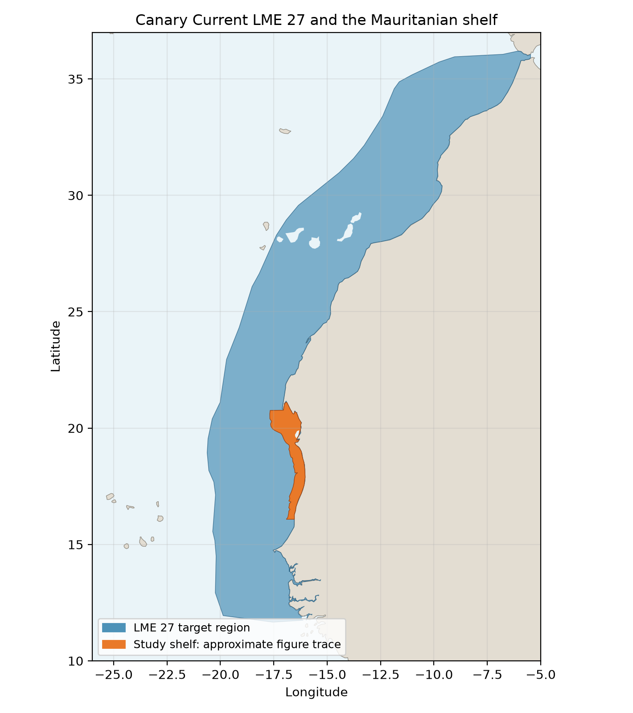
Canary Current LME 27 in blue; approximate study shelf in orange. Project LME boundary and Natural Earth 1:50m land mask. Regional comparison

Study area in the article
Study boundary for the selected model
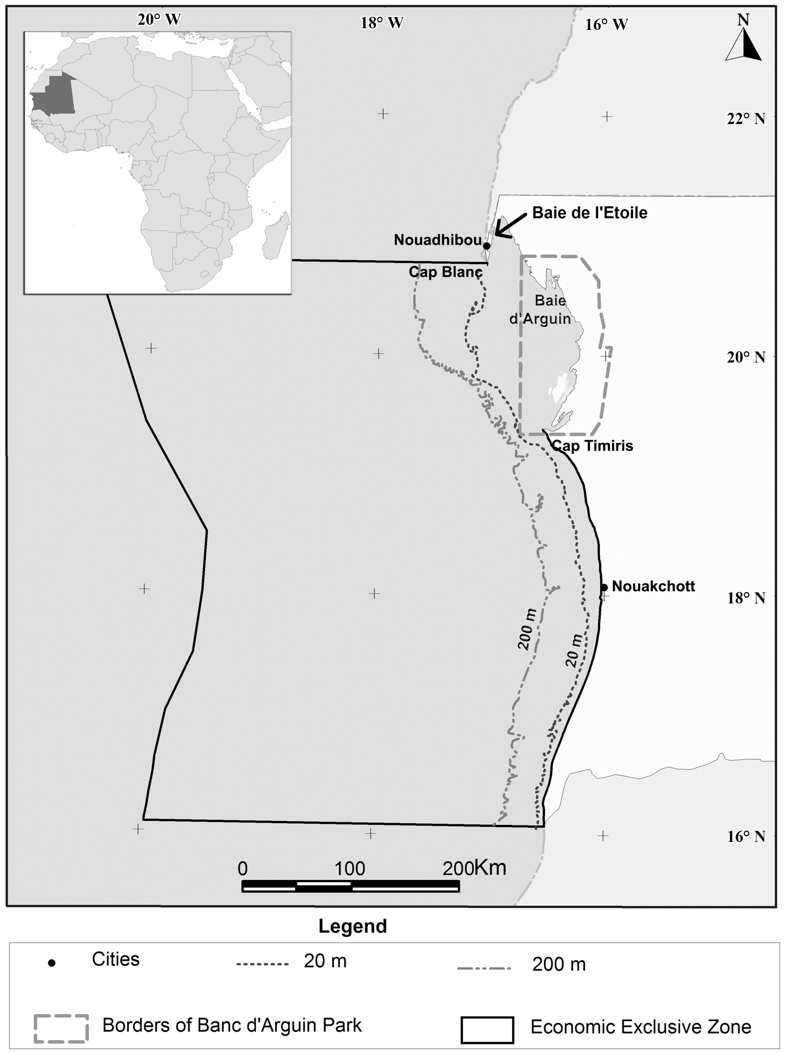
Guénette, Meissa & Gascuel (2014), Figure 1, PDF page 3. The study area is the shelf shallower than 200 m, approximately 33,224 km² including the 6,450 km² Banc. The solid black offshore line marks the larger EEZ. Original figure

