Canary Current Sine Saloum thesis candidate review
The preferred thesis describes a 37-group estuary model for 1991–1992. Its basic table and diet annex disagree about group 20, preventing a defensible SPPR calculation. Its reported area can cover at most 0.049% of the Canary Current LME. This is an unsigned candidate review draft; the active selection remains EcoBase 118.
Field | Entry
Region | Canary Current | LME_027  Candidate: Sine-Saloum estuary, Senegal.  Regional workbook
Catch source | Sea Around Us; retained regional catch records 1950–2019. Reference: 2019 landings, excluding discards.  Catch evidence
Preferred source | Villanueva, Maria Concepcion S. (2004). Biodiversité et relations trophiques dans quelques milieux estuariens et lagunaires de l’Afrique de l’Ouest : adaptations aux pressions environnementales. Doctoral thesis, Institut National Polytechnique de Toulouse / ENSAT. Source title page: defended 29 October 2004; a harvested catalogue date differs. No DOI located.  Thesis PDF | Source metadata | Archimer record
Other known articles | Villanueva, Tito-de-Morais, Weigel and Moreau, An Ecopath model of the Sine-Saloum Delta Biosphere Reserve (Senegal), proceedings report cover 2004 / legal imprint 2005: a different 38-group preliminary version.  Villanueva, Diouf, Albaret and Moreau (2005), Complexity in trophic structure and stability in a modelled West African estuary, in Coastal Ecosystems of West-Africa, edited by J.-J. Symoens, pp. 15–26: a related 37-group release.  Morissette et al. (2009), Northwest Africa food-web model, FCRR 17(2): same model lineage as selected EcoBase 118. Guénette et al. (2014), Banc d’Arguin and Mauritanian Shelf, PLOS ONE e94742: distinct shelf models.  Supplied chapter | 2005 follow-up
Candidate model | 27_Villanueva2004_SineSaloum  Preferred variant: thesis Table 6.5 / Annex II.A, Sine-Saloum, 1991–1992, 37 source groups. Related EcoBase accession 612 identifies this model lineage, but its official numerical input is unavailable. The local canonical representation is explicitly incomplete.  Candidate folder | Canonical partial model | Identity assessment
Other models from the same article | The thesis also models Gambia (41 groups, 2000–2002; Table 6.6), Ébrié Lagoon (42 groups, 1980–1981; Table 6.7), and Nokoué Lagoon (31 groups, 2000–2001; Table 6.8). These are separate ecosystem models and were not evaluated as Sine-Saloum replacements in this review.
Selection rationale | Article – The researcher authorized the downloaded and documented thesis as the preferred source after the supplied chapter lacked a quantitative diet matrix.  Model – Review the thesis Sine-Saloum model as a regional alternative; its stated period and quantitative annex improve evidence. Geographic proximity does not establish suitability.
Model extraction | Table 6.5 and the complete 37-prey × 34-consumer Annex II.A were extracted separately. The annex uses fractions despite its percent caption; consumer sums are 0.999–1.000 and are preserved.  Group 27 labels refer to the same documented mullet pool. Group 20 is unresolved: the basic table names Epinephelus aeneus, but the annex names Hemichromis fasciatus; Table 3.3 separates those compartments. Canonical cells requiring that join remain unknown. GS, BA and routing are unreported; no defaults, normalization or numerical repair were applied.  Full literal extraction | Diet identity crosswalk | Admission blocker  Retained departures and evidence limits: model notes
GE diagnostics | NOT_RUN — unresolved group 20 diet identity blocks source admission.  Negative SPPR entries, rho_living, b and Detritus (37) SPPR cannot be determined. No GE matrix or coefficients are available.
TE diagnostics | NOT_RUN — the same source identity conflict blocks source admission.  Negative SPPR entries, rho_living and Detritus (37) SPPR cannot be determined. No TE matrix or coefficients are available.
SPPR calculation | [Researcher calculation choices and notes]
Geographic fit | A. Region covered by study: at most approximately 0.049% (reported-area upper bound).  B. Study area covered by region: not determined; the model water boundary is ambiguous in the schematic and source bounds. Main channels lie within the target geometry.
Temporal fit | The modeled period is 1991–1992; thesis field sampling also includes 1992–1993. The reference landings year 2019 is 27–28 years later. Fixed source catch/biomass mixtures across 1950–2019 are assumptions and cannot reconstruct annual estuarine or offshore food-web change.
Other | With Egestion is also NOT_RUN. No candidate GE/TE/Egestion regional PPR or PPR/NPP is available. Independent simple-chain PPR remains calculable from the regional taxon coefficients.  The selected EcoBase 118 remains disqualified on 02/10/2026: “Reason – too strong living compartments recycling due to near-zero EE values (rho_living = 0.99).” The thesis is a distinct local model, but shared source lineage and model distinction do not establish independent observations or whole-LME representativeness.  Direct diagnostic records | Preserved signed review
Open issues and next action
Review and reproducibility | Researcher name: ____________________ | review date: dd/mm/yyyy

Taxon mapping and coverage
Reference: 2019 landings, excluding discards; all recorded taxon labels, including zero-landings rows. Candidate mappings below remain unadopted.
37 source groups; 512 catch taxa.
Simple-chain PPR totals 244,709,206 t C in 2019.
100 taxa have no saved classic coefficient; all have zero 2019 landings and contribute zero annual PPR. No positive-catch contribution is unknown.
Method: independent simple trophic chain using the saved regional taxon coefficients.
Excel taxon appendix and descriptive Sources sheet
Overall confidence | Taxa (n) | Catch (%) | Simple-chain PPR (%)
High | 71 | 19% | 9.2%
Medium | 23 | 0.66% | 1.4%
Low | 4 | 0.19% | 0.49%
Very low | 414 | 80% | 89%
Unresolved | 0 | 0% | 0%
Overall confidence uses the weaker required membership or allocation component.

Group assignment rules
Plain-language rule | Confidence | PPR percentage
The closest represented ecological or taxonomic analogue is used for an unrepresented taxon, with the actual mismatch disclosed. | Very low | 78%
A broad catch label is approximated by a recorded set of source pools because its composition or containment is unknown. | Very low | 11%
Species is explicitly assigned by the Sine-Saloum source membership table or is the exact model principal species. | High | 7.1%
The catch taxon fits an explicitly documented generic source group, with its taxonomic reporting scope verified. | High | 1.6%
An unlisted relative is added to a documented pooled group on taxonomic evidence; membership remains an assumption. | Medium | 1.3%
A source membership or compartment-identity conflict weakens an otherwise supported assignment. | Low | 0.49%
An authoritative synonym or historical spelling links the catch taxon to an explicitly listed source member. | High | 0.47%
Taxonomy and source pool definitions support an inferred candidate set whose composition remains assumed. | Medium | 0.11%
Thesis Tables 3.3 and 6.5, group-definition prose and verified taxonomy. Full candidate audit

Allocation weight rules
Plain-language rule | Confidence | PPR percentage
The complete catch taxon is assigned to one model group; no numerical split is needed. | High | 89%
Complete thesis-model biomass proportions replace incomplete source catch values, assuming representative composition and catchability. | Medium | 10%
Weights use the candidate groups’ thesis-model catch proportions, assumed applicable to the regional catch and constant over years. | Medium | 0.70%
Source catch proportions, then complete biomass where usable, supply assumed mixtures. One-group assignments need no split. Fixed historical mixtures are transferred to 2019 landings. Candidate allocation evidence
Each percentage is the independent simple-chain PPR associated with taxa using that rule.
Unresolved taxa: none. 414 Very low decisions account for 80% of catch and 89% of simple-chain PPR. High assignment coverage does not establish valid SPPR or whole-LME ecological fit.

Very low decisions
Affected taxa | Why confidence is very low
Actinopterygii; Marine finfishes not identified; Marine fishes not identified; Perciformes | Broad bony-fish composition is unknown across named and residual estuarine fish pools; whole-LME unidentified catch is approximated by the source assemblage.
Alectis ciliaris; Campogramma glaycos; Decapterus; Decapterus macarellus; Elagatis bipinnulata; Pseudocaranx dentex; Scyris alexandrina | Unlisted jack/scad taxa use the source Carangidae pool as a taxonomic analogue; their ecology and actual source membership remain uncertain.
Selene dorsalis; Seriola dumerili; Seriola rivoliana; Trachurus; Trachurus mediterraneus; Trachurus picturatus; Trachurus trachurus | Unlisted jack/scad taxa use the source Carangidae pool as a taxonomic analogue; their ecology and actual source membership remain uncertain.
Trachurus trecae | Unlisted jack/scad taxa use the source Carangidae pool as a taxonomic analogue; their ecology and actual source membership remain uncertain.
Ablennes hians; Acanthocybium solandri; Alepisaurus ferox; Antimora rostrata; Argentina sphyraena; Auxis; Auxis rochei | Unrepresented pelagic and bathypelagic fishes use the predatory barracuda pool; habitat, taxonomy and trophic specialization differ.
Auxis thazard; Belone belone; Belonidae; Brama brama; Bramidae; Coryphaena; Coryphaena hippurus | Unrepresented pelagic and bathypelagic fishes use the predatory barracuda pool; habitat, taxonomy and trophic specialization differ.
Dicentrarchus punctatus; Diplodus bellottii; Echeneidae; Euthynnus alletteratus; Hoplostethus atlanticus; Istiophoridae; Istiophorus albicans | Unrepresented pelagic and bathypelagic fishes use the predatory barracuda pool; habitat, taxonomy and trophic specialization differ.
Kajikia albida; Katsuwonus pelamis; Lagocephalus laevigatus; Lampris guttatus; Makaira nigricans; Megalops atlanticus; Mora moro | Unrepresented pelagic and bathypelagic fishes use the predatory barracuda pool; habitat, taxonomy and trophic specialization differ.
Orcynopsis unicolor; Pomatomus saltatrix; Rachycentridae; Rachycentron canadum; Sarda; Sarda sarda; Scomber | Unrepresented pelagic and bathypelagic fishes use the predatory barracuda pool; habitat, taxonomy and trophic specialization differ.
Scomber colias; Scomber scombrus; Scomberesox saurus; Scombridae; Scombroidei; Tetrapturus belone; Tetrapturus pfluegeri | Unrepresented pelagic and bathypelagic fishes use the predatory barracuda pool; habitat, taxonomy and trophic specialization differ.
Thunnus; Thunnus alalunga; Thunnus albacares; Thunnus obesus; Thunnus thynnus; Trachichthyidae; Trachyrincus scabrus | Unrepresented pelagic and bathypelagic fishes use the predatory barracuda pool; habitat, taxonomy and trophic specialization differ.
Xiphias gladius | Unrepresented pelagic and bathypelagic fishes use the predatory barracuda pool; habitat, taxonomy and trophic specialization differ.
Alosa; Atherina presbyter; Atherinidae; Engraulidae; Engraulis encrasicolus; Myctophidae; Sardina pilchardus | Unrepresented small pelagics use the source Sardinella pool as a schooling-fish analogue; taxonomy and sometimes habitat differ.
Aluterus; Aluterus monoceros; Anguilla anguilla; Anguilliformes; Anthias anthias; Apsilus fuscus; Balistes | Unrepresented demersal, reef and benthopelagic fishes use the coastal grunt pool; family, depth, habitat and feeding specialization can differ.
Balistes capriscus; Balistidae; Berycidae; Beryx; Beryx decadactylus; Beryx splendens; Bodianus scrofa | Unrepresented demersal, reef and benthopelagic fishes use the coastal grunt pool; family, depth, habitat and feeding specialization can differ.
Boops boops; Branchiostegus; Brotula; Brotula barbata; Capros aper; Centracanthus cirrus; Centrolophidae | Unrepresented demersal, reef and benthopelagic fishes use the coastal grunt pool; family, depth, habitat and feeding specialization can differ.
Chelidonichthys lastoviza; Chelidonichthys lucerna; Chromis limbata; Conger conger; Congridae; Coris julis; Dentex | Unrepresented demersal, reef and benthopelagic fishes use the coastal grunt pool; family, depth, habitat and feeding specialization can differ.
Dentex angolensis; Dentex dentex; Dentex gibbosus; Dentex macrophthalmus; Dentex maroccanus; Dicentrarchus; Dicentrarchus labrax | Unrepresented demersal, reef and benthopelagic fishes use the coastal grunt pool; family, depth, habitat and feeding specialization can differ.
Diplodus; Diplodus annularis; Diplodus cervinus; Diplodus puntazzo; Diplodus sargus; Diplodus vulgaris; Echelus myrus | Unrepresented demersal, reef and benthopelagic fishes use the coastal grunt pool; family, depth, habitat and feeding specialization can differ.
Epigonus telescopus; Fistularia tabacaria; Fistulariidae; Gadidae; Gadiformes; Gephyroberyx darwinii; Gymnothorax | Unrepresented demersal, reef and benthopelagic fishes use the coastal grunt pool; family, depth, habitat and feeding specialization can differ.
Gymnothorax maderensis; Gymnothorax polygonius; Gymnothorax unicolor; Halobatrachus didactylus; Helicolenus dactylopterus; Heteropriacanthus cruentatus; Labridae | Unrepresented demersal, reef and benthopelagic fishes use the coastal grunt pool; family, depth, habitat and feeding specialization can differ.
Labrus; Lethrinus atlanticus; Lithognathus mormyrus; Lophiidae; Lophius; Lophius budegassa; Lophius vaillanti | Unrepresented demersal, reef and benthopelagic fishes use the coastal grunt pool; family, depth, habitat and feeding specialization can differ.
Lutjanidae; Lutjanus; Lutjanus agennes; Macroramphosus scolopax; Merlucciidae; Merluccius; Merluccius merluccius | Unrepresented demersal, reef and benthopelagic fishes use the coastal grunt pool; family, depth, habitat and feeding specialization can differ.
Merluccius polli; Merluccius senegalensis; Micromesistius poutassou; Monacanthidae; Moronidae; Mullidae; Mullus | Unrepresented demersal, reef and benthopelagic fishes use the coastal grunt pool; family, depth, habitat and feeding specialization can differ.
Mullus barbatus; Mullus surmuletus; Muraena augusti; Muraena helena; Muraenidae; Oblada melanurus; Ophidiidae | Unrepresented demersal, reef and benthopelagic fishes use the coastal grunt pool; family, depth, habitat and feeding specialization can differ.
Pagellus; Pagellus acarne; Pagellus bellottii; Pagellus bogaraveo; Pagellus erythrinus; Pagrus; Pagrus africanus | Unrepresented demersal, reef and benthopelagic fishes use the coastal grunt pool; family, depth, habitat and feeding specialization can differ.
Pagrus auriga; Pagrus caeruleostictus; Pagrus pagrus; Parapristipoma octolineatum; Peristediidae; Phycis; Phycis blennoides | Unrepresented demersal, reef and benthopelagic fishes use the coastal grunt pool; family, depth, habitat and feeding specialization can differ.
Phycis phycis; Polymixia nobilis; Polynemidae; Polyprion americanus; Pomacentridae; Pontinus kuhlii; Priacanthidae | Unrepresented demersal, reef and benthopelagic fishes use the coastal grunt pool; family, depth, habitat and feeding specialization can differ.
Priacanthus; Priacanthus arenatus; Pseudupeneus prayensis; Schedophilus ovalis; Schedophilus pemarco; Scorpaena; Scorpaena notata | Unrepresented demersal, reef and benthopelagic fishes use the coastal grunt pool; family, depth, habitat and feeding specialization can differ.
Scorpaena porcus; Scorpaena scrofa; Scorpaenidae; Scorpaeniformes; Sebastidae; Serranus; Serranus cabrilla | Unrepresented demersal, reef and benthopelagic fishes use the coastal grunt pool; family, depth, habitat and feeding specialization can differ.
Serranus scriba; Similiparma lurida; Sparidae; Sparus aurata; Sphoeroides marmoratus; Spicara; Spondyliosoma cantharus | Unrepresented demersal, reef and benthopelagic fishes use the coastal grunt pool; family, depth, habitat and feeding specialization can differ.
Stephanolepis hispida; Stromateidae; Stromateus fiatola; Symphodus; Synodus saurus; Tetraodontidae; Thalassoma pavo | Unrepresented demersal, reef and benthopelagic fishes use the coastal grunt pool; family, depth, habitat and feeding specialization can differ.
Trachinus; Trachinus radiatus; Triglidae; Trisopterus luscus; Uranoscopus; Uranoscopus scaber; Zenopsis conchifer | Unrepresented demersal, reef and benthopelagic fishes use the coastal grunt pool; family, depth, habitat and feeding specialization can differ.
Zeus faber | Unrepresented demersal, reef and benthopelagic fishes use the coastal grunt pool; family, depth, habitat and feeding specialization can differ.
Alopias; Alopias superciliosus; Alopias vulpinus; Carcharhinidae; Carcharhiniformes; Carcharhinus; Carcharhinus brachyurus | Sharks have no source compartment; benthic cartilaginous or pelagic predatory-fish analogues transfer body form, trophic ecology and often depth.
Carcharhinus brevipinna; Carcharhinus falciformis; Carcharhinus galapagensis; Carcharhinus leucas; Carcharhinus limbatus; Carcharhinus longimanus; Carcharhinus obscurus | Sharks have no source compartment; benthic cartilaginous or pelagic predatory-fish analogues transfer body form, trophic ecology and often depth.
Carcharhinus plumbeus; Carcharhinus signatus; Carcharias taurus; Carcharodon carcharias; Centrophorus; Centrophorus granulosus; Centrophorus lusitanicus | Sharks have no source compartment; benthic cartilaginous or pelagic predatory-fish analogues transfer body form, trophic ecology and often depth.
Centrophorus squamosus; Centroscyllium fabricii; Centroscymnus coelolepis; Centroselachus crepidater; Cetorhinus maximus; Dalatias licha; Deania calceus | Sharks have no source compartment; benthic cartilaginous or pelagic predatory-fish analogues transfer body form, trophic ecology and often depth.
Echinorhinus brucus; Etmopterus; Etmopterus princeps; Galeocerdo cuvier; Galeorhinus galeus; Galeus melastomus; Ginglymostoma cirratum | Sharks have no source compartment; benthic cartilaginous or pelagic predatory-fish analogues transfer body form, trophic ecology and often depth.
Heptranchias perlo; Hexanchus griseus; Isurus; Isurus oxyrinchus; Isurus paucus; Lamna nasus; Lamnidae | Sharks have no source compartment; benthic cartilaginous or pelagic predatory-fish analogues transfer body form, trophic ecology and often depth.
Lamniformes; Leptocharias smithii; Mustelus; Mustelus asterias; Mustelus mustelus; Odontaspis ferox; Oxynotus centrina | Sharks have no source compartment; benthic cartilaginous or pelagic predatory-fish analogues transfer body form, trophic ecology and often depth.
Prionace glauca; Rhizoprionodon acutus; Scyliorhinidae; Scyliorhinus; Scyliorhinus canicula; Scyliorhinus stellaris; Scymnodon ringens | Sharks have no source compartment; benthic cartilaginous or pelagic predatory-fish analogues transfer body form, trophic ecology and often depth.
Somniosus rostratus; Sphyrna; Sphyrna lewini; Sphyrna mokarran; Sphyrna zygaena; Sphyrnidae; Squalidae | Sharks have no source compartment; benthic cartilaginous or pelagic predatory-fish analogues transfer body form, trophic ecology and often depth.
Squaliformes; Squalus; Squalus acanthias; Squalus blainville; Squatina squatina; Squatinidae; Triakidae | Sharks have no source compartment; benthic cartilaginous or pelagic predatory-fish analogues transfer body form, trophic ecology and often depth.
Cephalopoda; Illex coindetii; Loliginidae; Loligo; Loligo forbesii; Octopoda; Octopodidae | Cephalopods are unrepresented; a bivalve/gastropod-dominated macrobenthos analogue transfers trophic function and, for pelagic forms, habitat.
Octopus; Octopus vulgaris; Ommastrephes; Ommastrephes bartramii; Ommastrephidae; Sepia; Sepia officinalis | Cephalopods are unrepresented; a bivalve/gastropod-dominated macrobenthos analogue transfers trophic function and, for pelagic forms, habitat.
Sepiida; Sepiidae; Teuthida; Todarodes sagittatus; Todaropsis eblanae | Cephalopods are unrepresented; a bivalve/gastropod-dominated macrobenthos analogue transfers trophic function and, for pelagic forms, habitat.
Scomberomorus | An unrepresented taxon or unresolved reported genus uses a named single-species relative; the source does not document its inclusion.
Cephalopholis taeniops; Epinephelus; Epinephelus caninus; Epinephelus goreensis; Epinephelus marginatus; Mycteroperca fusca; Mycteroperca rubra | Grouper and bottom-predator placement is tentative because basic inputs and diet group20 identify different fish families.
Serranidae | Grouper and bottom-predator placement is tentative because basic inputs and diet group20 identify different fish families.
Batoidea; Chondrichthyes; Elasmobranchii; Rajiformes | Broad cartilaginous-fish composition mixes ray and predatory-fish analogues; unrepresented sharks, chimaeras and specialized rays remain a major biological mismatch.
Arnoglossus laterna; Bothidae; Bothus podas; Citharus linguatula; Dicologlossa cuneata; Dicologlossa hexophthalma; Lepidorhombus | Unrepresented flatfish families use the Citarichthys/Psettodes and Cynoglossus pools; source taxonomic containment and their target split are unknown.
Lepidorhombus boscii; Lepidorhombus whiffiagonis; Microchirus; Microchirus variegatus; Pleuronectiformes; Psettodes bennettii; Psettodidae | Unrepresented flatfish families use the Citarichthys/Psettodes and Cynoglossus pools; source taxonomic containment and their target split are unknown.
Solea; Solea senegalensis; Solea solea; Soleidae; Synapturichthys kleinii | Unrepresented flatfish families use the Citarichthys/Psettodes and Cynoglossus pools; source taxonomic containment and their target split are unknown.
Aphanopus carbo; Aphanopus intermedius; Gempylidae; Lepidocybium flavobrunneum; Lepidopus caudatus; Promethichthys prometheus; Ruvettus pretiosus | Unrepresented elongate benthopelagic predators use single-species Trichiurus lepturus; broader taxonomy and often deep-water habitat differ.
Trichiuridae; Trichiurus | Unrepresented elongate benthopelagic predators use single-species Trichiurus lepturus; broader taxonomy and often deep-water habitat differ.
Aetomylaeus bovinus; Chimaeriformes; Glaucostegus cemiculus; Gymnura altavela; Gymnura micrura; Mobula birostris; Myliobatidae | Non-dasyatid rays and chimaeras use the source dasyatid pool; specialized morphology, feeding and sometimes pelagic/deep habitat differ.
Myliobatis aquila; Pristidae; Raja; Raja brachyura; Raja clavata; Raja microocellata; Raja miraletus | Non-dasyatid rays and chimaeras use the source dasyatid pool; specialized morphology, feeding and sometimes pelagic/deep habitat differ.
Raja undulata; Rhinobatidae; Rhinobatos; Rhinobatos rhinobatos; Rostroraja alba; Torpedo | Non-dasyatid rays and chimaeras use the source dasyatid pool; specialized morphology, feeding and sometimes pelagic/deep habitat differ.
Calappa granulata; Chaceon affinis; Chaceon maritae; Eriphia verrucosa; Geryon; Homarus gammarus; Maja squinado | Non-portunid crabs and lobsters use the source portunid crab pool as a benthic decapod analogue; taxonomy, habitat and fishery differ.
Nephropidae; Nephrops norvegicus; Palinuridae; Palinurus; Palinurus mauritanicus; Panulirus; Panulirus regius | Non-portunid crabs and lobsters use the source portunid crab pool as a benthic decapod analogue; taxonomy, habitat and fishery differ.
Paromola cuvieri; Scyllaridae; Scyllarus arctus | Non-portunid crabs and lobsters use the source portunid crab pool as a benthic decapod analogue; taxonomy, habitat and fishery differ.
Dendrobranchiata | Broad shrimp reporting composition is unknown and can include offshore/deep-water families absent from the estuarine source pool.
Holothuroidea; Lepas | Unlisted benthic invertebrates use macrobenthos as a bottom-fauna analogue; the exact taxonomic/source composition is unverified.
Marine pelagic fishes not identified | Unidentified pelagic-fish composition is unknown; a mixture of source pelagic/benthopelagic pools transfers the estuarine assemblage to offshore regional catch.
Decapoda; Malacostraca; Miscellaneous marine crustaceans | Broad crustacean composition is unknown and can include unrepresented lobsters/krill; a shrimp-and-portunid-crab mixture is assumed.
Aristaeomorpha foliacea; Aristaeopsis edwardsiana; Aristeidae; Aristeus antennatus; Aristeus varidens; Parapenaeus longirostris; Solenocera africana | Unrepresented offshore/deep-water shrimps use the estuarine shrimp pool; source taxonomic and habitat containment is unverified.
Solenocera membranacea; Solenoceridae | Unrepresented offshore/deep-water shrimps use the estuarine shrimp pool; source taxonomic and habitat containment is unverified.
Acanthuridae; Acanthurus; Acanthurus monroviae; Kyphosus sectatrix; Sarpa salpa; Scaridae; Sparisoma cretense | Unrepresented reef/coastal herbivores use the mullet pool as a feeding analogue; taxonomy and habitat differ.
Clupeidae; Clupeiformes | Broad clupeid or clupeiform composition is unknown across dedicated and pooled source compartments.
Haemulidae; Inermiidae | Broad fish-family composition is unknown across represented pools; unlisted members may have different ecological affinities.
Mollusca | Broad mollusc composition is unknown and includes unrepresented cephalopods; all catch is approximated by the source macrobenthos pool.
Miscellaneous aquatic invertebrates | Unidentified aquatic invertebrates use a biomass-weighted mixture of represented consumer pools; unrepresented components and reporting composition remain unknown.
Marine groundfishes not identified | Groundfish composition is unknown among source bottom-associated pools; the estuarine assemblage is transferred to whole-LME reported groundfish.

Geographic evidence
R is the Canary Current LME and S is the thesis Sine-Saloum estuary. The reported 546 km² gives an upper bound on A even under full containment. Figure 2.2 does not delimit the exact model water area, and its eastward channels conflict with the printed longitude strip; B remains uncertain.

Region area
Target region boundary
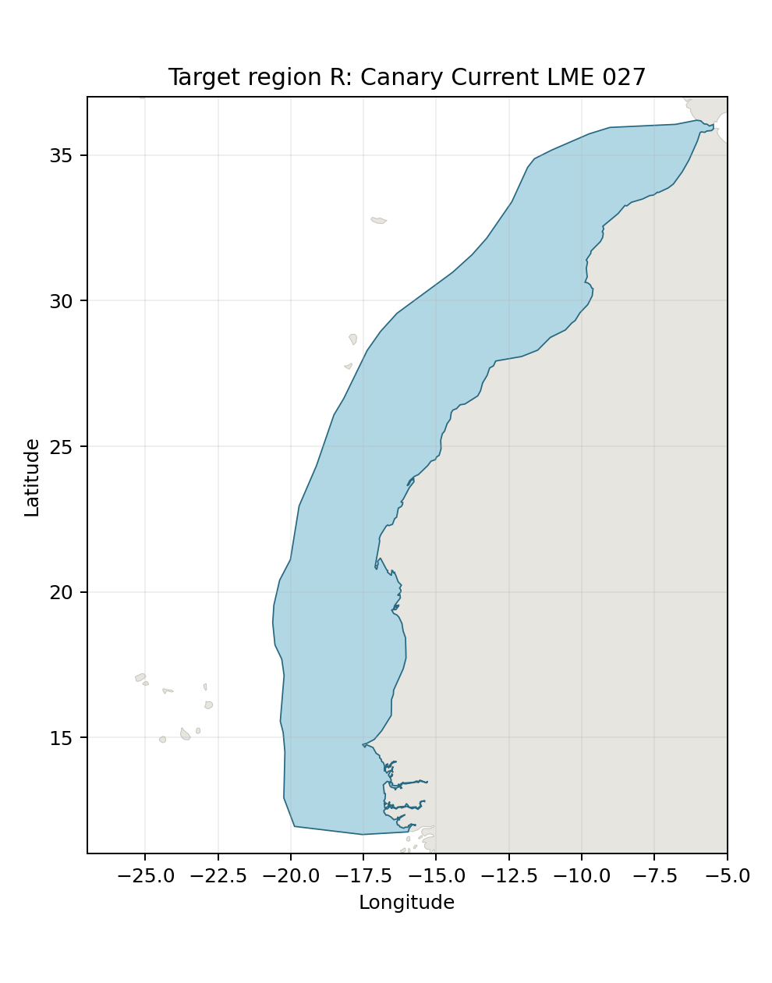
Geographic assessment
Canary Current LME_027, retained project LME geometry. The estuary is located near the southern end of this much larger marine region.

Study area in the article
Original thesis study area schematic
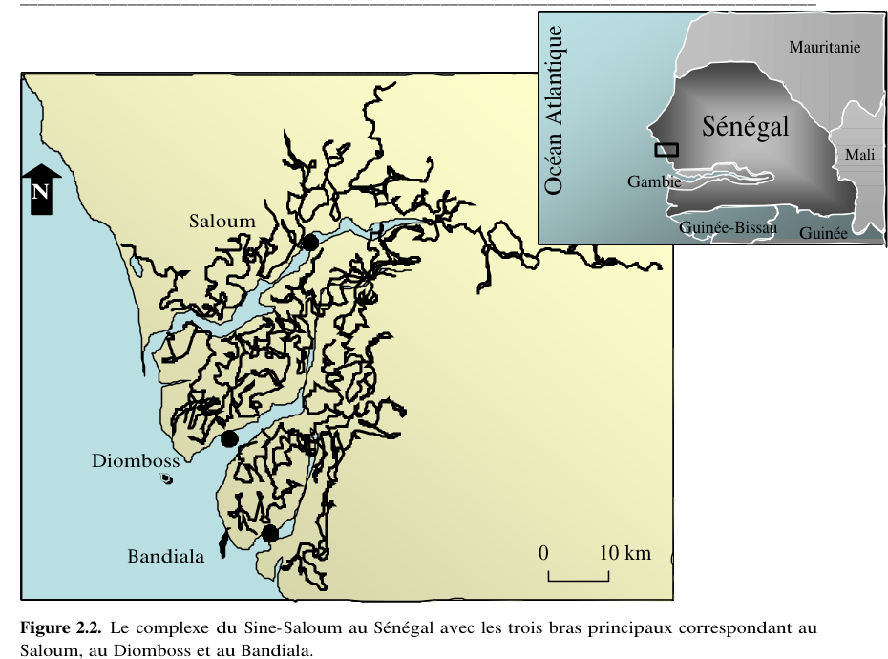
Geographic assessment
Villanueva thesis (2004), Figure 2.2, printed p. 18 / PDF p. 42: the original Sine-Saloum channel schematic. The frame is not a model boundary.

