Regional model validation record
Field | Entry
Region | Benguela Current, LME_029; target includes the northern Benguela. Regional workbook
Catch source | Sea Around Us, local 1950–2019 series; reference 2019 landings. All 247 labels, including zero catch and unidentified categories. Local retained version reviewed 30 September 2026. Catch inputs | Regional catch
Selected article | Shannon, Ortega-Cisneros, Lamont, Winker, Crawford, Jarre & Coll (2020). Exploring Temporal Variability in the Southern Benguela Ecosystem Over the Past Four Decades Using a Time-Dynamic Ecosystem Model. Frontiers in Marine Science 7:540. DOI | Main PDF | Supplement | Paper folder
Other known articles | Heymans & Sumaila (2007), Updated ecosystem model for the Northern Benguela ecosystem, Namibia; no local PDF verified. Roux & Shannon (2004), Ecosystem approach to fisheries management in the northern Benguela: the Namibian experience. Heymans, Shannon & Jarre (2004), Changes in the northern Benguela ecosystem over three decades: 1970s, 1980s and 1990s. 2007 record | Roux 2004 | Roux DOI | Heymans 2004 | Heymans DOI
Selected model | BEN2020_Southern_Benguela_1978; 1978 baseline, 49 ecological source groups (+1 computational import). Southern Benguela west and south coasts, Orange River to East London; reported 220,000 km². Ecosim fitted 1978–2015. Canonical JSON | Model folder | Accepted runtime
Other models from the same article | One complete static 1978 baseline in this article/source bundle. The 1978–2015 Ecosim fit, fishing/fitting scenarios and predecessor models do not provide additional complete static parameter sets here.
Selection rationale | Article — ?  Model — Explicit user selection of the extracted Southern Benguela 1978 model despite all three direct methods failing. Selection retains production, native stanza/BA and TE concerns; it does not authorize biological repair or establish regional applicability.
Model extraction | Main and supplement transcriptions verified. Two source-unknown deep-water-hake P/B values are separately completed as P/Q×Q/B. Sardine stock BA/B is expanded to both stanzas; native accounting remains uncertain. SC rock lobster has conflicting Panulirus/Palinurus identities. Diet sums 1.0001 and 1.0002 are preserved. Five GS=.35 are source-derived; 40 GS=.2, unknown BA, routing/import/migration and detritus EE/BA use accepted defaults. Extraction report | Source and conflicts  Retained departures and evidence limits: model notes
SPPR calculation | [MANUAL — Researcher: calculation choices and reasons]  [Excluded groups, scope and relevant values; other adjustments]

Field | Entry
GE diagnostics | No negative SPPR entries across the basal-source columns. rho_living=0.66883645; b=0.21224719; Detritus (49) SPPR=1.31924764.
TE diagnostics | No negative SPPR entries across the basal-source columns. rho_living=0.99932522; Detritus (49) SPPR=1.09919067.
Geographic fit | A. Region covered by study: approximately 8–12%.  B. Study area covered by region: approximately 50–65%.
Temporal fit | Static 1978 source applied across 1950–2019 whole-LME catches; reference 2019 is 41 years later. Fixed coefficients and composition proxies cannot reconstruct annual ecosystem changes or northern Benguela biology.
Other | All three accepted direct methods remain FAIL. Sardine native stanza/stock-BA interpretation and production imbalance remain unresolved. TE has near-zero Cape Gannet/Cormorant efficiencies and a 9.62% PP-balance gap. With Egestion also has no negative source SPPR; convergence does not remove input failure. Provisional regional arithmetic does not establish model approval. Full matrices and diagnostics
Open issues and next action | [Researcher: open issues and next actions]
Review and reproducibility | Researcher name: [name] | review date: [date]
Taxon mapping and coverage
Reference: 2019 landings; all taxon labels, including zero catch and unidentified categories; no group filter.
49 source ecological groups (+1 computational import); 247 catch taxa.
Simple-chain PPR totals 100,781,750.17 t C in 2019.
100 labels lack an assigned classic coefficient; all have zero 2019 landings and therefore zero annual PPR. Unknown TL/coefficient remains ?, without an invented value.
Method: independent simple trophic chain with the saved taxon coefficients.
All taxon mappings and descriptive Sources sheet
Overall confidence | Taxa | Catch percentage | PPR percentage
High | 52 | 5.9323% | 13.6590%
Medium | 77 | 52.4751% | 25.6843%
Low | 2 | 0.0092% | 0.0006%
Very low | 116 | 41.5835% | 60.6561%
Unresolved | 0 | 0.0000% | 0.0000%
The summary uses the weaker required membership or allocation confidence. The following tables show each component separately.
Group assignment rules
Plain-language rule | Confidence | PPR percentage
Broad reporting category approximated over compatible named and residual pools. | Very low | 58.1670%
Verified spelling or historical name bridge to an explicit source member. | High | 16.1902%
Explicit named member in the exact source group or source stage set. | High | 9.7232%
Supported ecological or historical stock-identity extension. | Medium | 5.0667%
Supported congeneric or related-member extension to the source guild. | Medium | 4.2094%
Closest represented taxonomic or ecological analogue with material mismatches. | Very low | 2.4892%
Unambiguous documented genus or operative ecological group definition. | High | 2.2427%
Taxonomy and source definitions support an assumed eligible group set. | Medium | 1.9111%
Partial fit with conflicting source taxon identities. | Low | 0.0006%
Membership evidence: main Table 1, supplement S2 and taxonomic and source decisions
Allocation weight rules
Plain-language rule | Confidence | PPR percentage
Complete 1978 source total-catch proportions, including genuine zero candidates. | Medium | 79.2648%
One reviewed group receives the whole taxon catch; no split. | High | 20.7352%
Each percentage is the simple-chain PPR share of taxa using that rule. Multi-group weights use complete source S3 catches as fixed composition proxies across catch years, bases and the whole LME; no compatible observed regional stage-mass partition was located. Catch values and allocation evidence
Unresolved: none. Very low: 116 taxa contribute 41.5835% of landings and 60.6561% of simple-chain PPR. Broad marine-fish and Merluccius categories rely on approximate represented composition, including northern taxa absent from this southern model. Unlisted demersal, reef, shark and invertebrate taxa also use weak analogues. All affected labels and assumptions appear in the linked appendix.

Geographic evidence screenshots
R is the Sea Around Us target and S is an approximate trace of source Figure 1. Geodesic areas use geographic coordinates. The reconstruction follows the blue study shading and adjacent visible coastline; original author coordinates are unavailable.

Region area
Benguela target R and southern study location
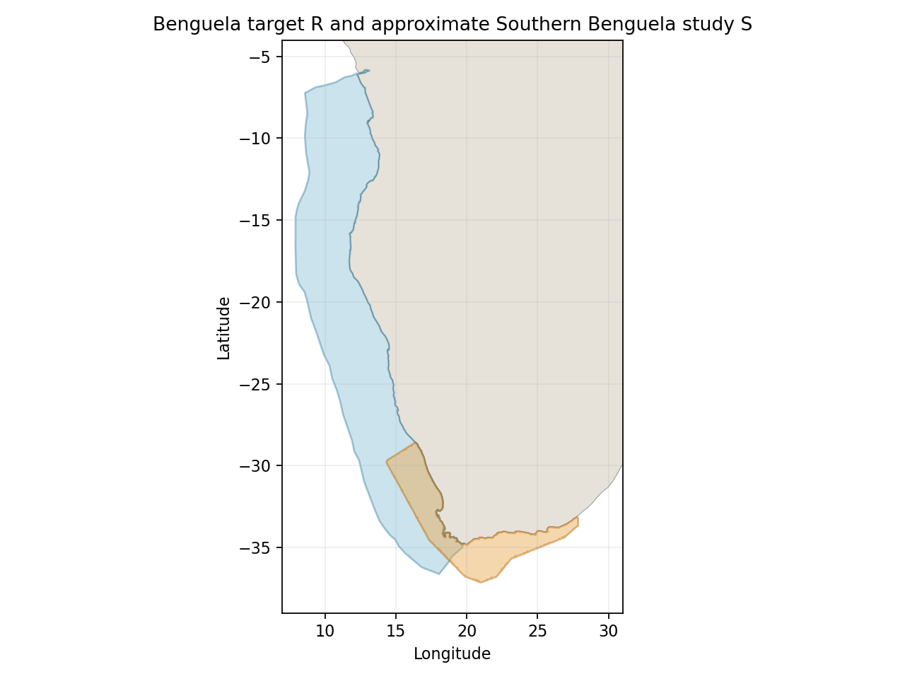
Target R: 1,458,329 km². Blue is the target; orange is the approximate study trace. The source south coast continues east beyond the target’s Cape Agulhas boundary. Target polygon | Image

Study area in the article
Approximate Southern Benguela source domain S
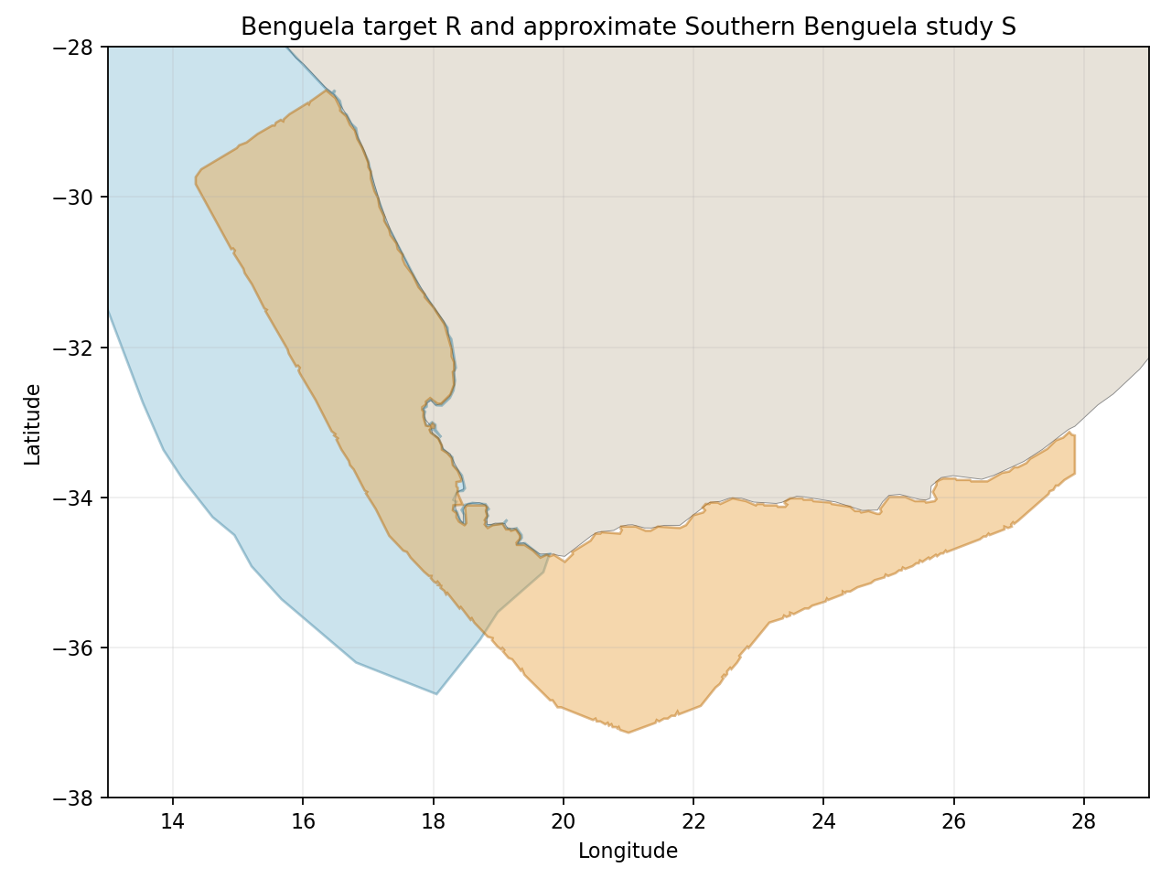
Main Figure 1/PDF3, Orange River to East London. The paper reports 220,000 km²; the approximate trace gives 278,823 km² and overlap 143,159 km². Traced A≈9.82%, B≈51.34%. Dividing the same traced intersection by the reported 220,000 km² gives B≈65.07% as a denominator sensitivity scenario, not a second measured polygon. Source-map resolution and coastline interpolation give nonstatistical approximation brackets. Source Figure 1 | Assessment and controls | Approximate trace
Original Figure 1 blue study area, retained from the article (PDF3). Cape Town and Cape Agulhas place markers interrupt shading; bounded interpolation removes demonstrated marker artifacts in the approximate trace. All eleven water controls pass.