Bay of Bengal model validation
Field | Entry
Region | Bay of Bengal regional workbook (LME_034).
Catch source | Sea Around Us regional catch series, 1950–2019. Reference: 2019 landings, excluding discards. Dated 3 September 2026.  Regional catch and classic-PPR tables | Retained catch archive
Selected article | Guénette, S. (December 2013). An exploratory ecosystem model of the Bay of Bengal Large Marine Ecosystem. 62-page report; the later 2014 distributed edition is distinct.  Original report PDF | Paper folder
Other known articles | Guénette (2014), User’s guide to the Ecopath with Ecosim model of the Bay of Bengal Large Marine Ecosystem. Related guide; no local copy.  Karim et al. (2019), Ecopath model of the coastal fisheries ecosystem of Bangladesh: unverified legacy inventory entry; separate from Karim (2018).  Dutta, Paul & Homechaudhuri (2023), Food web structure and trophic interactions of the Northern Bay of Bengal ecosystem (29 groups, West Bengal subregion); local PDF.  Karim et al. (2018), Ecosystem modeling of the resettled maritime area of the Bay of Bengal, Bangladesh through well-adjusted Ecopath approach (19 groups, >90,000 km²); local PDF.
Selected model | 34_1_Bay_of_Bengal_(1978). Baseline 1978; Bay of Bengal LME extended to Maldives, northern Sumatra and adjacent high seas (6,205,051 km²). 49 source ecological groups (+1 computational diet-import group).  Selected JSON | Model folder | Saved coefficient workbook
Other models from the same article | No other distinct static model identified. Initial and balanced inputs are states of the same 1978 baseline. The 1978–2010 Ecosim runs and alternative industrial-effort fits are scenarios of that baseline (pp6–7, 23–24, 28–29; Appendix A6).
Selection rationale | Article – ?  Model – ?
Model extraction | Diet composition matrix (Table 17) was corrected in several ways:  - Table 17 seems to omit detritus feeding for all "3" groups – as arises from comparing to the matrix for "2" groups. For these groups, diet was completed to sum to 1 by completing the detritus feeding cell. These include: 2–3 Indian mackerel (5.48%), 3 Carangids (0.95%), 3 S pelagics (0.88%), 3 SM inv (3.36%), 3 Crustaceans (40%), 3 Macrobenthos (55%), 3 Meiobenthos (100%), 3 Zooplankton (10%).  - Groups 46-48 (Bigeye tuna, Yellowfin tuna, Marlins) rows in Table 17 appear to be missing, and Detritus and Import groups are mistakenly put at indices 46, 47 instead of 49, 50. Missing values (for groups 46-48 as prey) were filled with zeros.  - After these corrections, normalization was applied to fix rounding erros.  Othe notes:  - BA not reported; auto completed through LIM
GE diagnostics | WARN: High recycling in living compartments (ρ_living>0.7).  No negative SPPR entries across the basal-source columns;  ρ_living = 0.74  b = 0.31  Detritus (49) SPPR = 1.68  Sppr calculation is balanced (inflow=outflow).
TE diagnostics | WARN: High recycling in living compartments (ρ_living>0.7).  No negative SPPR entries across the basal-source columns;  ρ_living = 0.78  b = 0.31.  Detritus (49) SPPR = 0.80.  Sppr calculation is balanced (inflow=outflow).
SPPR calculation | Removed groups from calculation:  - seabirds (GE<0.01%, EE=5%, TL=3.4, sppr_TE=3.75M, sppr_GE=21K)
Geographic fit | Approximate overlap:  A ≈ 100% of the target LME covered by the study  B ≈ 59% of the study covered by the target LME.  Note that the study extends to Maldives and high.  Geographic evidence and area calculation
Temporal fit | The static model represents 1978; retained catch series spans 1950–2019 and the validation reference is 2019. Fixed model coefficients and pooled 1978 total-catch weights assume stable food-web structure, taxon composition and fishery geography across years and catch bases.
Other | The assumed Marine fishes not identified mixture contributes 23.19% of GE, 22.49% of TE and 23.23% of With Egestion PPR. Its unknown composition remains consequential after candidate correction. Method-specific exposure
Open issues and next action
Review and reproducibility | Researcher name: Ido Carmel | review date: 01/10/2026  MODEL VALIDATED
Taxon mapping and coverage
Reference: 2019 landings, excluding discards.
49 source ecological groups (+1 computational import); 315 catch-taxon labels, including 28 zero-landings labels.
Total simple-chain PPR (2019): 379,324,412.047 tonnes C.
27 zero-landings labels lack a saved simple-chain coefficient and TL. They contribute zero annual PPR; no positive-landings taxon has unknown simple-chain PPR.
Method: simple trophic chain.
Full taxon-mapping appendix | Sources and detailed evidence
Overall confidence | Taxa (n) | Catch (%) | Simple-chain PPR (%)
High | 66 | 20.0050 | 24.5910
Medium | 244 | 59.1735 | 67.6100
Low | 0 | 0.0000 | 0.0000
Very low | 5 | 20.8215 | 7.7990
Unresolved | 0 | 0.0000 | 0.0000
Overall confidence is the weaker necessary group-assignment or allocation-weight confidence.
Group assignment rules
Membership evidence: Guénette (2013), A1.1 pp37–41 and A1.3 pp43–45; authoritative taxonomy and habitat records. Detailed evidence
Plain-language rule | Confidence | PPR percentage
Explicit assignment in the selected source | High | 60.3323
Assumed eligible set from source definitions and regional taxonomy | Medium | 28.2780
Broad reporting category approximated by compatible named and residual groups | Very low | 7.7990
Unambiguous fit to a completely defined source group | High | 2.5513
Supported extension from source-listed relatives | Medium | 0.6593
Verified same-taxon synonym of an explicit source member | High | 0.3802
Supported ecological extension to a represented guild | Medium | 0.0000
Allocation weight rules
Weights and assumptions: Guénette (2013), A2.1 p46; pooled 1978 model-catch proportions and transfer assumptions. Detailed evidence
Plain-language rule | Confidence | PPR percentage
Source-model catch proportions transferred across taxon composition, years and catch bases | Medium | 75.4090
Entire taxon assigned to one group | High | 24.5910
Rule percentages describe each component’s share of the same available simple-chain PPR.
No unresolved mappings remain. Very low assignments account for 20.8215% of landings and 7.7990% of simple-chain PPR: Marine fishes not identified, Perciformes, Marine pelagic fishes not identified, Scombroidei and Malacostraca. Their broad reporting mixtures are approximated by compatible named and residual pools; source-model catches proxy the unknown composition. Eligible deep-water and mixed fish pools are included where their source-listed constituents fit the reporting category. Whole-guild catches proxy the unknown constituent fractions. Broad marine fish now includes all 23 eligible bony-fish pools; the pelagic subset has 21. Named tuna/billfish categories do not prove absence from unidentified catches. Source-zero small bathypelagics remain eligible; Maldives shelf pools retain the documented geographic exclusion. Complete candidate evidence

Geographic evidence screenshots
Target region R and source-model study area S, used for the approximate geographic comparison.

Region area
Target region boundary
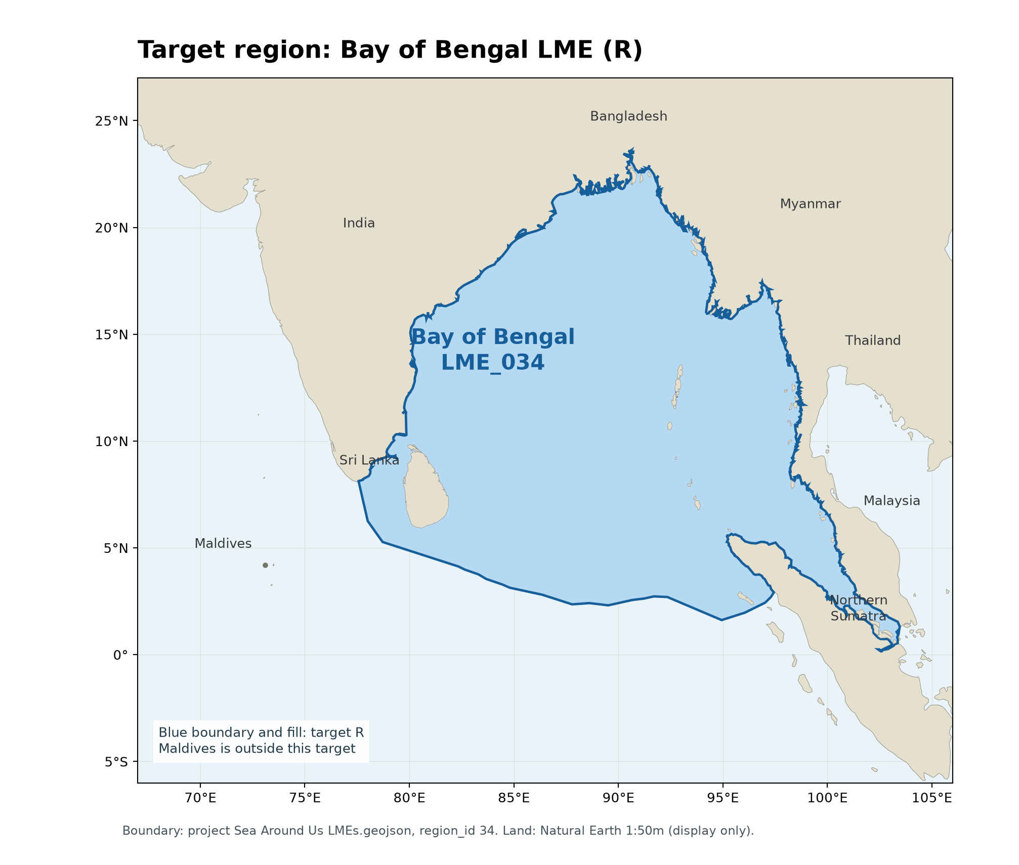
R: Bay of Bengal LME_034. WGS84 geodesic area ≈ 3,664,447 km²; project Sea Around Us boundary, region_id 34. Natural Earth land is a display basemap.

Study area in the article
Study boundary for the selected model
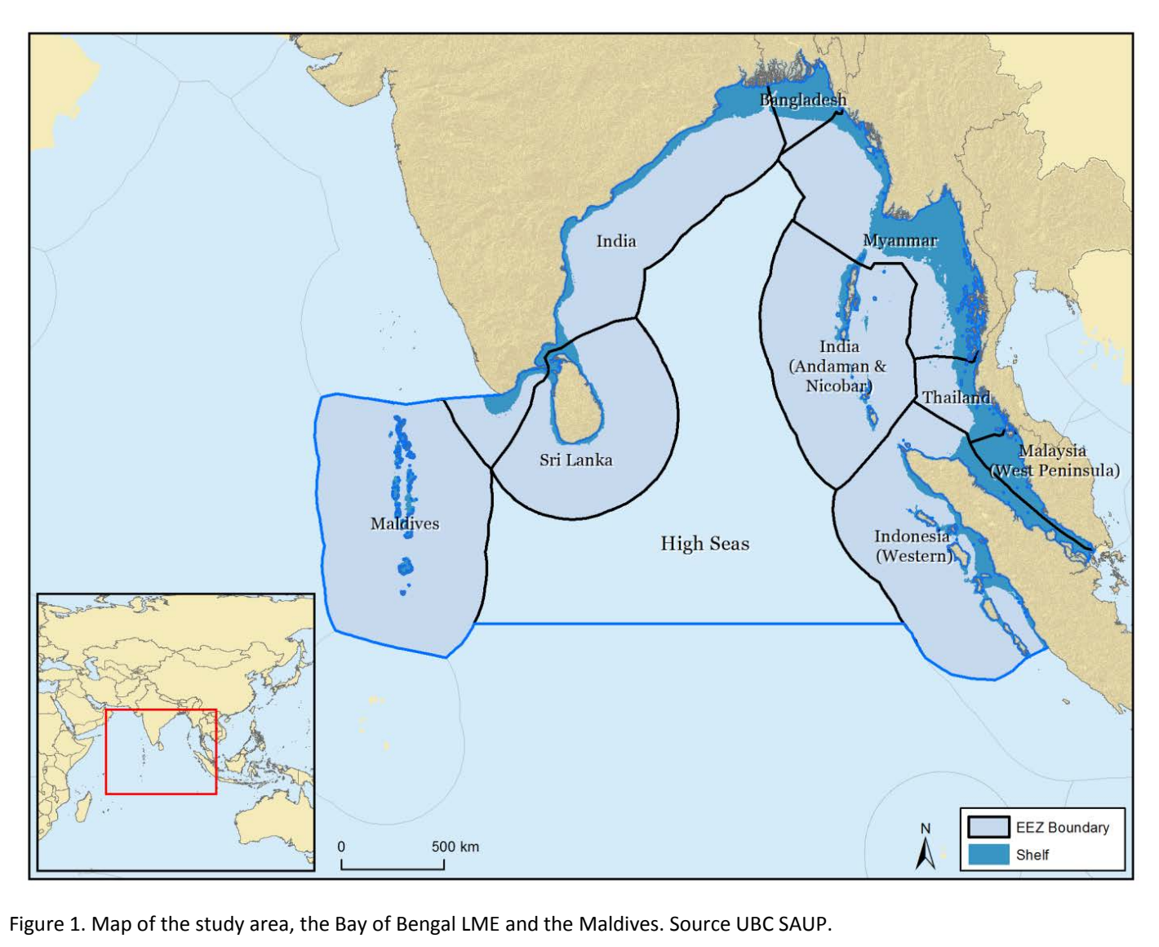
S: Guénette (2013), Figure 1, p8. The study includes Maldives and adjacent high seas; Table 1 gives 6,205,051 km².

