Regional model validation record
Field | Entry
Region | Gulf of Thailand, LME_035; source 10–50 m shelf applied across the whole LME. Regional workbook
Catch source | Sea Around Us v 50.1, local 1950–2019 catch; reference 2019 landings. All 247 exact taxon labels, including zero catch and unidentified categories. Original catch
Selected article | Christensen, V.(1998). Fishery-induced changes in a marine ecosystem: insight from models of the Gulf of Thailand. Journal of Fish Biology 53(Suppl. A):128–142. Author full HTML read; original PDF unavailable. DOI | Author full text | Retained source facts
Other known articles | Pauly & Christensen(1993), Stratified models of large marine ecosystems: application to the South China Sea — acknowledged 10–50 m Gulf predecessor. Vibunpant et al.(2003), Trophic model of the coastal fisheries ecosystem in the Gulf of Thailand — separate 40-group 1973 model. Premcharoen(2012), Mae Klong estuary — subregional alternative. 1993 predecessor | 1973 source | Estuary source
Selected model | 35_412_Gulf_of_Thailande_(1963); scientific payload 1980 despite inherited 1963 filename. EcoBase 412 description and all 11 TableII biomass comparisons identify 1980.29 source ecological groups(+1 computational import);10–50 m shelf. Canonical model | Identity evidence
Other models from the same article | Article compares 1963 and 1980 baselines. Selected canonical file contains 1980; a separate verified complete 1963 parameter/diet set is not supplied.1993 predecessor and 1973 candidate have different group structures.
Selection rationale | Article — ?  Model — Retained selected EcoBase 412 payload; independent identity evidence establishes 1980. Whole-LME/year application remains provisional; scientific approval is not established by finite coefficients.
Model extraction | Available source identity, habitat, illustrative membership and 11 biomasses were checked. Complete published B/PB/QB/EE/diet inputs are unavailable. Accepted canonical export, BA, diet, routing and runtime settings are retained; exact loaded groups agree. Zero juvenile exports are canonical values, not observed regional stage catches. Source limitations | Loaded proof
SPPR calculation | [MANUAL — Researcher: calculation choices and reasons]  [Excluded groups, scope and relevant values; other adjustments]

Field | Entry
GE diagnostics | No negative source SPPR entries; WARN retained. rho_living=0.24000000; b=0.27122037; Detritus(29) SPPR=2.58019597.
TE diagnostics | No negative source SPPR entries; WARN retained. rho_living=0.61423859; Detritus(29) SPPR=0.66004967.
Geographic fit | A. Focal 10–50 m study fraction: unavailable from the accessible source geometry.  B. Focal study fraction within LME: unavailable.  Context only: bounded 0–50 m lineage trace A≈26.5%, B≈91%; reported larger shallowband/target≈38.7%. These do not establish focal coverage.
Temporal fit | Static 1980 coefficients and fixed composition/stage proxies apply across 1950–2019 whole-LME catches; reference 2019 is 39 years later. Source shelf and reporting-population differences are not reconstructed annual ecosystem dynamics.
Other | GE, TE and With Egestion remain WARN. TE repairs consumed-production routing for twoEE 0 groups (marine mammals, jellyfish) under accepted runtime settings. All 270 direct source entries are finite/nonnegative, including unfished groups; six symbolic methods remain failed. Source fidelity and spatial/temporal application limits remain. Full diagnostics
Open issues and next action | [Researcher: open issues and next actions]
Review and reproducibility | Researcher name: [name] | review date: [date]
Taxon mapping and coverage
Reference:2019 landings; all exact taxon labels, including zero catch and unidentified categories; no group filter.
29 source ecological groups(+1 computational import);247 catch taxa.
Simple-chain PPR totals 192,544,832.38 t C in 2019.
33 labels lack an assigned classic coefficient; all have zero 2019 landings and zero annual PPR. Missing TL/coefficient stays ?, without an invented value.
Method: independent simple trophic chain using protected taxon coefficients; carbon conversion/9 once.
All taxon mappings and descriptive Sources sheet
Overall confidence | Taxa | Catch percentage | PPR percentage
High | 99 | 51.1938% | 32.6805%
Medium | 103 | 27.1916% | 44.7927%
Low | 11 | 8.6653% | 10.5229%
Very low | 34 | 12.9493% | 12.0040%
Unresolved | 0 | 0.0000% | 0.0000%
The summary uses the weaker required membership or allocation confidence. The following tables show each component separately.
Group assignment rules
Plain-language rule | Confidence | PPR percentage
Supported coastal/guild or historical ecological extension. | Medium | 26.3836%
Unambiguous documented generic taxonomic group fit. | High | 20.4005%
Explicit focal source taxon or genus assignment. | High | 18.8441%
Assumed complete eligible family or suborder set. | Medium | 16.0401%
Broad reporting category approximated over compatible pools. | Very low | 11.7371%
Related-member extension from source representatives. | Medium | 6.0025%
Verified source spelling or historical-name bridge. | High | 0.2692%
Closest represented analogue with material source mismatches. | Very low | 0.2669%
Partial or competing ecological/taxonomic fit. | Low | 0.0561%
Membership evidence: focalp130 and identity, predecessor Table2 and all taxon decisions
Allocation weight rules
Plain-language rule | Confidence | PPR percentage
One reviewed group receives 100%; no split. | High | 66.3184%
Complete 1980 canonical export proportions, including zero candidates. | Medium | 23.2148%
Retained historical identified-catch proxy with population mismatch. | Low | 10.4668%
Percentages are simple-chain PPR shares of taxa using each rule. Accepted 48 stage fractions remain unchanged. Revised broad candidate sets use complete model export proportions; historical identified-catch fractions with unchanged candidates remain at Low because donor country/gear/composition differ. No compatible observed stage-mass partitions were located. Weights and donor evidence
Unresolved: none. Very low: 34 labels contribute 12.9493% of landings and 12.0040% of simple-chain PPR. Broad fish/invertebrate residual composition, historical serranid and carangid concepts, coastal herbivore/trashfish analogues and nine billfish rely on explicit assumptions. Billfish use the acknowledged predecessor large-pelagic connection to focal Tuna, with narrowed coastal taxonomy and depth limits. All affected taxa appear in the linked appendix. Model-method shares differ: Very low contributes 14.12% of GE, 12.01% of TE and 13.86% of With Egestion all-source PPR; Carangidae alone contributes 7.93% of GE. Method-specific exposure

Geographic evidence screenshots
R is the Sea Around Us target. The accessible focal article establishes a 10–50 m shelf domain but provides no usable boundary here. Pauly & Chuenpagdee 2003 Figure 14-1 gives geographic lineage context with a 50 m contour; its bounded trace is illustrative and does not substitute for focal studyS.

Region area
Gulf of Thailand target and shelf context
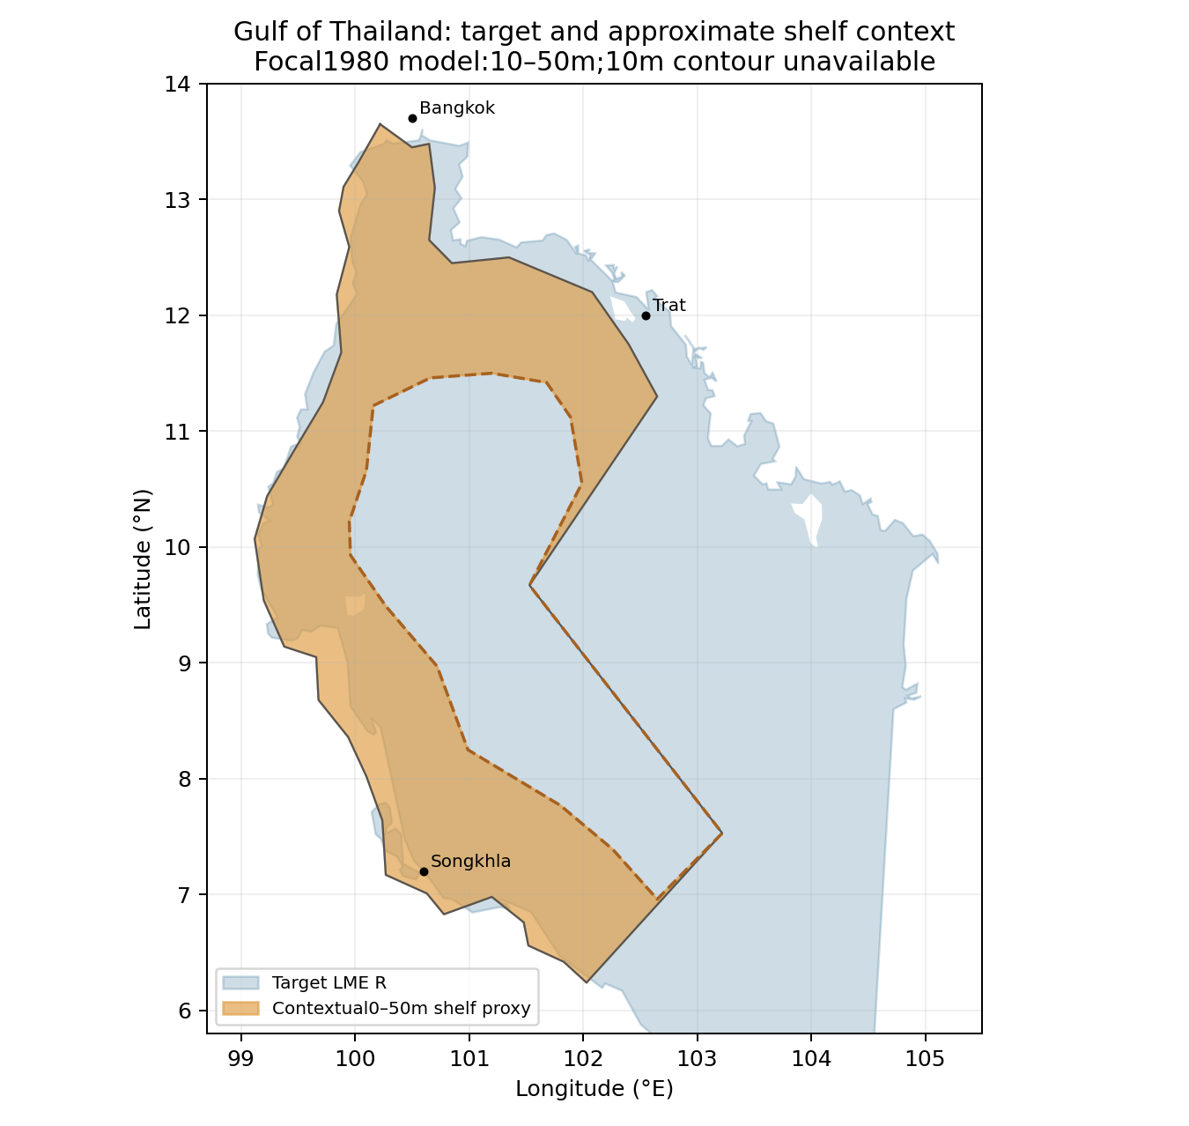
Target R:387,239 km². Blue shows the target; orange is a bounded contextual shelf trace within the visible angular lineage boundary. Coastline/islands are simplified; all eight stated water/land controls pass. Target polygon | Context trace

Study area in the article
Illustrative depth context from lineage map
Contextual trace:112,695 km²; intersection:102,520 km²; contextual A≈26.47%, B≈90.97%. The text's larger 0–50 m band≈150,000 km²/target≈38.74% is a separate area context, not a second measured polygon. Neither supplies the absent 10 m coastal boundary or full focal study extent. No spatial multiplier is applied. Lineage Figure14-1 | Calibration and limits
Original lineage Figure 14-1 (printed 338/PDF 2). Its 50 m contour and angular jurisdiction/location line are geography context. Figure 14-3 is an ecosystem diagram; no focal original-study figure is falsely claimed.