South China Sea model validation
Field | Entry
Region | South China Sea | LME_036 | Regional workbook
Catch source | Sea Around Us; 1950–2019; source contains landings, discards and total catch. Region | Catch ZIP | Taxon catch  Snapshot documented 3 Sep 2026;  Assessment: 2019 landings, as recorded in Overview / Settings. Total catch includes landings + discards.
Selected article | Cheung, Wai Lung (2007). Vulnerability of marine fishes to fishing: from global overview to the northern South China Sea. UBC doctoral thesis. DOI 10.14288/1.0074894 | Thesis PDF | Paper folder
Other known articles | • Pauly & Christensen (1993). Stratified models of large marine ecosystems: application to the South China Sea. Local record  • Pitcher et al. (2000). Marine Reserves and the Restoration of Fisheries and Marine Ecosystems in the South China Sea. Local record  • Lin, Chen & Lin (2020). Trophic model of a deep-sea ecosystem with methane seeps in the South China Sea. Local record | DOI  • Zhang et al. (2022). Effects of ocean warming and fishing on the coral reef ecosystem: A case study of Xisha Islands, South China Sea. Local record | DOI  • Jiang et al. (2023). A preliminary model of the mangrove ecosystem of Dongzhaigang Bay, Hainan, (China) based on Ecopath and Ecospace. Local record | DOI  • Feng et al. (2026). Ecosystem characteristics and ecological carrying capacity of a subtropical marine ranch in the pearl river estuary: an ecopath modeling approach. Local record | DOI
Selected model | 36_1_South_China_Sea_SCS-2007_Northern_South_China_Sea_(2000s)  Selected, 2000s northern shelf; 38 source groups. Folder | JSON | Saved runtime.
Other models from the same article | Northern South China Sea (1970s): same northern shelf and 38 source groups; earlier biomass, mortality and catch parameterization with adult-heavy stages. Kept separately from the selected 2000s model.
Selection rationale | Article – ?  Model – newer model (2000 vs 1970)
Model extraction | source reconstruction report  - several internal conflicts within the paper. Full conflict report.  - Diet Sums – only rounding errors.  max error = 0.0011, group 33 (Pelagic sharks and rays).  - GS not reported; default runtime values are filled.  - BA not reported; auto completed through LIM  - state comparison.  Retained departures and evidence limits: model notes
GE diagnostics | WARN: near-zero efficiency in (34) seabirds (GE<0.010%) and Pinnipeds (GE<0.10%)  No negative SPPR across basal-source columns.  rho_living = 0.32  b = 0.004  Detritus (38): SPPR = 1.008.  Sppr calculation is balanced (inflow=outflow).
TE diagnostics | WARN: near-zero efficiency in seabirds, other mammals and pinnipeds (34–36).  No negative SPPR across basal-source columns.  rho_living = 0.616.  Detritus (38): SPPR = 0.995.  Sppr calculation is balanced (inflow=outflow).
SPPR calculation | Removed groups from calculation:  - seabirds (GE<0.010%, EE=5.0%, TL=3.4, sppr_TE=3.75M, sppr_GE=21K)  - Pinnipeds (GE<0.10%, EE=30%, TL=4.1, sppr_TE=340K, sppr_GE=3400)  - other mammals (GE=1.0%, EE=3.0%, TL=3.9, sppr_TE=800K, sppr_GE=13K)  - Marine Turtles (GE=3.0%, EE=30%, TL=3, sppr_TE=20K, sppr_GE=724)
Geographic fit | A. Region covered by study: approximately 15–25%.  B. Study area covered by region: approximately 90–100%.
Temporal fit | Model period: 2000s (no verified single model year). Fixed coefficients and stage weights are applied to catch years 1950–2019, including the 2019 reference. They do not reconstruct annual ecosystems and transfer a northern-shelf model to whole-LME catch.
Other
Open issues and next action | - Test how much SPPR and PPR values change when using the 1970 model.  - Add article selection reason when we review other articles
Review and reproducibility | Researcher name: Ido Carmel | review date: 30/09/2026  MODEL VALIDATED

Taxon mapping and coverage
Reference: 2019 landings, excluding discards. All sources, all taxa and groups;
There are 38 source groups plus one computational import and 374 catch taxa.
Simple-chain PPR totals 837,452,937.79 t C in 2019.
The 34 taxa that lack an assigned trophic level have zero landings and therefore contribute zero PPR.
Simple-chain PPR is calculated with the simple trophic chain method.
Excel taxon appendix and Sources contains all taxa, sorted by unrounded PPR, and allocation values and assumptions.
Overall confidence | Taxa | Catch percentage | PPR percentage
High | 142 | 39% | 32%
Medium | 165 | 30% | 48%
Low | 57 | 19% | 16%
Very low | 10 | 12% | 4.0%
Unresolved | 0 | 0% | 0%

The summary uses the weaker required membership or allocation confidence. The following tables show each component separately.
Group assignment rules
Plain-language rule | Confidence | PPR percentage
Documented taxonomy and ecology unambiguously meet the group definition | High | 48%
Ecological fit is partial or the source definition is conflicting | Low | 16%
The source explicitly assigns the taxon to the model group | High | 15%
Taxonomy, ecology and group definitions support the eligible group set | Medium | 15%
A broad catch label is approximated by compatible model groups | Very low | 4.0%
Documented size and habitat support an ecological assignment | Medium | 1.1%
The closest represented ecological analogue substitutes for an absent group | Very low | 0%
Membership sources: Cheung group definitions; adopted regional mapping and evidence. Taxonomic authorities and ecological limitations are described on the Excel Sources sheet.
Allocation and mapping uncertainty
Plain-language rule | Confidence | PPR percentage
Model catch proportions supply an assumed allocation across eligible groups | Medium | 65%
The taxon is assigned to one group and needs no split | High | 35%
Each percentage is the simple-chain PPR associated with taxa using that rule.
All 374 catch taxa have an assigned group: 100% of 2019 landings and simple-chain PPR are mapped. Unresolved taxa: none. This includes 10 Very low assignments covering 12.2032% of landings and 4.0110% of simple-chain PPR; their taxa, weights and reasons are flagged in the Excel appendix.
Very low decisions
Affected taxa | Why confidence is very low
Marine fishes not identified; Perciformes; Marine finfishes not identified; Chondrichthyes; Miscellaneous aquatic invertebrates; Marine groundfishes not identified; Marine pelagic fishes not identified; Gadiformes | Catch composition is unknown; compatible named and residual pools provide a broad approximation. Exact candidates and assumptions are in the appendix.
Lampris guttatus | The historical opah label represents offshore deep-living fishes and a subsequently divided species complex. The adopted shelf large-pelagic pair remains a closest represented analogue without an established link to the source guild's sampled assemblage.
Lepidocybium flavobrunneum | Escolar is principally a continental-slope fish below 200 m with upward night movements. The adopted shelf large-pelagic pair remains a weak analogue; a competing benthopelagic interpretation and the missing deep-water compartment are unresolved.
Whole model-pool catch proportions are assumed representative of regional taxon catches across 1950–2019 and all catch bases. These are not observed target-catch mixtures. Another 57 taxa retain Low confidence because of size, habitat or source-group ambiguity. The four residual fish labels follow verified bony-fish reporting scope; dedicated demersal and pelagic shark/ray pools are excluded. Unknown composition and whole-region transfer remain Very low; complete source catch supplies Medium allocation weights. Reporting scope evidence
Allocation sources: selected model catch and biomass fields; adopted candidate decisions and calculations. Prior stage assumptions and their source conflicts remain in the regional Allocation assumptions ledger.
High mapping coverage does not establish model validity. The northern shelf model is extrapolated to the wider region; source-group ambiguity and the diagnostic WARN conditions above remain.

Geographic evidence screenshots
R is LME036; S is the northern shelf coast-to-broken-line area in Cheung Figure 6.1. The grid and shared coastal landmarks support the approximate ranges above.

Region area
Target region boundary
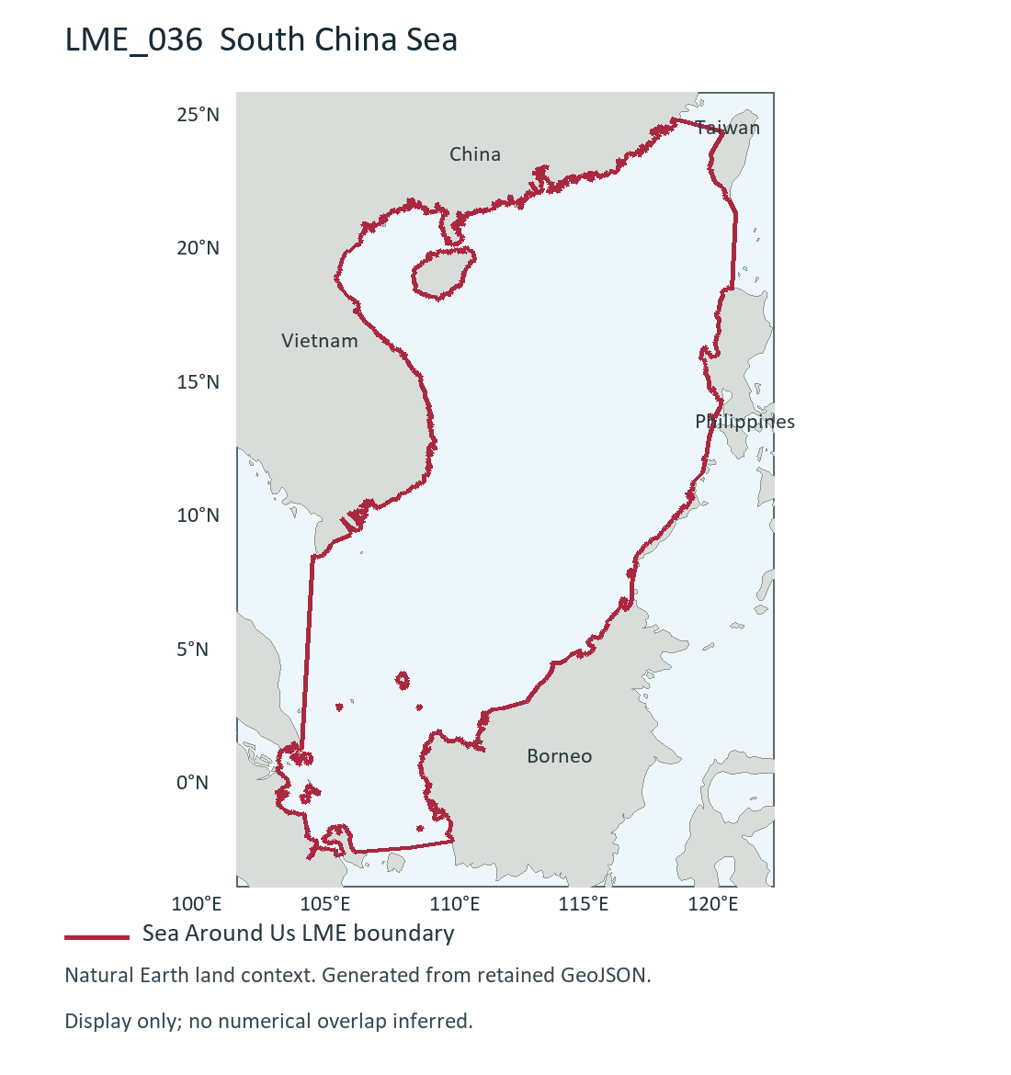
LME_036 South China Sea (R). Retained researcher figure drawn from Sea Around Us boundary; dataset release/date not recorded. Source and display method | Image.

Study area in the article
Study boundary for the selected model
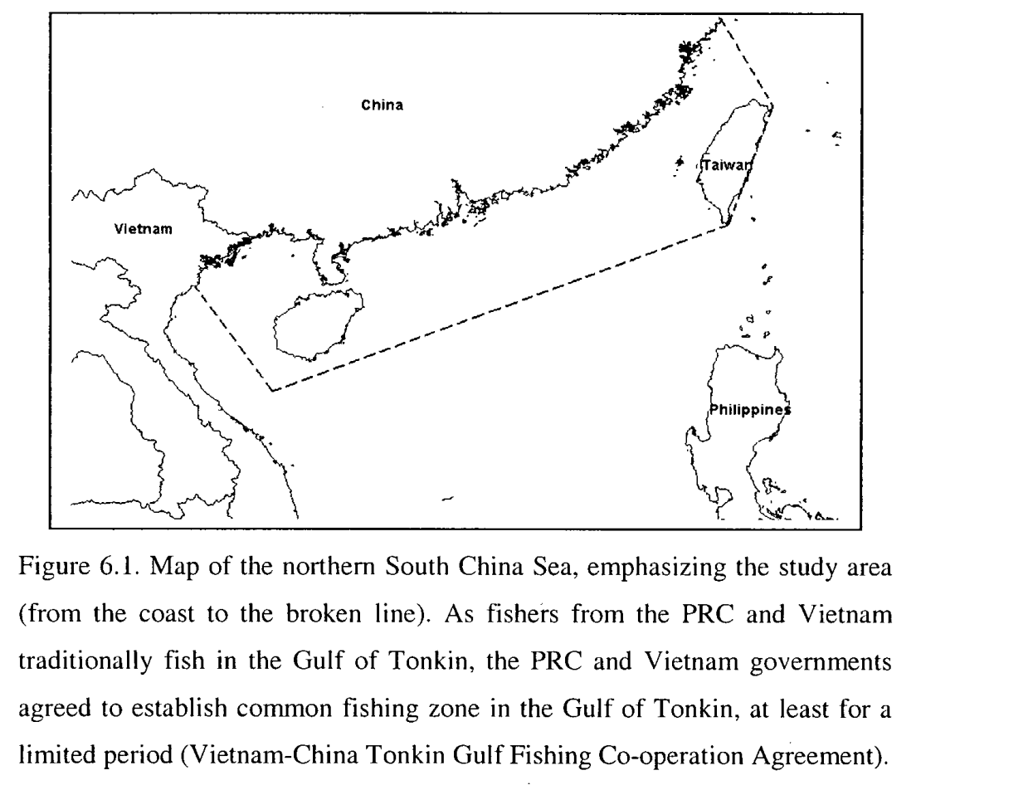
Cheung (2007), Figure 6.1, printed p.170 / PDF p.185. Northern South China Sea shelf (S), 2000s selected model; coast to broken line. Source PDF | DOI | Image.
Visual estimates transfer geographic landmarks between maps; raw screenshot pixel areas were not compared. Boundary interpretation near Taiwan and differing map scales limit precision.

