Sulu Celebes Sea model validation
Field | Entry
Region | Sulu-Celebes Sea, LME_037; Sea Around Us target boundary. Regional workbook
Catch source | Sea Around Us v50.1, 1950–2019. Reference: 2019 landings, including reported and unreported retained catch; discards separate. Raw catch | Taxon and TL source
Selected article | Bacalso, Wolff, Romagnoni & Fujitani (2026), Ecological and economic perspectives of two decades of change in a traditional fishing ground in the Philippines. Ocean & Coastal Management 273, 108027; DOI 10.1016/j.ocecoaman.2025.108027. Online 2025; journal 2026. Main paper | Supplement
Other known articles | Bacalso et al. (2023), Frontiers in Marine Science, DOI 10.3389/fmars.2023.1099400, is the verified baseline predecessor. Its official supplement supplies the 1997 diet and catch lineage; it is not an independent alternative model substituted here. Predecessor | Official supplement
Selected model | Bacalso2026_Visayan_Sea_1997_baseline; 1997 Visayan Sea municipal and commercial waters, 16,728.5 km². 33 ecological source groups plus synthetic diet_import 34. Local study transferred to the 1,013,866 km² Sulu-Celebes target. Selected JSON
Other models from the same article | The paper compares the 1997 baseline with a 2018 Ecosim endpoint. The endpoint lacks its realized diet/flow, catch and accumulation export and has censored group 15 biomass; it remains unselected and NOT_RUN. Stage pairs are already components of the baseline, not additional model versions.
Selection rationale | Article: ? (separate article-choice rationale unrecorded). Model: selected under the instruction to select all top-25 regions except LME_048 and EEZ_938. Available baseline uses verified 2023 diet/catch lineage and matching 2026 parameter cells; spatial suitability and production admission remain unresolved. The 2018 endpoint remains NOT_RUN. Recorded rationale
Model extraction | All 191 populated 2026 Table 1 cells match accepted full-area parameters after the documented reef conversion. Diet/catch lineage matches the 2023 supplement. Accepted diet sums and unknown fields remain; runtime uses GS 0.2, living accumulation/import/migration 0, DC tolerance 0.0021 without normalization, and single-detritus routing. Detritus EE 0.44→1 and derived accumulation remain accounting assumptions. Source review | Cell comparison  Retained departures and evidence limits: model notes
SPPR calculation | [MANUAL — Researcher: calculation choices and reasons]  [Excluded groups, scope and relevant values; other adjustments]

Field | Entry
GE diagnostics | No negative entries in any basal-source column, including unfished groups. rho_living=0.65909091; b=0.23206068; Detritus (33) SPPR=1.73940243.
TE diagnostics | No negative entries in any basal-source column, including unfished groups. rho_living=0.69377990; Detritus (33) SPPR=0.41749368.
Geographic fit | Approximate A: 1–2% of the region covered by the study. B: 90–100% of the study inside the region.
Temporal fit | Static 1997 coefficients and source catch proportions are transferred across 1950–2019. Reference 2019 is 22 years later. Supplementary membership/length traits mainly use 2004, 2009 and 2014 surveys; they do not supply observed baseline stage caught-mass shares.
Other | GE, TE and With Egestion remain WARN, with strict input and budget balance false. TE Seabirds (1) is near singular; its largest coefficient is unfished in this catch universe. Full mapping retains local-model, fleet, habitat and catch-basis assumptions; it does not establish whole-LME suitability. All source entries | Method exposure
Open issues and next action | [Researcher: open issues and next actions]
Review and reproducibility | Researcher name: [name] | review date: [date]
Taxon mapping and coverage
Reference: 2019 landings; all exact catch labels, including unidentified and zero-catch records; no taxon or group filter.
33 ecological source groups (+1 computational import); 250 catch labels.
Simple-chain PPR totals 108,985,038.35 t C in 2019.
31 labels lack a saved classic coefficient/TL; all have zero 2019 landings and zero annual PPR. Unavailable TL remains ?, not zero.
Method: independent classic/simple trophic chain using the saved taxon coefficient and a single carbon conversion.
Full taxon mapping appendix and descriptive Sources sheet
Overall confidence | Taxa | Catch percentage | PPR percentage
High | 97 | 23.3553% | 31.7800%
Medium | 79 | 41.1208% | 30.9968%
Low | 2 | 0.2951% | 0.9206%
Very low | 72 | 35.2287% | 36.3027%
Unresolved | 0 | 0.0000% | 0.0000%
The summary uses the weaker required membership or allocation confidence. The following tables show each component separately.
Group assignment rules
Plain-language rule | Confidence | PPR percentage
Exact source member in the applicable group or stage pair. | High | 44.4011%
Closest source analogue; habitat, diet, size or taxonomy differs. | Very low | 30.1348%
Unlisted taxon extends documented source representatives. | Medium | 9.1804%
Broad reporting label uses a compatible pool mixture of unknown composition. | Very low | 6.1679%
Verified taxon fits the explicit source compartment uniquely. | High | 5.8842%
Verified synonym connects the catch label to a source member. | High | 1.8763%
Actual members support an inferred family or stage candidate set. | Medium | 0.9603%
Young coastal shark pool partly represents the broader family/genus. | Low | 0.9206%
Habitat and feeding ecology extend an incomplete source boundary. | Medium | 0.4745%
Membership evidence: source Table S3 baseline crosswalk and all taxon decisions. Mixed families and pelagic members are reviewed. Residual bony labels exclude dedicated cartilage.
Allocation weight rules
Plain-language rule | Confidence | PPR percentage
Complete 1997 source group-catch proportions proxy the target mixture; fixed across years and bases. | Medium | 58.6225%
One reviewed source group; no numerical split. | High | 41.3775%
Overall confidence is the weaker membership/allocation component. All 96 split labels use complete published 1997 group-catch proportions at Medium confidence, including genuine zero candidates. Whole-guild species/stage, temporal, geographic, fleet and basis mixtures are assumptions. No applicable observed target stage fractions were found; traits are not mass shares. Allocation evidence
No unresolved taxa remain. Very low: 72 labels, 35.2287% of landings and 36.3027% of classic PPR. Broad residual mixtures, oceanic sharks/tunas/billfishes, bathyal fish, brackish/surface-feeding analogues and uncertain invertebrate families are named in the linked appendix. Their actual all-source contributions are 39.11% of GE, 37.95% of TE and 38.32% of With Egestion PPR. These conditional estimates retain the diagnostic and geographic limits. Method-specific contributions

Geographic evidence screenshots
R is the full Sulu-Celebes target. S includes commercial and all 33 municipal waters, inside and outside Visayan Sea proper, as explicitly defined in 2023 §2.1 (PDF 2). The 2026 §2.2 baseline reuse supports this extent; its dashed map is indicative. Native 2023 boundaries use the 2026 graticule and a consistent land mask. Nine water controls test the approximate trace; ranges are not statistical intervals.

Region area
Sulu Celebes Sea target region
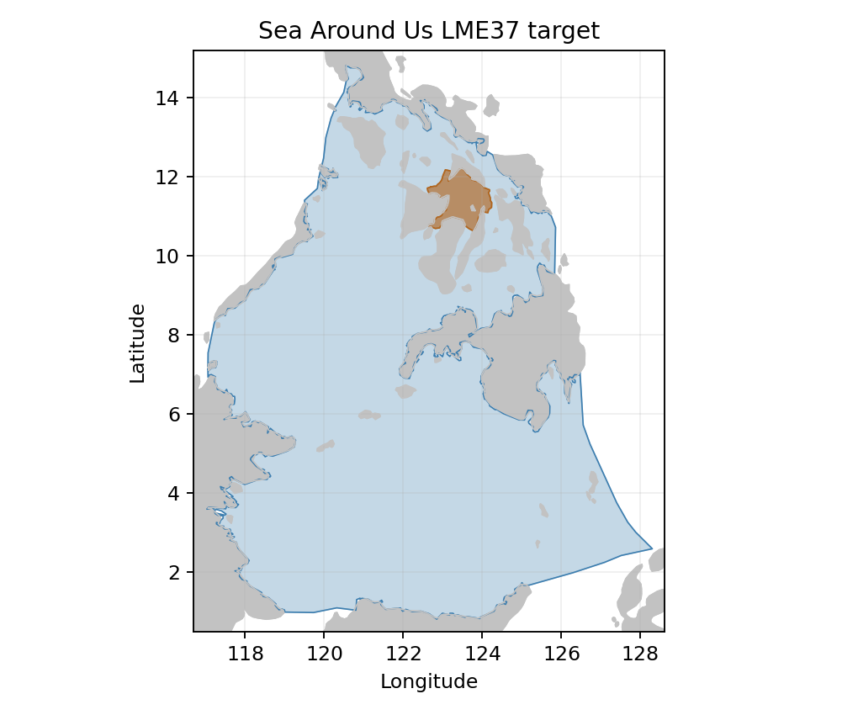
Sea Around Us LME 37 target R: 1,013,866 km². Target boundary | Map image

Study area in the article
Original Visayan baseline study area Figure 1
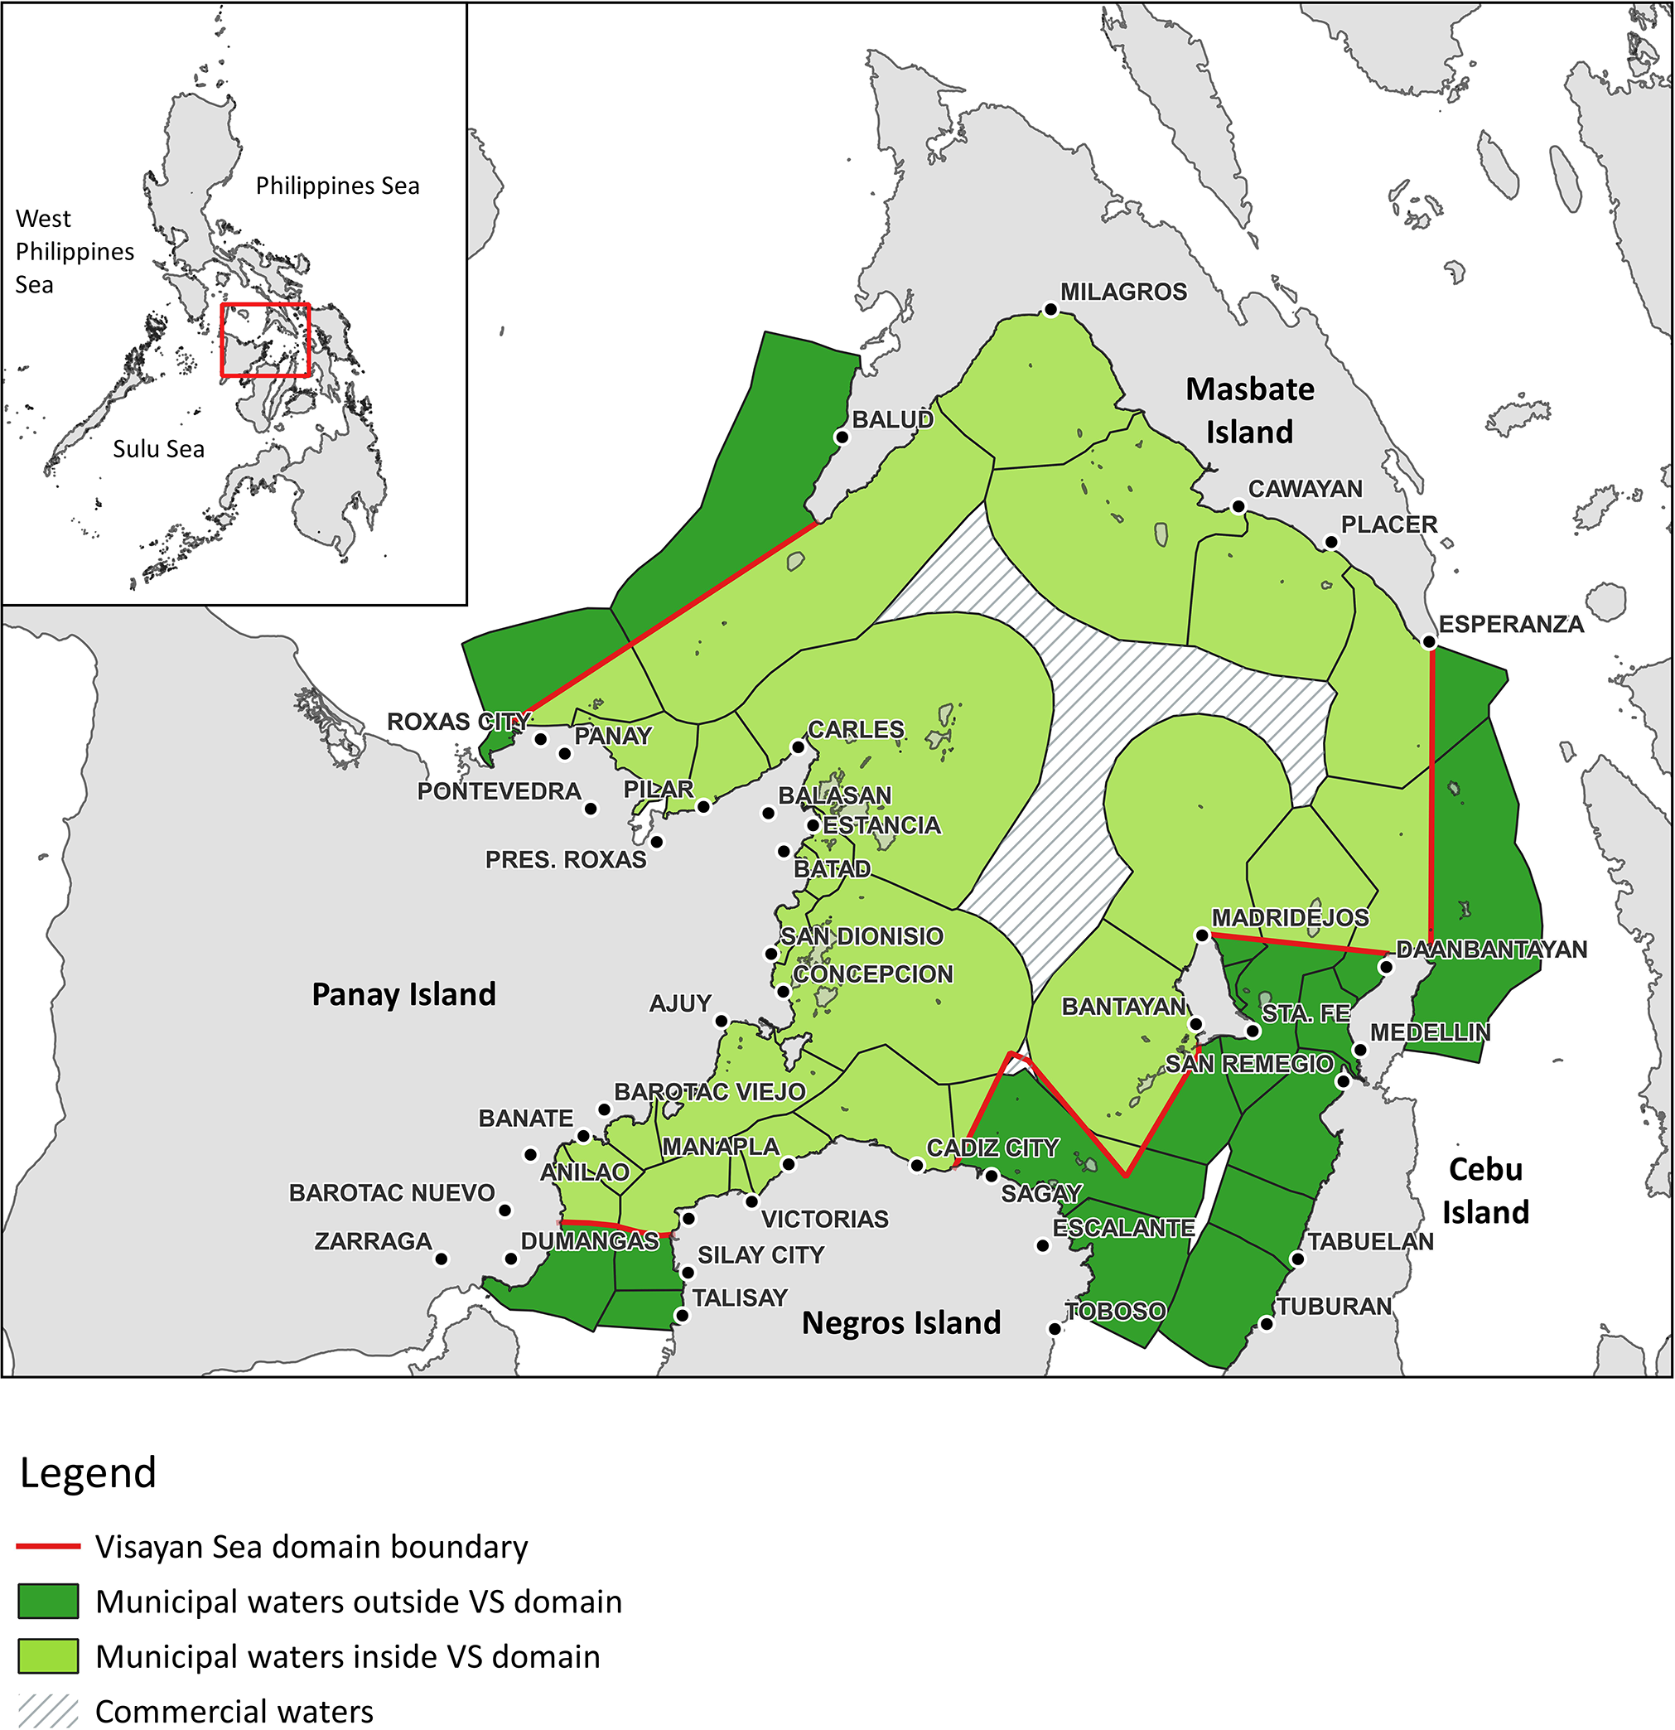
Bacalso et al. 2023 Figure 1, PDF 3. Light green is inside-domain municipal water; dark green is outside-domain municipal water. Both plus commercial waters form the 16,728.5 km² baseline under §2.1 (PDF 2); the narrower sea proper is 12,521.8 km². Baseline extent definition | Original figure | 2026 indicative map | Geographic assessment
Approximate comparison: reconstructed marine study area 16,457 km²; A≈1.59%, B≈98.05%. Coarse report ranges 1–2% and 90–100% reflect outline, coastline and registration uncertainty. Ordered coastlines and real offshore bends are retained; annotation holes are not water exclusions. Reconstructed polygon
