Java Sea regional model validation
Field | Entry
Region | Indonesian Sea, LME_038. The source Java Sea domain is subregional. Regional workbook
Catch source | Sea Around Us v 50.1,1950–2019 original catch. Reference:2019 landings; all 181 exact labels, including zero catch and residual categories. Original catch
Selected article | Buchary, E.A.(1999). Evaluating the effect of the 1980 trawl ban in the Java Sea, Indonesia: An ecosystem-based approach. MSc thesis, University of British Columbia. Local main PDF verified; inherited BUCHARY-1991 folder is an alias. Original thesis | Source review
Other known articles | Zainuri & Endrawati(1999):115 ha Awur Bay, a local 12-component model. Nurhakim(2003):27-group 1979 north Central Java survey model; printed diet defects prevent strict admission. Both are subregional alternatives. Awur Bay source | North Central Java source
Selected model | 38_38003_Java_Sea_normalized_BA_completed_(mid1970s). Static mid 1970s (1974–1976 catch context);28 source groups plus one computational import. Reported Java Sea area 471000 km². Accepted selected model | Variant provenance
Other models from the same article | The thesis contains one documented mid 1970s static baseline and Ecosim trawl-ban simulations. A second complete, independently verified static parameter/diet model was not identified; dynamic scenarios are not separate static baselines.
Selection rationale | Article — ?  Model — User-selected best available Java Sea derived variant. Full-LME and multi-decadal transfer remain provisional; source fidelity, warnings and applicability are assessed separately.
Model extraction | Source Tables 3.1,3.9,3.10 and parameter prose reviewed. Accepted Macrozoobenthos diet 0.660→1 proportional normalization and 28 signed computational BA completions are retained. BA is not measured biomass change. Canonical bytes, loaded biological inputs and source catches remain unchanged. Source/derived differences | Loaded-state proof  Retained departures and evidence limits: model notes  Administrative freshness note: retained diagnostic and modeled-PPR findings describe historical input db0bc803ea5a068e346b82df8d8b4e4b13f8351bf61103c6507997cb6996ae35. Required removal of that superseded extraction invalidates its runtime-equivalence bridge. Current numerical results are pending; the historical report, full workbook snapshot and authored mapping evidence remain available. See adjacent model notes for the retained source corrections and their limits.
SPPR calculation | [MANUAL — Researcher: calculation choices and reasons]  [Excluded groups, scope and relevant values; other adjustments]
Regional review completed
Field | Entry
GE diagnostics | No negative SPPR entries across the basal-source columns. OK retained. rho_living=0.40177283; b=0.24546092; Detritus(28) SPPR=1.31494772.
TE diagnostics | No negative SPPR entries across the basal-source columns. WARN retained. rho_living=0.62129934; b=0.00000000; Detritus(28) SPPR=0.77389867. Marine mammals have near-zero transfer efficiency; finite results remain provisional.
Geographic fit | A. Target fraction covered by study: approximately 19–22%.  B. Study fraction within target: approximately 99–100%.  Low geographic confidence: approximate prose-bound reconstruction with two eastern scenarios; no explicit source study polygon.
Temporal fit | Static mid 1970s coefficients and fixed source-catch/donor weights are applied across 1950–2019 whole-LME landings, catch and discards. Reference 2019 is about 44 years later. The source guild populations and historical trawl bycatch differ from modern recorded fisheries.
Other | With Egestion is OK under accepted thresholds. All 348 entries in the three direct 29×4 source matrices are finite/nonnegative, including unfished groups. GE/Egestion threshold grades do not establish ecological validity. Historical method-specific failures/warnings remain. Mixed bony/cartilage source pools and assumed composition limit coarse labels. Full matrices and warnings
Open issues and next action | [Researcher: open issues and next actions]
Review and reproducibility | Researcher name: [name] | review date: [date]
Taxon mapping and coverage
Reference:2019 landings; all exact labels, including zero catch and residual categories; no group filter.
28 source groups(+1 computational import);181 catch taxa.
Simple-chain PPR totals 177,164,712.36 t C in 2019.
39 labels lack a classic coefficient; all have zero 2019 catch and zero annual contribution. Unavailable TL/coefficient stays ?, with no invented value.
Method: protected independent simple trophic-chain coefficients; wet coefficient×catch/9 once.
All 181 taxon mappings and descriptive Sources sheet
Overall confidence | Taxa | Catch percentage | PPR percentage
High | 56 | 33.9189% | 29.0730%
Medium | 75 | 32.9581% | 48.5117%
Low | 14 | 2.1288% | 2.7273%
Very low | 36 | 30.9943% | 19.6880%
Unresolved | 0 | 0.0000% | 0.0000%
The summary uses the weaker required membership or allocation confidence. The following tables show each component separately.
Group assignment rules
Plain-language rule | Confidence | PPR percentage
Documented source taxon/family criterion supports the particular taxon. | High | 58.2144%
Assumed complete source-containing family or stage set. | Medium | 11.5475%
Closest represented analogue with material habitat/taxonomic mismatches. | Very low | 11.0682%
Supported ecological extension to represented source members. | Medium | 10.3928%
Broad reporting category approximated across compatible pools. | Very low | 8.6198%
Verified historical name or spelling bridge. | High | 0.1520%
Partial or competing source ecological/size fit. | Low | 0.0053%
Membership evidence: source Table3.1, habitat/size rule, native FAO support and all decisions
Allocation weight rules
Plain-language rule | Confidence | PPR percentage
Complete printed source Harvest proportions, including genuine zeros. | Medium | 48.8099%
One reviewed source group receives 100%; no numerical split. | High | 48.4430%
Historical identified-catch donor proportions; population/basis mismatch. | Low | 2.7471%
Percentages are each rule’s share of simple-chain PPR. Complete Harvest includes genuine zero stages. Juvenile shrimp 0.008 and juvenile large demersals 0.066 are author assumptions. Living bottom structure catch is 10×SAF assumed trawl bycatch and supplies 71.43% of the generic-invertebrate allocation. Retained donor fractions use all eligible identified direct/stage donors, with no same-family restriction; mismatch remains Low. Compatible measured stage-mass partitions were not located. Allocation evidence
Unresolved: none. Very low: 36 labels contribute 30.9943% of landings and 19.6880% of simple-chain PPR. Broad bony fish/invertebrate pools and unlisted billfish, sharks, tarpon, catfish, flatfish and deep-water taxa use explicit approximations. Mixed-source pools retain non-target members. Very low all-source model PPR shares: GE 33.35%; TE 49.58%; With Egestion 32.20%. Broad marine fish alone supplies 30.07%of TE; Lates calcarifer analogy 18.58%. Method-specific exposure

Geographic evidence screenshots
R is the full Sea Around Us Indonesian Sea LME. S reconstructs the thesis’s approximate 3°S–6°50′S,105°50′E–116°30′/117°30′E prose bounds, removing land consistently. Figure 2.1 supplies bathymetry and provincial context; it has no explicit study polygon. A/B are approximate regional-extent estimates.

Region area
Indonesian Sea target and two source-bound scenarios
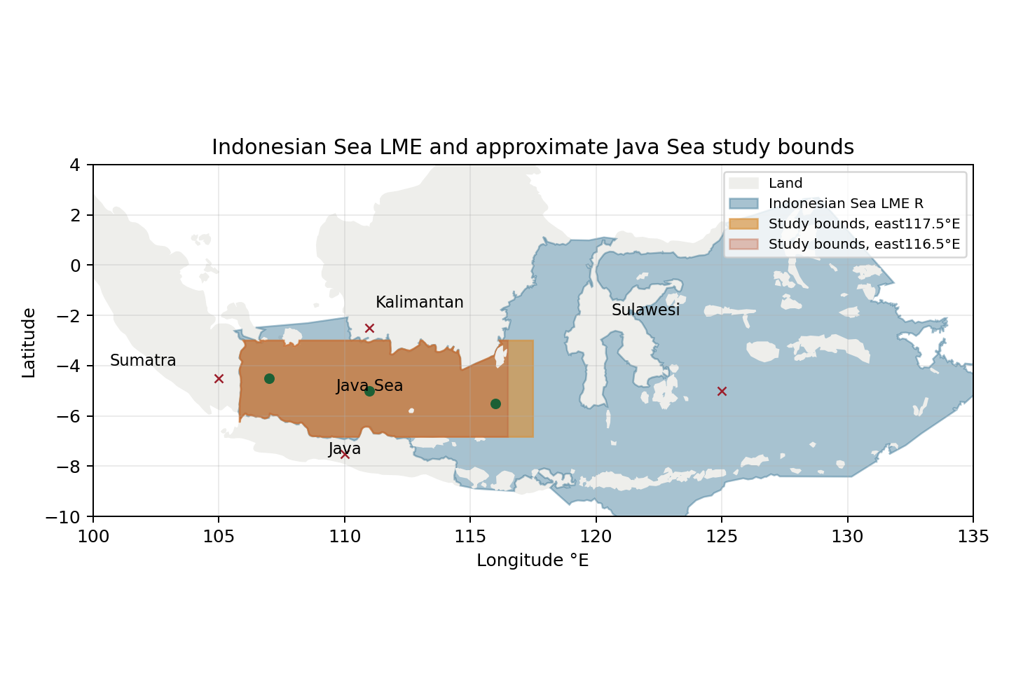
Target R:2,267,636 km². Reconstructed water areas:441114/488277 km²; intersections:439052/486216 km². A≈19–22%, B≈99–100%. Source-reported 471000 km² is separate context. All seven stated water/land controls pass. Target polygon | Approximate bounds

Study area in the article
Original source Figure 2.1: Java Sea geography and bathymetry
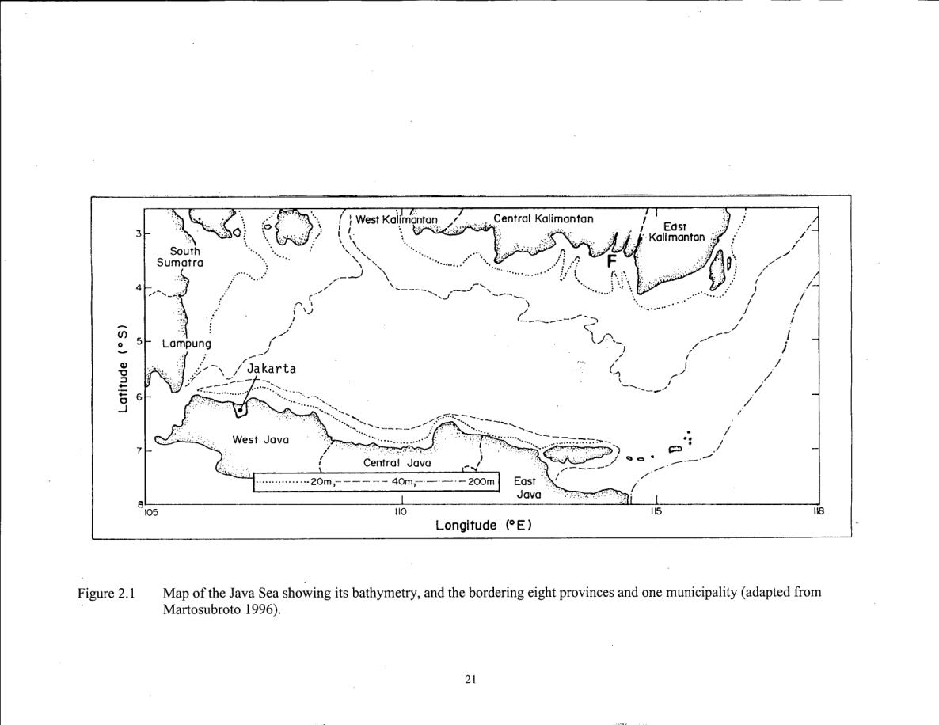
Original PDF 30/printed 21, rotated for readability. Its graticule and bordering provinces inform the reconstruction; source latitude bounds can truncate local coast-following water. Natural Earth 1:50 million land removal is generalized. Two eastern bounds express source ambiguity, not statistical confidence intervals. No geographic multiplier is applied. Original figure | Areas and limits
Original Table 3.1, PDF 58/printed 49: source biological groups and representative taxa. The family summary does not exhaust modern taxonomic membership.