Kuroshio Current regional model validation
Regional review completed
Field | Entry
Region | Kuroshio Current, LME_049. The source spans coastal and offshore western North Pacific blocks. Regional workbook
Catch source | Sea Around Us v50.1, 1950–2019 reconstructed catch. Reference: 2019 landings; all 253 reporting labels, including zero catch. Original catch
Selected article | Watari et al. (2019). Ecosystem modeling in the western North Pacific using Ecopath, with a focus on small pelagic fishes. DOI 10.3354/meps12508. Main PDF verified; supplementary text only partially readable. Original article | Partial supplement
Other known articles | Chen et al. (2025), Study in the ecosystem structure and trophodynamics in the Kuroshio-Oyashio Extension area. One 25-group 2023 offshore survey model; conditional GE, TE and Egestion diagnostics FAIL. Not selected. Main article
Selected model | 49_2019201301_Watari_Detritus_Pooled_Experiment_(2013). One static 2013 assumption scenario: 35 consumers, 3 spatial phytoplankton and pooled detritus; 39 source groups plus computational import 40. Source area 913,102 km². Accepted model
Other models from the same article | Original 41-group Watari 2013 model retains three spatial detritus pools. Missing between-pool routing blocks its source-faithful SPPR load. OYC, KC and OF form one linked model; they are not three independent baselines. Original model
Selection rationale | Article — User preferred the finer 41-group source structure.  Model — User selected detritus-only pooling because source routing is unavailable. Cross-block mixing and full internal retention remain assumptions; selection does not establish scientific validity.
Model extraction | Accepted pooling sums total-area detritus B to 44.12 without second habitat weighting. Canonical non-detritus inputs remain exact. Retained loader changes include 83 normalized diet cells, missing/default GS/catches, seabird B=1 and PB=QB=0, and solved BA. Pooled detritus BA +1,021.626599 is computational closure, not measured change. Source and runtime differences  Retained departures and evidence limits: model notes
SPPR calculation | [MANUAL — Researcher: calculation choices and reasons]  [Excluded groups, scope and relevant values; other adjustments]

Field | Entry
GE diagnostics | No negative SPPR entries across the basal-source columns. rho_living=0.33343023; b=0.04017288; pooled Detritus 39 SPPR=1.40229805. Full source matrices
TE diagnostics | Detritus (pooled OYC KC OF; experiment) 39 → Seabirds (all) 3; Phytoplankton (OYC) 36 → Seabirds (all) 3; Phytoplankton (KC) 37 → Seabirds (all) 3; Phytoplankton (OF) 38 → Seabirds (all) 3. TE FAIL remains. rho_living=0.54627838; b=0.00000000; pooled Detritus 39 SPPR=0.64654301. b=0 is the TE convention. Full source matrices
Geographic fit | A. Region covered by study: approximately 30–36%.  B. Study covered by region: approximately 49–51%.
Temporal fit | Static 2013 coefficients and fixed source-catch/biomass proportions transfer across 1950–2019 whole-LME landings, catch and discards. Reference 2019 is six years later. This does not reconstruct annual ecosystem dynamics or observed spatial catch composition.
Other | GE and With Egestion retain threshold OK with strict SPPR balance false. All 600 source-matrix entries were checked, including unfished groups. Near-singular TE and existing MC 0/100 accepted remain; the cause is deferred. Partial later supplement and habitat proxies limit membership. Global diagnostic returned no object. Diagnostics and limits
Open issues and next action | [Researcher: open issues and next actions]
Review and reproducibility | Researcher name: [name] | review date: [date]
Taxon mapping and coverage
Reference: 2019 landings; all source scope, all exact reporting labels, no group filter.
39 source groups (+1 computational import); 253 catch taxa.
Simple-chain PPR totals 180,683,377.69 t C in 2019.
24 labels lack a classic coefficient/TL; all have zero 2019 landings and zero annual contribution. Unknown coefficients and TL remain ?.
Method: protected independent simple trophic-chain coefficients.
All 253 taxon mappings and descriptive Sources sheet
Overall confidence | Taxa | Catch percentage | PPR percentage
High | 15 | 35.2337% | 29.2963%
Medium | 143 | 31.8095% | 51.7575%
Low | 1 | 0.0000% | 0.0000%
Very low | 94 | 32.9568% | 18.9463%
Unresolved | 0 | 0.0000% | 0.0000%
The summary uses the weaker required membership or allocation confidence. The following tables show each component separately.
Group assignment rules
Plain-language rule | Confidence | PPR percentage
Exact species explicitly named by the selected source. | High | 27.3207%
Assumed eligible source family or spatial/depth set. | Medium | 23.5701%
Supported ecological extension to a represented guild. | Medium | 21.6600%
Closest represented habitat/taxonomic analogue, with mismatch. | Very low | 12.6790%
Supported extension from named source representatives. | Medium | 6.5274%
Broad reporting union approximated across compatible pools. | Very low | 6.2673%
Authoritatively verified source-to-reporting synonym. | High | 1.9756%
Partial ecological fit with a material source mismatch. | Low | 0.0000%
Membership evidence: main Table 1 and Section 2.3, partial Supplement 1, exact taxonomy and traits and all decisions
Allocation weight rules
Plain-language rule | Confidence | PPR percentage
One reviewed group; no numerical split. | High | 54.5095%
Complete whole-domain biomass after incomplete/censored catch. | Medium | 29.6102%
Complete printed source Landings proportions, used as a proxy. | Medium | 15.8803%
Weights and assumptions: complete 2013 source Landings first; otherwise complete total-area biomass. Censored <0.01 and dash/missing catch never become measured zero. No second habitat fraction is applied. Proxies assume composition/catchability and remain fixed across years and catch bases. No usable source catch time-series or observed caught-stage split was recovered. Each table partitions the same simple-chain PPR. Complete candidate vectors
Unresolved: none. Very low: 94 labels account for 32.9568% of landings and 18.9463% of simple-chain PPR. They include broad bony/invertebrate pools and unrepresented reef/deep fish, jellyfish and benthic cephalopods. Broad Sepiida includes bobtail depth habitats; narrower octopus/cuttlefish labels use benthos analogues. Very low all-source model PPR shares: GE 13.71%; TE 24.49%; With Egestion 15.10%; TE remains failed. Exact flagged appendix rows | Largest method contributors

Geographic evidence screenshots
R is the Sea Around Us Kuroshio Current LME. S is the calibrated colored KC/OYC/OF footprint in original Figure 1. This graphical reconstruction has Low confidence; enclosing 30–50°N/150°E prose does not establish a full rectangular study polygon.

Region area
Target LME049 and calibrated source-colored domain
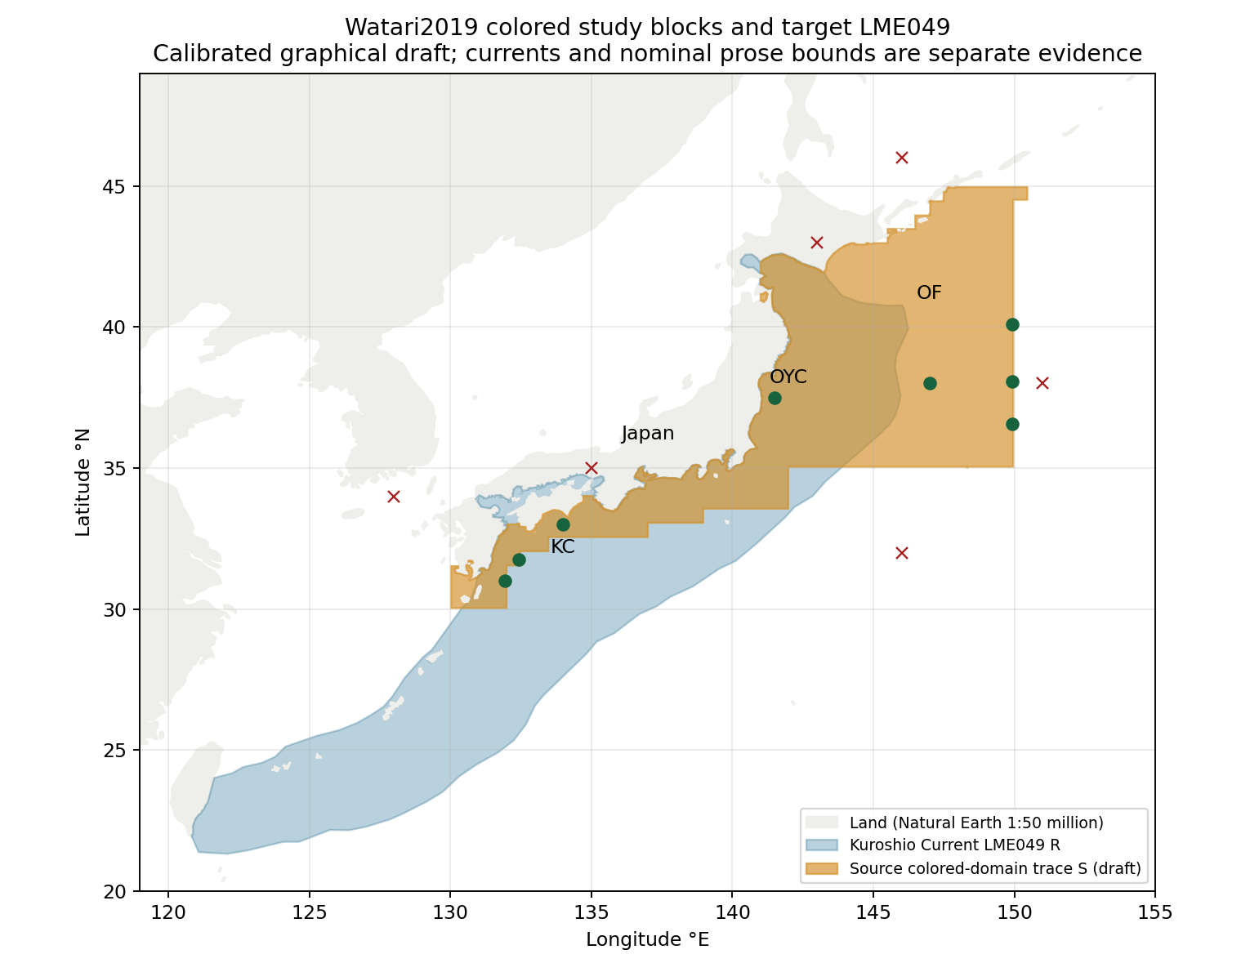
Target R: 1,320,443 km². Central trace S: 887,821 km²; intersection 448,167 km². Approximate A/B ranges include ±0.10° graphical sensitivity. Fourteen ordered water/land controls pass. Generalized coastline and schematic grid boundaries limit accuracy. Target polygon | Calibrated trace

Study area in the article
Original Figure 1 with coastal and offshore study blocks
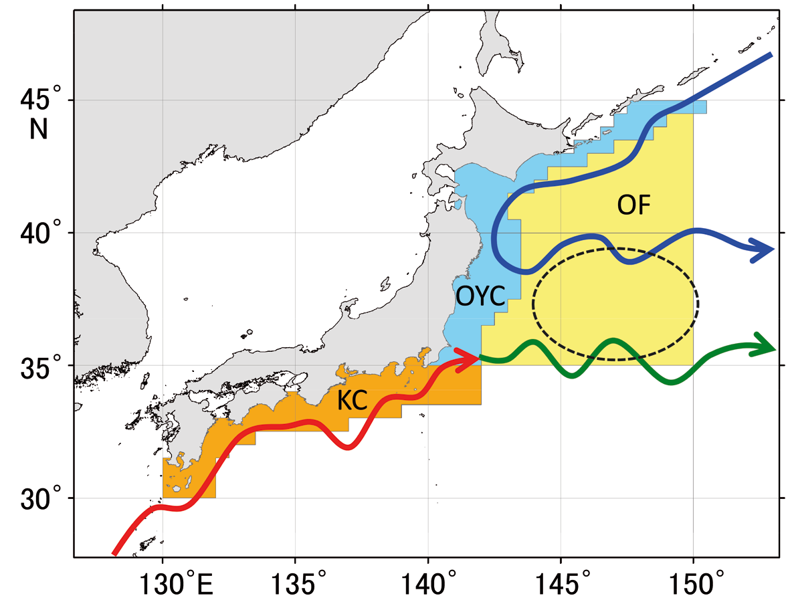
Original main PDF 3/printed 296. KC and OYC are coastal water pools; offshore OF is the colored stepped wedge. Current arrows and the transition-zone ellipse are overlays, not water exclusions. Published source area 913,102 km² is separate from traced area. No geographic multiplier is applied. Original Figure 1 | Assessment and controls
Figure 1 and methods give KC 186,220 and OYC 186,128 km²; Table 4 reverses those labels while preserving the total. The discrepancy is retained as source context without changing accepted model inputs.

