Sea of Japan / East Sea model validation
Field | Entry
Region | Sea of Japan / East Sea, LME_050; Sea Around Us target boundary. Regional workbook
Catch source | Sea Around Us v50.1, 1950–2019. Reference: 2019 landings, including reported and unreported retained catch; discards separate. Raw catch | Taxon/TL source
Selected article | Inoue, Watari, Sawada, Lavergne & Yamashita (2023), Impacts of regime shift on the fishery ecosystem in the coastal area of Kyoto prefecture, Sea of Japan, assessed using the Ecopath model. Fisheries Science 89:573–593; DOI 10.1007/s12562-023-01691-9. Main paper | Publisher supplement
Other known articles | No other candidate article is recorded for this selection. The 2024 publisher correction concerns Open Choice/copyright; it supplies no numeric or year-specific diet correction. Publisher correction
Selected model | 50_502013_Coastal_Kyoto_Inoue_(2013); static 2013 coastal Kyoto model, reported 2,230 km² from the coastline to 240 m depth. 40 ecological groups plus synthetic diet_import (41). Selected JSON
Other models from the same article | 50_501985_Coastal_Kyoto_Inoue_(1985), cold-regime counterpart, remains an explicitly good comparison candidate. Both years use the shared, year-ambiguous published diet matrix. 1985 JSON
Selection rationale | Article: “only available paper.” Model: the user chose 2013 because it is newer; 1985 is also good for comparison. Recency does not demonstrate numerical superiority or whole-LME suitability. Recorded rationale
Model extraction | All 240 final Table 1 source cells match accepted 2013 values. One Table 2 diet matrix is captioned both years despite year-specific sardine/anchovy prose. Nine nonunit diet columns, accepted normalization, GS 0.2, solved accumulation, missing/default catch/migration and single-detritus routing remain documented. Supplementary depth-bin areas total 1,223 km² versus main 2,230 km²; no scientific repair, rescaling or new normalization. Source review | Source cells  Retained departures and evidence limits: model notes
SPPR calculation | [MANUAL — Researcher: calculation choices and reasons]  [Excluded groups, scope and relevant values; other adjustments]

Field | Entry
GE diagnostics | No negative SPPR entries in import (41), Detritus (40) or Phytoplankton (39) columns across all 41 groups, including unfished groups. rho_living=0.10604454; b=0.03129443; Detritus (40) SPPR=1.36109201.
TE diagnostics | No negative SPPR entries in import (41), Detritus (40) or Phytoplankton (39) columns across all 41 groups, including unfished groups. rho_living=0.24614202; Detritus (40) SPPR=0.67578005.
Geographic fit | Approximate A: 0.15–0.23% of the target region. B: 95–100% of the study area inside the target. Indicative ranges; graphical trace differs from the reported area.
Temporal fit | Static 2013 coefficients and source catch/biomass splits are transferred across 1950–2019. The model postdates the 1980s regime shift; fixed Kyoto guild composition does not describe observed whole-LME change across years, fleets or catch bases.
Other | Historical GE, TE and With Egestion diagnoses remain WARN; strict balance passes. Tongue sole (30) EE is 0. Every source-recipient entry is finite and nonnegative. Exact old/current loader parity supports reuse; no fresh solve was performed. Production eligibility remains false. Full matrices | Loader parity
Open issues and next action | [Researcher: open issues and next actions]
Review and reproducibility | Researcher name: [name] | review date: [date]
Taxon mapping and coverage
Reference: 2019 landings; all exact catch labels, including unidentified and zero-catch records; no taxon or group filter.
40 ecological source groups (+1 computational import); 253 catch labels.
Simple-chain PPR totals 145,016,301.85 t C in 2019.
35 labels lack a saved classic coefficient/TL; all have zero 2019 landings and zero annual PPR. Unavailable TL remains ?, not zero.
Method: independent classic/simple trophic chain using the saved taxon coefficient and a single carbon conversion.
Full taxon mapping appendix and descriptive Sources sheet
Overall confidence | Taxa | Catch percentage | PPR percentage
High | 20 | 28.4481% | 20.1996%
Medium | 89 | 18.5567% | 18.5625%
Low | 1 | 0.0124% | 0.0178%
Very low | 143 | 52.9828% | 61.2201%
Unresolved | 0 | 0.0000% | 0.0000%
The summary uses the weaker required membership or allocation confidence. The following tables show each component separately.
Group assignment rules
Plain-language rule | Confidence | PPR percentage
Closest represented taxonomic or ecological analogue for an absent compartment | Very low | 56.7420%
Taxon explicitly named in the selected source group | High | 19.0223%
Related unlisted taxon extends a representative source pool | Medium | 10.3494%
Represented candidate set established with a stated regional extension | Medium | 8.2132%
Broad reporting category approximated by its supported source pools | Very low | 4.4780%
Authoritative synonym connects the source name to the catch label | High | 1.1773%
Partial/conflicting source identity or historical reporting scope | Low | 0.0178%
Membership evidence: Table S3 and source methods | all taxon decisions. Representative lists are not exhaustive. Residual bony fish exclude Stingray; source pelagic fish include Red seabream and Seabass. Name joins resolve the S3 Sole/Dragonet row reversal.
Allocation weight rules
Plain-language rule | Confidence | PPR percentage
One candidate receives the entire taxon catch | High | 72.3367%
Complete source-model catch proportions assumed for regional catch composition | Medium | 23.1821%
Complete source-model biomass proportions assumed after source catch is incomplete | Medium | 4.4812%
Overall confidence is the weaker membership/allocation component. Complete 2013 S4 detailed fleet catches supply Medium split proxies; incomplete catch sets use complete final Table 1 biomass with common catchability assumed. Missing source rows and loaded zeros are distinct. Both proxy types transfer local historical composition across regional years, fleets and bases; taxon-specific observed shares were unavailable. Allocation evidence
No unresolved labels remain. Very low: 143 labels, 52.9828% of landings and 61.2201% of classic PPR. Absent northern/deep fish, salmon, sharks, broad residuals and jellyfish retain explicit analogue limits. This cohort contributes 66.52% of GE, 76.86% of TE and 64.39% of With Egestion PPR under the same controls; assignment completeness does not establish scientific suitability. Method-specific contributions

Geographic evidence screenshots
R is the Sea Around Us Sea of Japan / East Sea LME target. S follows the dashed model boundary in source Figure 1, from the coastline to 240 m. Native longitude/latitude ticks calibrate the curved offshore edge and source coastline/islands; 12 water/land controls pass. The historical broad rectangle is rejected. The trace remains approximate and does not establish exact bathymetry.

Region area
Sea of Japan / East Sea target region
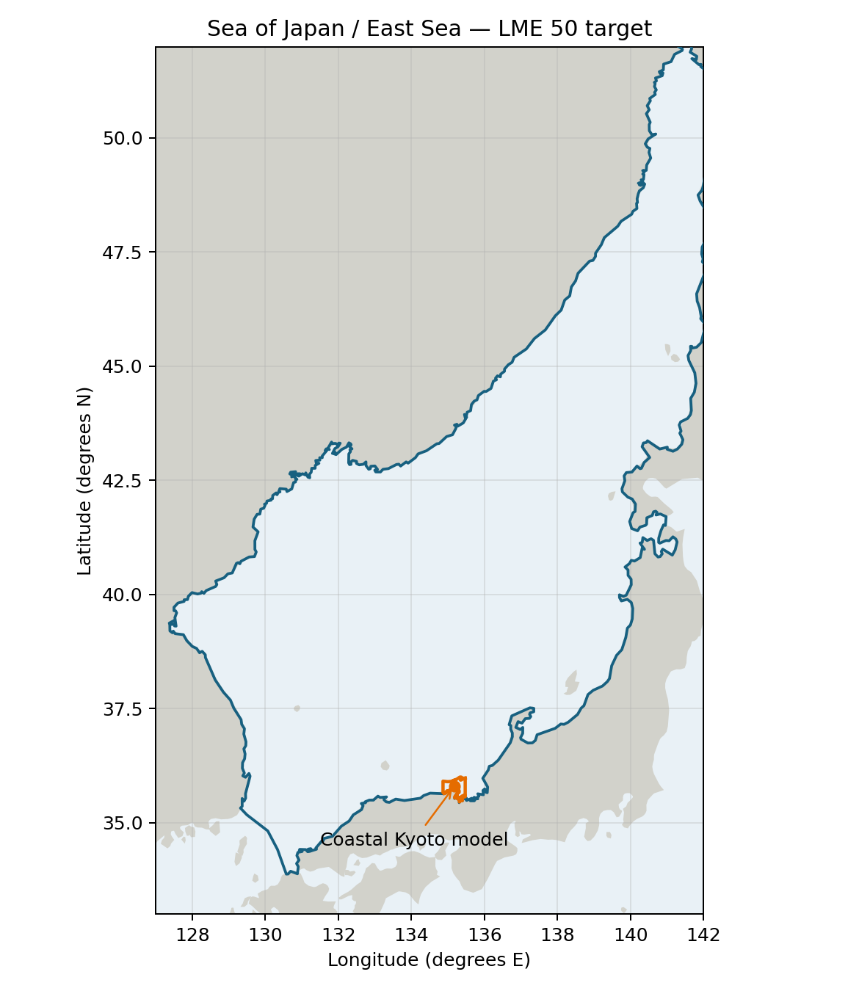
Sea Around Us LME 50 target R: approximately 988,290 km². Orange marks the small coastal Kyoto model location. Target boundary | Map image

Study area in the article
Original coastal Kyoto model area — Figure 1
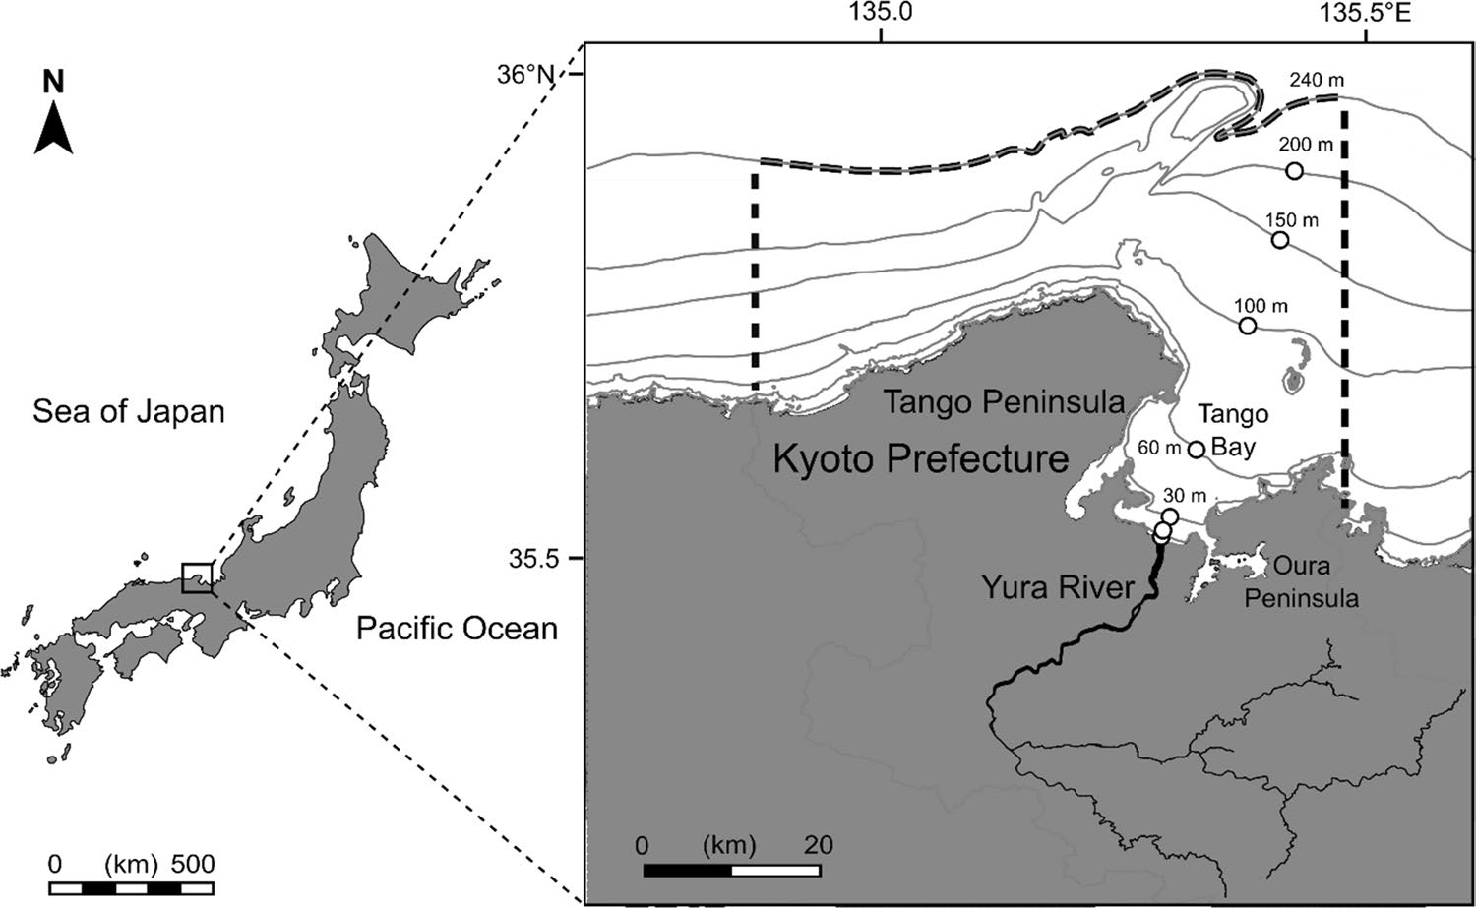
Inoue et al. 2023 Figure 1, PDF 2 / printed p.574; methods PDF 4 / p.576: model domain is coastline to 240 m, reported 2,230 km². The dashed border is the model area; white circles are sampling stations. Figure reproduced without geographic alteration; article CC BY 4.0. Original figure | Methods | CC BY 4.0
Approximate trace S is 1,681 km² and intersection 1,654 km²: central graphical A≈0.17%, B≈98%. The trace is 24.62% below the reported 2,230 km², an unresolved discrepancy larger than graphical sensitivity. Indicative Low ranges A≈0.15–0.23%, B≈95–100% retain both uncertainties; they are not statistical intervals. Supplementary S1 depth-bin areas total 1,223 km² without reconciliation to 2,230 km²; this is a separate benthic biomass-denominator limit, not a replacement polygon. Orange is the source trace; blue is the target coastline. Coverage is not a catch/PPR multiplier. Geographic assessment | Native trace controls
