Sea of Okhotsk regional model validation
Field | Entry
Region | Sea of Okhotsk | LME_052 | Regional workbook
Catch source | Sea Around Us, 1950–2019 reconstructed catch. Original catch
Selected article | Chaikina (2004), A trophic mass-balance model of the Sea of Okhotsk for the 1980s period. BSc thesis, UBC, 49 pages. Original thesis unavailable. A related 2020 chapter documents the earlier model. Thesis listing | Related chapter
Other known articles | Radchenko (2015), Characterization of the Sea of Okhotsk Ecosystem Based on Ecosystem Modelling. A 48-group contemporary model is retained as an alternative; full reconstruction is unreviewed. Alternative article
Selected model | 52_1_Sea_of_Okhotsk_NE_(1980). NE means newly constructed detailed Ecopath (not North East). It is a whole-sea 1980s annual-average model with 29 source groups. Reported area: 1,590,000 km². Accepted model
Other models from the same article | The same source also compares a simplified nine-group SD 1980s model derived from the Shuntov–Dulepova food web. NE and SD are model structures, not northeastern and southern subregions. Simplified model
Selection rationale | Article — Retained as the broadest located whole-sea model despite incomplete original documentation.  Model — The detailed NE structure supplies finer biological resolution; existing numerical caveats remain.
Model extraction | All supplied native Table 1 B/PB/QB/EE values agree with accepted inputs. The accepted diet contains 74 normalized cells from eight printed columns totaling 0.998–1.001. Native catch fields and pollock cutoff are absent; export zeros, detritus B=1 and existing defaults/balance remain accepted assumptions. Source fidelity
GE diagnostics | WARN — living network near divergence; EE = 0 in Seabirds (5) and Sperm whales (3).  No negative SPPR entries across the basal-source columns.  rho_living = 0.867166  b = 0.152044  Detritus (29): SPPR = 1.251014  Model and system balance checks pass; native group catch is unavailable.  Full source matrices | Signed entries
TE diagnostics | FAIL — living network diverges (rho_living > 1).  Negative SPPR: Detritus (29) → Cottidae (14), Other Gadidae (12), Pinnipeds (4), Toothed whales (2).  Phytoplankton (28) → Cottidae (14), Other Gadidae (12), Pinnipeds (4), Toothed whales (2).  Phytobenthos (27) → Cottidae (14), Other Gadidae (12), Pinnipeds (4), Toothed whales (2).  rho_living = 1.025120  Detritus (29): SPPR = 0.948648  b = 0 is the TE convention.  Model and system balance checks pass; they do not resolve living-network divergence.  Full source matrices | Signed entries
SPPR calculation | [MANUAL — Researcher: calculation choices and reasons]  [Excluded groups, scope and relevant values; other adjustments]
Geographic fit | A. Region covered by study: approximately 100% under the intended whole-sea proxy.  B. Study covered by region: approximately 100% under that proxy.
Temporal fit | Static 1980s coefficients and fixed biomass proportions transfer across 1950–2019 whole-LME landings, catch and discards. Reference 2019 is roughly three decades later. Seasonal source averaging does not reconstruct annual catch composition or ecosystem change.
Other | With Egestion returns WARN. Inherited near-singular Monte Carlo TE and negative/unsupported methods remain. Failed TE annual PPR is unavailable; broader mapping does not resolve these scientific limits.  Method exposure and signed contributions
Open issues and next action | - Sensitivity test to the simplified SD model.
Review and reproducibility | Researcher name: [name] | review date: [date]
Taxon mapping and coverage
Reference: 2019 landings; all source scope, all reporting labels, no group filter.
29 source groups (+1 computational import); 151 catch taxa.
Simple-chain PPR totals 248,368,608.38 t C in 2019.
20 labels lack a classic coefficient/TL; all have zero 2019 landings and zero annual contribution. Unknown coefficients and TL remain ?.
Method: protected independent simple trophic-chain coefficients.
All 151 taxon mappings and descriptive Sources sheet
Overall confidence | Taxa (n) | Catch (%) | Simple-chain PPR (%)
High | 46 | 33% | 64%
Medium | 56 | 56% | 31%
Low | 2 | 0.090% | 0.36%
Very low | 46 | 11% | 4.2%
Unresolved | 1 | 0.0051% | 0.00050%
The summary uses the weaker required membership or allocation confidence. The following tables show each component separately.
Group assignment rules
Plain-language rule | Confidence | PPR percentage
Literal member or verified common-name crosswalk to a named taxonomic source pool. | High | 93%
Broad reporting union approximated across compatible source pools. | Very low | 2.8%
Inferred eligible regional family, depth, habitat or feeding set. | Medium | 1.8%
Represented ecological or lineage analogue with substantial mismatch. | Very low | 1.4%
Supported ecological extension to a represented feeding or habitat guild. | Medium | 0.90%
Partial or conflicting habitat fit with a material source mismatch. | Low | 0.36%
Supported extension from a named, closely related regional representative. | Medium | 0.19%
No defensible source membership or complete analogue set established. | Unresolved | 0.00050%
Membership evidence: native Table 1 and diet, primary taxonomy and regional context and all candidate decisions
Allocation weight rules
Plain-language rule | Confidence | PPR percentage
One reviewed group receives all catch; no numerical split. | High | 67%
Complete source biomass after unavailable native catch; fixed composition and equal catchability assumed. | Medium | 33%
No numerical allocation without established membership. | Unresolved | 0.00050%
Weights and assumptions: native group catches are unavailable. Canonical export=0 is not an observed stage fraction. Complete source biomass supplies every multi-group vector at Medium allocation confidence. Pollock supplies 48.9157% of 2019 landings and is allocated 53.874619% adult/nonjuvenile and 46.125381% juvenile, with equal catchability assumed and no recovered cutoff. Fixed 1980s proportions apply across all years and catch bases. Complete candidate vectors
Each rule percentage is the share of independent simple-chain PPR associated with taxa using that rule.
Unresolved: Cyprinidae, because unknown freshwater-family composition has no defensible local marine assignment. Its 177.054315 t landings and 1,241.263560 t C simple-chain PPR remain in the totals. Very low: 46 labels, 11.0196% of landings and 4.1872% of simple-chain PPR. Failed TE has signed caught contributions, so ordinary positive confidence shares are unavailable. Flagged appendix rows Method contributors

Very low decisions
Affected taxa | Why confidence is very low
Actinopterygii; Marine fishes not identified | Unobserved species, stage and depth composition spans all represented bony-fish groups 6–19. The reporting functional tag does not restrict the set to demersal fish. Split weights use source biomass with equal catchability assumed; fixed 1980s composition is transferred across catch years and bases.
Scomber; Scomber japonicus | Pacific herring provides a coastal schooling pelagic-fish analogue. Scombrid lineage, greater piscivory and slope use differ; literal mackerel membership is absent. Allocation is 100% to herring.
Bramidae; Carangidae; Decapterus; Isurus; Isurus oxyrinchus; Prionace glauca; Rachycentridae; Rachycentron canadum; Scomberomorus niphonius; Seriola; Seriola dumerili; Seriola lalandi; Sphyraena barracuda; Thunnus alalunga; Thunnus orientalis; Trachurus; Trachurus japonicus; Xiphias gladius | Source Salmon supplies a mobile marine water-column fish analogue. Its pooled diet is predominantly zooplanktivorous, and it has no species/size inventory establishing a large-pelagic-predator guild. Lineage, size, residency and habitat mismatches remain; each taxon receives 100% in Salmon.
Cololabis saira | Capelin provides a schooling pelagic zooplanktivorous analogue. Saury oceanic/migratory ecology and beloniform lineage differ. Allocation is 100% to capelin.
Cephalopoda; Octopoda | Squids and carnivorous benthos approximate pelagic and benthic cephalopods. Octopus/cuttlefish/argonaut components are not literal listed squid members; habitat and lineage composition is unknown. Split weights use source biomass with equal catchability assumed; fixed 1980s composition is transferred across catch years and bases.
Scombridae; Scombroidei | Herring and Salmon provide coastal-schooling and mobile marine-fish analogues for absent mackerel, tuna, bonito and billfish components. Lineage and historical reporting scope differ; constituent shares are unobserved. Split weights use source biomass with equal catchability assumed; fixed 1980s composition is transferred across catch years and bases.
Engraulis japonicus | Pacific Sardine provides a schooling clupeoid plankton-filtering analogue. Engraulid identity differs and the source sardine binomial is unverified. Allocation is 100% to sardine.
Miscellaneous marine crustaceans | Crabs and shrimps plus inferred crustacean components of benthos and zooplankton approximate this broad label. Residual pools also contain non-crustaceans; constituent shares are unknown. Split weights use source biomass with equal catchability assumed; fixed 1980s composition is transferred across catch years and bases.
Salmonidae | Source Salmon is not an exhaustive salmonid-family inventory. Trout, char and whitefish introduce unrepresented freshwater habitats and feeding modes into the broad-family approximation.
Chondrichthyes; Elasmobranchii | No cartilage compartment is represented. Pollock, Salmon, residual bottom fish and mesopelagic fish form a weak habitat/predatory-fish analogue union; lineage, body form and constituent shares differ. Split weights use source biomass with equal catchability assumed; fixed 1980s composition is transferred across catch years and bases.
Panulirus; Squillidae | Crabs and shrimps and Carnivorous invertebrates provide competing benthic crustacean/feeding analogues. No inventory establishes literal lobster or mantis-shrimp membership; lineage, feeding pooling and lobster shallow-water transfer remain uncertain. Split weights use source biomass with equal catchability assumed; fixed 1980s composition is transferred across catch years and bases.
Miscellaneous aquatic invertebrates | Unknown composition can span named and residual benthic and pelagic invertebrate guilds. No source inventory or catch composition establishes the broad reporting mixture. Split weights use source biomass with equal catchability assumed; fixed 1980s composition is transferred across catch years and bases.
Mugil cephalus; Mugilidae; Scaridae | Other bottom fishes provides a substrate-associated fish analogue. The model lacks a grazing/detritivorous fish group; feeding mode, reef/brackish habitat and lineage differ. Allocation is 100% to this analogue.
Perciformes | Historical perch-like reporting crosses present-day taxonomy and habitats. Cottidae, Ammodytidae and residual fish pools are supplemented by herring/Salmon analogues for absent mackerels/jacks; herring is not a literal perch-like member. Split weights use source biomass with equal catchability assumed; fixed 1980s composition is transferred across catch years and bases.
Mollusca | Squids and basal/carnivorous benthos approximate clams, seasnails and cephalopods. Residual benthos lacks an exhaustive species list, and whole-phylum composition is unobserved. Split weights use source biomass with equal catchability assumed; fixed 1980s composition is transferred across catch years and bases.
Marine pelagic fishes not identified | Unknown composition is approximated across named pelagic, benthopelagic and mesopelagic fish. Explicit bottom-fish pools are excluded; the remaining union is not a measured catch composition. Split weights use source biomass with equal catchability assumed; fixed 1980s composition is transferred across catch years and bases.
Mola mola | Pacific herring provides a pelagic zooplankton/gelatinous-prey fish analogue. Giant size, nonschooling gelatinivory and lineage differ. Allocation is 100% to herring.
Stromateidae | Pacific herring provides a schooling pelagic planktivore/gelatinous-prey fish analogue. Family identity, feeding and size differ. Allocation is 100% to herring.
Chanos chanos | Pacific Sardine provides a coastal schooling plankton/detritus-feeding analogue. Milkfish lineage, tropical/brackish habitat and body size differ. Allocation is 100% to sardine.
Batoidea | Other bottom fishes provides a benthic predatory-fish analogue for skates/rays. The model has no cartilage pool; bony lineage, body form and habitat breadth differ. Allocation is 100% to this analogue.
Coregonus | Salmon provides a cold-water salmonid analogue. Freshwater/brackish life histories and feeding differ from the marine stock; the caught aquatic mode is unknown. Allocation is 100% to Salmon.

Geographic evidence screenshots
R is the Sea Around Us Sea of Okhotsk LME. S is described by the source as the whole sea. The displayed polygon reconstructs that intended domain using R; author GIS and a study-area map are unavailable. Approximate A/B values therefore describe the intended proxy, not measured overlap.

Region area
Target LME 052 and intended whole sea proxy
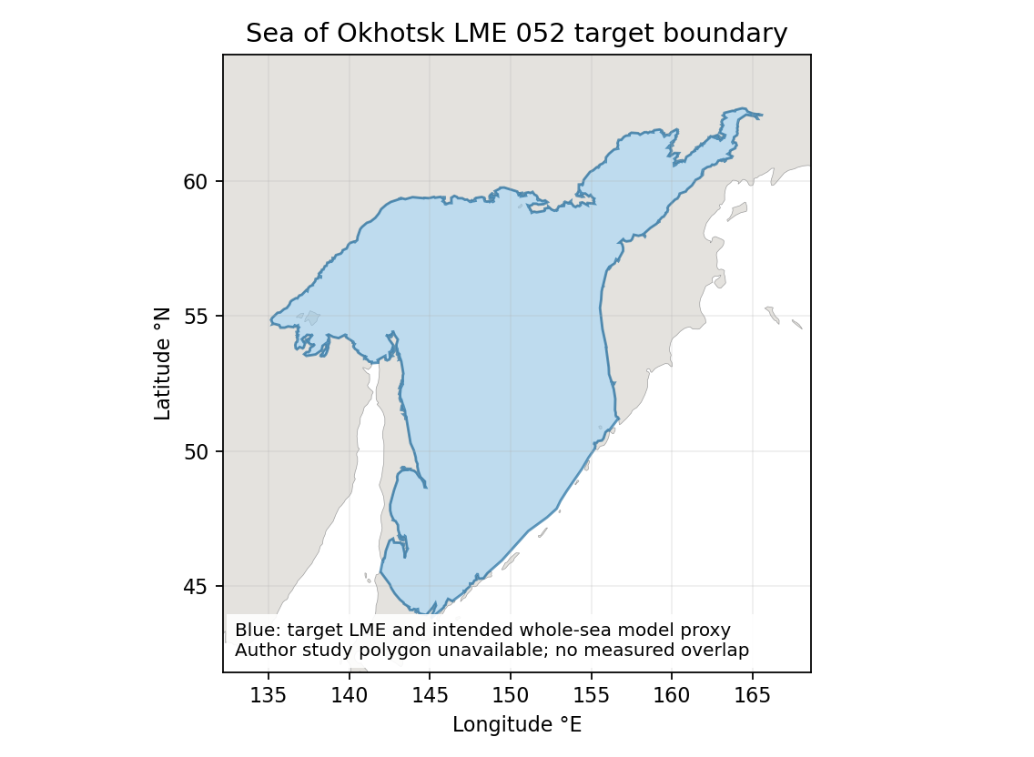
WGS84 target area: 1,563,743 km². Source reported area: 1,590,000 km². Their area ratio is 98.3486% (target/source); it is not an overlap calculation. No geographic multiplier is applied. Target polygon | Qualified geographic assessment

Study area in the article
Study area map unavailable native methods excerpt
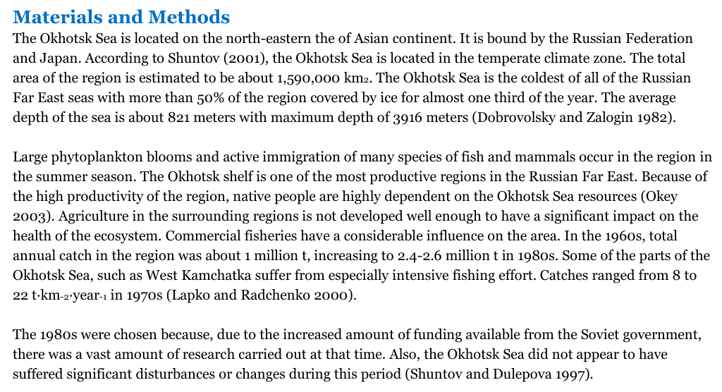
Related 2020 chapter PDF25 / printed24. The methods describe the whole sea and report 1,590,000 km². Chapter figures are food-web and simulation/results diagrams, not study-area maps. The excerpt supplies native geographic evidence while preserving the missing-map limitation. Native chapter | Source identity review
NE denotes the newly constructed detailed Ecopath model. The accepted identifier is retained; no northeastern boundary or original-thesis map is inferred.

