Sea of Okhotsk pelagic model validation
This record evaluates the reconstructed 2000–2014 epipelagic food web for LME 052. The native model balances. Its diagnostic warnings, source-number hypotheses and assumption-dependent catch mappings remain scientific limitations for researcher review.
Field | Entry
Region | Sea of Okhotsk | LME_052 | Regional workbook
Catch source | Sea Around Us reconstructed catch, 1950–2019; reference year 2019, landings. Original catch archive
Selected article | Gorbatenko K M and Melnikov I V (2019). Trophodynamics of marine organisms in the epipelagic layer of the Okhotsk Sea in the 2000s. Izvestiya TINRO 198, 143–163.  DOI | Original article | English translation | Paper folder
Other known articles | Chaikina (2004), A trophic mass-balance model of the Sea of Okhotsk for the 1980s period. Original thesis unavailable; related 2020 chapter retained. Prior model review  Radchenko (2015), Characterization of the Sea of Okhotsk Ecosystem Based on Ecosystem Modelling. A 48-group contemporary alternative is retained. Alternative article records
Selected model | 52_GM2019_Fig9_Pelagic_balanced_(2000-2014). Whole-Sea epipelagic reconstruction of Figure 9 and source feeding tables; 2000–2014. Twenty two source groups, including detritus, plus a synthetic external-food import.  Adopted native model JSON | Reconstruction folder
Other models from the same article | Figure 9 is the generalized pelagic energy-flow network for the 2000s. Figure 10 summarizes production by its components. Figure-only and text-plus-Figure calculations are reconstruction variants; the dissertation's shelf-bottom network is a separate supporting-source model.
Selection rationale | Article - The requested reconstruction uses the accessible whole-Sea production and feeding synthesis for 2000–2014, a more recent period than the previous 1980s model.  Model - The source-carbon Figure 9 network retains microbes and detritus and can be completed with the source feeding tables. The adopted variant follows the requested preference for plausible balance with minimal departures.
Model extraction | All 21 living Figure production values are retained. Twelve arrow magnitudes are reduced by factors of 10 or 100 as Very low confidence scientific decimal hypotheses. They are not demonstrated author typographical errors. Supporting diets repair hyperiid, salmon and jellyfish intake; external food and prey-category allocations are explicit.  Carbon stocks use source wet stocks and body factors. Microbes share assumed PB = 20 yr⁻¹; Protozoa wet/carbon = 10 is an allowed best guess. Living BA = 0; catch and migration = 0. Standard LIM solves GS freely (range 0.1000–0.3500); no default GS is inserted. All mortality and egestion enter detritus; detritus import/export = 0 and BA is positive residual.  Regional unit bridge: saved wet-equivalent SPPR = native carbon SPPR × 9 / the assigned group's source wet/C factor. Regional and map PPR multiply wet catch by that coefficient and divide by 9 exactly once. Native carbon budgets and raw coefficients remain unchanged.  Regional currency bridge audit  Every article departure and native input change | Exact source to final ledger  Retained departures and evidence limits: model notes
GE diagnostics | WARN - four apex groups have EE = 0: Predatory salmon (17), Baleen whales (18), Predatory fish (20), Predatory mammals (21).  No negative SPPR entries across the basal-source columns.  rho_living = 0.0532  b = 0.4529  Detritus (22): SPPR = 1.8913  Model and system balance checks pass; living network converges.  Full source matrix and diagnostic return
TE diagnostics | WARN - four apex groups have EE = 0: Predatory salmon (17), Baleen whales (18), Predatory fish (20), Predatory mammals (21).  No negative SPPR entries across the basal-source columns.  rho_living = 0.1699  Detritus (22): SPPR = 1.8913  TE gives those four apex groups zero coefficients despite positive consumption. Their fractionally assigned catch is 280,181.78 wet t (8.0% of 2019 landings), representing 15% of independent classic PPR. Finite numerical mapping coverage is not scientific coverage.  Model and system balance checks pass; living network converges.  Full source matrix and diagnostic return
SPPR calculation | [MANUAL — Researcher: calculation choices and reasons]  [Excluded groups, scope and relevant values; other adjustments]
Geographic fit | A. Region covered by study: approximately 100% under the intended whole-Sea domain approximation.  B. Study covered by region: approximately 100% under that approximation.
Temporal fit | The source network represents 2000–2014; the jellyfish feeding tables represent 2006–2014. The catch series spans 1950–2019 and the coverage reference is 2019. Fixed coefficients and biomass-based allocation extend average source-era relationships to earlier and later catches without resolving annual ecosystem or catch-composition change.
Other | With Egestion is WARN with finite coefficients and convergent living network (rho_living = 0.0461). Zero model catch makes the native catch footprints zero; regional catch PPR is a separate application. External food totals 13.3576 million tC/yr. Balance does not validate the decimal hypotheses, residual food compositions, stage splits or proxy chemical factors.  Independent import checks report no errors but flag unusual P/Q for copepods (0.641), euphausiids (0.638), chaetognaths (0.553), salmon (0.778), jellyfish (0.614), baleen whales (0.00467) and predatory mammals (0.00960). GS remains unknown in exported inputs; EwE's default 0.2 and its resulting indeterminate checks differ from the native LIM solution. Detritus residual accumulation is 374.43 million tC/yr, 24.16 times its assumed inventory per year; it does not establish stationary stock or measured burial. Annual PPR and map use remain provisional; production eligibility is false, Monte Carlo and global checks are NOT_RUN.  Regional unit bridge and terminal-group exposure | Import audit actual returns
Open issues and next action
Review and reproducibility | Researcher name: [name] | review date: [dd/mm/yyyy]

Taxon mapping and coverage
Reference: 2019 landings; all source scope, all catch labels, no model group filter.
22 source groups including detritus, plus 1 computational import; 151 catch taxa.
Simple-chain PPR totals 248,368,608.38 t C in 2019.
20 labels lack a classic coefficient/TL; all have zero 2019 landings and zero annual PPR. Unknown TL and coefficients remain ?.
Method: protected independent simple trophic-chain coefficients.
All taxon mappings and descriptive Sources sheet
Overall confidence | Taxa (n) | Catch (%) | Simple-chain PPR (%)
High | 13 | 24% | 49%
Medium | 7 | 51% | 33%
Low | 8 | 0.67% | 1.9%
Very low | 115 | 24% | 16%
Unresolved | 8 | 0.24% | 0.0095%
Overall confidence uses the weaker required membership or allocation component.

Group assignment rules
Plain-language rule | Confidence | PPR percentage
Explicit source assignment to a named taxonomic group. | High | 47%
Unambiguous documented fit to the source group or stage union. | High | 34%
Closest represented ecological or taxonomic analogue with habitat or lineage mismatch. | Very low | 13%
Broad reporting category approximated across a plausible source group set. | Very low | 2.7%
Partial or conflicting ecological fit with a material source mismatch. | Low | 1.9%
An inferred eligible regional group set with explicit membership assumptions. | Medium | 0.84%
No meaningful represented assignment or complete candidate set. | Unresolved | 0.0095%
Evidenced assignment transferred from the prior whole-Sea model through a group crosswalk. | Medium | 0.0011%
Supported extension from listed regional representatives. | Medium | 0.000000031%
Membership evidence: source Table 3, Figure 9 and source prose; prior whole-Sea taxonomy crosswalk where retained; explicitly weak habitat or lineage analogues. All taxon decisions

Allocation weight rules
Plain-language rule | Confidence | PPR percentage
One reviewed group receives the whole taxon; no numerical split. | High | 63%
Complete source biomass after unusable native catch, with equal catchability and fixed composition assumed. | Medium | 37%
Explicit last-resort equal allocation when source catch is unavailable and unrelated pool biomass is not a defensible composition proxy. | Very low | 0.029%
No defensible numerical allocation without a meaningful candidate set. | Unresolved | 0.0095%
Weights and assumptions: native catch is unavailable as a composition measure. Complete source wet biomass supplies eligible multi-group proportions at Medium allocation confidence, with equal catchability and fixed source-era composition. Gastropoda, Miscellaneous aquatic invertebrates and Mollusca use explicit equal-half, equal-sixth and equal-thirds last-resort allocations because unrelated source pool biomasses do not provide a defensible composition proxy. Carbon coefficients use the assigned group's source body factor, including transfers to weak analogues. Complete allocation evidence
Each percentage is the independent simple-chain PPR associated with taxa using that rule.
Unresolved taxa: Apostichopus japonicus: Benthic deposit-feeding sea cucumber requires a sediment/detritivore pathway absent from the biological compartments. Detritus is not an animal catch group. Cyprinidae: Freshwater cyprinids have no source freshwater/marine guild correspondence; no meaningful marine predatory/plankton-stock transfer is established. Echinoidea: Macroalgal/benthic-grazing sea urchins lack a phytobenthos consumer pathway; assigning them to pelagic microbes or a crustacean solely for coverage is not defensible. Echinozoa: Urchin/sea-cucumber reporting union spans missing macroalgal-grazing and sediment deposit-feeding benthic consumers; no meaningful represented group set. Haliotidae: Benthic macroalgal-grazing abalones lack a modeled phytobenthos/consumer pathway. Pelagic copepod grazing is too weak a transfer to adopt here. Haliotis: Benthic macroalgal-grazing abalones lack a modeled phytobenthos/consumer pathway; no source comparable consumer. Holothuroidea: Benthic deposit-feeding holothurians have no represented consumer compartment with comparable source pathway; detritus/bacteria are not usable taxon mappings. Scaridae: Reef algal-grazing parrotfishes have no represented source reef or macroalgal consumer pathway; the extremely small catch is retained unresolved. Very low assignments cover 24% of landings and 16% of independent simple-chain PPR. Numerical coefficient coverage of 99.7604625% does not establish ecological catch-footprint validity; terminal EE = 0 groups receive zero TE coefficients.

Very low decisions
Affected taxa | Why confidence is very low
Actinopterygii | Broad ray-finned category is approximated across all represented named bony stocks and the mixed predatory-fish pool. Source group 20 includes sharks as well as eligible bony fishes; its whole-pool biomass is a coarse proxy. Nonfish/groups and mammals are excluded.
Ammodytes personatus | Sandlance and capelin are forage fishes feeding on plankton. Sand-burrowing/coastal ecology differs; the source capelin group is a feeding analogue, not source membership.
Anoplopoma fimbria; Beryx; Bramidae; Carangidae; Congridae; Decapterus; Eleginus gracilis; Gadus macrocephalus; Hexagrammidae; Hexagrammos otakii; Hippoglossoides elassodon; Laemonema longipes; Lates calcarifer; Limanda aspera; Lutjanidae; Lycodes; Mola mola; Moridae; Muraenesox cinereus; Paralichthys olivaceus; Pentaceros wheeleri; Perciformes; Pleurogrammus azonus; Pleurogrammus monopterygius; Pleuronectidae; Pleuronectiformes; Rachycentridae; Rachycentron canadum; Saurida; Sciaenidae; Scomberomorus niphonius; Scombroidei; Scorpaenidae; Scorpaeniformes; Sebastes; Sebastes alutus; Sebastidae; Sebastolobus alascanus; Seriola; Seriola dumerili; Seriola lalandi; Serranidae; Sphyraena barracuda; Stromateidae; Synodontidae; Tetraodontidae; Thunnus alalunga; Thunnus orientalis; Trachurus; Trachurus japonicus; Trichiurus lepturus; Xiphias gladius | Unlisted marine fish uses the source predatory-fish guild as the closest represented fish-feeding/animal-feeding analogue; source pool is pelagic and includes sharks, whereas this catch label may be benthic/bathyal/reef-associated and have different prey/body carbon.
Arctoscopus japonicus | Japanese sandfish uses the small plankton-feeding capelin as a forage-fish analogue. Benthic/slope habitat and reproductive ecology differ; no literal stock membership is claimed.
Batoidea; Chondrichthyes; Elasmobranchii | Unlisted marine fish uses the source predatory-fish guild as the closest represented fish-feeding/animal-feeding analogue; source pool is pelagic and includes sharks, whereas this catch label may be benthic/bathyal/reef-associated and have different prey/body carbon. Rays/chimaeras are not automatically the source shark stock; source pool mixes eligible bony predators with sharks.
Bivalvia; Corbicula japonica; Crassostrea; Mactridae; Magallana gigas; Mizuhopecten yessoensis; Mytilidae; Pectinidae; Pinctada | Bivalve suspension feeding has a weak particulate/plankton-consumer analogue in copepods. Benthic filtration, shell/body carbon and detrital feeding differ; no literal copepod taxonomic membership is claimed.
Brachyura; Chionoecetes; Chionoecetes japonicus; Chionoecetes opilio; Erimacrus isenbeckii; Panulirus; Paralithodes; Paralithodes brevipes; Paralithodes camtschaticus; Paralithodes platypus | Crab/lobster uses hyperiids as the closest represented omnivorous/carnivorous crustacean analogue. Adult benthic feeding, size and body-carbon differences are substantial; no literal source membership is claimed.
Cephalopoda | Broad cephalopod category spans squid and unrepresented cuttlefish/octopus; the two squid guilds approximate that mixture. Benthic/nectonic feeding mismatch is explicit; source biomass weights are assumed.
Chanos chanos | Milkfish uses the plankton-feeding herring compartment only as a weak trophic analogue; tropical/estuarine range, diet details and body composition differ.
Clupeidae | Clupeid zooplanktivores use the source herring stock as a family/trophic analogue; sardines/menhadens are not explicit herring membership.
Clupeiformes | The closest represented clupeiform/plankton-feeding fish is herring; anchovies/shads and other constituent species have no exact source stock.
Cololabis saira | Saury is an epipelagic plankton feeder with no source stock. Herring is the closest abundant represented plankton-feeding fish, with migration/taxonomic differences.
Coregonus | Whitefish can include anadromous planktivorous salmonids. The plankton-fed salmon compartment is the closest family/trophic analogue; unknown freshwater components and different life history remain.
Decapoda | Omnivorous/predatory crustacean analogue pair uses euphausiids and hyperiids. Decapod size, benthic habitat and prey-source mismatch is substantial. Source crustacean wet biomass mixture transfers as an explicit assumption.
Dendrobranchiata; Metapenaeus; Pandalopsis japonica; Pandalus; Pandalus borealis; Pandalus goniurus; Pandalus hypsinotus; Pandalus kessleri; Penaeus chinensis; Sclerocrangon; Squillidae | Decapod/mantis shrimp uses euphausiids as the closest represented omnivorous crustacean feeding analogue. Taxonomic, size, benthic habitat and body-carbon differences are explicit; source membership is not asserted.
Engraulis japonicus | Anchovy is a small schooling clupeiform planktivore; source herring is the closest represented ecological/taxonomic analogue, with size/carbon-fraction and stock differences.
Gadidae | Pollock occupies three exact compartments; other gadids lack a named group and use the predatory-fish analogue. Whole source group 20 biomass is not measured gadid biomass. The assumed mixture combines stock and trophic proxies.
Gadiformes | The broad gadiform category spans pollock stages and unrepresented codlings; source group 20 is a weak predatory-fish analogue for those residual constituents. Complete source biomass is the explicit composition proxy.
Gastropoda | The generic snail label spans grazing and predatory taxa. Copepod grazer/omnivore and hyperiid predator are weak trophic analogues; shell/benthic food pathways are absent. An explicit equal-half mixture is used; no observed composition is claimed.
Loliginidae | Coastal pencil squids use the represented squid trophic guilds as a cephalopod predator analogue; source gonatid/open-water species and habitat differ substantially.
Marine fishes not identified | Verified provider ISSCAAP39 residual is bony fishes. All represented bony stocks plus eligible bony members of the mixed predatory-fish pool are retained; benthic/bathyal/unlisted fish receive this coarse pelagic mixture. Sharks are not asserted as catch members; source group 20 pooled biomass contaminates the composition proxy.
Marine pelagic fishes not identified | Broad pelagic bony-fish reporting mixture covers represented pelagic stocks and bony members of source20. Very large near-bottom pollock19 is excluded by its explicit source habitat. Source group 20 mixes shark/bony biomass; uncertain composition is disclosed.
Miscellaneous aquatic invertebrates | Broad unidentified invertebrates use represented grazer/omnivore, crustacean predator, gelatinous predator and cephalopod pools as a weak mixture; benthic composition is unknown. Equal-sixth avoids treating unrelated model pool biomass as observed catch composition.
Miscellaneous marine crustaceans | Provider shrimp/crab residual is approximated with represented omnivorous and predatory crustacean pools; benthic adult structure is absent. Source biomass allocation is assumed.
Mollusca | Broad mollusc catch spans suspension/plant-feeding and carnivorous cephalopods; copepod grazer and the two squid guilds are weak represented trophic analogues. Source pool biomasses are not a plausible mollusc composition measure; explicit equal-thirds is used.
Mugil cephalus | Mullet feeds on fine particulate/plant material and uses the low-trophic plankton-feeding herring as a weak consumer analogue; coastal benthic-detrital pathways are unrepresented.
Mugilidae | Mullet family receives the same weak low-trophic fish analogue, with unrepresented benthic/estuarine detrital feeding explicitly retained as uncertainty.
Octopoda | Carnivorous cephalopod analogue uses the nekton-feeding squid guild. Benthic octopus is not represented source membership; benthic food pathways and body composition differ.
Octopodidae | Benthic carnivorous octopods use nekton-feeding squid as the closest represented cephalopod predator analogue; habitat and prey-source mismatch is substantial.
Octopus | Benthic carnivorous octopus uses the closest represented cephalopod predator, Squid IV. No source octopus membership or matched benthic food supply is implied.
Osmeridae | Coastal smelts are closer taxonomically/ecologically to the capelin forage-fish compartment than to the source mesopelagic deep-sea smelt stock. Estuarine/freshwater constituents and species composition remain uncertain.
Sardinops sagax | The provider historical Pacific-sardine label uses herring as the closest represented small pelagic clupeid analogue. Source herring stock is not sardine; historical synonym/geographic transfer is disclosed.
Scomber | Mackerels feed on plankton and small nekton; herring and predatory fish provide the closest represented feeding analogue set. Source stock/species, trophic intensity and body-carbon mixture differ. Source biomass weighting is an explicit coarse proxy.
Scomber japonicus | Chub mackerel plankton/small-nekton feeding is approximated using the source herring and predatory-fish pools. Source herring/shark-dominated body-carbon factors and source guild biomass proportions transfer weakly.
Scombridae | Mackerel/tuna/bonito reporting union spans plankton/nekton feeding; the herring and predatory-fish mixture is a broad trophic approximation. Pool-specific source biomass is not measured scombrid catch composition.

Geographic evidence screenshots
R is the Sea Around Us Sea of Okhotsk LME. S is the primary article's whole-Sea epipelagic domain. The horizontal LME boundary approximates the intended whole-Sea domain. Figure 1 shows sampling stations rather than an author study-boundary polygon; overlap estimates are approximate and do not measure uniform sampling or benthic representation.

Region area
Target LME 052 and intended whole Sea domain approximation
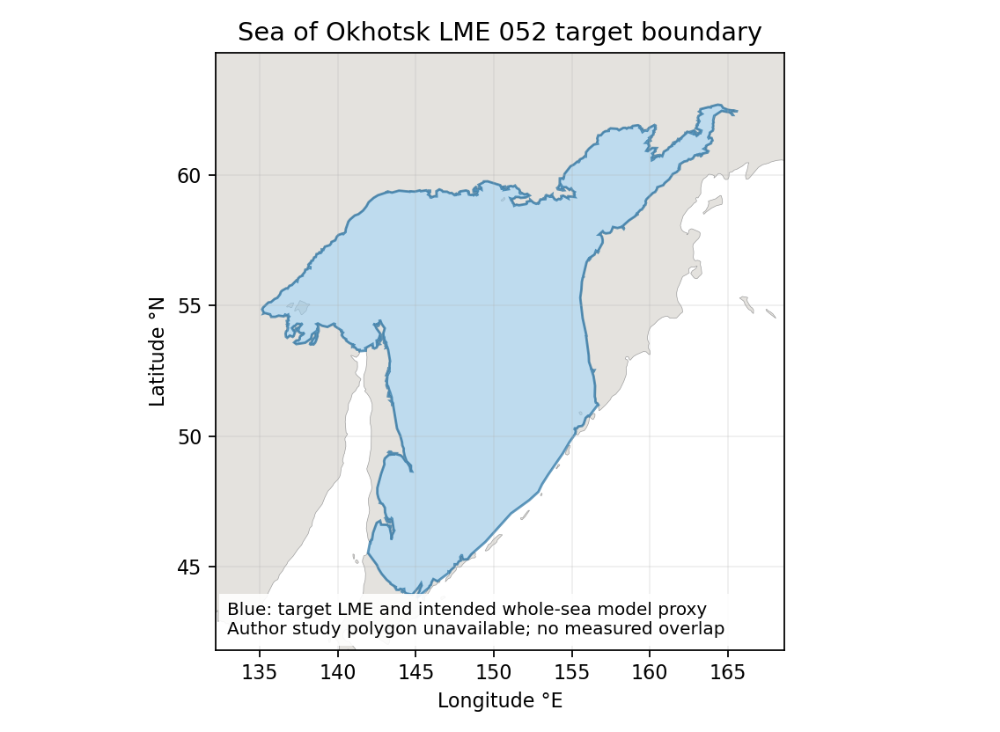
Sea of Okhotsk LME target boundary. Retained Sea Around Us boundary; WGS84 sea area 1,563,743 km². Blue also denotes the explicitly approximate intended whole-Sea horizontal domain. No geographic multiplier is applied. Geographic assessment

Study area in the article
Primary article Figure 1 sampling distribution
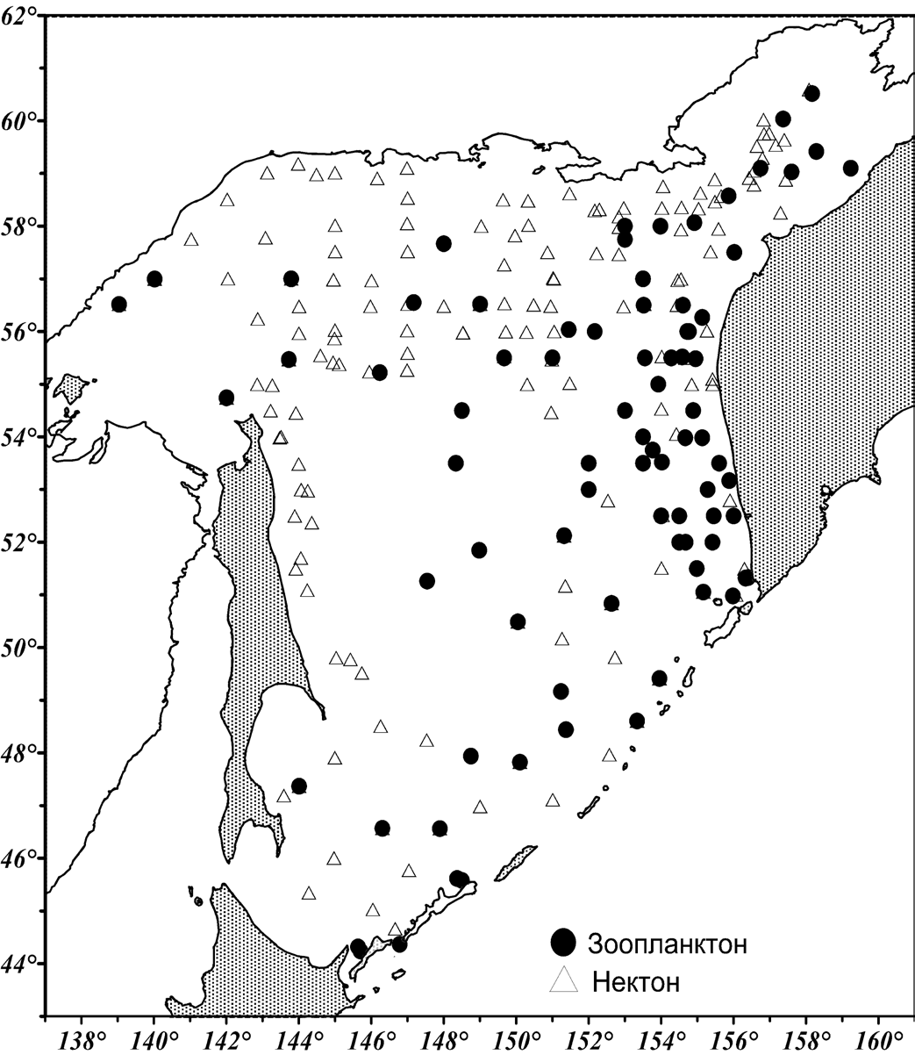
Gorbatenko and Melnikov 2019, Figure 1, printed page 146 / PDF page 4. Black circles show zooplankton and open triangles show nekton tissue sampling in 2003–2014. The methods define the epipelagic layer as 0–200 m, surface to bottom where shallower. This source sampling figure supports whole-Sea scope but does not provide an exact polygon. Original source page

