HS 077 model validation
Field | Entry
Region | Pacific, Eastern Central high seas, HS_077. Regional workbook
Catch source | Sea Around Us regional catch, 1950–2019; reference: 2019 landings. Eastern Central Pacific high-seas reporting unit; historical local download retained. Catch inputs | Regional catch
Selected article | Olson, R.J.; Watters, G.M. (2003). A model of the pelagic ecosystem in the eastern tropical Pacific Ocean. IATTC Bulletin 22(3), pp. 135–218. DOI: not recorded. Source PDF | Official IATTC bulletin | Paper folder
Other known articles | No additional article is recorded for HS_077 in the reviewed local inventory; this is not an exhaustive literature search.
Selected model | 077HS_1_Eastern_tropical_Pacific_(1993-1997); final ETP7, 1993–1997. 39 source ecological groups plus one computational import. Pelagic domain: 20°N–20°S, 150°W to the approximate American shelf break. Selected JSON | Model folder | Accepted loaded state
Other models from the same article | ETP1: initial 34-group, explicitly unbalanced model for the same broad period/domain. ETP2–ETP6: intermediate revisions; separate complete static tables unavailable. ETP5 sensitivities and Ecosim runs are scenarios. ETP7 is the final published parameterization. Source model inventory
Selection rationale | Article: recorded as the selected pilot article; comparative criterion beyond that designation: ?. Model: ? — the recorded diet-consistency concern does not explain choosing among model versions.
Model extraction | Nine material published diet-sum errors are retained in canonical inputs. The accepted historical runtime normalizes ten diets at 0.001 tolerance, including Albacore 1.001; infers missing BA; supplies missing-catch zeros and detritus/import defaults. Source BA and detritus routing remain undocumented. Censored whale EE and fleet catches are distinct from exact zero. No source values were restored or rebalanced. Reconstruction report | Source and runtime review  Retained departures and evidence limits:model notes
GE diagnostics | OK  No negative SPPR entries across the basal-source columns.  rho_living = 0.538806  b = 0  Detritus (39): SPPR = 1.689166
TE diagnostics | WARN: near-zero efficiencies in five mammal/bird groups.  rho_living = 0.627205  Detritus (39): SPPR = 0.755
SPPR calculation | Removed groups from calculations:  - Grazing birds (GE<1%, TE=0.1%)  - Pursuit birds (GE<1%, TE=0.1%)  - Toothed whales (GE<1%, EE=0)  - Spotted dolphin (GE<1%, TE=0.1%)  - Mesopelagic dolphins (GE<1%, TE=0.1%)  - Large sharks (Eat small-GE mammals)  - Small sharks (Eat small-GE mammals)
Geographic fit | Approximate A: 47% of HS_077 is covered by the study. B: 46–48% of the study is covered by HS_077. Boundary estimate
Temporal fit | 1993–1997 model averages; catch series 1950–2019. The 2019 reference is 22–26 years later. Fixed ecosystem coefficients and assumed composition weights do not reconstruct annual ecosystem changes.
Other
Open issues and next action
Review and reproducibility | Researcher name: Ido Carmel| review date: 08/10/2026  MODEL VALIDATED

Taxon mapping and coverage
Reference: 2019 landings; all catch labels, including zero catch and unidentified categories; no group filter.
39 source ecological groups (+1 computational import); 26 catch labels.
Simple-chain PPR totals 226,007,970.44 t C in 2019.
Method: independent simple trophic chain using saved classic taxon coefficients.
Taxon mapping appendix and descriptive Sources sheet
Overall confidence | Taxa (n) | Catch (%) | Simple-chain PPR (%)
High | 4 | 54% | 53%
Medium | 18 | 44% | 46%
Low | 0 | 0% | 0%
Very low | 4 | 2.1% | 0.52%
Unresolved | 0 | 0% | 0%
Overall confidence uses the weaker required membership or allocation component.
Group assignment rules
Plain-language rule | Confidence | PPR percentage
Explicit final source membership in the group or stage union. | High | 99%
Unknown finfish or shark/ray composition uses represented-pool proxies. | Very low | 0.52%
Verified current and historical names identify the source taxon. | High | 0.49%
Related pelagic billfish or mako extends listed source species. | Medium | 0.21%
Family spans a supported complete set of named and mixed fish groups. | Medium | 0.058%
Southern bluefin uses Pacific bluefin despite habitat/residency mismatch. | Very low | 0%
Membership evidence: final definitions, synonyms and complete candidates
Allocation weight rules
Plain-language rule | Confidence | PPR percentage
One group receives the entire catch taxon; no split uncertainty. | High | 53%
Historical source total removals provide assumed composition, transferred across areas, years and catch bases. | Medium | 47%
Unreported candidate catches reject the catch proxy; complete model biomass assumes regional composition/catchability. | Medium | 0.089%
Each percentage is the simple-chain PPR associated with taxa using that rule. Weights and assumptions: source catch, biomass and stage evidence
Unresolved taxa: none. Four Very low decisions represent 2.0780% of landings and 0.5194% of simple-chain PPR.

Very low decisions
Affected taxa | Why confidence is very low
Elasmobranchii | Unknown sharks, rays and skates composition is approximated by both shark stages and the Manta ray pool. Other rays/skates and benthic elasmobranchs are unrepresented. Source-removal proportions are transferred across areas, years and catch bases.
Marine pelagic fishes not identified | Unknown finfish composition is approximated by 22 named and residual fish pools, including flyingfishes and mesopelagic fishes. Omitted pelagic lineages remain uncertain. Model biomass assumes regional composition and catchability, fixed across years.
Marine fishes not identified | The provider medium-demersal label uses the 22 represented fish pools as a weak pelagic proxy. Benthic/coastal habitats are absent. Model biomass assumes composition and catchability across the regional catch series.
Thunnus maccoyii | Southern bluefin is absent from ETP7. Pacific bluefin is the closest represented taxonomic analogue, with cold-temperate geography, temperature and residency mismatches. Recorded 2019 landings are zero.

Geographic evidence screenshots
Target region R and reconstructed study area S share geographic coordinates and scale. Approximate shelf-break sensitivity and the published study-area denominator support the estimates.

Region area
Eastern Central Pacific high seas HS_077
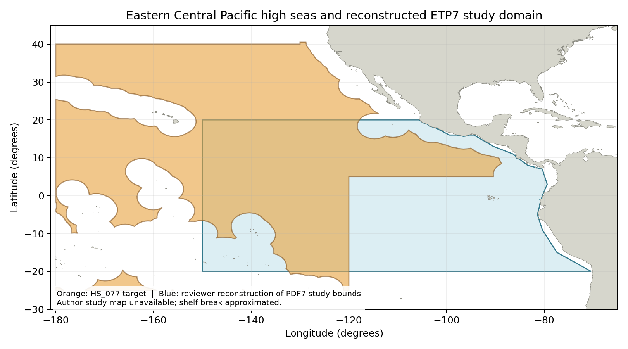
HS_077: repaired Sea Around Us high-seas region 77 boundary; Natural Earth 1:50m land exclusion. Target boundary | Image

Study area in the article
Reviewer reconstruction of source PDF7 bounds
Olson and Watters (2003), printed p. 137 / PDF7: 20°N–20°S, 150°W to American shelf break; 32.8 million km². Coast-following reconstruction; the original article supplies no study map. Source passage | Bounds page | Reconstructed image
Original geographic study figure: unavailable. Article Figures 1–4 show sensitivity and dynamic trajectories rather than the study boundary.

