Northern Humboldt model validation
Field | Entry
Region | Humboldt Current, LME_013. Selected-model evaluation of the northern Peruvian food web.  Regional workbook
Catch source | Sea Around Us, 1950–2019; confidence reference: 2019 landings. All 218 exact labels, including zero catch and unidentified categories.  Catch and classic inputs | Reference arithmetic
Selected article | Chiaverano et al. (2018). Evaluating the role of large jellyfish and forage fishes as energy pathways, and their interplay with fisheries, in the Northern Humboldt Current System. Progress in Oceanography 164, 28–36. DOI 10.1016/j.pocean.2018.04.009.  Source PDF | DOI
Other known articles | Neira et al. (2026), Chilean Patagonia 1980–2020 food-web modelling, DOI 10.1016/j.pocean.2025.103631. Its static 1980 model is retained as previous-selection evidence. Tam et al. (2008), Northern Humboldt trophic linkages under La Niña and El Niño, is a predecessor; its stocks cannot replace this model without a verified crosswalk.  Selected-model review
Selected model | Chiaverano2018_detailed_Northern_Humboldt_1995_1998; selected audited detailed Northern Humboldt baseline, 1995–1998. 39 ecological stocks plus two source fleet nodes, over 165,000 km² at 4°S–16°S and up to 111 km offshore. The paper counts 36 living groups and three detritus pools. Anchovy eggs (36) are a nonfeeding pool in the supplement, giving four operational detritus pools in this translation. The runtime adds one synthetic diet_import source.  Published source representation | Corrected model JSON
Other models from the same article | The aggregated baseline has 24 ecological groups plus one pooled fishery node (25 source nodes), over the same area and period. It merges source groups and uses rounded printed values. Full detailed detritus/fleet routing is retained only in the resolved version. The four structural scenarios alter jellyfish consumption, forage-fish consumption or fishing rates; they are separate scenarios, not replacement static baselines.
Selection rationale | Article - Requested source review to test the local source evidence and its applicability to Northern Humboldt catches.  Model - Prioritize the resolved supplement because its distinct taxa, hake stages, two fleets and detailed diets/routing permit a more faithful audit than the aggregated alternative. The user selected this audited model after auto returned finite, nonnegative SPPR in all three methods. Selection does not establish scientific validity or researcher validation.
Model extraction | Accepted corrections: Chrysaora plocamia (7) diet is 68% mesozooplankton, 17% macrozooplankton and 15% anchovy eggs, with zero direct diatom/small-gelatinous links. Author Table H I14/J14 reconstructs the 68/17 fractions; F14/K14 are zero and Table B H39 retains the egg fraction. This resolves the contradictory Table B diet totaling 1.045 without changing small-gelatinous biomass.  Sardine (9) landings follow the article’s explicit 1.4 t/km2/year correction; reported discards 0.17462648325 remain. Total JSON export is 1.57462648325; estimated EE is recalculated to 0.68720654. Article Table 1 and Scenario III still support the older high-catch branch. These are documented reconstructions/derived corrections, not newly printed author values.  The corrected model passes mass balance with living BA=0 and normalization compensation disabled. GS retains source assimilation efficiencies. Runtime normalization of the remaining diets is separate; pool EE/BA and detritus-fate identity replacement remain computational transformations. Native fleet discard-return ancestry is unsupported in the SPPR translation.  Published-source extraction audit | Source conflicts | Prior loader matrix audit  Retained departures and evidence limits:model notes
GE diagnostics | WARN: had to pool detritus groups.  Unpooled negative SPPR sources: Anchovy eggs (36), Pelagic detritus (38) and Benthic detritus (39).  rho_living = 0.7000; Pooled b = 0.7459; unpooled b = 1.6356.  No negative pooled SPPR entries across any basal-source column or recipient.  Pooled Detritus SPPR: (groups 36-39) = 5.4726  Strict model balance and SPPR budget balance pass in both configurations.  Full GE return | Labeled GE matrix  Complete negative source-to-group pairings (Excel)
TE diagnostics | FAIL: primary-production budget does not close despite the corrected model passing mass balance.  No negative SPPR entries across any basal-source columns.  rho_living = 0.7316.  Detritus SPPR: Anchovy eggs (36) = 0.0000; Fishery offal (37) = 0.0000; Pelagic detritus (38) = 0.3043; Benthic detritus (39) = 0.0000.  PP budget gap = 14%.  Five EE=0 living groups and very small jellyfish EE remain formulation concerns.  Full TE return | Labeled TE matrix
SPPR calculation | Removed groups from calculations:  - Cetaceans (GE<1%)  - Fishery offal (EE=0)  - Pinnipeds (GE<1%, EE=0)  - Seabirds (GE<0.1%, EE=0)  - Chrysaora plocamia (EE near-zero)
Geographic fit | Approximate A. Region covered by study: 6.0–8.0%.  Approximate B. Study covered by region: 90–100%. The northern shelf domain leaves most of this LME outside the model.  Boundary assessment
Temporal fit | Static 1995–1998 baseline applied to catch years 1950–2019; 2019 is 21–24 years later. Fixed coefficients and source catch/biomass allocations do not represent annual ecosystem or catch-composition changes. Publication year 2018 is separate from model period.
Other | Taxon allocations retain their documented published native-landings proxies; the sardine correction does not silently alter those assumptions. Updated regional estimates remain provisional and production-ineligible. Map refresh awaits researcher review.  Full direct report | Updated workbook calculations  Complete negative source-to-group pairings (Excel)
Open issues and next action
Review and reproducibility | Researcher name: Ido Carmel| review date: 08/10/2026  MODEL VALIDATED  Warnings: Pooled detritus groups + strong recylcling + Cetaceans GE<1% (across models)

Taxon mapping and coverage
Reference: 2019 landings; all recorded labels, all model groups and no taxon exclusions.
39 source ecological groups plus two fleet records and one computational import; 218 catch taxa.
Simple-chain PPR totals 277,099,551.43 t C in 2019.
34 labels lack classic TL/coefficient inputs; all have zero 2019 landings and contribute zero annual PPR. Their coefficients remain unavailable.
Method: independent simple trophic chain using the saved regional coefficients.
Excel taxon appendix | Descriptive Sources sheet
Overall confidence | Taxa (n) | Catch (%) | Simple-chain PPR (%)
High | 70 | 87% | 71%
Medium | 104 | 9.4% | 24%
Low | 17 | 0.24% | 0.26%
Very low | 27 | 3.2% | 4.9%
Unresolved | 0 | 0% | 0%
Overall confidence uses the weaker required membership or allocation component.

Group assignment rules
Plain-language rule | Confidence | PPR percentage
Explicit inclusion of the taxon in the source model | High | 71%
Supported extension from the source’s listed representative taxa | Medium | 7.3%
Source membership connected through a verified synonym or documented spelling correction | High | 6.7%
Supported ecological assignment requiring a group-boundary interpretation | Medium | 6.6%
Closest represented ecological or taxonomic analogue | Very low | 3.3%
Assumed eligible group set supported by taxonomy and ecology | Medium | 3.2%
Approximation of a broad reporting category across plausible model pools | Very low | 1.6%
Partial or competing ecological fit | Low | 0.26%
Unambiguous fit to a documented taxonomic or ecological group | High | 0.15%
Membership evidence: exact supplement group definitions, source taxonomic lists and authoritative synonym/habitat records. Complete mapping evidence

Allocation weight rules
Plain-language rule | Confidence | PPR percentage
One group; no allocation split required | High | 86%
Allocation proportional to native source-model landings | Medium | 14%
Complete source-model biomass fallback after unusable landings | Medium | 0.046%
Weights use measured composition only when applicable. The source-model landings proxy is used before biomass; assumed proportions are fixed across catch years, with stage, fishery and geographic transfers recorded. Allocation evidence
Each percentage is the independent simple-chain PPR associated with taxa using that rule.
Unresolved taxa: none. 27 Very low decisions account for 3.2% of catch and 4.9% of independent simple-chain PPR.

Very low decisions
Affected taxa | Why confidence is very low
Actinopterygii; Gadiformes; Marine finfishes not identified; Marine fishes not identified; Marine groundfishes not identified; Marine pelagic fishes not identified; Perciformes; Scorpaeniformes | Broad fish reporting labels have unknown composition across named and residual pools, historical taxonomic scope, and potentially unrepresented deep-water members; native landings approximate their mixtures.
Batoidea; Chondrichthyes; Elasmobranchii; Myliobatidae | Broad/historical cartilaginous labels cross benthic and water-column pools with unrepresented chimaera or filter-feeding ray components.
Callorhinchus callorynchus | Benthic chimaera uses an elasmobranch analogue across the Holocephali/Elasmobranchii boundary.
Decapoda; Malacostraca; Miscellaneous marine crustaceans | Benthic/pelagic mixture uses macrozooplankton/benthos biomass because native landings are zero; a 2–20 mm size mismatch remains.
Dissostichus eleginoides; Hoplostethus atlanticus | Deep, cold-water fishes use a medium-demersal analogue with population, depth and size mismatches.
Galatheidae; Grimothea monodon | Squat lobsters lack a source pool; macrozooplankton/benthos biomass weights retain the 2–20 mm size mismatch.
Galaxias maculatus | Amphidromous galaxiid lacks a corresponding source population; a coastal small-fish analogue is assumed.
Macruronus magellanicus; Merluccius australis; Merluccius gayi; Micromesistius australis | Non-Peruvian hake/cod-like fishes use Peruvian hake groups; species, southern ecology and size boundaries differ, and native stage landings are transferred.
Mobula birostris | Pelagic filter-feeding manta uses the closest chondrichthyan pool despite the source apex-predator correspondence.
Ophichthus | Snake eel mapped to unnamed conger pool despite taxonomic identity differing from the regional congrio interpretation.

Geographic evidence
The study covers a northern coastal shelf segment of the target LME. The shaded source boundary was traced approximately against its graticule; reported area and traced area differ, so the A/B ranges express boundary uncertainty.

Region area
Target region boundary
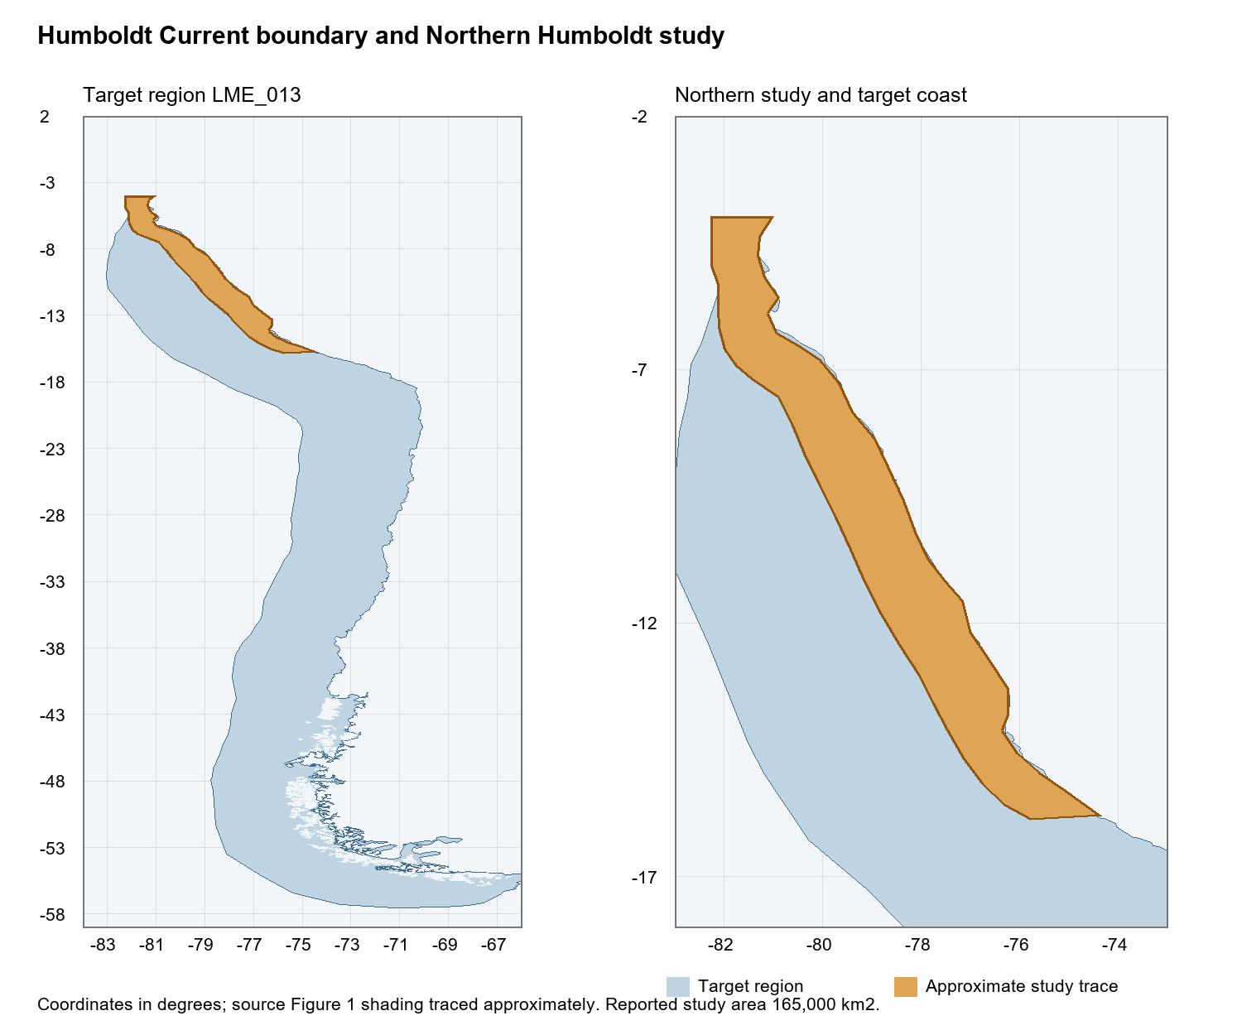
Humboldt Current LME_013 Sea Around Us boundary and approximate study trace in common geographic coordinates. Boundary evidence

Study area in the article
Study boundary for the selected model
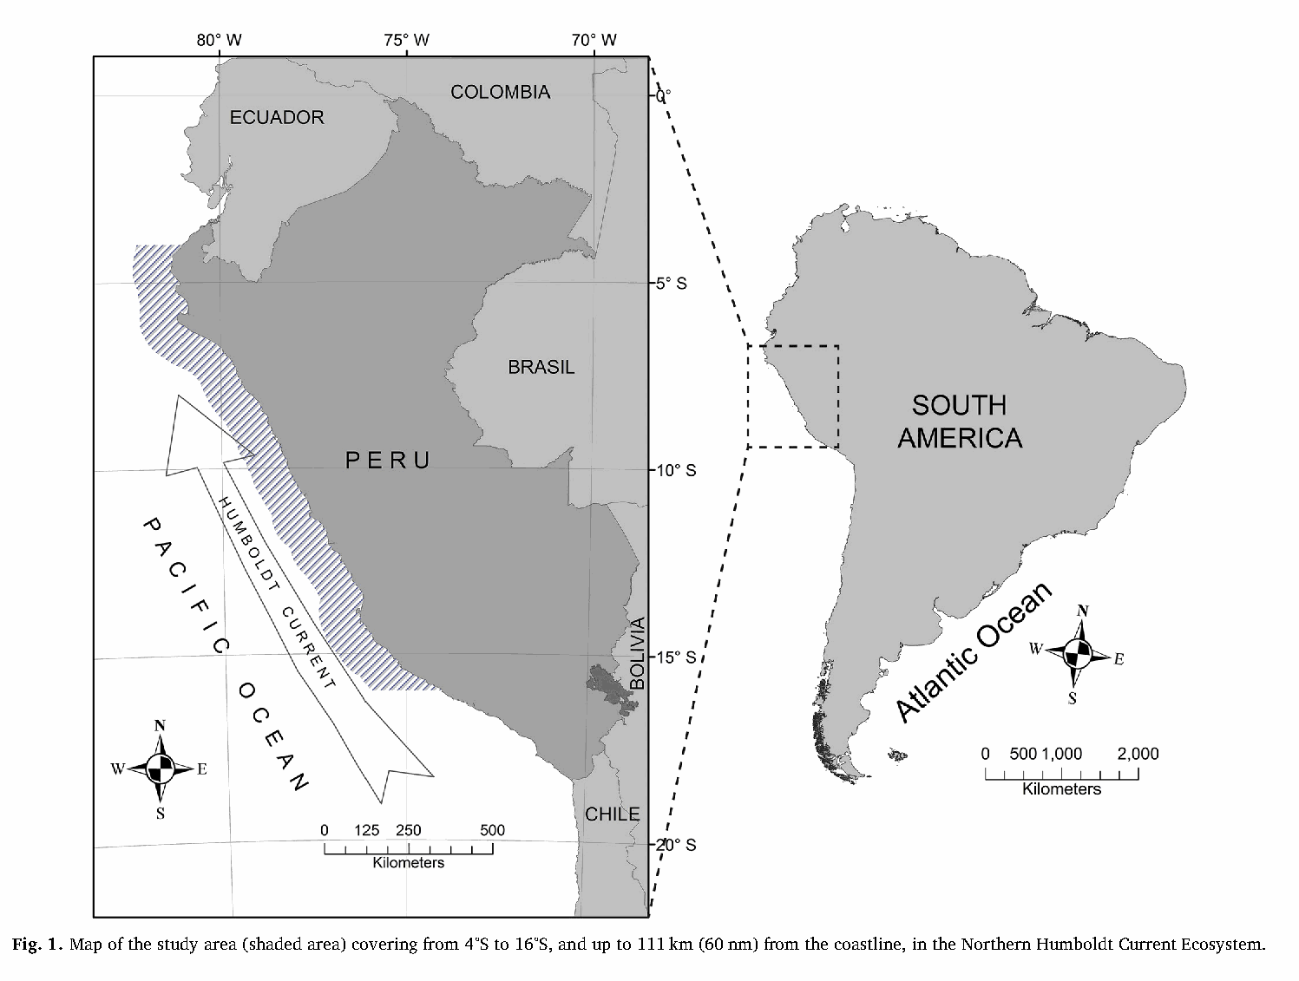
Chiaverano et al. (2018), original Figure 1, PDF page 2 / printed page 29. Hatching marks the 4°S–16°S coastal domain, up to 111 km offshore. Source PDF

