Guinea Current model validation
Field | Entry
Region | Guinea Current, LME_028; Sea Around Us target boundary. Regional workbook
Catch source | Sea Around Us v 50.1 catch series, 1950–2019; retained API 88 material dated 3 September 2026. Reference: 2019 landings, including reported/unreported retained catch; discards separate. Raw catch | Taxon/TL source
Selected article | Guénette & Diallo (2004), Addendum: Modèles de la côte guinéenne, 1985 et 1998, pp.124–159. In Palomares & Pauly (eds.), West African marine ecosystems: models and fisheries impacts, FCRR 12(7). Chapter PDF | Paper folder
Other known articles | Gascuel, Guénette, Diallo & Sidibé (2009), Impact de la pêche sur l’écosystème marin de Guinée – Modélisation EwE 1985/2005, FCRR 17(4), 60 printed pages. The title says 1985/2005; Ecopath construction and Table 3 specify 1985/2004. 2009 report
Selected model | 28_646_Guinea_(1998); 1998, waters off the Republic of Guinea, 111,932 km². 44 ecological source groups plus synthetic diet_import 45. This is a national coastal/offshore model transferred to the full LME. Selected JSON | Model folder
Other models from the same article | The chapter also presents a 44-group 1985 counterpart derived from balanced 1998, with reconstructed early catches. Stored 28_726_Guinea_(1985) is the distinct 35-group, 42,969 km² shelf revision in the 2009 report. Hash-suffixed copies are extraction identities, not extra baselines. Stored 1985 identity
Selection rationale | Article: ? (separate article-choice rationale unrecorded). Model: recorded rationale is geographic transfer requiring overlap validation. The source supports preferring 1998 over 1985 because contemporary landing/biomass estimates were available; the earlier model has greater catch-reconstruction uncertainty.
Model extraction | Accepted canonical parameters retained. Native database JSON differs only in 44 added taxonomy descriptions. Table 9 (p.143/PDF 147) has 13 B/EE values outside strict printed-rounding bounds; PB/QB agree at displayed precision. Oiseaux TL 3.77 differs from accepted calculated 3.545. Coarse diets and reconstructed catch/discards remain limitations. Inherited diet normalization changes cells by at most 3.07×10⁻⁸; default GS, derived BA and import 45 remain accepted conventions. Source/runtime comparison | Table9 differences  Retained departures and evidence limits:model notes
GE diagnostics | OK.  No negative SPPR entries across the basal-source columns, including unfished groups.  rho_living = 0.4497; b = 0.3548; Detritus (44) SPPR = 1.7792.
TE diagnostics | WARN: the deep large shark/ray pool has an extreme coefficient; saved annual TE results remain unavailable under the implausibility flags.  No negative SPPR entries across the basal-source columns, including unfished groups.  rho_living = 0.7176; Detritus (44) SPPR = 0.4259.
SPPR calculation | Removed groups from calculation:  - Dolphins (GE=0.5%, EE=0.4, TL=4.7, sppr_TE=500K, sppr_GE=100K)  - Birds (GE=0.3%, EE=0.36, TL=3.5, sppr_TE=345K, sppr_GE=66K)  - Whales (GE=0.4%, EE=0.5, TL=4.0, sppr_TE=275K, sppr_GE=66K)
Geographic fit | Approximate A: 5.0–7.0% of the region covered by the study. B: 95–100% of the study inside the region.
Temporal fit | Static 1998 coefficients and historical mixture weights are applied across 1950–2019. The reference year is 21 years later; annual ecosystem/fleet changes are not reconstructed.
Other | TE retains its implausibility warning: the deep large shark/ray pool has an extreme coefficient. Symbolic negative-source failures, Monte Carlo implausibility flags and unavailable source decompositions remain. Full catch mapping does not establish whole-LME ecological validity. Method-specific exposure
Open issues and next action | [Researcher: open issues and next actions]
Review and reproducibility | Researcher name: Ido Carmel | review date: 08/10/2026  MODEL VALIDATED

Taxon mapping and coverage
Reference: 2019 landings; all exact catch labels, including unidentified and zero-catch records; no taxon or group filter.
44 source ecological groups (+1 computational import); 375 catch labels.
Simple-chain PPR totals 202,194,055.86 t C in 2019.
50 labels lack a saved classic coefficient/TL; all have zero 2019 landings and therefore zero annual PPR. Unavailable TL remains ?, not zero.
Method: independent classic/simple trophic chain using the saved taxon coefficient.
Full taxon mapping appendix and descriptive Sources sheet
Overall confidence | Taxa (n) | Catch (%) | Simple-chain PPR (%)
High | 159 | 37% | 51%
Medium | 107 | 17% | 24%
Low | 32 | 7.0% | 9.3%
Very low | 77 | 38% | 16%
Unresolved | 0 | 0% | 0%
Overall confidence uses the weaker required membership or allocation component.

Group assignment rules
Plain-language rule | Confidence | PPR percentage
Exact source member in every documented applicable group. | High | 49%
Complete actual source representative union supports a higher label or stage mixture; local composition inferred. | Medium | 30%
Broad reporting category approximated over compatible named and residual source pools; caught composition unknown. | Very low | 15%
Taxonomic extension from source congeneric representatives; unlisted membership assumed. | Medium | 3.0%
Verified taxon fits the explicit source compartment without a competing specific placement. | High | 1.3%
Closest positive taxonomic or habitat analogue; unrepresented habitat, size or taxon mismatch disclosed. | Very low | 0.60%
Verified accepted synonym connects the catch label to a printed member. | High | 0.41%
Membership evidence: source members, taxonomy and complete candidate decisions Broad bony fish includes named stocks and deep/pelagic members; dedicated cartilage groups are excluded. Elasmobranchii excludes chimaeras. Broad invertebrate sets review actual euphausiids, benthos and larval stages. Scaridae denotes the historical parrotfish family, now Scarinae within Labridae; the genus-misspelling homonym is excluded. Scaridae rank bridge

Allocation weight rules
Plain-language rule | Confidence | PPR percentage
One reviewed group; no numerical split. | High | 75%
Complete accepted 1998 group-export catch proportions; historical mixture/catchability assumed. | Medium | 16%
Retained whole-period single-group donor total-catch proxy; reporting/population mismatch assessed separately. | Low | 9.5%
All 71 split labels retain explicit assumptions: 37 use complete 1998 model catch proportions; 34 retain historical donor total-catch weights at Low confidence. These mixtures are transferred across 1950–2019 and catch bases. Allocation and donor applicability evidence
Each rule percentage is the share of independent simple-chain PPR associated with taxa using that rule.
No unresolved taxa remain. The 77 Very low decisions cover 38.4107% of landings and 15.6210% of simple-chain PPR; the table below identifies the source-definition, composition and analogue uncertainties.

Very low decisions
Affected taxa | Why confidence is very low
Actinopterygii; Marine finfishes not identified; Marine fishes not identified | All 29 bony-fish pools include named stocks, pelagic and deep guilds; dedicated cartilage pools are excluded. Actual caught composition is unknown. Complete 1998 model catch proportions are a whole-guild proxy transferred across 1950–2019 and catch bases.
Scombroidei | Historical reporting boundaries span named and residual source fishes but differ from modern taxonomy. The actual species mixture is unknown. The source-member union and complete 1998 group catch proportions are assumptions transferred across years and bases.
Alepisaurus ferox; Aphanopus intermedius; Berycidae; Beryx; Beryx decadactylus; Beryx splendens; Brama brama; Bramidae; Gephyroberyx darwinii; Guentherus altivela; Lampris guttatus; Promethichthys prometheus; Ruvettus pretiosus | Deep-water fish are weak predatory, habitat or family analogues of the source Gempylus, Lepidocybium or other bathy members. Exact placement and size/depth boundaries remain unverified; mixed diets and pelagic overlap weaken the pooled pathway. Lampris also has an uncertain local role.
Apsilus fuscus; Brotula barbata | The snapper and brotula are weak shelf-predator analogues. Apsilus is not established by the source coastal Lutjanus members; Brotula also overlaps deeper and crustacean-feeding compartments.
Batoidea; Chondrichthyes | The four shark/ray pools lack observed species, size and habitat composition. Chondrichthyes additionally includes chimaeras absent from the source. Historical donor catch proportions mix guild members and reporting populations; they do not establish residual composition and are transferred across years/bases.
Perciformes | Historical reporting boundaries span named and residual source fishes but differ from modern taxonomy. The actual species mixture is unknown. The source-member union and complete 1998 group catch proportions are assumptions transferred across years and bases.
Aetobatus narinari; Carcharias taurus; Carcharodon carcharias; Galeorhinus galeus; Ginglymostoma cirratum; Glaucostegus cemiculus; Pristidae | Large coastal sharks/rays are weak size, habitat or family analogues of source coastal elasmobranch members. These taxa are not explicitly listed, and compartment limits are incompletely verified; white-shark regional representativeness is also unverified.
Marine pelagic fishes not identified | Source pelagic members include named tuna/billfish, clupeids and mixed shelf/bathy guilds. Their proportions within this reporting label are unknown; whole-pool 1998 catch weights transfer an assumed mixture across years/bases.
Lithognathus mormyrus | The sea bream is a weak coastal benthic-invertebrate-feeder analogue; source membership and the precise feeding/size boundary remain unverified.
Elagatis bipinnulata; Tylosurus crocodilus | These large pelagic fishes are weak feeding/habitat analogues of source Alectis/Coryphaena or Ablennes. Exact source membership and size/habitat limits are unverified.
Branchiostegus; Lagocephalus laevigatus; Parapristipoma octolineatum; Spondyliosoma cantharus | Shelf benthic feeders are weak analogues of source members such as Balistes, Plectorhinchus, Pagellus and Boops. No explicit placement is documented; the puffer overlaps pelagic/benthic guilds and source puffers span several compartments.
Sarotherodon galilaeus; Sarotherodon melanotheron | Tilapia plant/detritus feeding links weakly to source Liza/Mugil and Acanthurus/Sarpa. These are not mullets or source members; freshwater/brackish or lagoon habitats are transferred to marine pathways without a freshwater compartment.
Bathygobius soporator; Gobiidae; Solea | Gobies and soles are weak shallow benthic-feeder analogues of the source coastal guild. No explicit goby compartment exists; Solea species/depth composition is unknown. The provider large-reef bin does not establish Bathygobius placement.
Miscellaneous marine crustaceans | Actual source invertebrates include benthic taxa, euphausiids and unspecified larvae. Provider bins do not prove adult-only composition. Larval taxonomy and caught-stage composition are unobserved; source whole-pool catch weights are fixed across years/bases.
Scorpaeniformes | Source scorpionfish, gurnard and flying-gurnard members span coastal, shelf and bathy groups. Legacy order boundaries and unidentified caught composition remain uncertain; 1998 whole-group catch weights transfer the mixed pathways across years/bases.
Centrophorus; Centrophorus granulosus; Centrophorus lusitanicus; Centrophorus squamosus; Centroscymnus coelolepis; Centroselachus crepidater; Cetorhinus maximus; Dalatias licha; Deania calceus; Echinorhinus brucus; Hexanchus griseus; Rostroraja alba; Scymnodon ringens; Somniosus rostratus | These are weak size, depth or family analogues of source large deep elasmobranchs; exact membership and size cutoffs are unverified. Basking shark follows the named whale-shark analogue despite pelagic filter feeding; skate catch depths and some local geographic fits remain uncertain.
Centrolophidae; Peristediidae; Schedophilus ovalis; Schedophilus pemarco | Barrelfishes and armoured gurnards are weak benthopelagic-feeder analogues of source Ariomma or Trigla. Heterogeneous diets, uncertain local feeding and shelf/slope overlap leave source-specific placement unresolved.
Pellonula leonensis | Pellonula provides a weak small coastal-pelagic feeding analogue, but river/lagoon and brackish occurrence complicate transfer. Marine catch does not establish a shared freshwater food web or documented source membership.
Pseudocaranx dentex; Uraspis secunda | Trevally/jack are weak analogues of source Caranx/Trachinotus. Offshore habitat overlap and incomplete source guild boundaries prevent stronger membership confidence.
Holocentrus adscensionis | The reef squirrelfish is a weak nocturnal invertebrate-feeding analogue of source Sargocentron; exact membership and the small/medium compartment boundary are unverified.
Tetrapturus pfluegeri | The spearfish is linked to the source billfish members in Thons majeurs, but is not a printed member; source-specific placement remains a weak analogue.
Dicentrarchus; Dicentrarchus punctatus | Sea bass are weak coastal/estuarine piscivore analogues. They are not source-listed and cannot be assigned literally to Bars, which denotes Pseudotolithus; exact guild boundaries remain uncertain.
Miscellaneous aquatic invertebrates | Actual source invertebrates include benthic taxa, euphausiids and unspecified larvae. Provider bins do not prove adult-only composition. Larval taxonomy and caught-stage composition are unobserved; source whole-pool catch weights are fixed across years/bases.
Centroscyllium fabricii; Oxynotus centrina; Scyliorhinidae | Small/medium deep sharks are weak analogues of source Etmopterus/Galeus. Family depth composition and group size boundaries remain uncertain; documented Sierra Leone occurrence prevents excluding Centroscyllium merely by geography.
Chimaeriformes | Chimaeras are absent from the source inventory and belong to Holocephali rather than sharks/rays. Deep cartilaginous pools are a weak depth/body-form analogue; coastal and bony alternatives fit less closely. Source catch proportions fix an unobserved mixture across years and bases.
Cyprinidae | Freshwater carp/barbel bottom-feeding, omnivory and detritivory provide a weak link to shallow Mulets and coastal invertebrate feeders. The marine model has no freshwater compartment or measured family composition; source catch weights transfer those pathways across all years/bases.
Inermiidae | Bonnetmouth schooling and plankton feeding connect to the small pelagic guilds, but Western Atlantic identity and absence of a printed member weaken regional transfer. Model catch weights assume an unobserved coastal/offshore mixture across years and bases.
Pentheroscion mbizi | The shelf croaker has a weak source medium-predator habitat connection, supported by 80–200 m occurrence and fish/shrimp feeding. Exact membership and pooled diet fit remain uncertain.
The excluded TE arithmetic is 4.5717 billion t C: Elasmobranchii contributes 23.6895%, Prionace glauca 13.2955% and Sphyrna zygaena 10.0636%. Explicit shark membership is retained; the extreme pooled coefficient and Low donor mixture make TE scientifically implausible. Actual method contributions

Geographic evidence screenshots
R is the full Guinea Current LME; S is the study waters off Guinea. The graticule trace and ordered coastline approximate the original figure. Nine source-visible water controls test both sides of the maritime limits and coastal water; these ranges are not statistical intervals.

Region area
Guinea Current target region
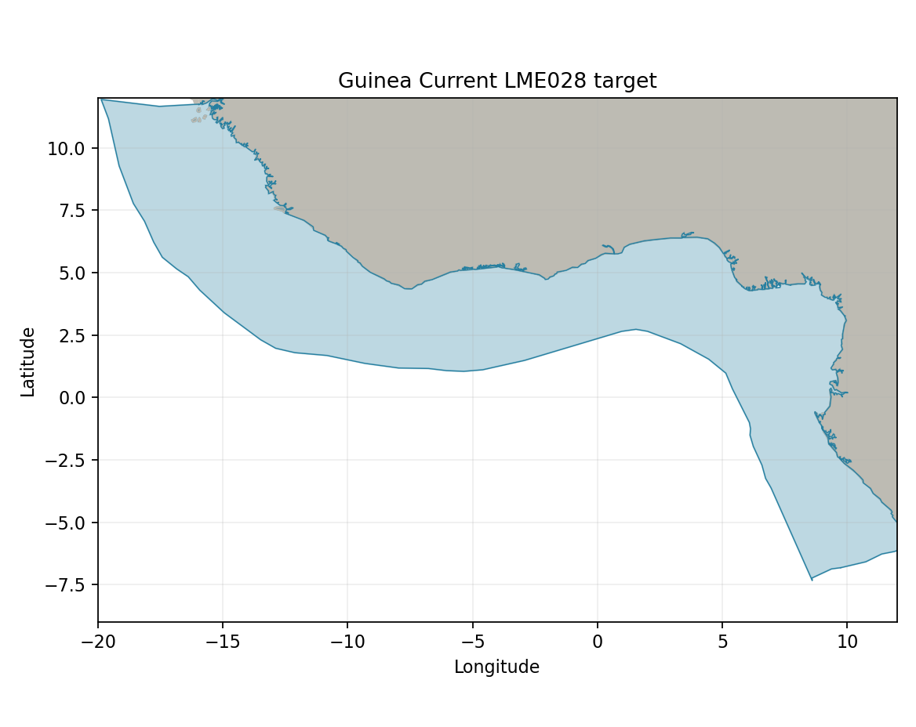
Sea Around Us LME 28 target R: 1,918,762 km². Target boundary | Map image

Study area in the article
Original Guinea study area Figure 1
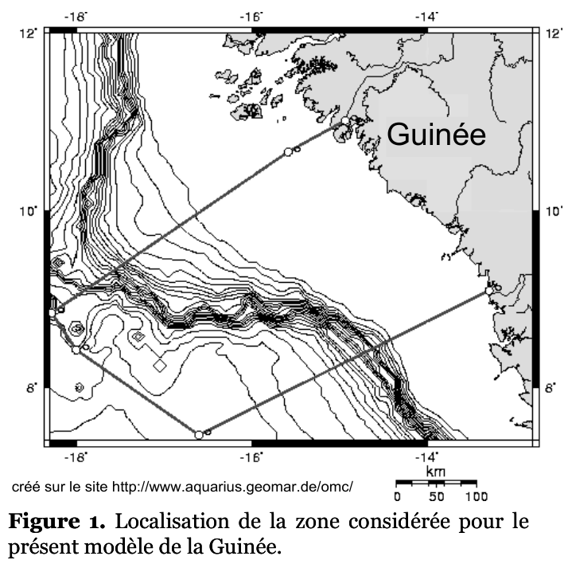
Guénette & Diallo 2004 Figure 1, printedp.124/PDF 128. The model covers waters off the Republic of Guinea; the LME continues far beyond the study. Source-reported area is 111,932 km². Original source | Geographic assessment
Approximate source-boundary comparison: reconstructed marine area 109,016 km², A≈5.64%, B≈99.28%; coarse report ranges 5–7% and 95–100% reflect line/coast uncertainty. The calibrated western corner and two real boundary bends follow the printed outline; markers/annotations were not water exclusions. Reconstructed polygon
