Gulf of Thailand model validation
Field | Entry
Region | Gulf of Thailand, LME_035; source 10–50 m shelf applied across the whole LME. Regional workbook
Catch source | Sea Around Us v50.1; local 1950–2019 catch; reference: 2019 landings. Original catch
Selected article | Christensen, V. (1998). Fishery-induced changes in a marine ecosystem: insight from models of the Gulf of Thailand. Journal of Fish Biology 53 (Suppl. A): 128–142. Author full HTML read; original PDF unavailable. DOI | Author full text | Retained source facts
Other known articles | Pauly & Christensen (1993), Stratified models of large marine ecosystems: application to the South China Sea — acknowledged 10–50 m Gulf predecessor. Vibunpant et al. (2003), Trophic model of the coastal fisheries ecosystem in the Gulf of Thailand — separate 40-group 1973 model. Premcharoen (2012), Mae Klong estuary — subregional alternative. 1993 predecessor | 1973 source | Estuary source
Selected model | 35_412_Gulf_of_Thailande_(1963); scientific payload 1980 despite inherited 1963 filename. EcoBase 412 description and all 11 Table II biomass comparisons identify 1980. 29 source ecological groups (+1 computational import); 10–50 m shelf. Canonical model | Identity evidence
Other models from the same article | Article compares 1963 and 1980 baselines. Selected canonical file contains 1980; a separate verified complete 1963 parameter/diet set is not supplied. 1993 predecessor and 1973 candidate have different group structures.
Selection rationale | Article — ?  Model — Retained selected EcoBase 412 payload; independent identity evidence establishes 1980. Whole-LME/year application remains provisional; scientific approval is not established by finite coefficients.
Model extraction | Available source identity, habitat, illustrative membership and 11 biomasses were checked. Complete published B/PB/QB/EE/diet inputs are unavailable. Accepted canonical export, BA, diet, routing and runtime settings are retained; exact loaded groups agree. Zero juvenile exports are canonical values, not observed regional stage catches. Source limitations | Loaded proof  Retained departures and evidence limits:model notes
GE diagnostics | WARN: Jellyfish (18) and M. mammals (1) have EE = 0.  No negative SPPR entries across the basal-source columns.  rho_living = 0.2400  b = 0.2712  Detritus (29): SPPR = 2.5802
TE diagnostics | WARN: Jellyfish (18) and M. mammals (1) have EE = 0.  No negative SPPR entries across the basal-source columns.  rho_living = 0.6142  Detritus (29): SPPR = 0.6600
SPPR calculation | Removed groups from calculations:  - M. mammals (GE=0.1%, SPPR_GE=110K)
Geographic fit | A. Region covered by the focal 10–50 m study: not determined.  B. Focal study area covered by the region: not determined.  The original focal boundary is unavailable; the contextual estimates are shown with the figures below.
Temporal fit | Static 1980 coefficients and fixed composition/stage proxies apply across 1950–2019 whole-LME catches; reference 2019 is 39 years later. Source shelf and reporting-population differences are not reconstructed annual ecosystem dynamics.
Other | GE, TE and With Egestion remain WARN. TE repairs consumed-production routing for two EE = 0 groups (marine mammals, jellyfish) under accepted runtime settings. All 270 direct source entries are finite/nonnegative, including unfished groups; six symbolic methods remain failed. Source fidelity and spatial/temporal application limits remain. Full diagnostics
Open issues and next action | [Researcher: open issues and next actions]
Review and reproducibility | Researcher name: Ido Carmel | review date: 08/10/2026  MODEL VALIDATED

Taxon mapping and coverage
Reference: 2019 landings; all taxon labels, including zero catch and unidentified categories; no group filter.
29 source ecological groups (+1 computational import); 247 catch taxa.
Simple-chain PPR totals 192,544,832.38 t C in 2019.
33 labels lack a classic TL/coefficient; all have zero 2019 landings and contribute zero annual PPR.
Method: independent simple trophic chain.
All taxon mappings and descriptive Sources sheet
Overall confidence | Taxa (n) | Catch (%) | Simple-chain PPR (%)
High | 99 | 51% | 33%
Medium | 103 | 27% | 45%
Low | 11 | 8.7% | 11%
Very low | 34 | 13% | 12%
Unresolved | 0 | 0% | 0%
Overall confidence uses the weaker required membership or allocation component.
Group assignment rules
Plain-language rule | Confidence | PPR percentage
Supported coastal/guild or historical ecological extension. | Medium | 26%
Unambiguous documented generic taxonomic group fit. | High | 20%
Explicit focal source taxon or genus assignment. | High | 19%
Assumed complete eligible family or suborder set. | Medium | 16%
Broad reporting category approximated over compatible pools. | Very low | 12%
Related-member extension from source representatives. | Medium | 6.0%
Verified source spelling or historical-name bridge. | High | 0.27%
Closest represented analogue with material source mismatches. | Very low | 0.27%
Partial or competing ecological/taxonomic fit. | Low | 0.056%
Membership evidence: Christensen (1998), p.130 and model identity, Pauly & Christensen (1993), Table 2 and all taxon decisions
Allocation weight rules
Plain-language rule | Confidence | PPR percentage
One reviewed group receives 100%; no split. | High | 66%
Complete 1980 canonical export proportions, including zero candidates. | Medium | 23%
Retained historical identified-catch proxy with population mismatch. | Low | 10%
Each percentage is the independent simple-chain PPR associated with taxa using that rule. The 1980 model-catch proportions, including zero candidates, are fixed composition proxies. Historical identified-catch proxies remain Low because donor populations and gear differ. Weights and donor evidence
Unresolved taxa: none. The 34 Very low decisions cover 12.9493% of landings and 12.0040% of simple-chain PPR. Their specific uncertainties appear below. Very low decisions contribute 14.12% of GE, 12.01% of TE and 13.86% of With Egestion all-source PPR; Carangidae alone contributes 7.93% of GE. Method-specific exposure
Very low decisions
Affected taxa | Why confidence is very low
Carangidae | Scad explicitly includes Decapterus; larger predators use the large-piscivore stage pair as an analogue. The reported jacks/pompanos mixture is unknown. Model-catch proportions assume fixed 1980 composition.
Marine fishes not identified | Unidentified bony fish may span named, residual and juvenile pools. Separate reported categories do not establish exclusions; species and stage composition is unknown. Model-catch proportions are a fixed 1980 proxy.
Serranidae | The historical basses/groupers category includes Epinephelus, now Epinephelidae, while other basses are unlisted. The grouper/snapper stage union is a proxy for an unresolved taxonomic and feeding mixture; model-catch proportions are assumed.
Alepes | Scad provides a coastal schooling Decapterus connection, but reef habitat, feeding and species composition differ. No direct source membership is documented; the whole taxon is placed in Scad.
Marine groundfishes not identified | Plausible demersal and juvenile pools are retained, but the large-piscivore pool also contains pelagic Chirocentrus/Sphyraena. Unknown residual composition and mixed guilds require fixed 1980 model-catch proportions.
Caesio; Caesionidae | Small pelagics provides a coastal schooling sardine/anchovy connection. Reef habitat, feeding and species composition differ; fusiliers are not directly named. The whole taxon is placed in that analogue.
Acanthurus; Mugil; Mugilidae; Scarus; Scatophagus; Scatophagus argus; Siganidae; Siganus; Siganus canaliculatus | These unlisted coastal herbivores/omnivores have a residual-catch connection to O.fish (trash fish). Its species composition and feeding fit are unverified. Named piscivore/benthivore pools offer weaker connections; each whole taxon is assigned to O.fish.
Perciformes | The historical perch-like reporting category spans scombrids, carangids and reef/demersal guilds; the current narrow order does not define that mixture. Source piscivore pools also include other orders. Model-catch proportions assume fixed composition.
Chondrichthyes | Shark stages and rays approximate the reporting category; chimaeras have no documented source group. Species/stage composition is unknown. Historical whole-guild donor fractions have country, gear and period mismatches and remain Low allocation proxies.
Decapoda; Malacostraca; Miscellaneous aquatic invertebrates; Miscellaneous marine crustaceans; Mollusca | Compatible named invertebrate, benthic and planktonic stage pools provide a practical connection. The full reported composition is unenumerated, so eligible pools and species/stage mix are approximate. Fixed 1980 model-catch proportions are assumed.
Coryphaena hippurus | The large-predator stage pair connects to source coastal piscivores, but dolphinfish is unlisted and Tuna is a plausible competing pelagic analogue. Surface habitat and source composition differ. The accepted stage split uses fixed 1980 model-catch proportions.
Istiompax indica; Istiophoridae; Istiophorus; Istiophorus platypterus; Kajikia audax; Makaira; Makaira mazara; Tetrapturus angustirostris; Xiphias gladius | The 1993 predecessor places billfish with tuna in Large pelagics, supporting a crosswalk to focal Tuna. Focal members are coastal tuna examples; oceanic/deeper habitat and narrower taxonomy limit the analogy. No focal billfish membership or donor coefficients are implied.
Marine pelagic fishes not identified | Named pelagic pools and mixed guilds containing Chirocentrus/Sphyraena or Pampus provide positive source connections. The full residual species/stage mixture is unknown; explicit demersal exclusions do not remove mixed-guild uncertainty. Fixed 1980 model-catch proportions are assumed.

Geographic evidence screenshots
Target region R is the Sea Around Us LME. The focal source specifies a 10–50 m shelf domain, but its original study boundary is unavailable. Pauly & Chuenpagdee (2003), Figure 14-1, provides contextual geography; its illustrative trace does not establish the focal study extent.

Region area
Gulf of Thailand target and shelf context
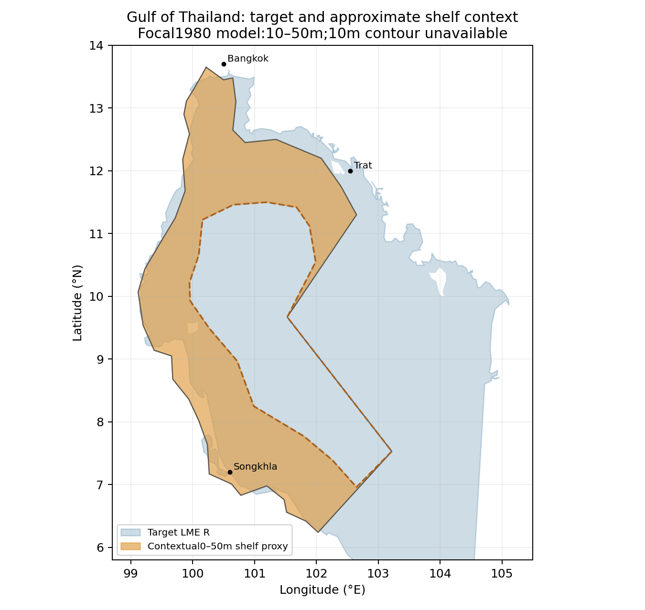
Target R: 387,239 km². Blue shows the target; orange shows an approximate contextual shelf trace within the lineage map boundary. Coastline and islands are simplified. Target polygon | Context trace

Study area in the article
Illustrative depth context from lineage map
Contextual trace: 112,695 km²; intersection: 102,520 km². Contextual A ≈ 26.5%; B ≈ 91.0%. The reported larger 0–50 m band (≈150,000 km², ≈38.7% of R) is separate area context. Neither identifies the missing focal 10 m boundary or full study extent. Lineage Figure14-1 | Calibration and limits
Contextual Figure 14-1 from Pauly & Chuenpagdee (2003), printed p.338 / PDF p.2. Its 50 m contour and angular location boundary do not constitute the original focal study map.