Sea of Okhotsk regional model validation
Pending alignment draft
Field | Entry
Region | Sea of Okhotsk, LME_052. The selected model describes the whole sea. Regional workbook
Catch source | Sea Around Us, 1950–2019 reconstructed catch. Reference: 2019 landings; all 151 exact reporting labels, including zero catch. Original catch
Selected article | Chaikina (2004), A trophic mass-balance model of the Sea of Okhotsk for the 1980s period. BSc thesis, UBC, 49 pages. Original thesis unavailable. A related 2020 chapter documents the earlier model. Thesis listing | Related chapter
Other known articles | Radchenko (2015), Characterization of the Sea of Okhotsk Ecosystem Based on Ecosystem Modelling. A 48-group contemporary model is retained as an alternative; full reconstruction is unreviewed. Alternative article
Selected model | 52_1_Sea_of_Okhotsk_NE_(1980). NE means newly constructed detailed Ecopath. It is a whole-sea 1980s annual-average model with 29 source groups and computational import 30. Reported area: 1,590,000 km². Accepted model
Other models from the same article | The same source also compares a simplified nine-group SD 1980s model derived from the Shuntov–Dulepova food web. NE and SD are model structures, not northeastern and southern subregions. Simplified model
Selection rationale | Article — Retained as the broadest located whole-sea model despite incomplete original documentation.  Model — The detailed NE structure supplies finer biological resolution; existing numerical caveats remain.
Model extraction | All supplied native Table 1 B/PB/QB/EE values agree with accepted inputs. The accepted diet contains 74 normalized cells from eight printed columns totaling 0.998–1.001. Native catch fields and pollock cutoff are absent; export zeros, detritus B=1 and existing defaults/balance remain accepted assumptions. Source fidelity
SPPR calculation | [MANUAL — Researcher: calculation choices and reasons]  [Excluded groups, scope and relevant values; other adjustments]

Field | Entry
GE diagnostics | No negative SPPR entries across the basal-source columns. rho_living=0.86716588; b=0.15204353; Detritus 29 SPPR=1.25101369. Full source matrices | Signed entries
TE diagnostics | Detritus 29 → Cottidae 14, Other Gadidae 12, Pinnipeds 4, Toothed whales 2; Phytoplankton 28 → Cottidae 14, Other Gadidae 12, Pinnipeds 4, Toothed whales 2; Phytobenthos 27 → Cottidae 14, Other Gadidae 12, Pinnipeds 4, Toothed whales 2. All 12 pairs are retained, including unfished mammals. TE FAIL remains. rho_living=1.02512005; b=0.00000000; Detritus 29 SPPR=0.94864761. b=0 is the TE convention. Full source matrices | Signed entries
Geographic fit | A. Region covered by study: approximately 100% under the intended whole-sea proxy.  B. Study covered by region: approximately 100% under that proxy. Author boundaries are unavailable; exact overlap is unmeasured and boundary confidence is Low.
Temporal fit | Static 1980s coefficients and fixed biomass proportions transfer across 1950–2019 whole-LME landings, catch and discards. Reference 2019 is roughly three decades later. Seasonal source averaging does not reconstruct annual catch composition or ecosystem change.
Other | GE and With Egestion return WARN; TE returns FAIL. All 120 source-recipient entries per method were inspected, including unfished groups and import. Inherited near-singular MC TE and negative/unsupported methods remain. Expanded mapping cannot approve these failed results. Method exposure and signed contributions
Open issues and next action | [Researcher: open issues and next actions]
Review and reproducibility | Researcher name: [name] | review date: [date]
Taxon mapping and coverage
Reference: 2019 landings; all source scope, all reporting labels, no group filter.
29 source groups (+1 computational import); 151 catch taxa.
Simple-chain PPR totals 248,368,608.38 t C in 2019.
20 labels lack a classic coefficient/TL; all have zero 2019 landings and zero annual contribution. Unknown coefficients and TL remain ?.
Method: protected independent simple trophic-chain coefficients.
All 151 taxon mappings and descriptive Sources sheet
Overall confidence | Taxa | Catch percentage | PPR percentage
High | 46 | 33.0296% | 64.0466%
Medium | 56 | 55.8556% | 31.4082%
Low | 2 | 0.0901% | 0.3575%
Very low | 46 | 11.0196% | 4.1872%
Unresolved | 1 | 0.0051% | 0.0005%
The summary uses the weaker required membership or allocation confidence. The following tables show each component separately.
Group assignment rules
Plain-language rule | Confidence | PPR percentage
Literal member or verified common-name crosswalk to a named taxonomic source pool. | High | 92.5385%
Broad reporting union approximated across compatible source pools. | Very low | 2.7698%
Inferred eligible regional family, depth, habitat or feeding set. | Medium | 1.8253%
Represented ecological or lineage analogue with substantial mismatch. | Very low | 1.4174%
Supported ecological extension to a represented feeding or habitat guild. | Medium | 0.9010%
Partial or conflicting habitat fit with a material source mismatch. | Low | 0.3575%
Supported extension from a named, closely related regional representative. | Medium | 0.1900%
No defensible source membership or complete analogue set established. | Unresolved | 0.0005%
Membership evidence: native Table 1 and diet, primary taxonomy and regional context and all candidate decisions
Allocation weight rules
Plain-language rule | Confidence | PPR percentage
One reviewed group receives all catch; no numerical split. | High | 67.4159%
Complete source biomass after unavailable native catch; fixed composition and equal catchability assumed. | Medium | 32.5836%
No numerical allocation without established membership. | Unresolved | 0.0005%
Weights and assumptions: native group catches are unavailable. Canonical export=0 is not an observed stage fraction. Complete source biomass supplies every multi-group vector at Medium allocation confidence. Pollock supplies 48.9157% of 2019 landings and is allocated 53.874619% adult/nonjuvenile and 46.125381% juvenile, with equal catchability assumed and no recovered cutoff. Fixed 1980s proportions apply across all years and catch bases. Each rule table partitions the same simple-chain PPR. Complete candidate vectors
Unresolved: Cyprinidae, because unobserved freshwater family composition supplies no defensible local marine home. It retains 177.054315 t landings and 1,241.263560 t C classic PPR in the denominator. Very low: 46 labels, 11.0196% landings and 4.1872% classic PPR. These include broad bony/invertebrate unions and unrepresented cartilage, pelagic and grazing-fish analogues. Source Salmon is mostly zooplanktivorous, limiting tuna/shark transfer. Failed TE has signed caught contributions; ordinary positive confidence percentages are unavailable. Flagged appendix rows | Method contributors

Geographic evidence screenshots
R is the Sea Around Us Sea of Okhotsk LME. S is described by the source as the whole sea. The displayed polygon reconstructs that intended domain using R; author GIS and a study-area map are unavailable. Approximate A/B values therefore describe the intended proxy, not measured overlap.

Region area
Target LME 052 and intended whole sea proxy
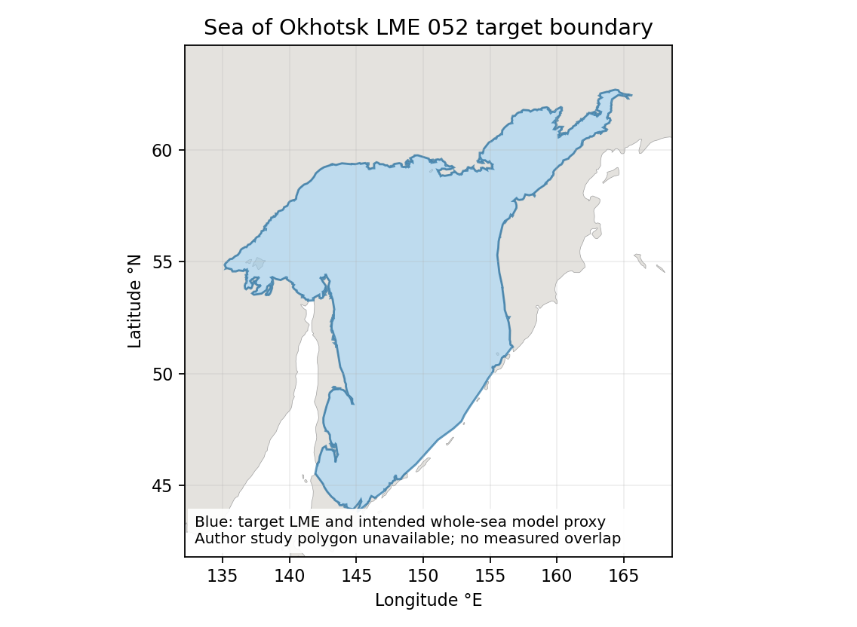
WGS84 target area: 1,563,743 km². Source reported area: 1,590,000 km². Their area ratio is 98.3486% (target/source); it is not an overlap calculation. No geographic multiplier is applied. Target polygon | Qualified geographic assessment

Study area in the article
Study area map unavailable native methods excerpt
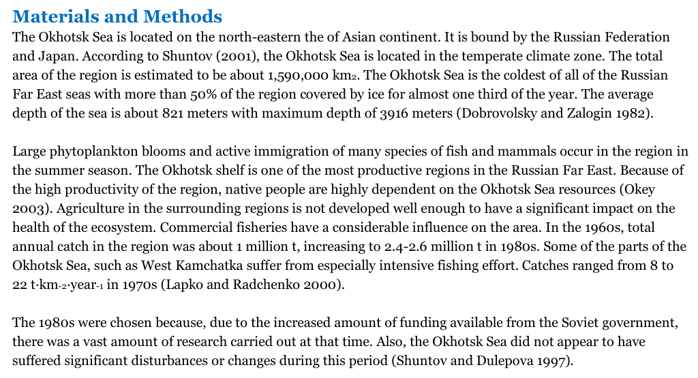
Related 2020 chapter PDF25 / printed24. The methods describe the whole sea and report 1,590,000 km². Chapter figures are food-web and simulation/results diagrams, not study-area maps. The excerpt supplies native geographic evidence while preserving the missing-map limitation. Native chapter | Source identity review
NE denotes the newly constructed detailed Ecopath model. The accepted identifier is retained; no northeastern boundary or original-thesis map is inferred.

