Supplementary Material

Figure S1: Trophic level decomposition of functional groups of the Ecopath model with relative flow of each group per trophic level (available as interactive plot)

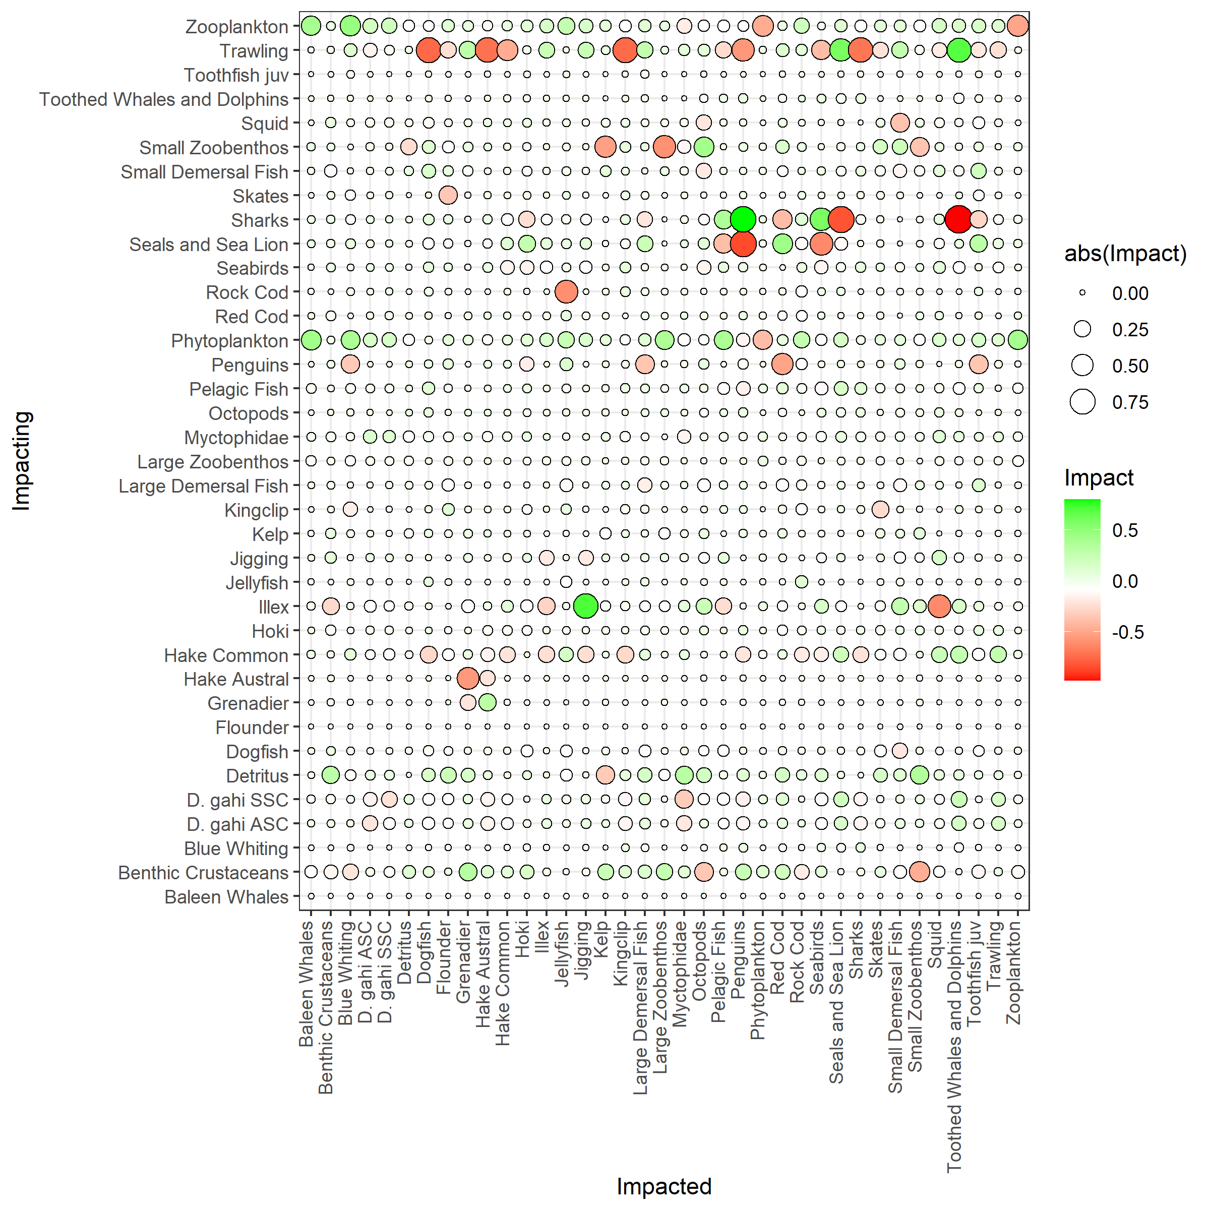Figure S2: Positive and negative impacts of all groups on each other, derived from the mixed trophic impacts routine from the Ecopath model; green = positive impacts, red = negative impacts, size = absolute impact
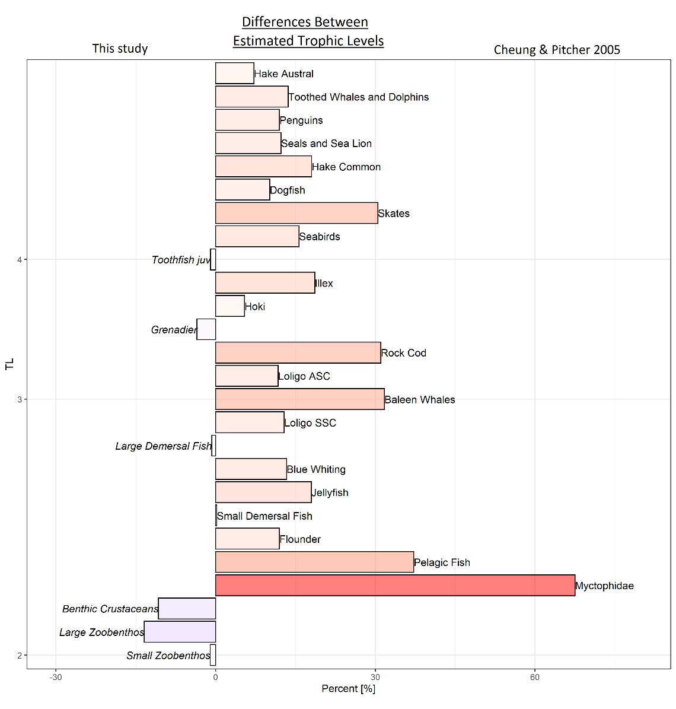
Figure S3: Difference (in%) in trophic level between the Ecopath model (this study) and the model by Cheung & Pitcher (2005). Differences are ordered according to trophic level values (bottom low, top high).

Table S1: Number of samples per month for the stable isotope groups
Month | Benthic M. gregaria | Birds | Omnivorous | Omnivorous(benthic) | POM | Piscivorous | Primary Producer | Top Predators | Zooplanktivorous | Zooplankton
1 | - | - | 108 | - | - | - | - | - | - | -
2 | 5 | 2 | 284 | 2 | 1 | 3 | 3 | 3 | 3 | 13
3 | - | 5 | 36 | 3 | - | 5 | - | - | - | -
4 | 1 | 2 | 103 | 8 | - | 7 | - | - | - | -
5 | - | - | 16 | 5 | - | 14 | - | - | - | -
6 | - | 1 | 16 | - | - | - | - | - | - | -
7 | 11 | - | 316 | 29 | - | 34 | 7 | - | 6 | -
8 | - | 2 | - | - | - | - | - | - | - | -
9 | - | 12 | 27 | 10 | - | 6 | - | - | - | 4
10 | 2 | 6 | 112 | 13 | - | 5 | 2 | - | - | -
11 | - | - | 22 | 6 | - | 5 | - | - | - | 2

Table S2: Diet Matrix (separate file)

Table S3: Initial production (P/B), consumption (Q/B) and ecotrophic efficiency (EE) values for the Ecopath model
Functional Group | P/B | Q/B | EE
Algae | 7.526 |  | 0.251
Baleen Whales | 0.840 | 10.365 | 0.308
Bathydemersal | 0.045 | 0.658
Benthic crustaceans | 2.241 | 10.944 | 0.937
Blue Whiting | 0.399 | 13.081 | 0.759
Corals | 6.168 |  | 0.895
Demersal fish | 1.170 | 4.950 | 0.303
Detritus |  |  | 0.219
Discards |  |  | 0.487
Dogfish | 0.412 | 5.818 | 0.965
Flatfish | 0.952 | 7.868 | 0.753
Flounder | 0.962 | 36.222
Grenadier | 1.055 | 2.344 | 0.990
Hake austral | 0.297 | 1.385 | 0.983
Hake common | 0.574 | 2.686 | 0.859
Hoki | 1.297 | 2.505 | 0.888
Illex | 1.161 | 4.996 | 0.747
Jellyfish | 7.360 | 25.851 | 0.520
Kingclip | 0.435 | 11.923 | 0.714
Krill | 4.219 | 21.678 | 0.735
Large bathydemersal fish | 0.525 | 3.419 | 0.682
large bathypelagic fish | 0.300 | 2.000 | 0.610
Large Demersal | 0.307 | 29.149
Large demersal fish | 0.799 | 5.233 | 0.737
Large pelagic fish | 0.500 | 2.500 | 0.950
Large zoobenthos | 1.668 | 10.922 | 0.864
Loligo | 1.172 | 4.964 | 0.904
Myctophidae | 1.227 | 9.420 | 0.642
Pelagic fish | 0.890 | 7.713 | 0.500
Penguins | 4.000 | 80.000 | 0.001
Phytoplankton | 124.041 |  | 0.429
Red Cod | 0.543 | 2.184 | 0.854
Rock Cod | 0.570 | 21.321 | 0.980
Seabirds | 1.707 | 81.816 | 0.217
Seals and sea lion | 0.317 | 16.954 | 0.284
Sharks | 0.435 | 3.866 | 0.590
Skates | 0.369 | 2.740 | 0.592
small bathydemersal fish | 1.320 | 12.000 | 0.950
Small demersal | 0.770 | 17.780 | 0.843
Small pelagic fish | 1.218 | 19.766 | 0.727
Small zoobenthos | 3.303 | 11.719 | 0.728
Squid | 3.084 | 16.368 | 0.817
Toothed whales & dolphins | 0.525 | 10.463 | 0.136
Toothfish | 0.562 | 3.489 | 0.950
Zooplankton | 25.015 | 93.617 | 0.775
Table S4: Landings and Discards used for the Ecopath model (in t per km²)
 |  | Landings |  |  | Discards
 | Group name | Trawling | Jigging | Total | Trawling | Jigging | Total
1 | Baleen Whales | - | - | - | 0 | 0 | 0
2 | Benthic Crustaceans | - | - | - | 0.0002 | - | 0.0002
3 | Blue Whiting | 0.0003 | - | 0.0003 | - | - | -
4 | Dogfish | - | - | - | 0.0004 | - | 0.0004
5 | Flounder | - | - | - | - | - | -
6 | Grenadier | 0.0006 | - | 0.0006 | 0.0003 | - | 0.0003
7 | Hake Austral | 0.0003 | - | 0.0003 | - | - | -
8 | Hake Common | 0.2172 | - | 0.2172 | 0.0004 | - | 0.0004
9 | Hoki | 0.0382 | - | 0.0382 | 0.0004 | - | 0.0004
10 | Illex | - | 0.3451 | 0.3451 | - | - | -
11 | Jellyfish | - | - | - | - | - | -
12 | Kelp | - | - | - | - | - | -
13 | Kingclip | 0.0082 | - | 0.0082 | 0.0001 | - | 0.0001
14 | Large Demersal Fish | - | - | - | 0.0003 | - | 0.0003
15 | Large Zoobenthos | - | - | - | - | - | -
16 | D. gahi ASC | 0.15 | - | 0.15 | 0.0001 | - | 0.0001
17 | D. gahi SSC | 0.1547 | - | 0.1547 | 0.0001 | - | 0.0001
18 | Myctophidae | - | - | - | - | - | -
19 | Octopods | - | - | - | - | - | -
20 | Pelagic Fish | 0.0038 | - | 0.0038 | 0.0001 | - | 0.0001
21 | Penguins | - | - | - | - | - | -
22 | Phytoplankton | - | - | - | - | - | -
23 | Red Cod | 0.0071 | - | 0.0071 | 0.0001 | - | 0.0001
24 | Rock Cod | 0.0013 | - | 0.0013 | 0.0027 | - | 0.0027
25 | Seabirds | - | - | - | - | - | -
26 | Seals and Sea Lion | - | - | - | - | - | -
27 | Sharks | - | - | - | - | - | -
28 | Skates | 0.0067 | - | 0.0067 | 0.0004 | - | 0.0004
29 | Small Demersal Fish | - | - | - | - | - | -
30 | Small Zoobenthos | 0.0001 | - | 0.0001 | - | - | -
31 | Squid | - | - | - | - | - | -
32 | Toothed Whales and Dolphins | - | - | - | - | - | -
33 | Toothfish juv | 0.0014 | - | 0.0014 | - | - | -
34 | Zooplankton | - | - | - | 0.0001 | - | 0.0001
35 | Detritus | - | - | - | - | - | -
36 | Sum | 0.5899 | 0.3451 | 0.935 | 0.0059 | - | 0.0059

Table S5: Niche overlap [%] of each functional group and contrasting group on a 95% alpha level, based on δ¹³C and δ¹⁵N values

Group | Contrast | Niche overlap prob.
Birds | Mgregaria | 13.52
Birds | Omnivorous | 65.79
Birds | Omnivorous(benthic) | 8.91
Birds | Piscivorous | 37.16
Birds | PrimaryProducer | 0.04
Birds | Zooplanktivorous | 8.28
Birds | Zooplankton | 0.54
Mgregaria | Birds | 30.27
Mgregaria | Omnivorous | 36.87
Mgregaria | Omnivorous(benthic) | 51.82
Mgregaria | Piscivorous | 22.43
Mgregaria | PrimaryProducer | 17.01
Mgregaria | Zooplanktivorous | 2.89
Mgregaria | Zooplankton | 2.43
Omnivorous | Mgregaria | 56.58
Omnivorous | Birds | 99.19
Omnivorous | Omnivorous(benthic) | 39.04
Omnivorous | Piscivorous | 52.72
Omnivorous | PrimaryProducer | 0.99
Omnivorous | Zooplanktivorous | 60.83
Omnivorous | Zooplankton | 8.8
Omnivorous(benthic) | Mgregaria | 34.59
Omnivorous(benthic) | Birds | 10.76
Omnivorous(benthic) | Omnivorous | 14.44
Omnivorous(benthic) | Piscivorous | 26.24
Omnivorous(benthic) | PrimaryProducer | 0.12
Omnivorous(benthic) | Zooplanktivorous | 0.04
Omnivorous(benthic) | Zooplankton | 0.01
Piscivorous | Mgregaria | 21.52
Piscivorous | Birds | 85.14
Piscivorous | Omnivorous | 59.02
Piscivorous | Omnivorous(benthic) | 38.58
Piscivorous | PrimaryProducer | 0.02
Piscivorous | Zooplanktivorous | 1.51
Piscivorous | Zooplankton | 0.14
Primary Producer | Mgregaria | 30.25
Primary Producer | Birds | 0.21
Primary Producer | Omnivorous | 2.72
Primary Producer | Omnivorous(benthic) | 0.65
Primary Producer | Piscivorous | 0.12
Primary Producer | Zooplanktivorous | 21.68
Primary Producer | Zooplankton | 65.16
Zooplanktivorous | Mgregaria | 3.27
Zooplanktivorous | Birds | 9.54
Zooplanktivorous | Omnivorous | 21.15
Zooplanktivorous | Omnivorous(benthic) | 0.05
Zooplanktivorous | Piscivorous | 1.16
Zooplanktivorous | PrimaryProducer | 4.78
Zooplanktivorous | Zooplankton | 41.49
Zooplankton | Mgregaria | 2.97
Zooplankton | Birds | 1.2
Zooplankton | Omnivorous | 7.02
Zooplankton | Omnivorous(benthic) | 0
Zooplankton | Piscivorous | 0.23
Zooplankton | PrimaryProducer | 15.25
Zooplankton | Zooplanktivorous | 64.09

Table S6: ANOVA Group comparisons δ¹⁵N versus sex for each species, Df = Degrees of freedom, mean sum of squares, F statistic and p-value
Species |  | Df | Sum Sq | Mean Sq | F value | p-val
Bathyraja albomaculata | Sex | 1 | 0.151 | 0.1508 | 0.166 | 0.691
 | Residuals | 12 | 10.915 | 0.9096
Bathyraja brachyurops | Sex | 1 | 0.418 | 0.4183 | 0.396 | 0.535
 | Residuals | 24 | 25.375 | 1.0573
Cottoperca gobio | Sex | 1 | 0.027 | 0.0268 | 0.026 | 0.875
 | Residuals | 16 | 16.713 | 1.0446
Dipturus lamillai | Sex | 1 | 0.806 | 0.8063 | 1.698 | 0.215
 | Residuals | 13 | 6.172 | 0.4748
Dissostichus eleginoides | Sex | 1 | 0.06 | 0.0597 | 0.039 | 0.848
 | Residuals | 8 | 12.24 | 1.5298
Doryteuthis gahi | Sex | 1 | 0.76 | 0.7624 | 0.729 | 0.394
 | Residuals | 264 | 276.23 | 1.0463
Genypterus blacodes | Sex | 1 | 0.0111 | 0.0111 | 0.033 | 0.861
 | Residuals | 7 | 2.3388 | 0.3341
Illex argentinus | Sex | 1 | 5.78 | 5.775 | 1.555 | 0.238
 | Residuals | 11 | 40.85 | 3.714
Macruronus magellanicus | Sex | 1 | 0.592 | 0.5923 | 1.056 | 0.323
 | Residuals | 13 | 7.294 | 0.561
Merluccius hubbsi | Sex | 1 | 0.778 | 0.7785 | 0.536 | 0.479
 | Residuals | 11 | 15.972 | 1.452
Moroteuthopsis ingens | Sex | 1 | 2.532 | 2.531 | 1.28 | 0.278
 | Residuals | 13 | 25.711 | 1.978
Patagonotothen ramsayi | Sex | 1 | 0.032 | 0.0318 | 0.035 | 0.854
 | Residuals | 29 | 26.613 | 0.9177
Puffinus griseus | Sex | 1 | 0.0575 | 0.05752 | 0.264 | 0.622
 | Residuals | 8 | 1.7458 | 0.21822
Salilota australis | Sex | 1 | 1.84 | 1.842 | 0.855 | 0.367
 | Residuals | 18 | 38.77 | 2.154
Schroederichthys bivius | Sex | 1 | 6.907 | 6.907 | 9.766 | 0.00653
 | Residuals | 16 | 11.316 | 0.707
Squalus acanthias | Sex | 1 | 1.79 | 1.793 | 0.453 | 0.52
 | Residuals | 8 | 31.7 | 3.963
Thalassarche melanophrys | Sex | 1 | 0.172 | 0.1719 | 0.218 | 0.649
 | Residuals | 12 | 9.444 | 0.787

Table S7: Linear model estimates for δ¹⁵N vs. log(weight) and δ¹³C vs. log(weight); Estimate, Standard error, F-statistic, t value, p value and adjusted r-square
 | δ¹³C |  |  |  |  |  | δ¹⁵N
Species | Estimate | Std. Error | F | t value | p-val | adj.r² | Estimate | Std. Error | F | t value | p-val | adj.r²
Bathyraja albomaculata | -17.172 | 0.653 | 2.898 | -26.292 | <0.001 | 0.137 | 10.476 | 0.627 | 29.951 | 16.700 | <0.001 | 0.707
 | 0.162 | 0.095 |  | 1.702 | 0.117 |  | 0.501 | 0.091 |  | 5.473 | <0.001
Bathyraja brachyurops | -17.536 | 0.479 | 2.014 | -36.623 | <0.001 | 0.046 | 10.714 | 0.673 | 20.532 | 15.910 | <0.001 | 0.482
 | 0.103 | 0.073 |  | 1.419 | 0.171 |  | 0.464 | 0.103 |  | 4.531 | <0.001
Cottoperca gobio | -18.654 | 0.563 | 0.926 | -33.111 | <0.001 | -0.004 | 11.112 | 0.489 | 36.367 | 22.739 | <0.001 | 0.651
 | 0.098 | 0.102 |  | 0.962 | 0.349 |  | 0.533 | 0.088 |  | 6.031 | <0.001
Dipturus lamillai | -17.743 | 0.847 | 0.837 | -20.950 | <0.001 | -0.012 | 13.486 | 1.985 | 0.466 | 6.793 | <0.001 | -0.040
 | 0.096 | 0.105 |  | 0.915 | 0.377 |  | 0.169 | 0.247 |  | 0.683 | 0.507
Dissostichus eleginoides | -21.157 | 1.297 | 4.264 | -16.308 | <0.001 | 0.266 | 10.261 | 1.346 | 6.279 | 7.626 | <0.001 | 0.370
 | 0.393 | 0.190 |  | 2.065 | 0.073 |  | 0.494 | 0.197 |  | 2.506 | 0.037
Doryteuthis gahi | -19.086 | 0.216 | 0.052 | -88.178 | <0.001 | -0.004 | 11.807 | 0.256 | 10.683 | 46.114 | <0.001 | 0.035
 | 0.013 | 0.058 |  | 0.227 | 0.820 |  | 0.225 | 0.069 |  | 3.268 | 0.001
Genypterus blacodes | -17.417 | 1.066 | 0.104 | -16.334 | <0.001 | -0.111 | 17.694 | 0.899 | 2.334 | 19.684 | <0.001 | 0.129
 | 0.048 | 0.147 |  | 0.322 | 0.756 |  | -0.190 | 0.124 |  | -1.528 | 0.165
Illex argentinus | -21.464 | 0.402 | 34.179 | -53.361 | <0.001 | 0.689 | 8.648 | 1.128 | 14.444 | 7.667 | <0.001 | 0.473
 | 0.478 | 0.082 |  | 5.846 | <0.001 |  | 0.871 | 0.229 |  | 3.801 | 0.002
Macruronus magellanicus | -18.203 | 0.928 | 0.153 | -19.617 | <0.001 | -0.064 | 11.836 | 1.561 | 1.395 | 7.581 | <0.001 | 0.027
 | 0.060 | 0.154 |  | 0.391 | 0.702 |  | 0.307 | 0.260 |  | 1.181 | 0.259
Merluccius hubbsi | -21.427 | 1.172 | 9.538 | -18.281 | <0.001 | 0.437 | 10.676 | 1.481 | 11.381 | 7.207 | <0.001 | 0.486
 | 0.538 | 0.174 |  | 3.088 | 0.011 |  | 0.743 | 0.220 |  | 3.374 | 0.007
Moroteuthopsis ingens | -19.495 | 0.866 | 0.454 | -22.500 | <0.001 | -0.035 | 9.850 | 1.497 | 1.393 | 6.580 | <0.001 | 0.024
 | -0.090 | 0.134 |  | -0.674 | 0.511 |  | 0.273 | 0.231 |  | 1.180 | 0.256
Patagonotothen ramsayi | -20.517 | 0.280 | 52.891 | -73.333 | <0.001 | 0.604 | 10.875 | 0.350 | 20.333 | 31.071 | <0.001 | 0.362
 | 0.455 | 0.063 |  | 7.273 | <0.001 |  | 0.353 | 0.078 |  | 4.509 | <0.001
Puffinus griseus | -10.860 | 16.566 | 0.253 | -0.656 | 0.531 | -0.090 | 44.528 | 27.566 | 1.327 | 1.615 | 0.145 | 0.035
 | -1.213 | 2.410 |  | -0.503 | 0.628 |  | -4.620 | 4.011 |  | -1.152 | 0.283
Salilota australis | -19.707 | 0.230 | 67.651 | -85.623 | <0.001 | 0.769 | 11.239 | 0.605 | 38.276 | 18.572 | <0.001 | 0.651
 | 0.314 | 0.038 |  | 8.225 | <0.001 |  | 0.622 | 0.101 |  | 6.187 | <0.001
Schroederichthys bivius | -17.211 | 0.453 | 2.760 | -38.025 | <0.001 | 0.094 | 11.950 | 0.721 | 9.784 | 16.575 | <0.001 | 0.341
 | 0.129 | 0.078 |  | 1.661 | 0.116 |  | 0.387 | 0.124 |  | 3.128 | 0.006
Squalus acanthias | -16.036 | 5.072 | 0.215 | -3.162 | 0.016 | -0.109 | 15.767 | 4.986 | 0.109 | 3.163 | 0.016 | -0.125
 | -0.325 | 0.701 |  | -0.464 | 0.657 |  | -0.228 | 0.689 |  | -0.330 | 0.751
Thalassarche melanophrys | 2.662 | 13.291 | 2.609 | 0.200 | 0.845 | 0.110 | 15.276 | 19.470 | 0.007 | 0.785 | 0.448 | -0.083
 | -2.543 | 1.574 |  | -1.615 | 0.132 |  | -0.199 | 2.306 |  | -0.086 | 0.933

