Impacts of regime shift on the fishery ecosystem in the coastal area of Kyoto Prefecture, Sea of Japan, assessed using the Ecopath model

Journal name: Fisheries Science
Author names: Hiroshi Inoue ^{a*}, Shingo Watari ^{b}, Hideki Sawada ^{c}, Edouard Lavergne ^{d}, and Yoh Yamashita ^{e}
Affiliation:
ª Graduate School of Agriculture, Kyoto University, Kitashirakawa-oiwakecho, Sakyo-ku, Kyoto, 606–8502, Japan
^{b} Fisheries Resources Institute, Japan Fisheries Research and Education Agency, Fukuura, Kanazawa-ku, Yokohama, Kanagawa, 236-8648, Japan
^{c} Maizuru Fisheries Research Station, Field Science Education and Research Center, Kyoto University, Nagahama, Maizuru, Kyoto 625-0086, Japan
^{d} Plastic@Sea, Observatoire Océanologique de Banyuls-sur-Mer, 1 Avenue Pierre Fabre, 66650 Banyuls-sur-Mer
^{e} Field Science Education and Research Center, Kyoto University, Kitashirakawa-oiwakecho, Sakyo-ku, Kyoto, 606-8502, Japan
* Corresponding author: inouehiroshi0831@gmail.com

ONLINE RESOURCE OUTLINE
Online Resource 1. Benthos sampling for functional groups.
Online Resource 2. Annual catch data by fishing methods in Kyoto Prefecture from 1956 to 2015
Online Resource 3. Details of functional groups.
Online Resource 4. Catch and fishing gear for each functional group in both 1985 model and 2013 model for CAK.
Online Resource 5. Definitions and results of Q/B ratios for CAK.
Online Resource 6. Input data sources for each functional group in both 1985 model and 2013 model for CAK
Online Resource 7. Reference list of diet composition for functional groups.
Online Resource 8. Data quality ratings (“pedigree”) for CAK models parameters.
Online Resource 9. Results of pre-balance diagnostics (PREBAL) in both 1985 model and 2013 model for CAK based on: Link (2010).

Online Resource 1.
Benthos species from sampling
Sampling of the benthic community was conducted in 2013 and 2014 at Tango Bay as a representative of the CAK (Table S1-1) and as part of the Japan Long Term Ecological Research Network (JaLTER) cruise onboard the R.V. Ryokuyo-maru (Kyoto University, 8 t). Organisms were collected at depths of 5, 10, 30, 60, 100, 150, and 200 m using a NRIFE II type beam trawl net (height: 20 cm, width: 2 m, mesh size: 5 mm; Kimoto et al. 2001). The research vessel was supposed to trawl three times at each location, with each passage lasting for five minutes at a speed of two knots. However, for some sites, it was not possible to sample three times due to sea conditions (Table S1-1). The towing distance was calculated based on the recorded latitude and longitude positions using a global positioning system (GPS) plotter (HE-61GPII; Honda Electronics Co., Ltd., Aichi, Japan). The towing distance was then used to calculate the sampled surface area (i.e., SSA (km²) = towing distance × beam trawl net width). The organisms were transported to the laboratory on ice and identified for the species level, weighed, and fixed with 70% ethanol. The bottom water temperature and salinity were measured using a conductivity, temperature, and depth profiler (Compact-CTD ASTD687; JFE Advantech Co., Ltd., Nishinomiya, Japan) immediately after net towing.

Benthos species selection for Ecopath
Nine functional groups were selected for the benthic community (Table S1-2). Species selection was mainly based on species dominance in the CAK (i.e., high biomass in benthic sampling). Species were also selected if there were known prey for fishery-targeted fish species in the CAK. Species smaller than 5 mm were not selected in the present study because the net mesh size was 5 mm. Although jellyfish species (e.g., Aurelia coerulea and Nemopilema nomurai) were collected in the CAK, they were not selected in this study because the net substantially affected their structural integrity and no exploitable data on these species in the CAK were available in the literature. The data on the benthic community can help characterize the spatio-temporal variability of coastal biological productivity across depths and seasons (Yokoyama and Hayashi 1980b) and for building an ecosystem-based model.

Biomass estimation
For the benthic community, the CAK was divided into seven depth bins (i.e., 0–5, 5–10, 10–30, 30–60, 60–100, 100–150, and 150–240 m). The annual biomass of each benthic functional group (B in t/km² /year) was estimated as follows:
$B= \sum{\frac{W_{x}×A_{x}}{SSA×CAK×C_{eff}}}$
where W_{x} is the average benthic functional group wet weight in tons collected at depth bin x over the seven temporal samplings, SSA is the sampling surface area (in km², including replicates), A_{x} is the area (in km²) of the bin at depth x, the CAK is the area (in km²) of the whole model, and C_{eff} is the catch efficiency of the beam trawl net for the relevant functional groups (Table S1-2). The catch efficiency of this beam trawl net for tongue soles, dragonets, gobies, and shrimps was assumed to be 30%; that for starfish, brittle stars, polychaetes, hermit crabs, and mysids was assumed to be 100% (Yamamoto and Makino 2002; Yoshida et al. 2005).
Table S1-1 Location of sample collection and the number of sampling replicates
Sampling depth (m) | Latitude(N) | Longitude(E) | Date
 |  |  | 2013 |  |  |  | 2014
 |  |  | Jun. 28 | Aug. 12 | Oct. 30 | Nov. 29 | Mar. 24 | Jun. 10 | Sep. 11
5 | 35.521 | 135.288 | 3 | 3 | 2 | 1 | 2 | 2 | 2
10 | 35.524 | 135.290 | 2 | 2 | 2 | 2 | 2 | 2 | 2
30 | 35.544 | 135.297 | 2 | 1 | 2 | 1 | 2 | 2 | 2
60 | 35.611 | 135.324 | - | - | - | - | 2 | 2 | 2
100 | 35.740 | 135.379 | - | - | - | - | 2 | 2 | 2
150 | 35.827 | 135.413 | - | - | - | - | 2 | 2 | -
200 | 35.899 | 135.427 | - | - | - | - | 2 | 2 | -

Table S1-2 Mean wet weight (t/km² /year) of functional group from benthic sampling and literature. C_{eff} is the catch efficiency of the beam trawl net for the functional groups
 | 5 m | 10 m | 30 m | 60 m | 100 m | 150 m | 200 m | C_{eff} (%)
Tongue soles | 0.0236 | 0.0236 | 0.0157 | 0 | 0 | 0 | 0 | 30
Dragonets | 0.0077 | 0.0055 | 0.0192 | 0 | 0 | 0 | 0 | 30
Gobbies | 0 | 0.0001 | 0.0334 | 0.0021 | 0.0006 | 0 | 0 | 30
Shrimps | 0.0287 | 0.0337 | 0.0888 | 0.0105 | 0.0091 | 0.0244 | 0.1721 | 30
Starfishes | 0.0477 | 0.1188 | 0.004 | 0.0172 | 0.0236 | 0.0143 | 0.3599 | 100
Brittle stars | 0 | 0 | 0.0002 | 0.0006 | 0.0006 | 3.6492 | 81.1458 | 100
Polychaetes | 5 | 5 | 5 | 5 | 13.5 | 10.7 | 8.9 | 100
Hermit crabs | 0.0448 | 0.0495 | 0.0217 | 0 | 0 | 0.0002 | 0.1026 | 100
Mysids | 0.1359 | 0.1383 | 0 | 0 | 0 | 0 | 0 | 100
area size (km²) | 60 | 60 | 100 | 300 | 300 | 250 | 153

Online Resource 2.
Fig. S2 Annual catch data by fishing methods in Kyoto Prefecture from 1956 to 2015 (SDBSWeb: https://www.maff.go.jp/j/tokei/kouhyou/kaimen_gyosei/ “Accessed 17 June 2022”).

Online Resource 3.
Table S3 Functional group and representative species
# | Functional group | Representative taxa
1 | Sardine | Sardinops melanostictus
2 | Round herring | Etrumeus micropus
3 | Anchovy | Engraulis japonicus
4 | Mackerel | Scomber japonicus, Scomber austlasicus
5 | Jack mackerel | Trachurus japonicus
6 | Amberjack | Seriola quinqueradiata
7 | Frigate tuna | Auxis rochei, Auxis thazard
8 | Tuna | Thunnus thynnus
9 | Sailfish | Istiophorus platypterus, Makaira mazara
10 | Spanish mackerel | Scomberomorus niphonius
11 | Stingray | Dasyatis akajei, Rhinobatos schlegelii, Raja kenojei
12 | Flounder | Paralichthys olivaceus
13 | Black porgy | Acanthopagrus schlegelii
14 | Red seabream | Pagrus major, Evynnis tumifrons, Dentex hypselosomus
15 | Tilefish | Branchiostegus japonicus, Branchiostegus albus, Branchiostegus auratus
16 | Seabass | Lateolabrax japonicus
17 | Flying fish | Cypselurus doederleini, Cypselurus hiraii
18 | Rockfish | Sebastes inermis, Sebastes ventricosus, Sebastes cheni
19 | Barracuda | Sphyraena japonica, Sphyraena pinguis
20 | Flying squid | Todarodes pacificus
21 | Other squids | Thysanoteuthis rhombus, Sepioteuthis lessoniana, Uroteuthis edulis
22 | Octopus | Octopus vulgaris
23 | Ivory shell | Babylonia japonica
24 | Sea cucumber | Apostichopus armata, Apostichopus japonicus
25 | Other conch | Buccinum striatissimum, Buccinum tsubai
26 | Crab | Portunus trituberculatus, Portunus pelagicus
27 | Prawn | Metapenaeus ensis
28 | Bivalve | Crassostrea gigas, Crossostrea nippona
29 | Sole | Paraplagusia japonica, Heteromycteris japonica, Cynoglossus interruptus
30 | Dragonet | Repomucenus valenciennei, Repomucenus richardsonii
31 | Goby | Amblychaeturichthys sciistius, Acentrogobius pflaumii, Acentrogobius virgatulus
32 | Shrimp | Crangon affinis, Metapenaeopsis barbata, Trachysalambria curvirostris, Parapenaeopsis tenella, Metapenaeopsis acclivis
33 | Starfish | Astropecten latespinosus, Astropecten scoparius, Ctenodiscus crispatus, Luidia quinaria, Asterias amurensis
34 | Brittle star | Ophiura sarsii
35 | Polychaeta | 29 species from Yokoyama and Hayashi (1980a)
36 | Hermit crab | Pagurus filholi, Pagurus rubrior,
37 | Mysid | Orientomysis japonica, Neomysis Awatschensis
38 | Zooplankton
39 | Phytoplankton
40 | Detritus

Online Resource 4.
Table S4 Catch (t/km²/year) and fishing gear for each functional group in 1985 and 2013
 |  |  |  | 1985
 | Group name | set net | purse seining | trawl net | gill net | dredge net | angling | others | Total
1 | Sardine | 7.718 | 8.046 | 0.00002 | 0.0001 |  | 0.0001 | 0.000002 | 15.764
2 | Round herring | 0.096 | 0.019 |  | 0.00001 |  | 0.00001 |  | 0.115
3 | Anchovy | 1.963 |  |  |  |  |  | 0.00001 | 1.963
4 | Mackerel | 0.148 | 1.069 | 0.00003 | 0.0002 |  | 0.0002 | 0.00001 | 1.217
5 | Jack mackerel | 0.343 | 0.094 | 0.003 | 0.001 |  | 0.001 | 0.000004 | 0.440
6 | Yellowtail | 0.163 | 0.078 | 0.000 | 0.022 |  | 0.022 | 0.00001 | 0.286
7 | Frigate tuna | 0.169 | 0.0001 | 0.000002 | 0.0001 |  | 0.0001 | 0.000001 | 0.169
8 | Tuna | 0.065 |  |  | 0.000001 |  | 0.000001 |  | 0.065
9 | Sailfish | 0.013 |  |  |  |  |  |  | 0.013
10 | Spanish mackerel | 0.026 |  |  | 0.006 |  | 0.006 |  | 0.038
11 | Stingray | 0.003 |  | 0.001 | 0.0002 |  | 0.0002 |  | 0.004
12 | Flounder | 0.010 | 0.000003 | 0.0001 | 0.008 |  | 0.008 | 0.00004 | 0.026
13 | Black porgy | 0.003 | 0.00001 | 0.001 | 0.0002 |  | 0.0002 | 0.00001 | 0.004
14 | Red seabream | 0.010 | 0.00003 | 0.005 | 0.001 |  | 0.001 | 0.00005 | 0.017
15 | Tilefish | 0.0001 |  | 0.0003 | 0.0004 |  | 0.0004 | 0.00001 | 0.001
16 | Seabass | 0.004 |  | 0.00001 | 0.002 |  | 0.002 | 0.00003 | 0.007
17 | Flying fish | 0.485 | 0.00002 |  | 0.004 |  | 0.004 | 0.002 | 0.495
18 | Rockfish | 0.002 | 0.000001 | 0.007 | 0.006 | 0.000001 | 0.006 | 0.002 | 0.022
19 | Barracuda | 0.346 | 0.0002 | 0.001 | 0.006 |  | 0.006 | 0.000001 | 0.358
20 | Flying squid | 0.012 | 0.001 | 0.001 | 0.0001 |  | 0.0001 |  | 0.014
21 | Other squids | 0.196 | 0.0001 | 0.023 | 0.004 | 0.000001 | 0.004 | 0.0001 | 0.228
22 | Octopus | 0.004 |  | 0.018 | 0.002 | 0.0002 | 0.002 | 0.012 | 0.039
23 | Ivory shell
24 | Sea cucumber |  |  |  | 0.0003 | 0.041 | 0.041 | 0.004 | 0.087
25 | Other conch | 0.00003 |  |  | 0.005 |  | 0.005 | 0.004 | 0.014
26 | Crab | 0.0002 |  | 0.038 | 0.005 | 0.00002 | 0.005 | 0.0001 | 0.049
27 | Prawn | 0.001 |  | 0.009 | 0.003 | 0.000002 | 0.003 | 0.00003 | 0.016
28 | Bivalve |  |  |  |  | 0.006 | 0.006 |  | 0.011
 | Sum | 11.778 | 9.307 | 0.107 | 0.076 | 0.047 | 0.123 | 0.024 | 21.461

2013
 | Group name | set net | trawl net | gill net | dredge net | angling | other | Total
1 | Sardine | 0.280 |  |  |  |  | 0.006 | 0.286
2 | Round herring | 0.002 |  |  |  |  |  | 0.002
3 | Anchovy | 1.015 |  |  |  |  | 0.001 | 1.016
4 | Mackerel | 0.054 |  | 0.0003 |  | 0.0001 |  | 0.055
5 | Jack mackerel | 0.316 | 0.00001 | 0.001 |  | 0.002 | 0.0001 | 0.320
6 | Yellowtail | 0.477 |  | 0.048 |  | 0.021 |  | 0.546
7 | Frigate tuna | 0.043 |  |  |  | 0.000 |  | 0.043
8 | Tuna | 0.022 |  |  |  | 0.000 |  | 0.022
9 | Sailfish | 0.008 |  |  |  |  |  | 0.008
10 | Spanish mackerel | 0.750 |  | 0.002 |  | 0.015 |  | 0.767
11 | Stingray | 0.000003 |  | 0.000002 |  |  |  | 0.000
12 | Flounder | 0.012 | 0.001 | 0.002 |  | 0.0002 | 0.0002 | 0.015
13 | Black porgy | 0.007 | 0.002 | 0.000 |  | 0.002 |  | 0.011
14 | Red seabream | 0.016 | 0.005 | 0.001 |  | 0.010 | 0.001 | 0.032
15 | Tilefish | 0.00002 | 0.0001 | 0.001 |  | 0.009 | 0.0004 | 0.011
16 | Seabass | 0.049 | 0.001 | 0.002 |  | 0.001 | 0.0002 | 0.054
17 | Flying fish | 0.097 |  | 0.0004 |  |  | 0.001 | 0.098
18 | Rockfish | 0.004 | 0.001 | 0.006 |  | 0.007 | 0.002 | 0.019
19 | Barracuda | 0.191 | 0.0001 | 0.0001 |  | 0.001 | 0.00001 | 0.192
20 | Flying squid | 0.021 | 0.001 | 0.000002 |  | 0.003 | 0.040 | 0.064
21 | Other squids | 0.163 | 0.002 | 0.005 |  | 0.048 | 0.001 | 0.220
22 | Octopus | 0.005 | 0.005 |  | 0.0001 |  | 0.023 | 0.033
23 | Ivory shell |  |  |  | 0.00001 |  |  | 0.000
24 | Sea cucumber |  |  | 0.002 | 0.037 |  | 0.011 | 0.050
25 | Other conch |  |  | 0.023 |  |  | 0.002 | 0.025
26 | Crab | 0.00003 |  | 0.002 | 0.00001 |  | 0.00003 | 0.002
27 | Prawn | 0.001 | 0.003 | 0.0001 |  |  | 0.0001 | 0.004
28 | Bivalve |  |  |  |  |  | 0.104 | 0.104
 | Sum | 3.533 | 0.021 | 0.096 | 0.037 | 0.119 | 0.193 | 3.999

Online Resource 5.
P/B is defined to be similar to total mortality (Z) (Allen 1971). In addition, Z is defined to be the same as fishing mortality (F) and natural mortality (M) (Pauly 1980). F was calculated from the catch and biomass (F = Catch / B). Q/B ratios and M were calculated using the life history tool of FishBase (https://www.fishbase.de, “Accessed 3 April 2021”) (Palomares and Pauly 1989; Pauly 1989; Palomares 1991). For invertebrates, M and Q were calculated from the SeaLifeBase (http://www.sealifebase.org, “Accessed 3 April 2021”). The Q/B ratios for fish functional groups were estimated using the empirical ratios of Palomares and Pauly (1998):
$\log\left(\frac{Q}{B}\right)=7.0764-0.204×\log\left(W_{∞}\right)-1.965×T^{'}+0.083×A+0.532×h+0.398×d$
where T’ is the mean annual habitat temperature for the population expressed as T’ = 1000/TK (TK = T°C + 273.15); A is the aspect ratio of the fish tail, a proxy of the swimming and metabolic activity of the fish expressed as A = h_{CF}²/s, where h_{CF} is the height of the caudal fin, and s is the surface area of the caudal fin. The parameters h and d are defined by the type of food consumed by a fish functional group: for detritivores, h = 0 and d = 1; for herbivores and omnivores, h = 1 and d = 0; and for carnivores, h = 0 and d = 0 (Table S3).
Table S5 Several values for each functional group for calculating Q/B. Winf (g) is the asymptotic weight and A indicates the aspect ratio of the caudal fin. The types of food consumed was categorized, i.e., h for herbivores (H) (h = 1 and d = 0); d for detritivores (D) (h = 0 and d = 1); and carnivores (C) are identified by default (h = 0 and d = 0) (Palomares 1991)
 | Group name | Winf(g) | temperature(℃) | A | food type | h | d | Q/B
1 | Sardine | 343 | 12 | 2.5 | C | 0 | 0 | 5.80
2 | Round herring | 245 | 20 | 4 | C | 0 | 0 | 12.75
3 | Anchovy | 45 | 15 | 3 | C | 0 | 0 | 11.39
4 | Mackerel | 990 | 17 | 2.5 | C | 0 | 0 | 6.14
5 | Jack mackerel | 2480 | 20 | 2.5 | C | 0 | 0 | 5.97
6 | Yellowtail | 40000 | 15 | 5.8 | C | 0 | 0 | 4.87
7 | Frigate tuna | 20000 | 15 | 5.8 | C | 0 | 0 | 5.61
8 | Tuna | 348000 | 20 | 9.8 | C | 0 | 0 | 8.79
9 | Sailfish | 425000 | 20 | 9.8 | C | 0 | 0 | 8.44
10 | Spanish mackerel | 12000 | 15 | 5.8 | C | 0 | 0 | 6.22
11 | Stingray | 26000 | 15 | 0.7 | D | 0 | 1 | 5.01
12 | Flounder | 14500 | 15 | 0.7 | C | 0 | 0 | 2.26
13 | Black porgy | 1580 | 15 | 0.7 | C | 0 | 0 | 3.55
14 | Red seabream | 11300 | 15 | 0.7 | C | 0 | 0 | 2.38
15 | Tilefish | 2250 | 18 | 0.7 | C | 0 | 0 | 3.88
16 | Seabass | 2878 | 15 | 2.5 | C | 0 | 0 | 4.43
17 | Flying fish | 500 | 15 | 0.7 | C | 0 | 0 | 4.49
18 | Rockfish | 1120 | 15 | 0.7 | C | 0 | 0 | 3.81
19 | Barracuda | 500 | 15 | 0.7 | C | 0 | 0 | 4.49
29 | Dragonet | 120 | 15 | 0.6 | D | 0 | 1 | 14.73
30 | Tongue sole | 150 | 15 | 0.6 | D | 0 | 1 | 14.08
31 | Goby | 10 | 15 | 0.6 | D | 0 | 1 | 24.46

Online Resource 6.
Table S6-1 Biomass data sources for each functional group in the 1985 and the 2013 models for the CAK.
Yi catch (t / km² /year), Bi biomass (t / km²).
Table S6-2 Data sources for other parameters of each functional group in both the 1985 and the 2013 models for the CAK. The numbers indicate the reference used. 1: FishBase (https://www.fishbase.de); Yamada et al. (2007). 2: SeaLifeBase (https://www.sealifebase.ca/); Brey (2001). 3: Watari (2015). 4: Allen (1971); Pauly (1980). 5: Vignot (2007). Empty cells indicate that values were calculated by Ecopath.
 | Group name | P/B | Q/B | EE | P/Q
1 | Sardine | 3 | 1
2 | Round herring | 3 | 1
3 | Anchovy | 3 | 1
4 | Mackerel | 3 | 1
5 | Jack mackerel | 3 | 1
6 | Yellowtail | 3 | 1
7 | Frigate tuna | 3 | 1
8 | Tuna | 3 | 1
9 | Sailfish | 3 | 1
10 | Spanish mackerel | 3 | 1
11 | Stingray | 3 | 1
12 | Flounder | 3 | 1
13 | Black porgy | 3 | 1
14 | Red seabream | 3 | 1
15 | Tilefish | 3 | 1
16 | Seabass | 3 | 1
17 | Flying fish | 3 | 1
18 | Rockfish | 3 | 1
19 | Barracuda | 3 | 1
20 | Flying Squid | 3 | 2
21 | Cuttlefish | 3 | 2
22 | Octopus | 3 | 2
23 | Ivory shell | 3 | 2
24 | Sea cucumber | 3 | 2
25 | Other conch | 3 | 2
26 | Crab | 2 |  |  | 3
27 | Prawn | 2 |  |  | 3
28 | Bivalve | 2 |  |  | 3
29 | Dragonet | 3 | 1
30 | Tongue sole | 3 | 1
31 | Goby | 3 | 1
32 | Shrimp | 2 |  |  | 3
33 | Starfish | 2 |  |  | 3
34 | Brittle star | 2 |  |  | 3
35 | Polychaeta | 2 |  |  | 3
36 | Hermit crab | 2 |  |  | 3
37 | Mysid | 2 |  |  | 3
38 | Zooplankton | 3 |  |  | 3
39 | Phytoplankton | 3 |  | 5
40 | Detritus
P/B production/biomass (/year), Q/B consumption/biomass (/year), EE ecotrophic efficiency, P/Q production/consumption.
Online Resource 7.
Table S7 References of diet composition for functional groups
 | Functional group | Reference
1 | Sardine | Baba et al. (2018)
2 | Round herring | Baba et al. (2018)
3 | Anchovy | Baba et al. (2018)
4 | Mackerel | Takahashi (1966); Moriwaki and Miyabe (2012)
5 | Jack mackerel | Kawano (2007)
6 | Yellowtail | Mitani (1958)
7 | Frigate tuna | Iizuka et al. (1989)
8 | Tuna | Shimose et al. (2013)
9 | Sailfish | Shimose et al. (2006)
10 | Spanish mackerel | Kawano (2017)
11 | Stingray | Taniuchi and Shimizu (1993)
12 | Flounder | Takeno (2010)
13 | Black porgy | Yamada et al. (2007)
14 | Red seabream | Yamada et al. (2007)
15 | Tilefish | Kiyono and Hayashi (1977)
16 | Seabass | Hayashi and Kiyono (1978); Fuji et al. (2010)
17 | Flying fish | Kawano (1988); Kawano (2004)
18 | Rockfish | Akeda et al. (2012)
19 | Barracuda | Yamada et al. (2007)
20 | Flying squid | Okiyama (1965)
21 | Other squids | Moriwaki (1994); Nigmatullin and Arkhipkin (1998); Tega et al. (2016)
22 | Octopus | Vaz-Pires et al. (2004)
23 | Ivory shell | Kajikawa (1976)
24 | Sea cucumber | Kitano et al. (2003)
25 | Other conch | Shiomi et al. (1984)
26 | Crab | Matsui et al. (1986)
27 | Prawn | Ariyama (1997)
28 | Bivalve | Hayakawa, Y et al. (2012)
29 | Tongue sole | Yamada et al. (2007)
30 | Dragonet | Kakuda et al. (1979)
31 | Goby | Matsui et al. (2014)
32 | Shrimp | Oh et al. (2001)
33 | Starfish | Kurihara (1996)
34 | Brittle star | Fujita (2018)
35 | Polychaeta | Fauchald and Jumars (1979); Yokoyama and Hayashi (1980); Hayashi (1983a); Hayashi (1983b)
36 | Hermit crab | Ramsay et al. (1996)
37 | Mysid | Antonio et al. (2010)

Online Resource 8
Table S8-1 Data quality ratings (“pedigree”) for CAK models parameters in both 1985 and 2013. Ratings scale from 1 (highest data quality) to 8 (lowest data quality). See table S8-2 for a detailed explanation of the ratings (source: Aydin et al. 2007, Table C-27)
 | Functional group | B | P/B | Q/B | DC | Y
1 | Sardine | 3 | 7 | 6 | 6 | 2
2 | Round herring | 3 | 7 | 6 | 6 | 2
3 | Anchovy | 3 | 7 | 6 | 6 | 2
4 | Mackerel | 3 | 7 | 6 | 6 | 2
5 | Jack mackerel | 3 | 7 | 6 | 6 | 2
6 | Yellowtail | 3 | 7 | 6 | 6 | 2
7 | Frigate tuna | 3 | 7 | 6 | 6 | 2
8 | Tuna | 3 | 7 | 6 | 6 | 2
9 | Sailfish | 3 | 7 | 6 | 6 | 2
10 | Spanish mackerel | 3 | 7 | 6 | 6 | 2
11 | Stingray | 3 | 7 | 6 | 6 | 2
12 | Flounder | 3 | 7 | 6 | 6 | 2
13 | Black porgy | 3 | 7 | 6 | 6 | 2
14 | Red seabream | 3 | 7 | 6 | 6 | 2
15 | Tilefish | 3 | 7 | 6 | 6 | 2
16 | Seabass | 3 | 7 | 6 | 6 | 2
17 | Flying fish | 3 | 7 | 6 | 6 | 2
18 | Rockfish | 3 | 7 | 6 | 6 | 2
19 | Barracuda | 3 | 7 | 6 | 6 | 2
20 | Flying squid | 3 | 7 | 7 | 6 | 2
21 | Other squids | 3 | 7 | 7 | 6 | 2
22 | Octopus | 3 | 7 | 7 | 6 | 2
23 | Ivory shell | 3 | 7 | 8 | 6 | 2
24 | Sea cucumber | 3 | 7 | 8 | 6 | 2
25 | Other conch | 3 | 7 | 8 | 6 | 2
26 | Crab | 3 | 7 | 8 | 6
27 | Prawn | 3 | 7 | 8 | 6
28 | Bivalve | 3 | 7 | 8 | 6
29 | Dragonet | 2 | 7 | 6 | 6
30 | Tongue sole | 2 | 7 | 6 | 6
31 | Goby | 2 | 7 | 6 | 6
32 | Shrimp | 2 | 7 | 8 | 6
33 | Starfish | 2 | 7 | 8 | 6
34 | Brittle star | 2 | 7 | 8 | 6
35 | Polychaeta | 2 | 7 | 8 | 6
36 | Hermit crab | 2 | 7 | 8 | 6
37 | Mysid | 2 | 7 | 8 | 6
38 | Zooplankton | 2 | 7 | 8 | 6
39 | Phytoplankton | 8 | 7
40 | Detritus | 2

Table S8-2 Detailed explanation of the ratings for pedigrees in table S8-1 (source: Aydin et al. 2007, Table 6)
 | Parameter
1 | Data is established and substantial, includes more than one independent method (from which best method is selected) with resolution on multiple spatial scales
2 | Data is direct estimate but with limited coverage/corroboration, or established regional estimate is available while subregional resolution is poor
3 | Data is proxy, proxy may have known but consistent bias
4 | Direct estimate or proxy with high variation/limited confidence or incomplete coverage
 | Biomass and catch
 | Parameter
5 | Estimate requires inclusion of highly uncertain scaling factors or extrapolation
6 | Historical and/or single study only, not overlapping in area or time
7 | Requires selection between multiple incomplete sources with wide range
8 | No estimate available (estimated by Ecopath)
 | P/B, Q/B, and diet composition
 | Parameter
5 | Estimation based on same species but in “historical” time period, or a general model specific to the area
6 | For P/B or Q/B, general life-history proxies; For diets, same species in neighboring region, or similar species in same region
7 | General literature review from wide range of species, or outside of region
8 | Functional group represents multiple species with diverse life history traits

Online Resource 9.
Results of pre-balance diagnostics (PREBAL) in both 1985 model and 2013 model for CAK based on: Link (2010)
Table S9-1 Summary of the pre-balance diagnostics (PREBAL) in both 1985 model and 2013 model for CAK (source: Link 2010, Table 1-5)

Table S9-2 Biomass ratios corresponding to diagnostic criteria 4–6 in Table S9-1. TL: trophic level. Top predators include sailfish, Spanish mackerel, and tuna. Small pelagic fishes include anchovy, round herring, and sardine. Demersal fishes include dragonet, flounder, goby, rockfish, stingray, and tongue sole. Benthos include bivalve, brittle star, crab, hermit crab, ivory shell, mysid, octopus, other conch, other squid, polychaeta, prawn, sea cucumber, shrimp, and star fish. The same categories were used for table S9-3

1985
Predator / Prey | Biomass ratio
Top predators / Small pelagic fishes | 0.002
Top predators / Zooplankton | 0.016
Small pelagic fishes / Zooplankton | 7.968
Zooplankton / Phytoplankton | 0.231
Small pelagic fishes / Phytoplankton | 1.844
Demersal fishes / Benthos | 0.004
Small pelagic fishes / all fishes | 0.923
Demersal fishes / all fishes | 0.001
Top predators / all fishes | 0.002
Top predators / Demersal fishes | 1.667
Benthos / Zooplankton | 2.755
TL4 / <TL3 | 0.002

2013
Predator / Prey | Biomass ratio
Top predators / Small pelagic fishes | 0.744
Top predators / Zooplankton | 0.359
Small pelagic fishes / Zooplankton | 0.483
Zooplankton / Phytoplankton | 0.207
Small pelagic fishes / Phytoplankton | 0.100
Demersal fishes / Benthos | 0.006
Small pelagic fishes / all fishes | 0.328
Demersal fishes / all fishes | 0.015
Top predators / all fishes | 0.244
Top predators / Demersal fishes | 16.629
Benthos / Zooplankton | 3.887
TL4 / <TL3 | 0.038

Table S9-3 Vital rate ratios corresponding to diagnostic criteria 9 and 10 in Table S9-1

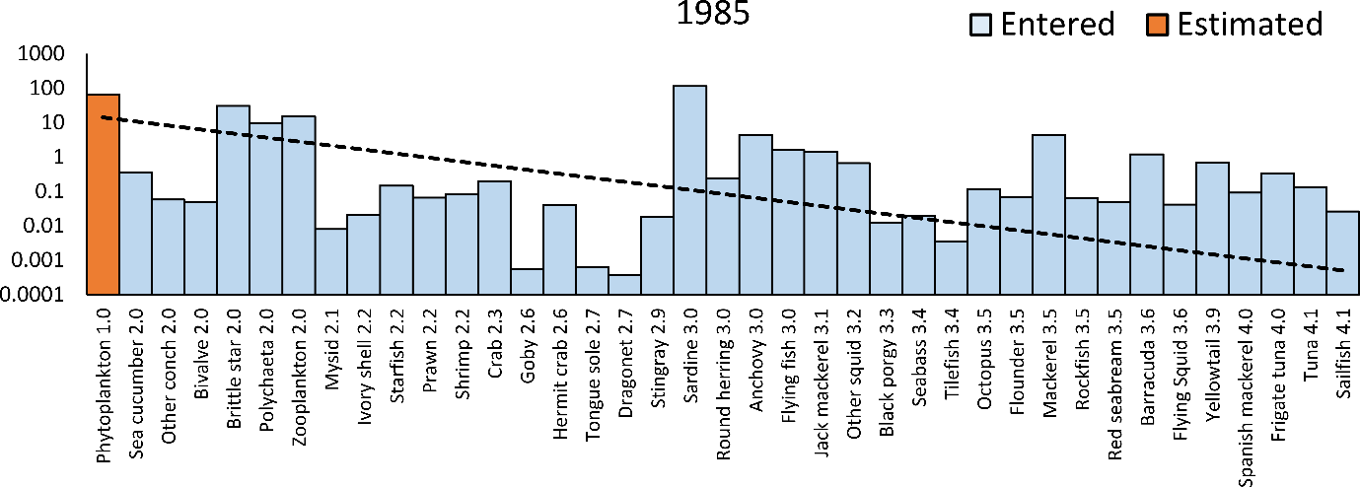
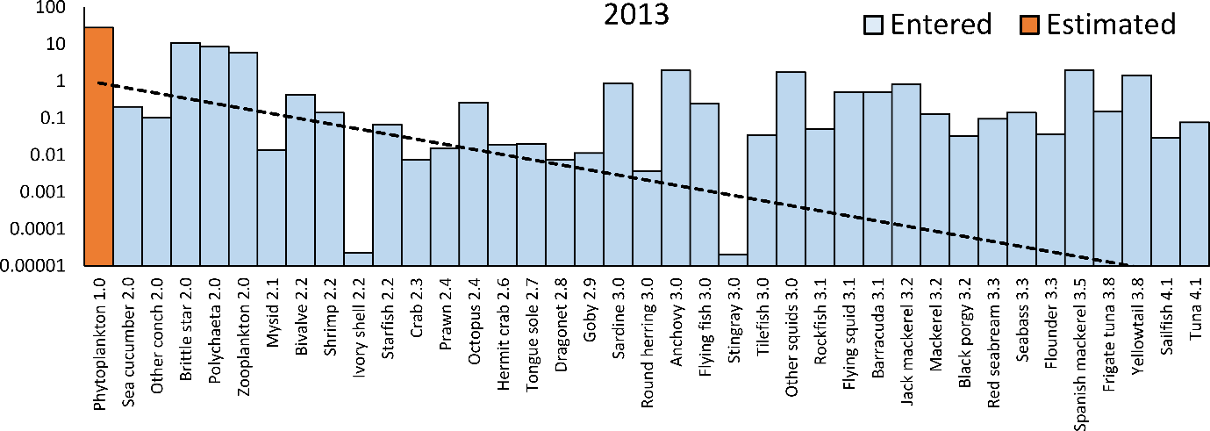
Fig. S9-1 Pre-balance diagnostics (PREBAL) in the 1985 and 2013 models for the CAK based on Link (2010). Trophic decomposition (trend line) showing the level of decline in biomass (B) with increasing trophic level (log scale). The trophic levels increase from left to right. This figure corresponds to diagnostic criteria 1–3 in Table S9-1
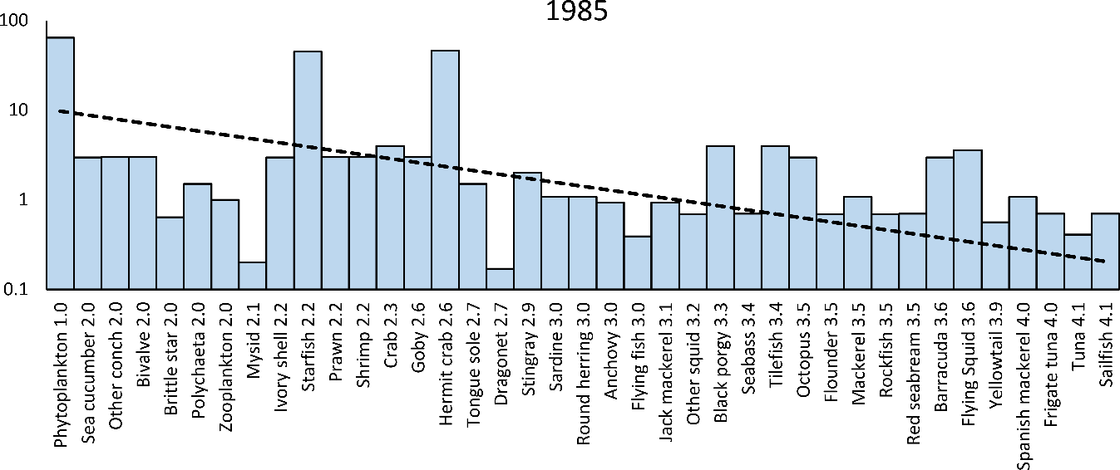
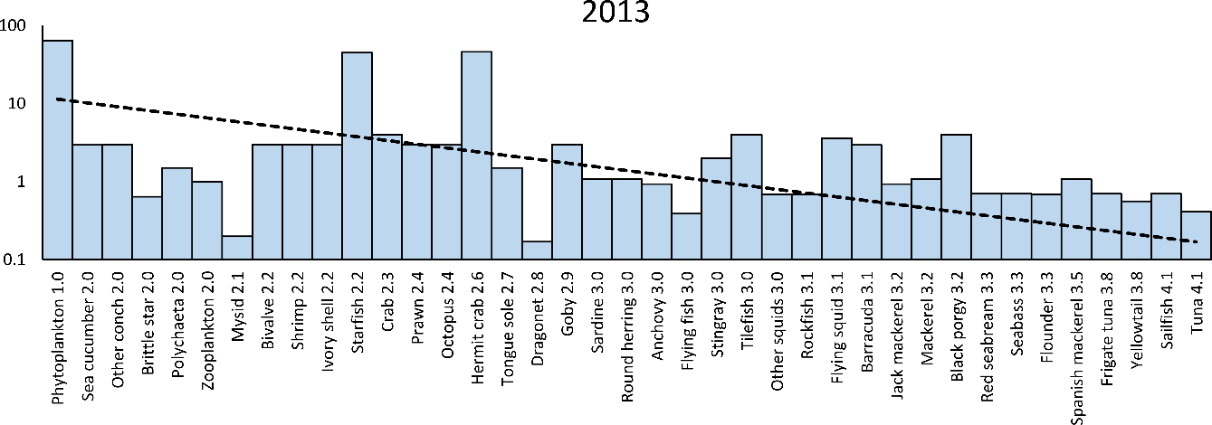
Fig. S9-2 Pre-balance diagnostics (PREBAL) in the 1985 and 2013 models for the CAK based on Link (2010). Trophic decomposition (trend line) showing the level of decline in production per biomass (P/B) with increasing trophic level (log scale). The trophic levels increase from left to right. This figure corresponds to diagnostic criteria 7 and 8 in Table S9-1

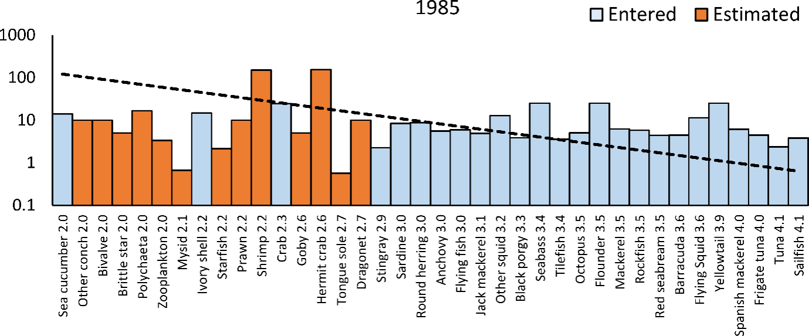

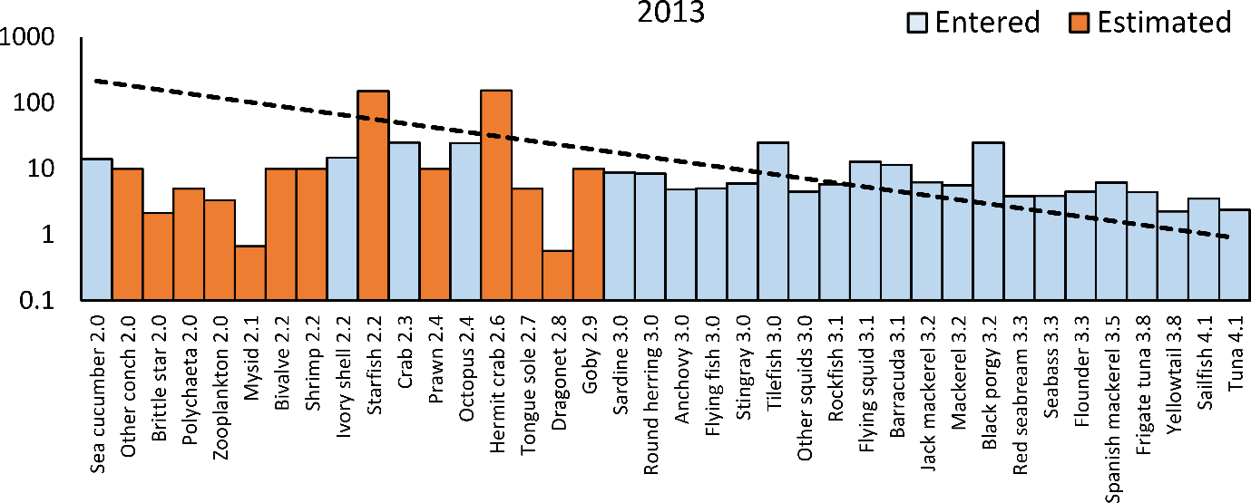
Fig. S9-3 Pre-balance diagnostics (PREBAL) in the 1985 and 2013 models for the CAK based on Link (2010). Trophic decomposition (trend line) showing the level of decline in consumption per biomass (Q/B) with increasing trophic level (log scale). The trophic levels increase from left to right. This figure corresponds to diagnostic criteria 7 and 8 in Table S9-1

Fig. S9-4 Pre-balance diagnostics (PREBAL) in the 1985 and 2013 models for the CAK based on Link (2010). Trophic decomposition (trend line) showing the level of decline in respiration per biomass (R/B) with increasing trophic level (log scale). The trophic levels increase from left to right. This figure corresponds to diagnostic criteria 7 and 8 in Table S9-1

Fig. S9-5 Pre-balance diagnostics (PREBAL) in the 1985 and 2013 models for the CAK based on Link (2010). Vital rate ratio (log scale) compared with the primary producers. The trophic levels increase from left to right. This figure corresponds to diagnostic criterion 11 in Table S9-1

Fig. S9-6 Pre-balance diagnostics (PREBAL) in the 1985 and 2013 models for the CAK based on Link (2010). Trophic decomposition (trend line) showing the level of decline in production per consumption (P/Q) and production per respiration (P/R) with an increasing trophic level (log scale). The trophic levels increase from left to right. This figure corresponds to diagnostic criterion 12 in Table S9-1

Figure S9-7 Total production and removal, scaled to the full ecosystem, comparing internal flows in the 1985 and 2013 models for the CAK. The trophic level increases from left to right. This figure corresponds to diagnostic criteria 13–15 in Table S9-1

Figure S9-8 Flows relative to external removal in the 1985 and 2013 models for the CAK. The trophic level increases from left to right. This figure corresponds to diagnostic criteria 16 and 17 in Table S9-1

Reference for Online Resource
Akeda K, Yodo T, Kai Y, Yoshioka M (2012) Feeding Habits of the Sebastes inermis Species Complex in Western Wakasa Bay, Central Japan. Aquac Sci 60:207-214. doi: 10.11233/aquaculturesci.60.207 (in Japanese with English abstract)
Akiyama S, Ueno M, Yamashita Y (2015) Population dynamics and reproductive biology of the mysid Orientomysis japonica in Tango Bay, Japan. Plankton Benthos Res 10:121-131. doi: 10.3800/pbr.10.121
Allen KR (1971) Relation between production and biomass. J Fish Board Can 28:1573-1581
Antonio ES, Kasai A, Ueno M, Won N, Ishihi Y, Yokoyama H, Yamashita Y (2010) Spatial variation in organic matter utilization by benthic communities from Yura River-Estuary to offshore of Tango Sea, Japan. Estuar Coast Shelf Sci 86:107-117
Ariyama H (1997) Dynamics of megabenthos in the innermost area of Osaka Bay II. Seasonal change in number of individuals, distribution and body length composition of dominant species. Bull Coast Oceanogr 35:83-91 (in Japanese with English abstract)
Aydin KY, Gaichas S, Ortiz I, Kinzey D, Friday N (2007) A Comparison of the Bering Sea, Gulf of Alaska, and Aleutian Islands Large Marine Ecosystems through Food Web Modeling. U.S. Department of Commerce, NOAA Tech. Memo. NMFS-AFSC-178, p. 298.
Baba T, Morimoto H, Goto T, Nanjo N, Oda M, Ueno Y (2018) Comparison of stomach contents between Japanese sardine Sardinops melanostictus and anchovy Engraulis japonicus using commercial fisheries together with the two species in the Japan Sea during spring. Nippon Suisan Gakkaishi 84:288-290. doi: 10.2331/suisan.17-00018 (in Japanese)
Brey T (2001) Population dynamics in benthic invertebrates. A virtual handbook. Version 01.2. http://www.thomas-brey.de/science/virtualhandbook
Fauchald K, Jumars PA (1979) The diet of worms: a study of polychaete feeding guilds. Oceanogr. Mar. Biol. Annual review 17:193-284
Fuji T, Kasai A, Suzuki KW, Ueno M, Yamashita Y (2010) Freshwater migration and feeding habits of juvenile temperate seabass Lateolabrax japonicus in the stratified Yura River estuary, the Sea of Japan. Fish Sci 76:643-652
Fujita T (2018) Natural history science of echinoderms and its promotion in Japan. Taxa Proc Jpn Soc Syst Zool 45:4-15. doi: 10.19004/taxa.45.0_4 (in Japanese with English abstract)
Hamatsu T,Yanagimoto T, Narimatsu Y (2003) Estimation of the fishing efficiency of kichiji rockfish, Sebastolobus macrochir, by comparison of the trawl survey and the submarine survey. JAMSTEC Journal of Deep Sea Research 22:63-69 (in Japanese with English abstract)

Hayakawa, Y, Ban, K, Kamo, T, Ezaki, Y (2012) Measurement of variations in chlorophyll-a as food index for oyster culture in Hakata Bay. Journal of National Fisheries University. 61:1-10 (in Japanese with English abstract)
Hayashi B, Kiyono S (1978) Ecological studies on the Japanese sea bass, in the western Wakasa Bay [Japan], 2: The food habitat and growth of Japanese sea bass in yearling. Bull Kyoto Inst Ocean Fish Sci 109-116 (in Japanese)
Hayashi I (1983a) Benthic polychaetes on the coastal level bottom of the Wakasa Bay area. Benthos Res 24:49-53. doi: 10.5179/benthos1970.1983.49 (in Japanese)
Hayashi I (1983b) Distribution of Macrobenthic Animals on the Flat Bottom in Obama Bay. Nippon Suisan Gakkaishi 49:1765-1775. doi: 10.2331/suisan.49.1765
Hayashi I, Kiyono S (1984) Macrobenthos in and offshore of Wakasa Bay in the Japan Sea. Mem Coll Agric, Kyoto Univ 123:1-26
Hino H, Kuroda H, Muko S, Sassa C, Kunimatsu S (2021) Stock assessment and evaluation for anchovy (1985 and 2013). Marine fisheries stock assessment and evaluation for the Tsushima warm current stock. Japan Fisheries Agency and Japan Fisheries Research and Education Agency, Tokyo, 16 pp, http://abchan.fra.go.jp/digests2021/details/202126.pdf (in Japanese)

Iizuka K, Asano M, Naganuma A (1989) Feeding habits of skipjack tuna (Katsuwonus pelamis Linnaeus) caught by pole and line and the state of young skipjack tuna distribution in the tropical seas of the western Pacific Ocean. Bull Tohoku Reg Fish Res Lab Jpn. 51: 107-116
ISC (2018) Stock assessment of Bluefin tuna in the Pacific Ocean in 2018

Kajikawa A (1976) Aquaculture of the ivory shell, Babylonia japonica (Reeve). Bull Tottori Prefect Fish Exp Stn 18:1-83 (in Japanese)
Kakuda S, Gushima K, Nakai K, Ogushi Y, Murakami Y (1979) On the Food Habits of the Dragonets, Genus Callionymus : I. Food Habits of Callionymus punctatus LANGSDORFF. In: J. Fac. Appl. Biol. Sci. Hiroshima Univ 18:75-83 doi: 10.15027/41416 (in Japanese)
Kawano M (2007) Feeding habits of jack mackerel (Trachurus japonicus) caught in coastal waters off Yamaguchi Prefecture, southwestern Japan Sea. Bull Yamaguchi Pref Fish Res C 5:19-23 (in Japanese with English abstract)
Kawano M (2017) Biological characteristics of Spanish mackerel (Scomberomorus nihonius) caught in coastal waters off Yamaguchi Prefecture, southwestern Sea of Japan. Bull Yamaguchi Pref Fish Res C 14:17-21 (in Japanese with English abstract)
Kawano M (1988) Fisheries biology of flyingfish (Cypselurus hiraii and Cypselurus doederleini) in Yamaguchi prefecture. Contrib Fish Res Jpn Sea Block 12:39-51 (in Japanese)
Kawano M (2004) Fisheries biology of flyingfish (Cypselurus hiraii). Bull Yamaguchi Pref Fish Res Ct 27-76 (in Japanese)
Kimoto K, Fujita K, Noguchi M (2001) Development of the two-meter beam trawl (NRIFE ll Type) and estimate of the catch efficiency for Juvenile Japanese flounder. Bull Natl Res Inst Fish Sci 67-90 (in Japanese with English abstract)
Kitano M, Kozuki Y, Kurata K, Murakami H, Yamasaki T, Yoshida H, Mizutani M (2003) Bioturbation of deposit-feeding sea cucumber Stichopus japonicus in Summer. J Jpn Soc Civ Eng 2003:49-56 (in Japanese)
Kiyono S, Hayashi B (1977) Ecological studies on the red tilefish in Wakasa Bay [Japan], 2: Distributions of immatures and adults. Bull. Kyoto Inst. Ocean. Fish. Sci. 1:15-28 (in Japanese)
Kubota H, Miyahara H, Kaga T, Okamoto S, Nishijima S, Matsukura R, Matsui H, Abo J, Takazaki K, Saitou T, Inagake D (2021) Stock assessment and evaluation for Japanese flying squid (1985 and 2013). Marine fisheries stock assessment and evaluation for Autumn population. Japan Fisheries Agency and Japan Fisheries Research and Education Agency, Tokyo, 22 pp, http://abchan.fra.go.jp/digests2021/details/202119.pdf (in Japanese)

Kubota H, Watari S, Furukawa S, Nyuji M, Kamiyama R, Hanzawa Y, Takemura S, Sugimoto A (2019) Stock assessment and evaluation for yellowtail (2019). Marine fisheries stock assessment and evaluation for Japanese waters. Japan Fisheries Agency and Japan Fisheries Research and Education Agency, Tokyo, 26 pp, http://abchan.fra.go.jp/digests2019/details/201945.pdf (in Japanese)

Kurihara T (1996) Effects of sediment and depth on species composition of starfishes (Asteroidea) in Wakasa Bay, Japan Sea. Benthos Res. 1-10. doi: https://doi.org/10.5179/benthos1990.1996.50_1 (in Japanese with English abstract)
Kuroda H, Muko S, Yoda M, Hino H, Takahashi M, Sassa C, Kunimatsu S (2021) Stock assessment and evaluation for mackerel (1985 and 2013). Marine fisheries stock assessment and evaluation for the Tsushima warm current stock. Japan Fisheries Agency and Japan Fisheries Research and Education Agency, Tokyo, 29 pp, http://abchan.fra.go.jp/digests2021/details/202106.pdf (in Japanese)

Link JS (2010) Adding rigor to ecological network models by evaluating a set of pre-balance diagnostics: a plea for PREBAL. Ecol Model 221:1580-1591
Matsui S, Hagiwara Y, Tou H, Tsukahara H (1986) Study on the feeding habit of the Japanese blue crab, Portunus trituberculatus (Miers). Sci Bull Fac Agr., Kyushu Univ 40:175-181(in Japanese)
Matsui S, Ueno M, Yamashita Y (2014) Growth characteristics and reproductive biology of three sympatric Acentrogobius (Perciformes : Gobiidae) species in Maizuru Bay, Kyoto Prefecture. Bull Jpn Soc Fish Oceanogr 78:75-85 (in Japanese with English abstract)
Mitani F (1958) Feeding habits of the Yellow-tail, Seriola quinqueradiata T. & S., caught in Wakasa Bay, the Japan Sea, based on its stomach contents-I. Food elements and their seasonal variation. Nippon Suisan Gakkaishi 24:176-181. doi: 10.2331/suisan.24.176 (in Japanese with English abstract)
Moriwaki S (1994) Ecology and fishing condition of Kensaki-squid, Photololigo edulis, in the southwestern Japan Sea. Bull Shimane Pref Fish Exp Stat 8:1-111 (in Japanese)
Moriwaki S, Miyabe S (2012) Feeding habits of mackerel,Scomber japonicus, in the coastal waters southwestern Japan Sea. Bull Shimane Pref Fish Res C 4:39-44 (in Japanese)
Muko S, Takahashi M, Kuroda H, Yoda M, Hino H (2021) Stock assessment and evaluation for jack mackerel (1985 and 2013). Marine fisheries stock assessment and evaluation for Tsushima water. Japan Fisheries Agency and Japan Fisheries Research and Education Agency, Tokyo, 30-31 pp, http://abchan.fra.go.jp/digests2021/details/202102.pdf (in Japanese)

Nakagawa M and Yoshimura T (2019) Stock assessment and evaluation for red seabream (2019). Marine fisheries stock assessment and evaluation for eastern part of Sea of Japan. Japan Fisheries Agency and Japan Fisheries Research and Education Agency, Tokyo, 14, 19 pp, http://abchan.fra.go.jp/digests2019/details/201950.pdf (in Japanese)

Nigmatullin C, Arkhipkin A (1998) A review of the biology of the diamondback squid, Thysanoteuthis rhombus (Oegopsida: Thysanoteuthidae), in “Contributed papers to international symposium on large pelagic squids” (ed. By Okutani T.). Jpn Mar Fish Resour Res Cent 155-181
Oh C-W, Hartnoll RG, Nash RD (2001) Feeding ecology of the common shrimp Crangon crangon in Port Erin Bay, Isle of man, Irish Sea. Mar Ecol Prog Ser 214:211-223
Okiyama M (1965) On the feeding habits of the common squid, Todarodes pacificus Steenstrup, in the offshore region of the Japan Sea. Bull Jap Sea Reg Fish Res Lab 14:31-41 (in Japanese with English abstract)
Palomares F (1991) Vocalizations emitted by the Egyptian mongoose, Herpestes ichneumon, living in the wild. Mammalia 55:148-150
Palomares ML, Pauly D (1989) A multiple regression model for prediction the food consumption of marine fish populations. Mar Freshw Res 40:259-273
Palomares MLD, Pauly D (1998) Predicting food consumption of fish populations as functions of mortality, food type, morphometrics, temperature and salinity. Mar Freshw Res 49:447-453
Pauly D (1989) Food consumption by tropical and temperate fish populations: some generalizations. J Fish Biol 35:11-20
Pauly D (1980) On the interrelationships between natural mortality, growth parameters, and mean environmental temperature in 175 fish stocks. J Cons Cons Perm Int Pour Explor Mer 39:175-192
Ramsay K, Kaiser MJ, Hughes RN (1996) Changes in hermit crab feeding patterns in response to trawling disturbance. Mar Ecol Prog Ser 144:63-72
Shimose T, Shono H, Yokawa K, Saito H, Tachihara K (2006) Food and feeding habits of blue marlin, Makaira nigricans, around Yonaguni Island, southwestern Japan. Bull Mar Sci 79:761-775
Shimose T, Watanabe H, Tanabe T, Kubodera T (2013) Ontogenetic diet shift of age-0 year Pacific bluefin tuna Thunnus orientalis. J Fish Biol 82:263-276
Shiomi K, Shinagawa A, Igarashi T, Hirota K, Yamanaka H, Kikuchi T (1984) Contents and Chemical Forms of Arsenic in Shellfishes in Connection with Their Feeding Habits. Nippon Suisan Gakkaishi 50:293-297. doi: 10.2331/suisan.50.293
Takahashi M (1966) Studis on the Ecology of Feeding of the Mackerel, Pneumatophorus japonicus. 1. On the Food Habit and the Selective Feeding. Dep Fish Fac Fish Anim Husb Hiroshima Univ 6:431-446 (in Japanese)
Takeno K (2010) Studies on the Fisheries Biology of Japanese Flounder Paralichthys olivaceus in Westem Wakasa Bay. PhD dissertation, Kyoto University, Japan (in Japanese)
Taniuchi T, Shimizu M (1993) Dental Sexual Dimorphism and Food Habits in the Stingray Dasyatis akajei from Tokyo Bay, Japan. Nippon Suisan Gakkaishi 59:53-60. doi: 10.2331/suisan.59.53
Tega T, Niwa K, Chow S (2016) An attempt to clarify the diets of olive flounder and bigfin reef squid juveniles using PNA clamping. Nippon Suisan Gakkaishi 82. doi: 10.2331/suisan.15-00048 (in Japanese with English abstract)
Vaz-Pires P, Seixas P, Barbosa A (2004) Aquaculture potential of the common octopus (Octopus vulgaris Cuvier, 1797): a review. Aquaculture 238:221-238. doi: 10.1016/j.aquaculture.2004.05.018
Vignot C (2007) Relations trophiques au sein des communautés de poissons d’un estuaire inverse d’Afrique de l’Ouest, le Sine Saloum au Sénégal. Mém Master 2 Sci L’Univers Environ Ecol Univ Pierre Marie Curie Paris (in French)
Watari S (2015) Fish stock assessment targeting on multi-species and multi-fisheries based on Ecopath with Ecosim approach in Suo-nada, Seto Inland Sea, Japan. Bull Jpn Soc Fish Oceanogr 79:255-265 (in Japanese with English abstract)
Yagi Y, Fujiwara K, Iida S (2019) Stock assessment and evaluation for yellowtail (2019). Marine fisheries stock assessment and evaluation for eastern part of Sea of Japan. Japan Fisheries Agency and Japan Fisheries Research and Education Agency, Tokyo, 22 pp, http://abchan.fra.go.jp/digests2019/details/201962.pdf (in Japanese)

Yamada U, Tokimura M, Horikawa H, Nakabo T (2007) Fishes and fisheries of the East China and Yellow Seas. Kanagawa Tokai Univ Press 808-815 (in Japanese)
Yamamoto M, Makino H (2002) Estimation of catch efficiency of the two-meter beam trawl for juvenile Japanese flounder (Paralichthys olivaceus) in the Hiuchi-Nada Sea (Japan). Saibai Gyogyo Gijutsu Kaihatsu Kenkyu Jpn (in Japanese with English abstract)
Yang JM (2001) A study on food and trophic levels of Bohai invertebrates. Mod Fish Inf 16:8-16
Yoda M, Kuroda H, Muko S, Sassa C (2021) Stock assessment and evaluation for round herring (1985 and 2013). Marine fisheries stock assessment and evaluation for the Tsushima warm current stock. Japan Fisheries Agency and Japan Fisheries Research and Education Agency, Tokyo, 16 pp, http://abchan.fra.go.jp/digests2021/details/202122.pdf (in Japanese)

Yoda M, Sassa C, Takahashi M, Muko S, Kuroda H (2021) Stock assessment and evaluation for jack mackerel (1985 and 2013). Marine fisheries stock assessment and evaluation for Tsushima water. Japan Fisheries Agency and Japan Fisheries Research and Education Agency, Tokyo, 23 pp, http://abchan.fra.go.jp/digests2021/details/202104.pdf (in Japanese)

Yokoyama H, Hayashi I (1980) Zonation and species diversity of smaller macrobenthos in the westernmost part of Wakasa Bay (the Sea of Tango). J Oceanogr 36:46-58
Yoshida N, Takatsu T, Nakaya M, Joh M, Kimura O, Shimizu S (2005) Catch efficiencies of the Hirota’s sledge net for crangonid shrimp and marbled sole. Nippon Suisan Gakkaishi 71:172-177 (in Japanese with English abstract)

