Supplementary Material
Ecosystem Characteristics and Ecological Carrying Capacity of a Subtropical Marine Ranch in the Pearl River Estuary: An Ecopath Modeling Approach

Table S1. Diet composition of the functional groups in Wailingding Island marine ranch ecosystem.
Prey∖Predator | 1 | 2 | 3 | 4 | 5 | 6 | 7 | 8 | 9 | 10 | 11 | 12 | 13
1 | 0 | 0 | 0 | 0 | 0 | 0 | 0 | 0 | 0 | 0 | 0 | 0 | 0
2 | 0 | 0 | 0 | 0 | 0 | 0 | 0 | 0 | 0 | 0 | 0 | 0 | 0
3 | 0 | 0.00202 | 0.00131 | 0 | 0 | 0 | 0 | 0 | 0 | 0 | 0 | 0 | 0
4 | 0 | 0 | 0.0064 | 0.0521 | 0.0684 | 0.0433 | 0.0282 | 0.0457 | 0.0669 | 0.0819 | 0.0941 | 0 | 0
5 | 0.0125 | 0.117 | 0 | 0.1 | 0.13 | 0.0376 | 0.0475 | 0.0896 | 0.105 | 0.171 | 0 | 0 | 0
6 | 0.0566 | 0.0642 | 0 | 0 | 0.0522 | 0.043 | 0 | 0.0214 | 0.00123 | 0 | 0 | 0 | 0
7 | 0.0507 | 0.0117 | 0 | 0 | 0 | 0.00398 | 0 | 0.00329 | 0 | 0 | 0 | 0 | 0
8 | 0.152 | 0.202 | 0 | 0 | 0.104 | 0.109 | 0.00459 | 0.00225 | 0.038 | 0.00864 | 0.002 | 0 | 0
9 | 0 | 0.000317 | 0.00119 | 0 | 0 | 0 | 0.000108 | 0 | 0.000062 | 0 | 0 | 0 | 0
10 | 0.099 | 0.222 | 0.182 | 0 | 0 | 0 | 0.215 | 0 | 0.125 | 0.00419 | 0 | 0.000999 | 0
11 | 0.11 | 0.051 | 0.117 | 0 | 0.00541 | 0.0518 | 0.136 | 0.0903 | 0.187 | 0.158 | 0.0478 | 0.002 | 0
12 | 0 | 0.102 | 0.0624 | 0 | 0 | 0 | 0.0941 | 0.0741 | 0.00389 | 0.00168 | 0 | 0 | 0
13 | 0 | 0 | 0 | 0.0938 | 0.176 | 0.26 | 0.16 | 0.2 | 0.0389 | 0.151 | 0.164 | 0.475 | 0.0952
14 | 0 | 0 | 0 | 0.0469 | 0 | 0 | 0 | 0 | 0 | 0 | 0 | 0 | 0.0952
15 | 0 | 0 | 0 | 0.135 | 0.0108 | 0 | 0 | 0 | 0.249 | 0.112 | 0.141 | 0 | 0.0476
16 | 0 | 0 | 0 | 0.328 | 0.295 | 0.187 | 0 | 0.237 | 0.0882 | 0.13 | 0.148 | 0.208 | 0.476
17 | 0 | 0 | 0 | 0.344 | 0.345 | 0.173 | 0.016 | 0.301 | 0.125 | 0.217 | 0.225 | 0.312 | 0.286
Import | 0.396 | 0.351 | 0.235 | 0 | 0 | 0 | 0.157 | 0 | 0 | 0 | 0 | 0 | 0
Sum | 1 | 1 | 1 | 1 | 1 | 1 | 1 | 1 | 1 | 1 | 1 | 1 | 1
Note: The numbers in the table header correspond to the functional group numbers in Table 2 of the manuscript.
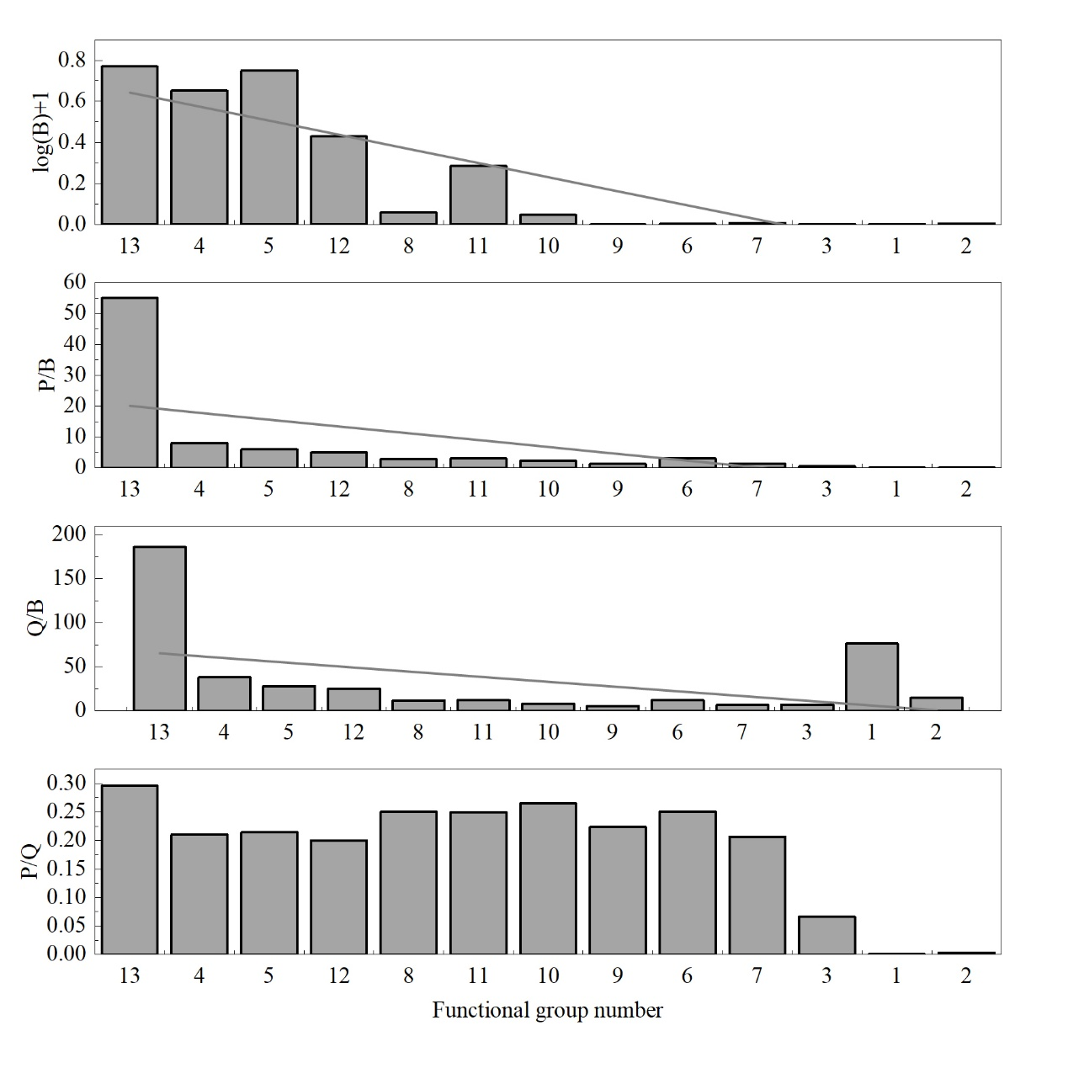
Figure S1. Trend chart of PREBAL pre-balance check for the National Marine Ranch Demonstration Zone of Wailingding Island. Functional group trophic levels increase from left to right.
Note: 1: Seabirds; 2: Marine mammals; 3: Cartilaginous fishes; 4: Small benthic invertebrates; 5: Benthic crustaceans; 6: Cephalopods; 7: Large pelagic fishes; 8: Small pelagic fishes; 9: Large demersal fishes; 10: Medium demersal fishes; 11: Small demersal fishes; 12: Jellyfish; 13: Zooplankton. The X-axis is arranged by TL, decreasing from right to left. Abbreviations: B, biomass (t/km²); P/B, production/biomass; Q/B, consumption/biomass.

