Arabian Sea model validation
Field | Entry
Region | Arabian Sea | LME_032  Regional workbook
Catch source | Sea Around Us frozen regional catch, 1950–2019; landings, discards and total catch. Appendix reference: 2019 landings. Source snapshot catalogued 3 September 2026.  Catch files | Taxon metadata
Selected article | Mohamed K. S., Zacharia P. U., Muthiah C., Abdurahiman K. P., Nayak T. H. (2008). Trophic Modelling of the Arabian Sea Ecosystem off Karnataka and Simulation of Fishery Yields. CMFRI Bulletin 51. No DOI recorded.  Paper PDF | Official source
Other known articles | Vivekanandan et al. (2003), Southwest Coast of India coastal fisheries model,11 groups. Mohamed & Zacharia(2009), Karnataka Ecosim yield simulations. Mohamed(2024), northeastern Arabian Sea model off Maharashtra/Gujarat.  Mohamed-2009 PDF | Mohamed-2024 PDF | Vivekanandan-2003 PDF
Selected model | 32_1_Arabian_Sea_off_Karnataka_(2000). Baseline landings 1999–2001; 27,000 km² Karnataka shelf and parts of slope, exploitation to 200 m. 24 source groups plus synthetic diet_import(ID 25).  Model JSON | Group coefficients
Other models from the same article | One Karnataka baseline Ecopath model is identified. Original and balanced diet tables are reconstruction states of that model; Ecosim effort/yield scenarios are simulations, not separately selected Ecopath models.
Selection rationale | Article — ?  Model — Karnataka coastal model applied to Arabian Sea catch; geographic transfer.
Model extraction | Published B/PB/QB/EE, landings and balanced diet agree with the canonical inputs. Printed diet column sums 0.999–1.001 are normalized by their actual sums. The paper specifies zero biomass accumulation; this replaces missing BA formerly solved as a balance residual. GS is unreported; the calculator uses 0.2 for consumers.  Source reconstruction | Loaded state
SPPR calculation | [MANUAL — Researcher: calculation choices and reasons]  [Excluded groups, scope and relevant values; other adjustments]

Field | Entry
GE diagnostics | No negative SPPR entries across the basal-source columns.  rho_living = 0.57669523; b = 0.51601594.  Detritus(ID 24): SPPR = 2.22371682.
TE diagnostics | No negative SPPR entries across the basal-source columns.  rho_living = 0.67271573.  Detritus(ID 24): SPPR = 0.32238039.
Geographic fit | A. Region covered by study: approximately 0.65–0.69%.  B. Study area covered by region: approximately 95–100%.
Temporal fit | Model baseline 1999–2001 is transferred over catch 1950–2019, including the 2019 reference. Fixed model coefficients and assumed category weights do not reconstruct changing annual ecosystems. Regional lineage weights use identified total catch 1950–2019, then transfer across individual years and bases.
Other | With source-stated zero BA, the rounded model remains unbalanced: maximum relative production residual 5.35%. TE also has a 3.81% primary-production closure gap and a near-singular marine-mammal group(ID 1). Nonnegative SPPR does not remove these limitations.  Diagnostic evidence
Open issues and next action | [Researcher: open issues and next actions]
Review and reproducibility | Researcher name: [name] | review date: [date]
Taxon mapping and coverage
Reference: 2019 landings; all 430 catch labels, including zero catches. Independent all-taxon simple-chain PPR; no group filter.
24 source groups plus one synthetic import; 430 catch taxa.
Simple-chain PPR totals 514,724,666.461 t C in 2019.
37 taxa lack a saved TL/coefficient. All have zero 2019 landings and contribute zero annual PPR; no positive-catch contribution is unknown.
Simple-chain PPR uses the independent simple trophic chain method.
Excel taxon appendix and descriptive Sources sheet
Overall confidence | Taxa | Catch percentage | PPR percentage
High | 145 | 34.2506% | 27.8791%
Medium | 207 | 49.3950% | 64.5210%
Low | 38 | 3.2033% | 4.2734%
Very low | 40 | 13.1512% | 3.3265%
Unresolved | 0 | 0.0000% | 0.0000%
Overall confidence uses the weaker required membership or allocation component.
Group assignment rules
Plain-language rule | Confidence | PPR percentage
Taxonomic extension from named source representatives | Medium | 51.2386%
Explicit source member or member of a source-listed genus | High | 20.7837%
Broad label interpreted through its recorded fishery classification | Medium | 7.4699%
Complete fit to an explicitly defined generic compartment | High | 7.0191%
Supported habitat and feeding-guild extension | Medium | 5.8126%
Partial or conflicting habitat and feeding-guild fit | Low | 4.2734%
Explicit coarse-category approximation to compatible compartments | Very low | 3.1959%
Closest available ecological analogue with a material mismatch | Very low | 0.1306%
Accepted-name synonym of an explicit source member | High | 0.0763%
Membership evidence: Bulletin 51 membership table and group accounts, accepted-name taxonomy, provider reporting meaning and cited ecological sources.
Allocation weight rules
Plain-language rule | Confidence | PPR percentage
One supported compartment receives the entire taxon | High | 89.3358%
Identified regional catch composition assumed for the coarse taxon | Medium | 6.4246%
Source-model landings proportions assumed for the catch category | Medium | 4.2395%
Weights and assumptions: seven identified-lineage catch mixtures are retained or reconstructed. Other splits use eligible source-group landings proportions at Medium allocation confidence, with zero candidates retained and transfer assumptions explicit.
Each percentage is the independent simple-chain PPR associated with taxa using that rule.
Unresolved taxa: none. 40 Very low decisions cover 13.1512% of landings and 3.3265% of PPR. They comprise coarse fish/invertebrate mixtures, unrepresented herbivorous or specialised reef feeders, deep/oceanic analogues and Scomber. Exact taxa, weights and reasons are flagged in the linked appendix.

Geographic evidence
Target region R and Karnataka study area S. Approximate overlap uses the published 27,000 km² footprint and target boundary; the study’s coordinate rectangle is not treated as its area.

Region area
Target region boundary
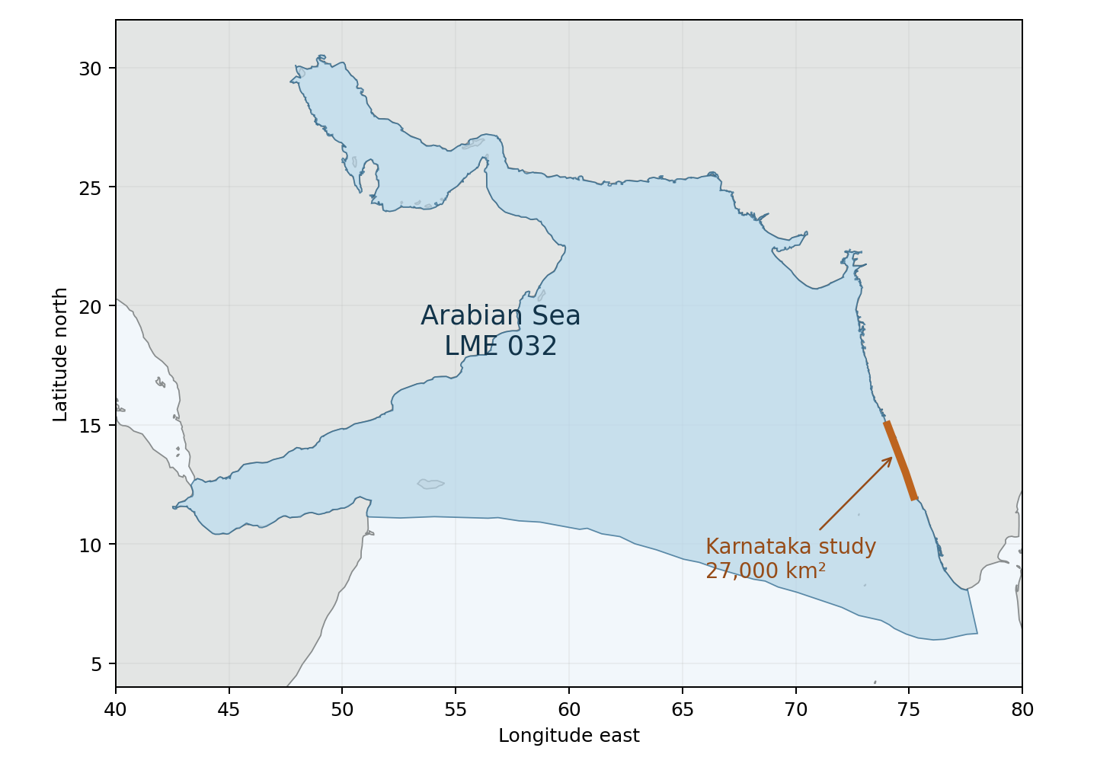
Arabian Sea LME_032. Sea Around Us boundary; WGS 84 geodesic area approximately 3.93 million km². Orange line locates the Karnataka coast near the study; it is not a digitized study polygon. | Boundary source | Overlap evidence

Study area in the article
Study boundary for the selected model
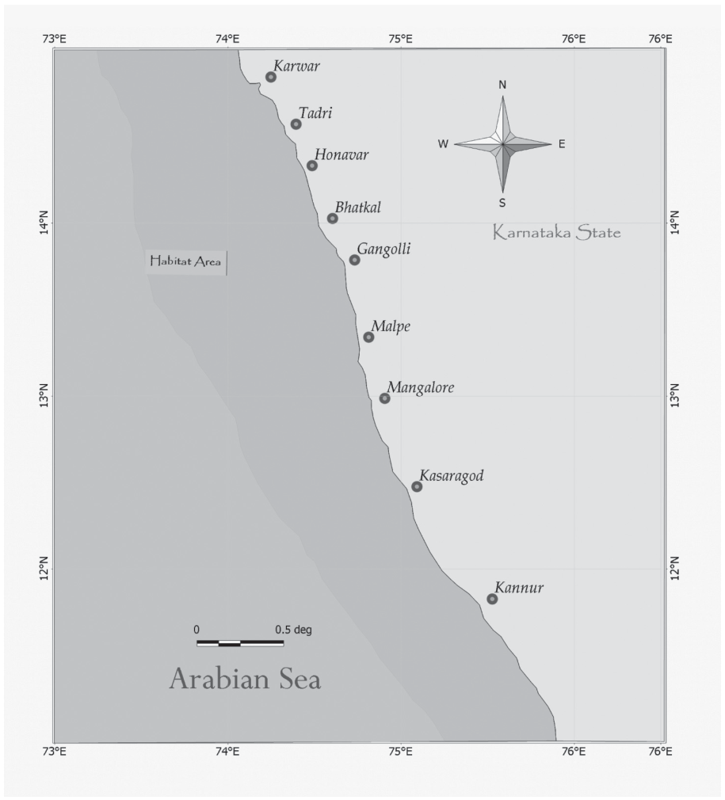
Mohamed et al. (2008), Habitat Area figure, printed p. 8 / PDF p. 18. Karnataka shelf and parts of slope; source area 27,000 km². | Source PDF

