Regional model validation record
Field | Entry
Region | Bay of Bengal regional workbook (LME_034).
Catch source | Sea Around Us regional catch series, 1950–2019. Reference: 2019 landings, excluding discards. Dataset version/download date: ?; retained source inventory dated 3 September 2026.  Regional catch and classic-PPR tables | Retained catch archive
Selected article | Guénette, S. (December 2013). An exploratory ecosystem model of the Bay of Bengal Large Marine Ecosystem. 62-page report; the later 2014 distributed edition is distinct.  Original report PDF | Paper folder
Other known articles | Guénette (2014), User’s guide to the Ecopath with Ecosim model of the Bay of Bengal Large Marine Ecosystem. Related guide; no verified local copy.  Karim et al. (2019), Ecopath model of the coastal fisheries ecosystem of Bangladesh: unverified legacy inventory entry; separate from Karim (2018).  Dutta, Paul & Homechaudhuri (2023), Food web structure and trophic interactions of the Northern Bay of Bengal ecosystem (29 groups, West Bengal subregion); local PDF.  Karim et al. (2018), Ecosystem modeling of the resettled maritime area of the Bay of Bengal, Bangladesh through well-adjusted Ecopath approach (19 groups, >90,000 km²); local PDF.
Selected model | 34_1_Bay_of_Bengal_(1978). Baseline 1978; Bay of Bengal LME extended to Maldives, northern Sumatra and adjacent high seas (6,205,051 km²). 49 source ecological groups (+1 computational diet-import group).  Selected JSON | Model folder | Saved coefficient workbook
Other models from the same article | No other distinct static model identified. Initial and balanced inputs are states of the same 1978 baseline. The 1978–2010 Ecosim runs and alternative industrial-effort fits are scenarios of that baseline (pp6–7, 23–24, 28–29; Appendix A6).
Selection rationale | Article: ? Model: ?  Recorded selection note: “Bay of Bengal pilot model; see source and mapping notes for coverage.” Comparative reasons were not recorded.
Model extraction | Balanced Table 16 parameters are reproduced; whole-area biomass uses habitat fraction × habitat biomass. Published diet columns contain omissions (Table 17; Appendix A3.2). The JSON normalizes nonzero columns and inserts a detritus diet for all-zero 3 Meiobenthos.  These transformations change production closure by up to 77.3%; the constructor derives biomass accumulation to close the transformed input and sets detritus EE to 1. Derived BA is not an observation. Native author-model fidelity remains unverified.  Source reconstruction findings
SPPR calculation | [MANUAL — Researcher: calculation choices and reasons]  [Excluded groups, scope and relevant values; other adjustments]
Bay of Bengal • LME_034 • 1978 model
Field | Entry
GE diagnostics | No negative SPPR entries across the basal-source columns. ρ_living = 0.7405556; b = 0.3145061. Detritus (49) SPPR = 1.6787253.
TE diagnostics | No negative SPPR entries across the basal-source columns. ρ_living = 0.7844868. Detritus (49) SPPR = 0.7954499.
Geographic fit | Approximate overlap: A ≈ 100% of the target LME covered by the study; B ≈ 59% of the study covered by the target LME. Study extension to Maldives and high seas limits transfer of pooled coefficients/weights. No exact digital author boundary was recovered.  Geographic evidence and area calculation
Temporal fit | The static model represents 1978; retained catch series spans 1950–2019 and the validation reference is 2019. Fixed model coefficients and pooled 1978 total-catch weights assume stable food-web structure, taxon composition and fishery geography across years and catch bases.
Other | Model-derived estimates remain provisional because source diet reconstruction and derived BA are unresolved. Numerical reproducibility does not establish author-native balance.
Open issues and next action | [Researcher: open issues and next actions]
Review and reproducibility | Researcher name: [name] | review date: [date]
Taxon mapping and coverage
Reference: 2019 landings, excluding discards.
49 source ecological groups (+1 computational import); 315 catch-taxon labels, including 28 zero-landings labels.
Total simple-chain PPR (2019): 379,324,412.047 tonnes C.
27 zero-landings labels lack a saved simple-chain coefficient and TL. They contribute zero annual PPR; no positive-landings taxon has unknown simple-chain PPR.
Method: simple trophic chain.
Full taxon-mapping appendix | Sources and detailed evidence
Overall confidence | Taxa (n) | Catch (%) | Simple-chain PPR (%)
High | 66 | 20.0050 | 24.5910
Medium | 244 | 59.1735 | 67.6100
Low | 0 | 0.0000 | 0.0000
Very low | 5 | 20.8215 | 7.7990
Unresolved | 0 | 0.0000 | 0.0000
Overall confidence is the weaker necessary group-assignment or allocation-weight confidence.
Group assignment rules
Membership evidence: Guénette (2013), A1.1 pp37–41 and A1.3 pp43–45; authoritative taxonomy and habitat records. Detailed evidence
Plain-language rule | Confidence | PPR percentage
Explicit assignment in the selected source | High | 60.3323
Assumed eligible set from source definitions and regional taxonomy | Medium | 28.2780
Broad reporting category approximated by compatible named and residual groups | Very low | 7.7990
Unambiguous fit to a completely defined source group | High | 2.5513
Supported extension from source-listed relatives | Medium | 0.6593
Verified same-taxon synonym of an explicit source member | High | 0.3802
Supported ecological extension to a represented guild | Medium | 0.0000
Allocation weight rules
Weights and assumptions: Guénette (2013), A2.1 p46; pooled 1978 model-catch proportions and transfer assumptions. Detailed evidence
Plain-language rule | Confidence | PPR percentage
Source-model catch proportions transferred across taxon composition, years and catch bases | Medium | 75.4090
Entire taxon assigned to one group | High | 24.5910
Rule percentages describe each component’s share of the same available simple-chain PPR.
No unresolved mappings remain. Very low assignments account for 20.8215% of landings and 7.7990% of simple-chain PPR: Marine fishes not identified, Perciformes, Marine pelagic fishes not identified, Scombroidei and Malacostraca. Their broad reporting mixtures are approximated by compatible named and residual pools; source-model catches proxy the unknown composition.

Geographic evidence screenshots
Target region R and source-model study area S, used for the approximate geographic comparison.

Region area
Target region boundary
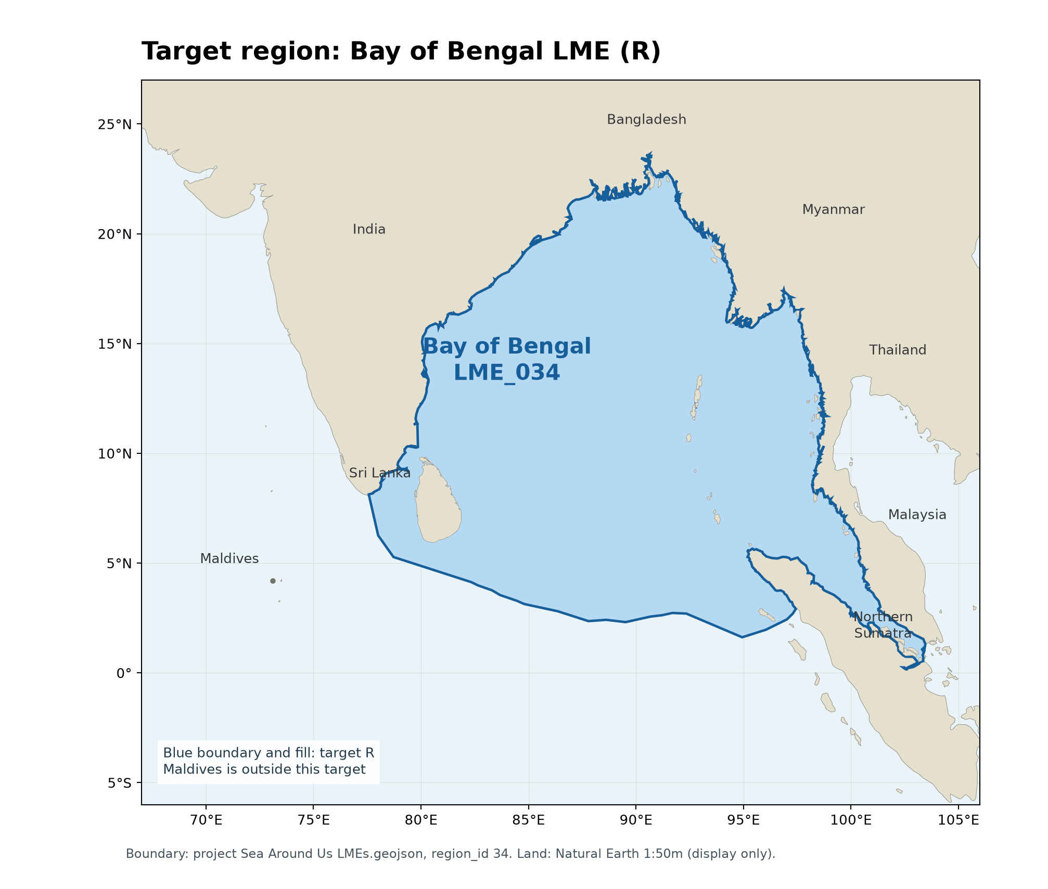
R: Bay of Bengal LME_034. WGS84 geodesic area ≈ 3,664,447 km²; project Sea Around Us boundary, region_id 34. Natural Earth land is a display basemap.

Study area in the article
Study boundary for the selected model
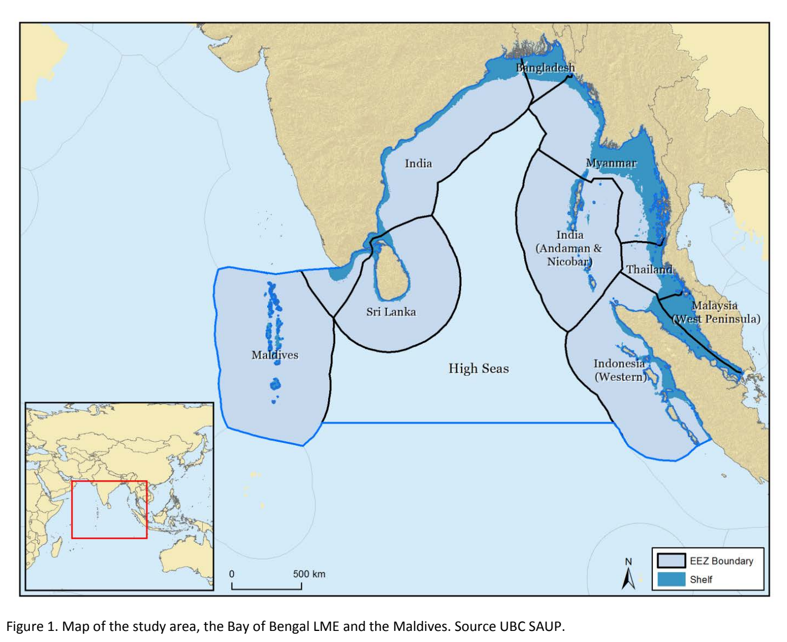
S: Guénette (2013), Figure 1, p8. The study includes Maldives and adjacent high seas; Table 1 gives 6,205,051 km².

