Regional model validation record
Field | Entry
Region | Pacific, Eastern Central high seas, HS_077. Regional workbook
Catch source | Sea Around Us regional catch, 1950–2019; reference: 2019 landings. Eastern Central Pacific high-seas reporting unit; historical local download retained. Catch inputs | Regional catch
Selected article | Olson, R.J.; Watters, G.M. (2003). A model of the pelagic ecosystem in the eastern tropical Pacific Ocean. IATTC Bulletin 22(3), pp. 135–218. DOI: not recorded. Source PDF | Official IATTC bulletin | Paper folder
Other known articles | No additional article is recorded for HS_077 in the reviewed local inventory; this is not an exhaustive literature search.
Selected model | 077HS_1_Eastern_tropical_Pacific_(1993-1997); final ETP7, 1993–1997. 39 source ecological groups plus one computational import. Pelagic domain: 20°N–20°S, 150°W to the approximate American shelf break. Selected JSON | Model folder | Accepted loaded state
Other models from the same article | ETP1: initial 34-group, explicitly unbalanced model for the same broad period/domain. ETP2–ETP6: intermediate revisions; separate complete static tables unavailable. ETP5 sensitivities and Ecosim runs are scenarios. ETP7 is the final published parameterization. Source model inventory
Selection rationale | Article: recorded as the selected pilot article; comparative criterion beyond that designation: ?. Model: ? — the recorded diet-consistency concern does not explain choosing among model versions.
Model extraction | Nine material published diet-sum errors are retained in canonical inputs. The accepted historical runtime normalizes ten diets at 0.001 tolerance, including Albacore 1.001; infers missing BA; supplies missing-catch zeros and detritus/import defaults. Source BA and detritus routing remain undocumented. Censored whale EE and fleet catches are distinct from exact zero. No source values were restored or rebalanced. Reconstruction report | Source and runtime review
SPPR calculation | [MANUAL — Researcher: calculation choices and reasons]  [Excluded groups, scope and relevant values; other adjustments]

Field | Entry
GE diagnostics | No negative SPPR entries across the basal-source columns. rho_living=0.53880579; b=0.00000000; Detritus(39) SPPR=1.68916596.
TE diagnostics | Negative sources: diet_import(40) → Toothed whales(4); Small producers(38) → Toothed whales(4); Large phytoplankton(37) → Toothed whales(4). rho_living=0.62720534; Detritus(39) SPPR=0.03354576.
Geographic fit | Approximate A: 47% of HS_077 is covered by the study. B: 46–48% of the study is covered by HS_077. Boundary estimate
Temporal fit | 1993–1997 model averages; catch series 1950–2019. The 2019 reference is 22–26 years later. Fixed ecosystem coefficients and assumed composition weights do not reconstruct annual ecosystem changes.
Other | TE fails PP-budget closure (relative gap 1.75287544) and has near-zero efficiencies in five mammal/bird groups. GE and With Egestion direct OK apply to the accepted transformed runtime; source/ecological admission remains unestablished. Exact matrix/diagnostic review
Open issues and next action | [Researcher: open issues and next actions]
Review and reproducibility | Researcher name: [name] | review date: [date]
Taxon mapping and coverage
Reference: 2019 landings; all catch labels, including zero catch and unidentified categories; no group filter.
39 source ecological groups (+1 computational import); 26 catch labels.
Simple-chain PPR totals 226,007,970.44 t C in 2019.
Method: independent simple trophic chain using saved classic taxon coefficients.
Taxon mapping appendix and descriptive Sources sheet
Overall confidence | Taxa | Catch percentage | PPR percentage
High | 4 | 53.8378% | 53.0702%
Medium | 18 | 44.0842% | 46.4103%
Low | 0 | 0.0000% | 0.0000%
Very low | 4 | 2.0780% | 0.5194%
Unresolved | 0 | 0.0000% | 0.0000%
The summary uses the weaker required membership or allocation confidence. The following tables show each component separately.
Group assignment rules
Plain-language rule | Confidence | PPR percentage
Explicit final source membership in the group or stage union. | High | 98.7237%
Unknown finfish or shark/ray composition uses represented-pool proxies. | Very low | 0.5194%
Verified current and historical names identify the source taxon. | High | 0.4922%
Related pelagic billfish or mako extends listed source species. | Medium | 0.2071%
Family spans a supported complete set of named and mixed fish groups. | Medium | 0.0575%
Southern bluefin uses Pacific bluefin despite habitat/residency mismatch. | Very low | 0.0000%
Membership evidence: final definitions, synonyms and complete candidates
Allocation weight rules
Plain-language rule | Confidence | PPR percentage
One group receives the entire catch taxon; no split uncertainty. | High | 53.0702%
Historical source total removals provide assumed composition, transferred across areas, years and catch bases. | Medium | 46.8406%
Unreported candidate catches reject the catch proxy; complete model biomass assumes regional composition/catchability. | Medium | 0.0892%
Each percentage is the simple-chain PPR associated with taxa using that rule. Weights and assumptions: source catch, biomass and stage evidence
Unresolved: none. Very low: Elasmobranchii and the two unidentified marine/pelagic finfish labels use assumed represented-pool composition; Thunnus maccoyii uses a Pacific bluefin analogue. These four labels represent 2.0780% of landings and 0.5194% of simple-chain PPR. Exact candidates and limitations are in the appendix.

Geographic evidence screenshots
Target region R and reconstructed study area S share geographic coordinates and scale. Approximate shelf-break sensitivity and the published study-area denominator support the estimates.

Region area
Eastern Central Pacific high seas HS_077
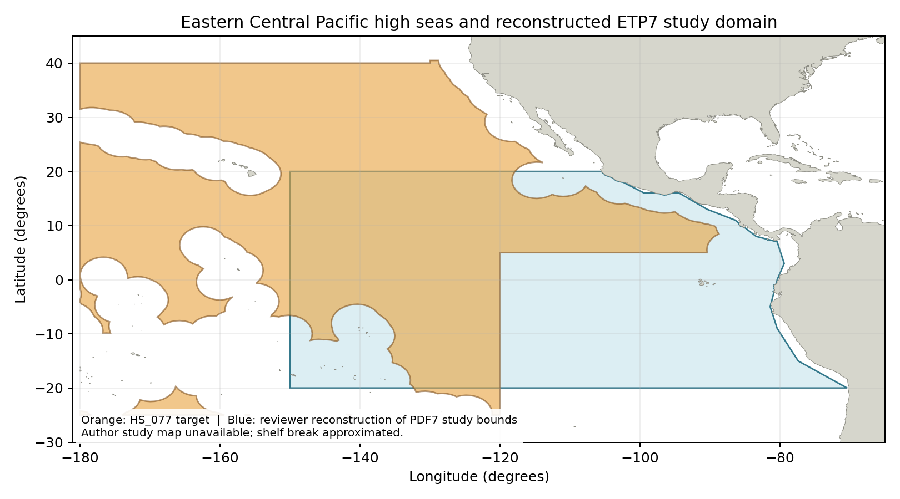
HS_077: repaired Sea Around Us high-seas region 77 boundary; Natural Earth 1:50m land exclusion. Target boundary | Image

Study area in the article
Reviewer reconstruction of source PDF7 bounds
Olson and Watters (2003), printed p. 137 / PDF7: 20°N–20°S, 150°W to American shelf break; 32.8 million km². Coast-following reconstruction; the original article supplies no study map. Source passage | Bounds page | Reconstructed image
Original geographic study figure: unavailable. Article Figures 1–4 show sensitivity and dynamic trajectories rather than the study boundary.

