Regional model validation record
Field | Entry
Region | Celtic-Biscay Shelf, LME_024. Selected study is the Celtic Sea shelf subarea. Regional workbook
Catch source | Sea Around Us 1950–2019 landings/catch/discards. Reference: 2019 landings; all 488 exact labels, including zero catch and unidentified categories. Retained API retrieval September 2026. Catch files
Selected article | Hernvann et al. (2020). The Celtic Sea Through Time and Space: Ecosystem Modeling to Unravel Fishing and Climate Change Impacts on Food-Web Structure and Dynamics. Frontiers in Marine Science 7:578717. DOI | Main PDF | Complete supplement
Other known articles | Lauria, Posen & Mackinson (2016): 65-group Celtic Sea 1991–2012 report; no verified local full input set. Bentorcha et al. (2017): Celtic Sea/Bay of Biscay 1980–2013 trophic models; retained PDF, incomplete static inputs. 2016 DOI | 2017 DOI
Selected model | Hernvann_2020_Celtic_Sea_1985; one fully tabulated 1985 static baseline, 54 source groups (+ synthetic diet_import). Shelf shallower than 200 m, ICES 7.e/f/g/h/j.2. Canonical source selected; accepted computational routing adapter is distinct. Canonical JSON | Accepted runtime
Other models from the same article | 1985–2016 dynamic simulation and six mean-period snapshots are not complete additional static models. Supplement B4 input/completed columns refer to the same 1985 baseline; no second final model. Two snapshot period labels conflict between article and supplement.
Selection rationale | Article: separate comparison reason not recorded (?). Model: user explicitly selected the extracted failing 1985 Celtic Sea model for provisional research. GE/With Egestion remain FAIL; TE is unsupported; production eligibility remains false.
Model extraction | Verified main PDF and full supplement support the source reconstruction. Canonical diets round to 0.996–1.002 and routing is absent: strict admission is NOT_RUN. Accepted adapter normalizes diets, completes six PB/missing Megrim EE and routing; printed BA and source conflicts remain. Source P/Q conflicts, zero bird biomass and physical balance failures limit validity. No scientific inputs rebalanced. Source layers | Retained extraction
SPPR calculation | [MANUAL — Researcher: calculation choices and reasons]  [Excluded groups, scope and relevant values; other adjustments]

Field | Entry
GE diagnostics | No negative SPPR entries across all five basal-source columns and all 55 recipients, including unfished groups. rho_living=0.41833433; b=0.52012021; Discards53 SPPR=529.29249131; Detritus54=1.58366795. Overall FAIL: living production residual up to 35.38%; PP balance gap 30.13%. Full matrix and returns
TE diagnostics | FAIL: TE_RETURN_UNSUPPORTED for this two-pool fishery-return configuration. Matrix, rho_living, b and detritus SPPR are unavailable; no zero or numerical substitute inferred. Raw diagnostic returns
Geographic fit | A. Approximately 25–35% of target region covered by the study. B. Approximately 95–100% of study covered by target. Manual source-contour trace gives central estimates 30.3% and 99.5%; these are approximate visual ranges, not statistical intervals. Boundary assessment
Temporal fit | Static 1985 source coefficients and guild compositions applied to 1950–2019 whole-LME catches; reference is 34 years after baseline. Article publication is 2020. Fixed values do not reconstruct annual ecosystems or changes in fishing composition.
Other | With Egestion: all 275 entries finite/nonnegative; rho_living=0.32649935; b=0.76189950; Discards53=257.01852139; Detritus54=3.57644818. FAIL, PP gap 5.17%. Provisional GE/Egestion are 26.83/13.30 million t C. Blue whiting supplies about 15% each; Lophiidae 7.10%/6.02% and Hake 5.70%/4.84% depend on source-catch allocation assumptions. Method exposure
Open issues and next action | [Researcher: open issues and next actions]
Review and reproducibility | Researcher name: [name] | review date: [date]
Taxon mapping and coverage
Reference: 2019 landings; all exact catch labels, zero catch and unidentified categories included; all sources, no group filter.
54 source groups (+1 synthetic import); 488 exact catch labels.
Independent simple-chain PPR totals 105,377,067.66 t C; landings total 1,067,444.89 t.
105 labels have unavailable classic TL/coefficient; all have true zero 2019 landings and zero annual PPR. TL remains ?, not zero. No positive-catch classic PPR is unknown.
Simple trophic chain: saved classic wet coefficient × catch ÷ 9 once. Percentages use the full unrounded independent denominator.
Complete taxon mapping appendix | Descriptive Sources sheet
Overall confidence | Taxa | Catch percentage | PPR percentage
High | 189 | 80.8313% | 70.4960%
Medium | 185 | 16.2260% | 28.8022%
Low | 0 | 0.0000% | 0.0000%
Very low | 114 | 2.9427% | 0.7018%
Unresolved | 0 | 0.0000% | 0.0000%
The summary uses the weaker required membership or allocation confidence. The following tables show each component separately.
Group assignment rules
Plain-language rule | Confidence | PPR percentage
Explicit named source member | High | 82.6349%
Broader label spans locally represented members | Medium | 12.5318%
Operational generic source definition | Medium | 1.8032%
Supported source genus or family extension | Medium | 1.0311%
Operational generic source definition | High | 0.9707%
Broad reporting-category approximation | Very low | 0.6399%
Verified accepted-name identity | High | 0.3262%
Closest meaningful analogue with mismatches | Very low | 0.0619%
Supported ecological connection | Medium | 0.0003%
Each membership rule uses actual source definitions and reporting scope. All candidate decisions and alternatives
Allocation weight rules
Plain-language rule | Confidence | PPR percentage
One reviewed group, no numerical split | High | 73.7268%
Complete accepted source catch proportions | Medium | 26.2732%
113 multigroup labels use complete accepted 1985 landings + discards, including genuine zero candidates; Medium allocation confidence. No compatible whole-LME caught-mass composition or source stage threshold was found. The four accepted stage splits are preserved. These fixed guild proportions transfer across years, fleets, space and catch bases. Exact weights and populations
Unresolved: none. Very low: 114 labels, 2.9427% of landings / 0.7018% of classic PPR. Broad residual fish/invertebrates, chimaeras, unlisted deep/freshwater fish and grazer gastropods carry explicit taxonomy, feeding and habitat mismatches. Their method shares are 5.17% GE / 4.77% With Egestion. Membership coverage does not establish ecological validity. Exact weak taxa and reasons

Geographic evidence screenshots
Target R and study S are separate geographic objects. The red dashed source contour supports an approximate manual WGS84 trace clipped to shared coastline land; no authoritative digital study polygon was supplied.

Region area
Celtic-Biscay Shelf LME_024 target region
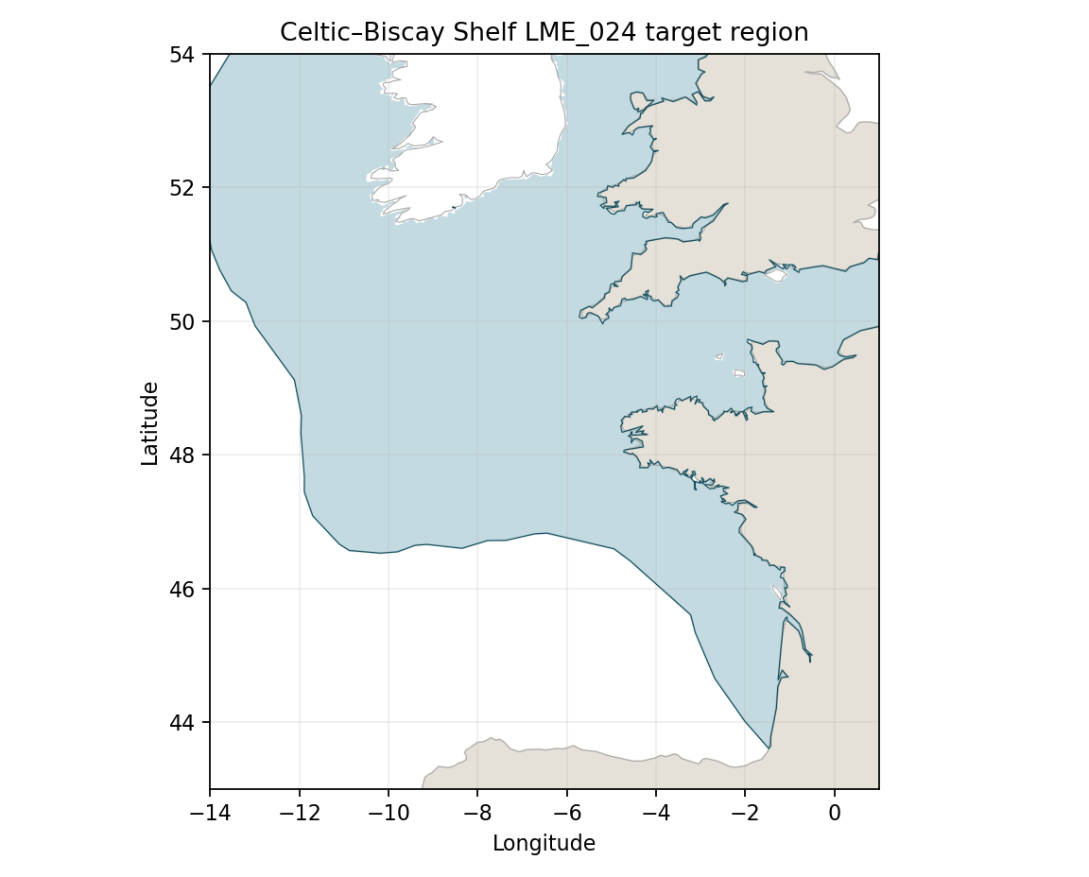
Target R: Sea Around Us LME24 boundary; geodesic area approximately 762,833 km². Target polygon | Image

Study area in the article
Celtic Sea shelf source contour — Figure 1
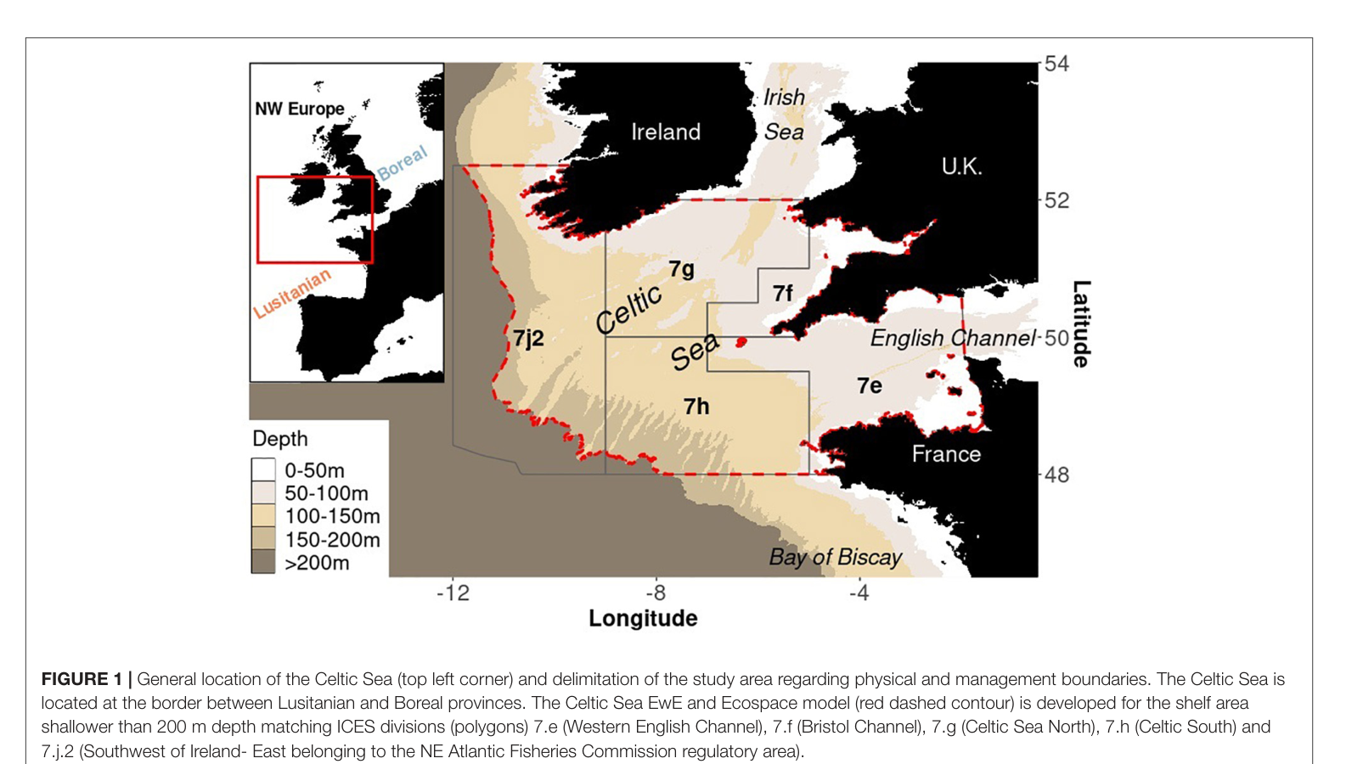
Hernvann et al. (2020), Figure1 p3: red dashed model domain is shelf shallower than 200 m, matching ICES7.e/f/g/h/j.2. The Bay of Biscay lies outside the source Celtic Sea shelf contour. Source PDF | Original full page | Figure image
Manual trace S≈232,138 km²; intersection≈231,021 km²: A≈30.3%, B≈99.5%. Use broad A25–35% and B95–100% ranges because contour/coastline digitization is approximate. Propose an explicitly approximate source-study display trace; preserve target and historical source material. Comparison | Approximate trace

