Mediterranean Sea model validation
Field | Entry
Region | Mediterranean Sea, LME_026  Regional workbook
Catch source | Sea Around Us reconstructed catches, 1950–2019. Reference: 2019 landings, excluding discards. Frozen regional extract.  Sea Around Us region | Catch files
Selected article | Piroddi, Coll, Macias, Steenbeek, Garcia-Gorriz, Mannini, Vilas and Christensen (2022). Modelling the Mediterranean Sea ecosystem at high spatial resolution to inform the ecosystem-based management in the region. Scientific Reports 12, 19680.  DOI | Paper PDF | Paper folder
Other known articles | Piroddi et al. (2017). Historical changes of the Mediterranean Sea ecosystem: modelling the role and impact of primary productivity and fisheries changes over time. Scientific Reports 7, 44491. 1950s baseline with 1950–2011 simulations and four sub-basin networks.  2017 article | Local PDF
Selected model | Piroddi_2022_Mediterranean_1995. Basin-wide 1995 baseline (supplement: 1990s); 71 source groups: 65 consumers, 4 producers and 2 nonliving pools; 37 fleet entries.  Model folder | Selected JSON
Other models from the same article | One distinct Ecopath baseline is supplied. The 1995–2016 Ecosim/Ecospace simulations and spatial outputs are dynamic applications of that baseline, with no separately tabulated alternative Ecopath parameterization.
Selection rationale | Article — The recorded recommendation prefers the recent whole-basin source with supplied parameter-bearing XLSX and DOCX supplements.  Model — Explicit user selection of the extracted 1995 model despite blocked construction; missing routing and the conditional fin-whale conflict remain.
Model extraction | Source B/PB/QB/EE, diets and fleet values are preserved. Diet sums including imports span 0.99956013582–1.00000013576; no normalization. GS, BA, migration and routing remain unknown. Diagnostic staging assumes zero unlisted landings but preserves reported discards; construction stops before requested GS/BA defaults. Fin-whale discards exceed production under the stated zero-BA/net-migration arithmetic; the residual is unexplained and unapplied.  Source audit | Lossless roundtrip
SPPR calculation | [MANUAL — Researcher: calculation choices and reasons]  [Excluded groups, scope and relevant values; other adjustments]

Field | Entry
GE diagnostics | NOT_RUN: missing routing between Discards (70) and Detritus (71) blocks construction. Negative SPPR entries cannot be assessed. rho_living and b are unavailable; SPPR for Discards (70) and Detritus (71) is unavailable.
TE diagnostics | NOT_RUN: the same constructor restriction prevents calculation. Negative SPPR entries and rho_living cannot be assessed; SPPR for Discards (70) and Detritus (71) is unavailable.
Geographic fit | A. Region covered by study: approximately 95–100%.  B. Study area covered by region: approximately 95–100%.
Temporal fit | The 1995 baseline precedes reference catch year 2019 by 24 years. Fixed source composition and stage proxies are transferred across 1950–2019 catches and bases. These do not reconstruct annual ecosystem structure; model PPR remains unavailable.
Other | With Egestion also remains NOT_RUN. Unknown routing cannot be replaced by a source balance check or a taxonomic mapping.  Constructor and method evidence
Open issues and next action | [Researcher: open issues and next actions]
Review and reproducibility | Researcher name: [name] | review date: [date]
Taxon mapping and coverage
Reference: 2019 landings. Independent all-taxon simple-chain estimate; all source support, all recorded labels and no group filter.
71 source groups; 522 catch taxa. No synthetic computational import group.
Simple-chain PPR totals 105,846,498.898 t C in 2019.
40 taxa lack a classic TL/coefficient; all have zero 2019 landings and contribute zero annual PPR. No positive-catch contribution is unknown.
Simple-chain PPR uses the fixed taxon coefficients of the simple trophic chain method.
All-taxon Excel appendix | Descriptive Sources sheet
Overall confidence | Taxa (n) | Catch (%) | Simple-chain PPR (%)
High | 290 | 41.3944% | 64.9733%
Medium | 186 | 48.2426% | 31.1116%
Low | 26 | 0.1836% | 0.1535%
Very low | 20 | 10.1794% | 3.7615%
Unresolved | 0 | 0.0000% | 0.0000%
The summary uses the weaker required membership or allocation confidence. The following tables show each component separately.
Group assignment rules
Membership evidence: Source group definitions and authoritative taxonomic audit Scaridae denotes the historical parrotfish family, now Scarinae within Labridae; the genus-misspelling homonym is excluded. Scaridae rank bridge
Plain-language rule | Confidence | PPR percentage
Explicitly listed source member of the selected group or stage pair | High | 73.4641%
Assumed eligible group set supported by source members and taxonomy | Medium | 14.9221%
Supported ecological extension of the source-defined group | Medium | 6.7841%
Broad reporting category approximated by named and residual source pools | Very low | 3.7615%
Taxonomic extension from source-listed representatives | Medium | 0.3737%
Unambiguous fit to a documented taxonomic group with no competing pool | High | 0.2710%
Verified synonym of an explicitly listed source member | High | 0.2699%
Partial or conflicting ecological fit among plausible source pools | Low | 0.1535%
Closest represented taxonomic or ecological analogue for an absent compartment | Very low | <0.0001%
Allocation weight rules
Weights and assumptions: All candidates and source quantities | Primary-source composition search
Plain-language rule | Confidence | PPR percentage
One group receives the complete taxon catch; no split uncertainty | High | 79.2924%
Selected-model caught-mass proportions used as a fixed composition proxy | Medium | 16.3223%
Complete accepted model-biomass proportions when source landings are unusable | Medium | 4.3853%
Each rule percentage is the share of independent simple-chain PPR associated with taxa using that rule.
Unresolved taxa: none. Very low approximations account for 10.1794% of landings and 3.7615% of simple-chain PPR. They concern broad mixed categories and absent-compartment analogues; exact taxa, assumptions and weights are flagged in the appendix. Residual fish reporting uses bony-fish candidates; dedicated shark/ray pools are excluded. Mixed NC large pelagic retains Mola mola with cartilaginous pooling uncertainty. Complete source catch or biomass supplies assumed weights; model methods remain NOT_RUN. Reporting scope evidence The retained crustacean proxy includes documented decapods53–60, mixed nondecapod benthos61 and unspecified zooplankton65. The latter supplies76.34% of the biomass split; this is unobserved composition, not caught-mass evidence. Broad aquatic-invertebrate pools remain a weak ecological proxy; provider demersal metadata is not exhaustive taxonomy.

Geographic evidence screenshots
Target region R and selected-model study area S. The basin-wide geographic estimate is approximate; coastal grid cells and strait boundaries remain uncertain.

Region area
Target region boundary
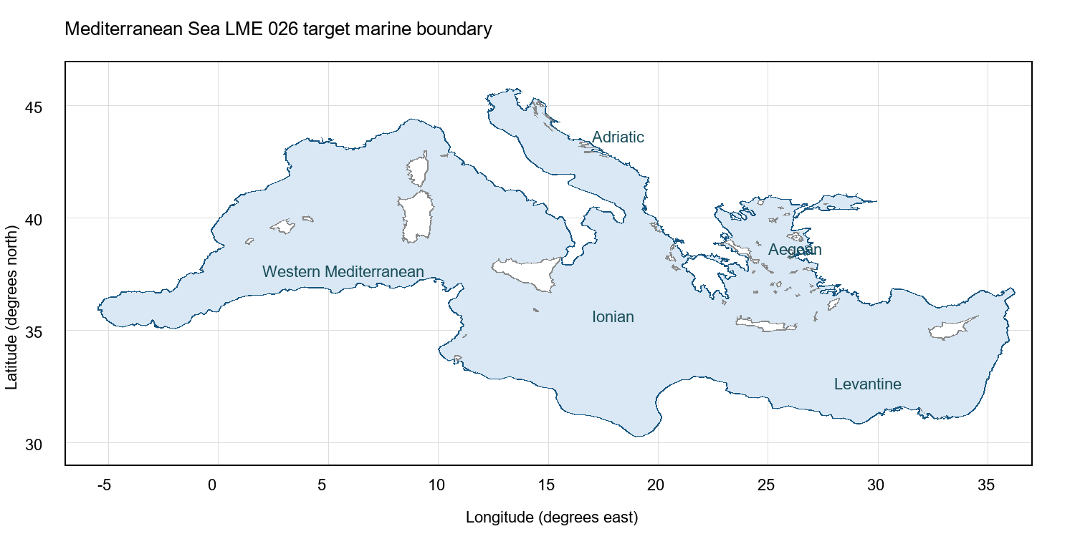
Mediterranean Sea LME_026. Current project marine polygon. Boundary source | Geographic assessment

Study area in the article
Study boundary for the selected model
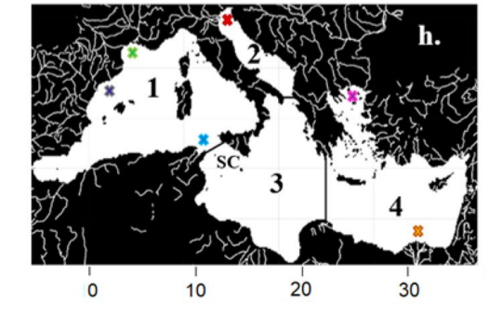
Piroddi et al. (2022), Figure 4h, p. 9. Whole Mediterranean ocean domain and four sub-basins; Figure 4a provides the matching marine mask. Source PDF

