Guinea Current model validation
Field | Entry
Region | Guinea Current, LME_028; Sea Around Us target boundary. Regional workbook
Catch source | Sea Around Us v 50.1 catch series, 1950–2019; retained API 88 material dated 3 September 2026. Reference: 2019 landings, including reported/unreported retained catch; discards separate. Raw catch | Taxon/TL source
Selected article | Guénette & Diallo (2004), Addendum: Modèles de la côte guinéenne, 1985 et 1998, pp.124–159. In Palomares & Pauly (eds.), West African marine ecosystems: models and fisheries impacts, FCRR 12(7). Chapter PDF | Paper folder
Other known articles | Gascuel, Guénette, Diallo & Sidibé (2009), Impact de la pêche sur l’écosystème marin de Guinée – Modélisation EwE 1985/2005, FCRR 17(4), 60 printed pages. The title says 1985/2005; Ecopath construction and Table 3 specify 1985/2004. 2009 report
Selected model | 28_646_Guinea_(1998); 1998, waters off the Republic of Guinea, 111,932 km². 44 ecological source groups plus synthetic diet_import 45. This is a national coastal/offshore model transferred to the full LME. Selected JSON | Model folder
Other models from the same article | The chapter also presents a 44-group 1985 counterpart derived from balanced 1998, with reconstructed early catches. Stored 28_726_Guinea_(1985) is the distinct 35-group, 42,969 km² shelf revision in the 2009 report. Hash-suffixed copies are extraction identities, not extra baselines. Stored 1985 identity
Selection rationale | Article: ? (separate article-choice rationale unrecorded). Model: recorded rationale is geographic transfer requiring overlap validation. The source supports preferring 1998 over 1985 because contemporary landing/biomass estimates were available; the earlier model has greater catch-reconstruction uncertainty.
Model extraction | Accepted canonical parameters retained. Native database JSON differs only in 44 added taxonomy descriptions. Table 9 (p.143/PDF 147) has 13 B/EE values outside strict printed-rounding bounds; PB/QB agree at displayed precision. Oiseaux TL 3.77 differs from accepted calculated 3.545. Coarse diets and reconstructed catch/discards remain limitations. Inherited diet normalization changes cells by at most 3.07×10⁻⁸; default GS, derived BA and import 45 remain accepted conventions. Source/runtime comparison | Table9 differences
SPPR calculation | [MANUAL — Researcher: calculation choices and reasons]  [Excluded groups, scope and relevant values; other adjustments]

Field | Entry
GE diagnostics | No negative SPPR entries across the basal-source columns, including unfished groups. rho_living=0.44972255; b=0.35481349; Detritus (44) SPPR=1.77921290.
TE diagnostics | No negative SPPR entries across the basal-source columns, including unfished groups. rho_living=0.71757128; Detritus (44) SPPR=0.42594772.
Geographic fit | Approximate A: 5–7% of the region covered by the study. B: 95–100% of the study inside the region.
Temporal fit | Static 1998 coefficients and historical mixture weights are applied across 1950–2019. The reference year is 21 years later; annual ecosystem/fleet changes are not reconstructed.
Other | TE retains its implausibility warning: the deep large shark/ray pool has an extreme coefficient. Symbolic negative-source failures, Monte Carlo implausibility flags and unavailable source decompositions remain. Full catch mapping does not establish whole-LME ecological validity. Method-specific exposure
Open issues and next action | [Researcher: open issues and next actions]
Review and reproducibility | Researcher name: [name] | review date: [date]
Taxon mapping and coverage
Reference: 2019 landings; all exact catch labels, including unidentified and zero-catch records; no taxon or group filter.
44 source ecological groups (+1 computational import); 375 catch labels.
Simple-chain PPR totals 202,194,055.86 t C in 2019.
50 labels lack a saved classic coefficient/TL; all have zero 2019 landings and therefore zero annual PPR. Unavailable TL remains ?, not zero.
Method: independent classic/simple trophic chain using the saved taxon coefficient.
Full taxon mapping appendix and descriptive Sources sheet
Overall confidence | Taxa | Catch percentage | PPR percentage
High | 159 | 37.1304% | 50.9112%
Medium | 107 | 17.4133% | 24.1215%
Low | 32 | 7.0456% | 9.3463%
Very low | 77 | 38.4107% | 15.6210%
Unresolved | 0 | 0.0000% | 0.0000%
The summary uses the weaker required membership or allocation confidence. The following tables show each component separately.
Group assignment rules
Plain-language rule | Confidence | PPR percentage
Exact source member in every documented applicable group. | High | 49.2426%
Complete actual source representative union supports a higher label or stage mixture; local composition inferred. | Medium | 30.4993%
Broad reporting category approximated over compatible named and residual source pools; caught composition unknown. | Very low | 15.0201%
Taxonomic extension from source congeneric representatives; unlisted membership assumed. | Medium | 2.9685%
Verified taxon fits the explicit source compartment without a competing specific placement. | High | 1.2596%
Closest positive taxonomic or habitat analogue; unrepresented habitat, size or taxon mismatch disclosed. | Very low | 0.6009%
Verified accepted synonym connects the catch label to a printed member. | High | 0.4091%
Membership evidence: source members, taxonomy and complete candidate decisions Broad bony fish includes named stocks and deep/pelagic members; dedicated cartilage groups are excluded. Elasmobranchii excludes chimaeras. Broad invertebrate sets review actual euphausiids, benthos and larval stages. Scaridae denotes the historical parrotfish family, now Scarinae within Labridae; the genus-misspelling homonym is excluded. Scaridae rank bridge
Allocation weight rules
Plain-language rule | Confidence | PPR percentage
One reviewed group; no numerical split. | High | 74.7211%
Complete accepted 1998 group-export catch proportions; historical mixture/catchability assumed. | Medium | 15.7985%
Retained whole-period single-group donor total-catch proxy; reporting/population mismatch assessed separately. | Low | 9.4805%
Each rule percentage is the share of the complete independent simple-chain PPR universe. Overall confidence is the weaker membership/allocation component. All 71 split labels retain explicit assumptions: 37 use complete 1998 model catch proportions; 34 preserve donor total-catch weights at Low confidence. Fixed mixtures are transferred across all years/bases. Allocation and donor applicability evidence
No unresolved taxa remain. Very low: 77 labels, 38.4107% of landings and 15.6210% of classic PPR. Broad mixtures and unlisted depth/taxonomic analogues, including freshwater tilapias/cyprinids and chimaeras, are flagged individually in the appendix. The excluded TE arithmetic estimate is 4.5717 billion t C; Elasmobranchii contributes 23.6895%, Prionace glauca 13.2955% and Sphyrna zygaena 10.0636%. Explicit shark membership is retained; the extreme pooled coefficient and Low donor mixture make TE scientifically implausible. Actual method contributions

Geographic evidence screenshots
R is the full Guinea Current LME; S is the study waters off Guinea. The graticule trace and ordered coastline approximate the original figure. Nine source-visible water controls test both sides of the maritime limits and coastal water; these ranges are not statistical intervals.

Region area
Guinea Current target region
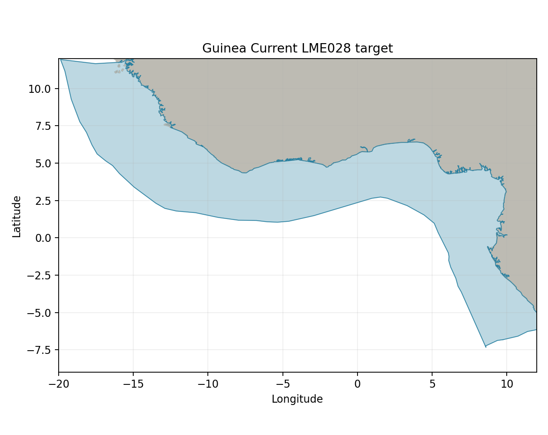
Sea Around Us LME 28 target R: 1,918,762 km². Target boundary | Map image

Study area in the article
Original Guinea study area Figure 1
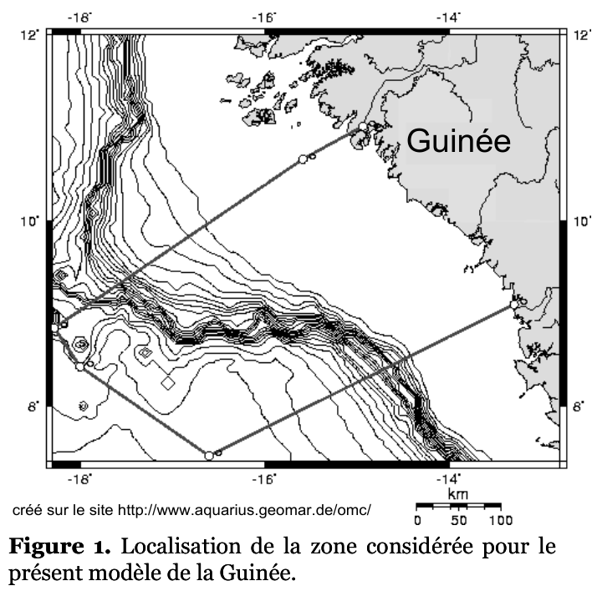
Guénette & Diallo 2004 Figure 1, printedp.124/PDF 128. The model covers waters off the Republic of Guinea; the LME continues far beyond the study. Source-reported area is 111,932 km². Original source | Geographic assessment
Approximate source-boundary comparison: reconstructed marine area 109,016 km², A≈5.64%, B≈99.28%; coarse report ranges 5–7% and 95–100% reflect line/coast uncertainty. The calibrated western corner and two real boundary bends follow the printed outline; markers/annotations were not water exclusions. Reconstructed polygon
