Israel Mediterranean model validation 1990 to 1994
Candidate review • Pending-alignment draft. The reconstructed model still fails strict mass balance.
Field | Entry
Region | Israel Mediterranean • EEZ_939 • Regional workbook
Catch source | Sea Around Us regional catch series, 1950–2019; reference year 2019, landings. Retained download/version date is unavailable.  Original catch bundle | Catch and classic PPR workbook
Selected article | Corrales X, Ofir E, Coll M, Goren M, Edelist D, Heymans JJ and Gal G (2017). Modeling the role and impact of alien species and fisheries on the Israeli marine continental shelf ecosystem. Journal of Marine Systems 170:88–102.  DOI | Article PDF | Author supplement
Other known articles | Corrales et al. (2017), Hindcasting the dynamics of an Eastern Mediterranean marine ecosystem under the impacts of multiple stressors. Related dynamic study; no additional numerical source adopted.  Related study DOI
Selected model | Corrales_2017_ICS_1990_1994_gray_fit_F_removals  Reviewed candidate for 1990–1994; 39 source groups (+1 synthetic diet import); shelf depths 0–200 m, area 3,725 km². Regional selection is currently blank.  Canonical model JSON | Saved runtime and diagnostics | Model folder
Other models from the same article | Published counterpart: 2008–2012 (41 groups), same shelf domain. Both periods retain source-only, assumed-fate, gray-only fit and gray-fit/F-removal variants. These reconstructions are separate from the author’s models.  All retained models
Selection rationale | Article: researcher supplied this paper for extraction. Model: both published periods assessed; no regional selection rationale recorded (?).
Model extraction | Ordinary blank diet cells are assumed zero on runtime copies. Original gray cells (<0.01) remain −9999 in source models; this separate variant fits them within their published bound. Printed diet values are fixed before runtime normalization.  Missing total removals are reconstructed from published F × biomass where consistent with known components. GS defaults to 0.2; living accumulation defaults to zero. Detritus accumulation is calculated. Fate is assumed, and explicit fleet-discard returns are omitted by the calculator.  Departures and source evidence | Gray-cell fit
GE diagnostics | WARN: input production residual up to 7.4%; strict mass balance is false.  No negative basal-source contributions in any retained group/source pairing.  ρ living = 0.228; b = 0.0897; Detritus (38) SPPR = 1.02; Discards (39) SPPR = 0.  PP budget gap = 0.11%; below the grading threshold, but strict budget closure is false.
TE diagnostics | WARN: input production residual up to 7.4%; strict mass balance is false.  No negative basal-source contributions in any retained group/source pairing.  ρ living = 0.27; Detritus (38) SPPR = 0.84; Discards (39) SPPR = 0.  PP budget gap = 0.23%; below the grading threshold, but strict budget closure is false.
SPPR calculation | [Researcher calculation choices and notes]
Geographic fit | Approximate containment scenario: A (region covered by study) ≈ 13–14%; B (study covered by region) ≈ 90–100%.
Temporal fit | Modeled period 1990–1994; assessed catch is 2019, outside that period. Fixed composition and coefficients would assume no later food-web/fishery change. Earlier model groups 24 and 35 are absent; no corresponding catches are invented.
Other | With Egestion also returned WARN. Finite SPPR and convergent recycling do not establish mass balance. Automatic detritus collapse and removal of Discards were deferred because the required mass-balanced prerequisite remains unmet.
Open issues and next action
Review and reproducibility | Researcher name: [name] | review date: [dd/mm/yyyy]

Mass balance findings
Filling only gray cells cannot balance the rounded translated model. Even after the authorized removal reconstruction, the smallest possible maximum production residual is 7.4%. Ordinary blanks stay zero, printed fractions remain fixed, and each fitted gray fraction is below 0.01. These are constraints on this reconstruction, not a finding that the original native Ecopath model was unbalanced.
Group and published ID | Production | Catch | Predation | Residual
Demersal sharks (29) | 0.014 | 0.01 | 0 | 7.4%
Mackerel (33) | 0.0994 | 0.02 | 0.080225 | 5.8%
Rays and skates (30) | 0.0282 | 0.02 | 0.0029859 | -5.5%
Large native dem. fishes (21) | 0.121 | 0.08 | 0.032177 | -4.3%
Native medium pelagic fishes (34) | 0.085 | 0.041 | 0.03891 | 4.0%
Dolphins (39) | 0.0009 | 0.0004 | 0 | -3.6%
Small pelagic fishes (31) | 1.68 | 0.12 | 1.4224 | -3.2%
Turtles (37) | 0.0102 | 0.0048 | 0 | -2.9%
Flows are t km⁻² yr⁻¹. Residual = (catch + predation + accumulation + net migration + other mortality − production) / production. Negative means an unexplained production sink deficit; positive means excess demand. Published IDs are used in the table. All groups and both balance equations
Demersal sharks require negative predation: catch 0.010 exceeds EE × production 0.008960 by 0.001040. Gray-cell filling cannot remove that contradiction. Mackerel needs predation 0.074430, below the smallest attainable 0.078645 with printed diets fixed. Rays/skates have no gray incoming diet cells; their required predation 0.004534 exceeds the attainable 0.002986. Large native demersal fishes also have no gray incoming diet cells, leaving a deficit that normalization can only worsen.
Turtles and dolphins have no incoming predation in the source diets but nonzero fishing mortality. Reconstructed removals reduce their original losses; residuals remain because rounded F, B, P/B and EE are not mutually exact. No published biomass accumulation, net migration or unrounded native values are available to resolve these terms. Seabird biomass printed as 0.00 prevents reliable reconstruction of its positive consumption.
Discards retains zero modeled inflow because the calculator omits explicit fleet-discard returns, while animals still eat it. Its negative calculated accumulation cancels that predation arithmetically; this is not an observed stock trend or a validated fishery-return budget. Natural detritus routing does not repair this missing return. Catch rounding, missing removals and defaults remain separate from gray-cell uncertainty.

Taxon mapping and coverage
Reference: 2019 landings; all recorded catch taxa, with no taxon or group exclusions. Proposed candidate mapping.
39 source groups (+1 synthetic diet-import group); 96 catch taxa.
Simple-chain PPR totals 153,259 t C in 2019.
46 taxa lack a saved TL/coefficient, all with zero reference-year catch; their annual contribution is zero. No positive catch has missing simple-chain PPR.
Method: simple trophic chain using the retained taxon coefficients and transfer efficiency 0.1.
Excel taxon appendix and descriptive Sources sheet: All 96 proposed taxon mappings
Overall confidence | Taxa (n) | Catch (%) | Simple-chain PPR (%)
High | 29 | 22% | 40%
Medium | 33 | 20% | 18%
Low | 0 | 0% | 0%
Very low | 34 | 58% | 41%
Unresolved | 0 | 0% | 0%
Overall confidence uses the weaker required membership or allocation component.

Group assignment rules
Plain-language rule | Confidence | PPR percentage
Broad reporting category with unknown internal composition | Very low | 41%
Explicit species membership in the author supplement | High | 40%
Ecological or taxonomic extension of the published group | Medium | 18%
Verified synonym of explicit source species | High | 0.036%
Closest ecological analogue without explicit source membership | Very low | 0%
Membership evidence: author supplement section 1 and verified historical-name crosswalks; ecological extensions remain explicit. Source group definitions

Allocation weight rules
Plain-language rule | Confidence | PPR percentage
Entire taxon assigned to one group | High | 59%
Source-model biomass proportions used when catch is incomplete | Medium | 30%
Source-model catch proportions used as composition proxy | Medium | 11%
Weights and assumptions: complete source catch proportions first, then original biomass proportions; composition and catchability are assumed transferable to 2019. Allocation evidence
Each percentage is the independent simple-chain PPR associated with taxa using that rule.
Unresolved taxa: none under the stated proposals. 34 Very low decisions cover 58% of catch and 41% of simple-chain PPR. These shares rely on uncertain composition or ecological analogues.

Very low decisions
Affected taxa | Why confidence is very low
Carangidae; Cephalopoda; Chondrichthyes; Decapoda; Dendrobranchiata; Elasmobranchii; Marine fishes not identified; Marine pelagic fishes not identified; Miscellaneous marine crustaceans; Mullidae; Perciformes; Sciaenidae; Scombridae; Serranidae; Sparidae; Tetraodontidae | Unknown internal composition across several source guilds; model catch/biomass proportions are proxies.
Acanthocybium solandri; Pomatomus saltatrix; Trachinotus ovatus | Unlisted pelagic predator approximated by the large-pelagic guild; size or geographic representation uncertain.
Alopias vulpinus; Cetorhinus maximus; Etmopterus; Galeus melastomus; Hexanchus griseus; Isurus oxyrinchus; Lamna nasus; Prionace glauca; Scyliorhinidae; Sphyrna lewini; Squalidae; Squaliformes; Squalus; Squalus acanthias | Unlisted shark approximated by the demersal-shark guild, with feeding or shelf/deep-water habitat mismatch.
Sarpa salpa | Native herbivore approximated by an alien herbivore guild.

Geographic evidence
The study covers the Israeli 0–200 m shelf. A ≈ 13–14% and B ≈ 90–100% use the reported 3,725 km² area and an assumed near-complete coastal-shelf containment within the 25,748 km² target EEZ. The study polygon and exact endpoints are unavailable; these are approximate containment scenarios, not a measured intersection.

Region area
Target region boundary
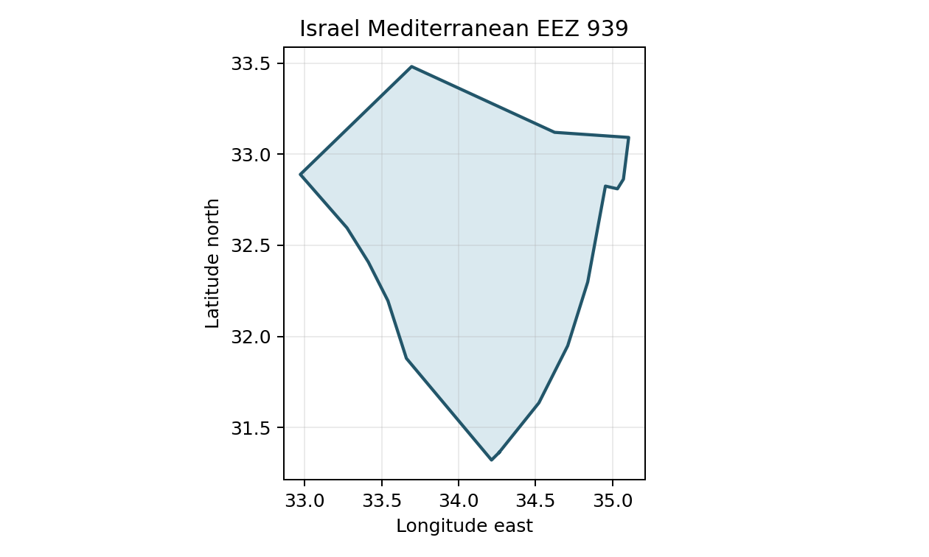
Israel Mediterranean EEZ_939; retained project boundary, spherical area approximation. Boundary evidence

Study area in the article
Study boundary for the selected model
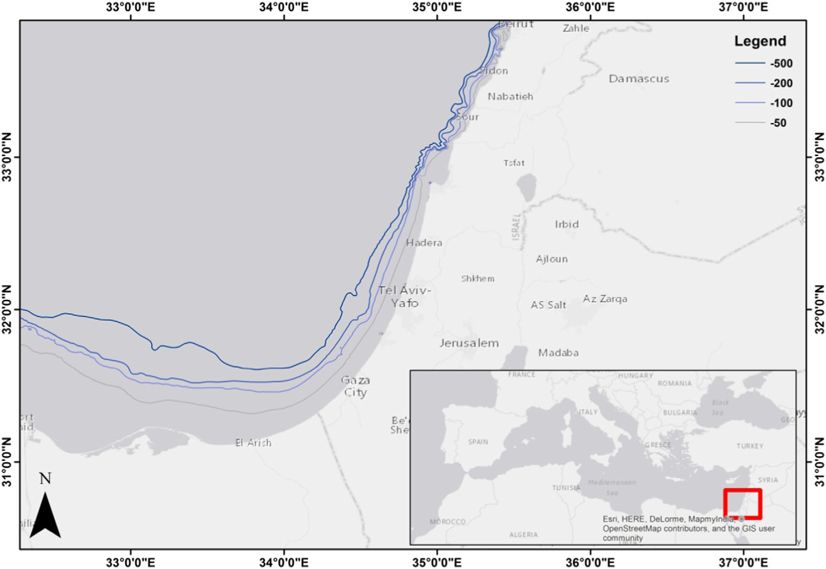
Corrales et al. (2017), Figure 1, PDF page 3 / printed page 90. The figure shows wider regional bathymetry; the study is restricted to the 0–200 m shelf. Original article

