**The Shteigen project**

The Shteigen project is a web application that is a studying aid.

It allows students to present the fruits of their studying as a logical graph of nodes and arches and create dynamic leveled flow charts.

Its technological stack is React/typescript for the client and Ruby on Rails for the server, with Postgres as the database.

**Description**

The groups of graphs are divided into modules.

You can choose a module and watch all its graphs and you can create a module:

The splash screen:

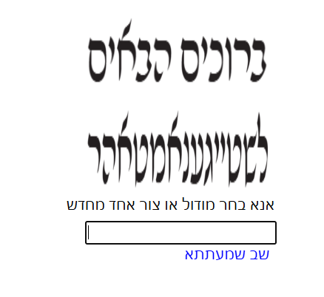

Adding a new module is done by writing the name in the input box and pressing enter.

Pressing the module name will lead you to the module page and watching all its graphs:

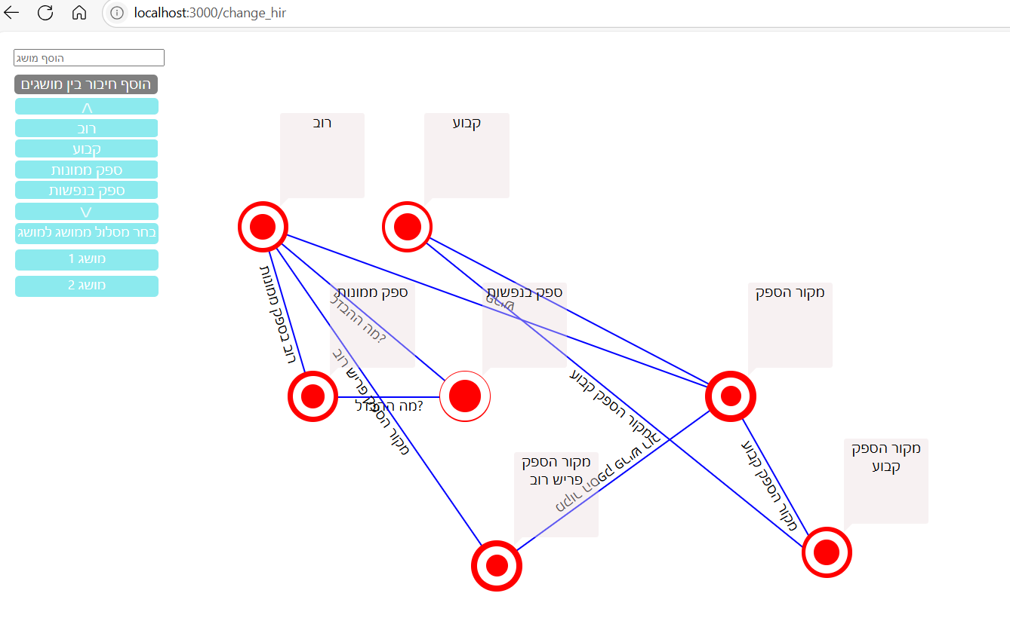

You can add a new node by entering its text on the top left inputbox, which represents a concept.

pressing on a node opens the concept modal:

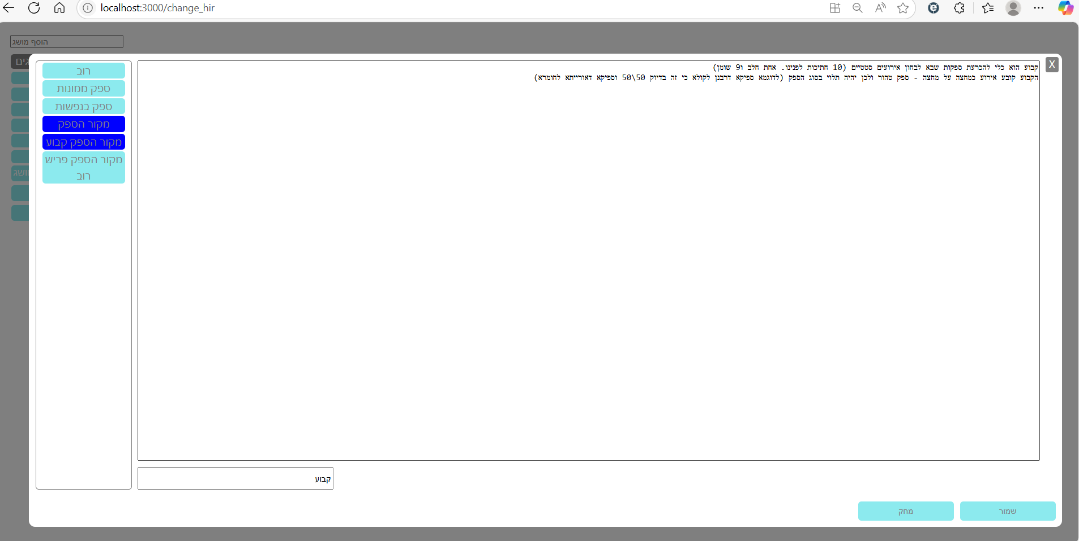

You can add text to the big textbox.you can save the text by pressing the saving button on the bottom right.

Pressing the erasing button will erase the concept.

on the upper left corner there is a list of the other concepts. the ones this concept is connected to are marked blue. the ones who are not connected are colored azure. you can create a relationship between them by pressing the azure nodes and giving the arch that connects the two concepts a name.

you can delete/update an arch by pressing on it, which opens the arch modal:

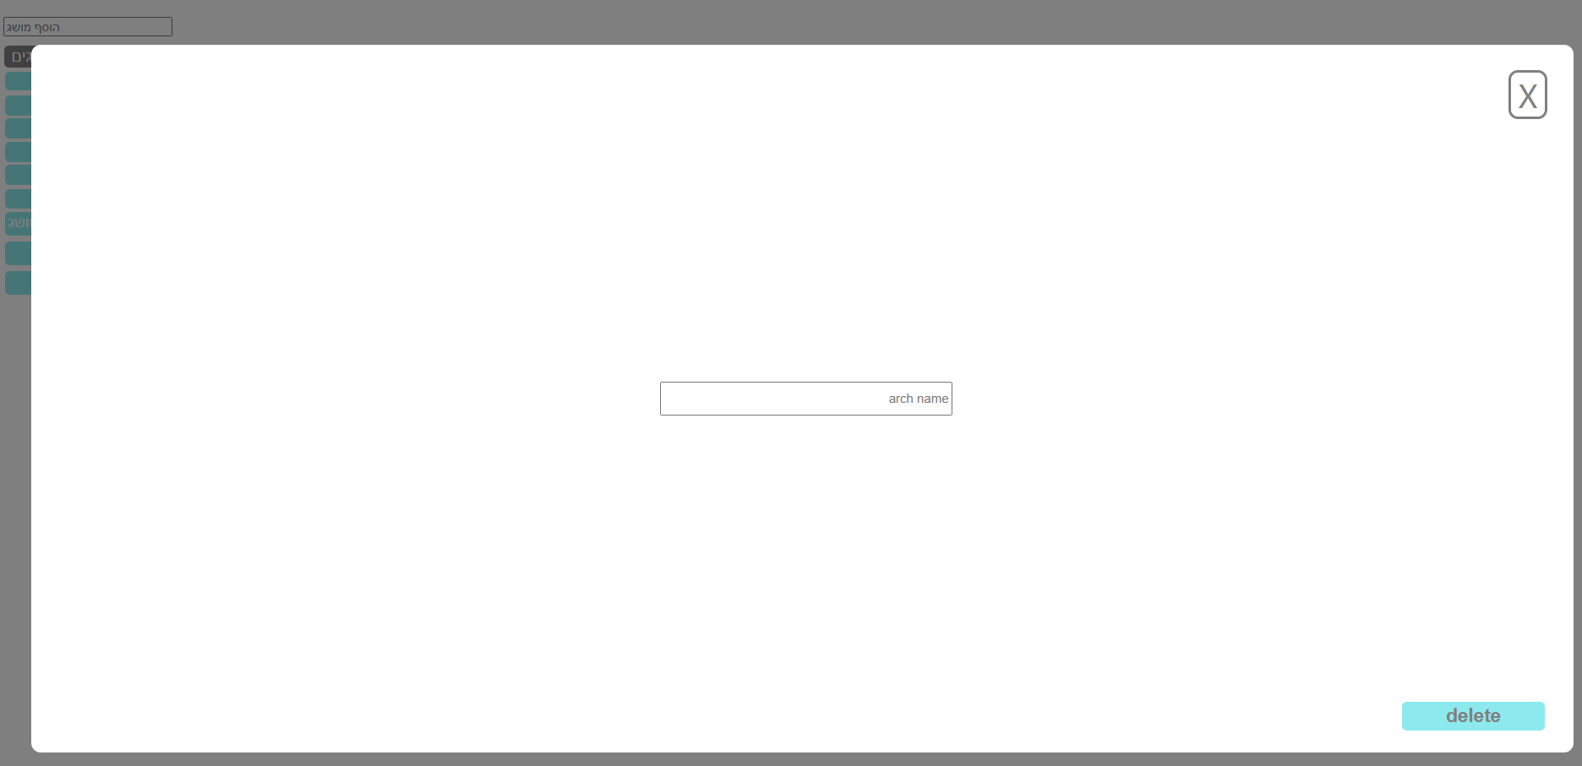

writing the new name and enter will save the new arch name. pressing delete will delete the arch

for next version: locking updating in case someone else is editing and reconciling differences between several changes made to a module at the same time by different computers.