**Deep Learning - 236606 – HW3**

Ido Glanz - 302568936 Matan Weksler - 302955372

1. **CNN architectures:**

In this part, we experimented with different CNN architectures for the CIFAR-10 dataset aiming to reach 85% accuracy for the validation set and using the Keras API while maintaining less than 50K trainable parameters. The dataset in general consists of 50K samples of 10 different classes, each one a picture 32-by-32 (RGB).

We started by reading on different architectures (mostly ones reviews in class) and using first a simple CNN with 13 layers as follows:

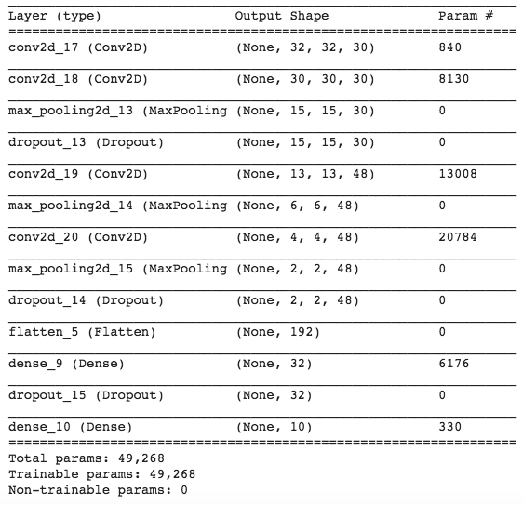

Using the Adam optimizer with learning rate 0.0001 with 1e-6 decay and running for 250 epochs we got:



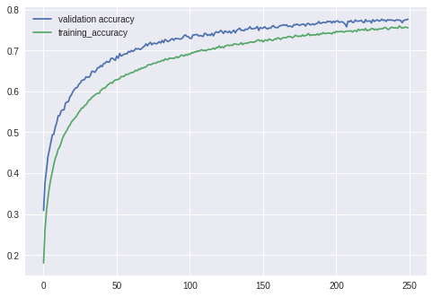

Running for more epochs did not do the job and we had to look for other architectures which could converge to the needed accuracy with the given parameters size

After reading more we started experimenting with the DenseNet architecture (*Huang, Gao, et al. "Densely connected convolutional networks." CVPR. Vol. 1. No. 2. 2017*), which is in a way similar to ResNet, utilizing a building block unit in which each layers’ input feature map dimension is merged with previous layers’ input as so it grows gradually inside a block. While in ResNet the previous layers’ input is added (summed) to the current ones, in DenseNet it is concatenated as so the inputs dimension gradually grows (i.e. if the block input is a of 10 feature maps, and the first layers output is 4, the next layers input will be 14 feature maps and so on). The blocks are then chained together with transition layers in between, reducing the number of feature maps where needed. These types of architectures allow usage of less parameters (as they in a sense “share” layers) and after altering it a bit to reduce the number of parameters even more we ended up with the following network:

_______________________________________________________________________

Layer (type) Output Shape Param # Connected to

=============================================================================================

input_1 (InputLayer) (None, 32, 32, 3) 0 _____________________________________________________________________________________________

conv2d_1 (Conv2D) (None, 32, 32, 24) 648 input_1[0][0] _____________________________________________________________________________________________

batch_normalization_1 (BatchNor (None, 32, 32, 24) 96 conv2d_1[0][0]

_____________________________________________________________________________________________

activation_1 (Activation) (None, 32, 32, 24) 0 batch_normalization_1[0][0]

_____________________________________________________________________________________________

conv2d_2 (Conv2D) (None, 32, 32, 48) 1152 activation_1[0][0]

_____________________________________________________________________________________________

batch_normalization_2 (BatchNor (None, 32, 32, 48) 192 conv2d_2[0][0]

_____________________________________________________________________________________________

activation_2 (Activation) (None, 32, 32, 48) 0 batch_normalization_2[0][0]

_____________________________________________________________________________________________

conv2d_3 (Conv2D) (None, 32, 32, 12) 5184 activation_2[0][0]

_____________________________________________________________________________________________

concatenate_1 (Concatenate) (None, 32, 32, 36) 0 conv2d_3[0][0]

conv2d_1[0][0]

_____________________________________________________________________________________________

batch_normalization_3 (BatchNor (None, 32, 32, 36) 144 concatenate_1[0][0]

_____________________________________________________________________________________________

activation_3 (Activation) (None, 32, 32, 36) 0 batch_normalization_3[0][0]

_____________________________________________________________________________________________

conv2d_4 (Conv2D) (None, 32, 32, 48) 1728 activation_3[0][0]

_____________________________________________________________________________________________

batch_normalization_4 (BatchNor (None, 32, 32, 48) 192 conv2d_4[0][0]

_____________________________________________________________________________________________

activation_4 (Activation) (None, 32, 32, 48) 0 batch_normalization_4[0][0]

_____________________________________________________________________________________________

conv2d_5 (Conv2D) (None, 32, 32, 12) 5184 activation_4[0][0]

_____________________________________________________________________________________________

concatenate_2 (Concatenate) (None, 32, 32, 48) 0 conv2d_5[0][0]

concatenate_1[0][0]

_____________________________________________________________________________________________

batch_normalization_5 (BatchNor (None, 32, 32, 48) 192 concatenate_2[0][0]

_____________________________________________________________________________________________

activation_5 (Activation) (None, 32, 32, 48) 0 batch_normalization_5[0][0]

_____________________________________________________________________________________________

conv2d_6 (Conv2D) (None, 32, 32, 24) 1152 activation_5[0][0]

_____________________________________________________________________________________________

average_pooling2d_1 (AveragePoo (None, 16, 16, 24) 0 conv2d_6[0][0]

_____________________________________________________________________________________________

batch_normalization_6 (BatchNor (None, 16, 16, 24) 96 average_pooling2d_1[0][0]

_____________________________________________________________________________________________

activation_6 (Activation) (None, 16, 16, 24) 0 batch_normalization_6[0][0]

_____________________________________________________________________________________________

conv2d_7 (Conv2D) (None, 16, 16, 48) 1152 activation_6[0][0]

_____________________________________________________________________________________________

batch_normalization_7 (BatchNor (None, 16, 16, 48) 192 conv2d_7[0][0]

_____________________________________________________________________________________________

activation_7 (Activation) (None, 16, 16, 48) 0 batch_normalization_7[0][0]

_____________________________________________________________________________________________

conv2d_8 (Conv2D) (None, 16, 16, 12) 5184 activation_7[0][0]

_____________________________________________________________________________________________

concatenate_3 (Concatenate) (None, 16, 16, 36) 0 conv2d_8[0][0]

average_pooling2d_1[0][0]

_____________________________________________________________________________________________

batch_normalization_8 (BatchNor (None, 16, 16, 36) 144 concatenate_3[0][0]

_____________________________________________________________________________________________

activation_8 (Activation) (None, 16, 16, 36) 0 batch_normalization_8[0][0]

_____________________________________________________________________________________________

conv2d_9 (Conv2D) (None, 16, 16, 48) 1728 activation_8[0][0]

_____________________________________________________________________________________________

batch_normalization_9 (BatchNor (None, 16, 16, 48) 192 conv2d_9[0][0]

_____________________________________________________________________________________________

activation_9 (Activation) (None, 16, 16, 48) 0 batch_normalization_9[0][0]

_____________________________________________________________________________________________

conv2d_10 (Conv2D) (None, 16, 16, 12) 5184 activation_9[0][0]

_____________________________________________________________________________________________

concatenate_4 (Concatenate) (None, 16, 16, 48) 0 conv2d_10[0][0]

concatenate_3[0][0]

_____________________________________________________________________________________________

batch_normalization_10 (BatchNo (None, 16, 16, 48) 192 concatenate_4[0][0]

_____________________________________________________________________________________________

activation_10 (Activation) (None, 16, 16, 48) 0 batch_normalization_10[0][0]

_____________________________________________________________________________________________

conv2d_11 (Conv2D) (None, 16, 16, 24) 1152 activation_10[0][0]

_____________________________________________________________________________________________

average_pooling2d_2 (AveragePoo (None, 8, 8, 24) 0 conv2d_11[0][0]

_____________________________________________________________________________________________

batch_normalization_11 (BatchNo (None, 8, 8, 24) 96 average_pooling2d_2[0][0]

_____________________________________________________________________________________________

activation_11 (Activation) (None, 8, 8, 24) 0 batch_normalization_11[0][0]

_____________________________________________________________________________________________

conv2d_12 (Conv2D) (None, 8, 8, 48) 1152 activation_11[0][0]

_____________________________________________________________________________________________

batch_normalization_12 (BatchNo (None, 8, 8, 48) 192 conv2d_12[0][0]

_____________________________________________________________________________________________

activation_12 (Activation) (None, 8, 8, 48) 0 batch_normalization_12[0][0]

_____________________________________________________________________________________________

conv2d_13 (Conv2D) (None, 8, 8, 12) 5184 activation_12[0][0]

_____________________________________________________________________________________________

concatenate_5 (Concatenate) (None, 8, 8, 36) 0 conv2d_13[0][0]

average_pooling2d_2[0][0]

_____________________________________________________________________________________________

batch_normalization_13 (BatchNo (None, 8, 8, 36) 144 concatenate_5[0][0]

_____________________________________________________________________________________________

activation_13 (Activation) (None, 8, 8, 36) 0 batch_normalization_13[0][0]

_____________________________________________________________________________________________

conv2d_14 (Conv2D) (None, 8, 8, 48) 1728 activation_13[0][0]

_____________________________________________________________________________________________

batch_normalization_14 (BatchNo (None, 8, 8, 48) 192 conv2d_14[0][0]

_____________________________________________________________________________________________

activation_14 (Activation) (None, 8, 8, 48) 0 batch_normalization_14[0][0]

_____________________________________________________________________________________________

conv2d_15 (Conv2D) (None, 8, 8, 12) 5184 activation_14[0][0]

_____________________________________________________________________________________________

concatenate_6 (Concatenate) (None, 8, 8, 48) 0 conv2d_15[0][0]

concatenate_5[0][0]

_____________________________________________________________________________________________

batch_normalization_15 (BatchNo (None, 8, 8, 48) 192 concatenate_6[0][0]

_____________________________________________________________________________________________

activation_15 (Activation) (None, 8, 8, 48) 0 batch_normalization_15[0][0]

_____________________________________________________________________________________________

global_average_pooling2d_1 (Glo (None, 48) 0 activation_15[0][0]

_____________________________________________________________________________________________

dense_1 (Dense) (None, 10) 490 global_average_pooling2d_1[0][0]

=============================================================================================

Total params: 45,634

Trainable params: 44,410

Non-trainable params: 1,224

_____________________________________________________________________________________________

We used the SGD optimizer and the datagen to enrich the data, and running for 250 epochs we obtained:



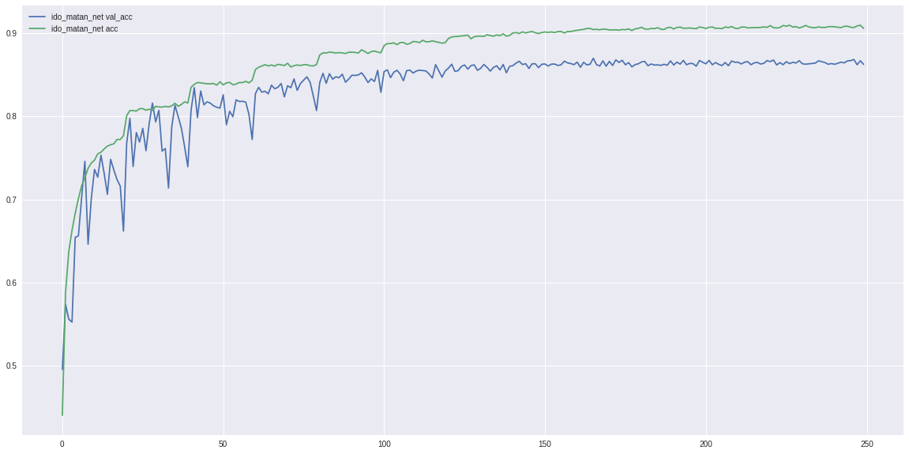

1. **Transfer Learning**

In this section, we experimented with 2 different transfer learning techniques using the VGG-16 architecture, trained for CIFAR-100 dataset in aim to generate a classifier for a subsection of the CIFAR-10 data. This relays on the general idea of having the inner layers of the network serve as feature extractors, regardless of the number of the specific number of classes in the given data set, and have the last fully connected layer (or layers) classify the image based on the features extracted and the number of classes.

* 1. In the first part, we used the pre-trained weights for the VGG-16 on CIFAR-100 dataset that was given in the recitation and replaced the last layer with one augmented for the 10 classes in the CIFAR-10 dataset. We then froze all the weights aside from the new layer we introduced, hence having only 5130 out of 15,001,418 parameters that are trainable. We ran the network using subsets of the CIFAR-10 of sizes 100, 1000 and 10K and the results were as follows:

|  |  |  |  |  |
| --- | --- | --- | --- | --- |
| Train set size | Train set loss | Train set accuracy | Test set loss | Test set accuracy |
| 100 |  |  |  |  |
| 1000 |  |  |  |  |
| 10K |  |  |  |  |

* 1. In the second part, we implemented a KNN classifier based on the first fully connected layer, again under the assumption it contains a variety of features extracted from the image and based on these a classification can be inferred.

In practice, we used the VGG-16 network with the pre-trained weights from the recitation, only stopping now at the layer-before-last, hence having an output of 512 features extracted by the network. We then used the SKlearn tool box to map features extracted from a subset of the training set to the KNN space and ran the test set through the network, then predicting their classification using the KNN map (again, using the SKlearn library). As ascribed in the assignment, we ran the classifier for subsets of sizes 100, 1000 and 10K. For the K parameter in the KNN algorithm, we ran it from k=1 to k=100 and the results were as follows: