**Subnet Calculator**

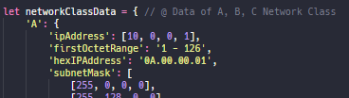

**networkClassData : Object data of 3 Class**



**networkClassSelected : Radio input HTML**

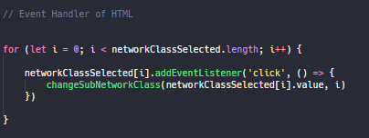

**.addEventListener to 3 Class Radio input**

**if select class X then loop will uncheck another class**

**except the selected class**

**and call function changeSubNetworkClass( X )**

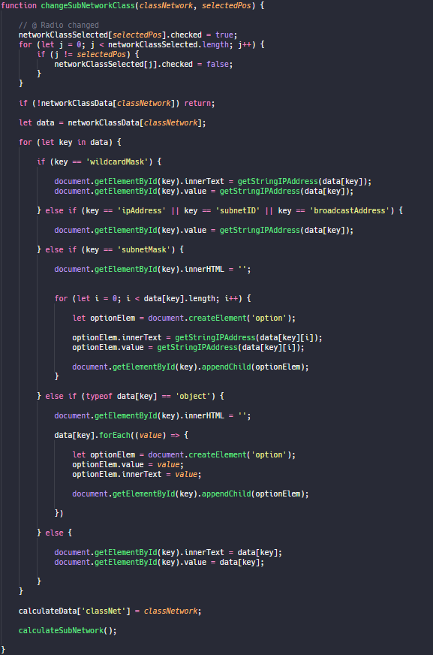

**If networkClassData[ X ] is null then return  
  
but if it’s not null**

**We’ll loop for set the interface for X class data**