**Existing Data**

Introduction

**Local Schools**

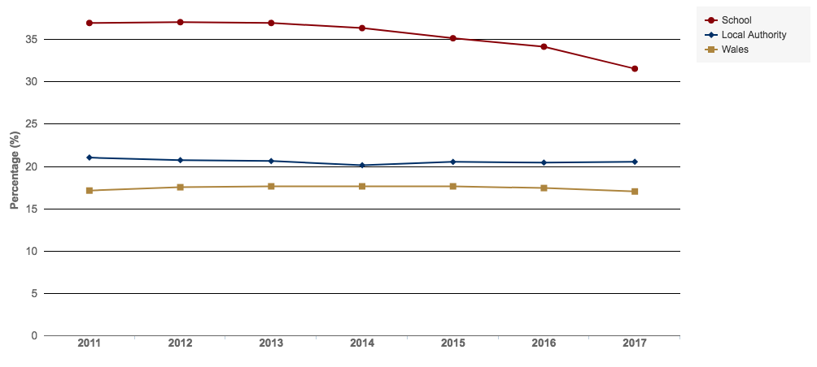

**Fig.** This shows the number of students on free school meals at Fitzalan Secondary School, which is the nearest secondary school to the areas we are studying. While the number of students on free school meals is falling in recent years, it is still well above the local authority and Wales averages.

( <http://mylocalschool.wales.gov.uk/School/6814042?lang=en> )

**Percentage of Students on Free School Meals at Fitzalan Secondary School**

**Introduction**

**Study of Poverty and Deprivation in the Canton, Grangetown, and Riverside areas in Cardiff**

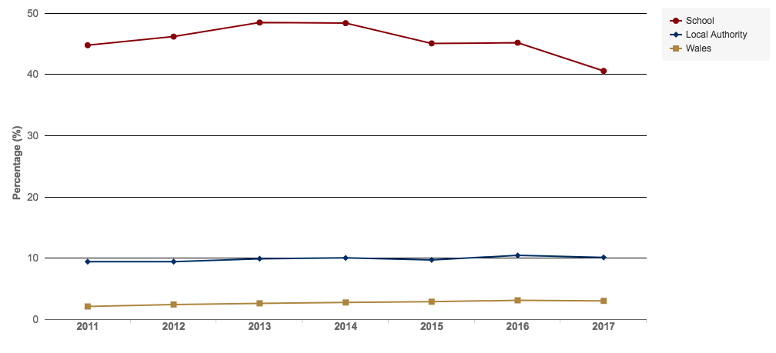

**Percentage of Students with English as an Additional Language at Fitzalan Secondary School**

**Fig.** Shown here is the percentage of students at Fitzalan Secondary School with English as an Extra Language (EAL). The percentage of EAL students is more than 10x the average for Wales. ( <http://mylocalschool.wales.gov.uk/School/6814042?lang=en> )

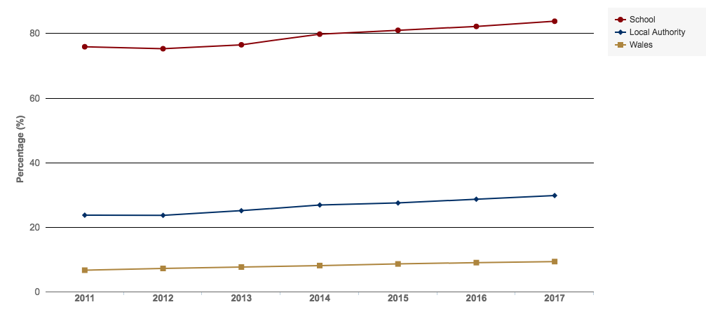

**Percentage of Students of Minority Ethnic Background at Fitzalan Secondary School**

**Fig.** This figure shows the percentage of students at Fitzalan Secondary School who responded that their ethnic background was anything other than white-British. This excludes students whom there is no data or who preferred not to say. The percentage of minority ethnic students at this school is 9x the average for Wales

( <http://mylocalschool.wales.gov.uk/School/6814042?lang=en> )

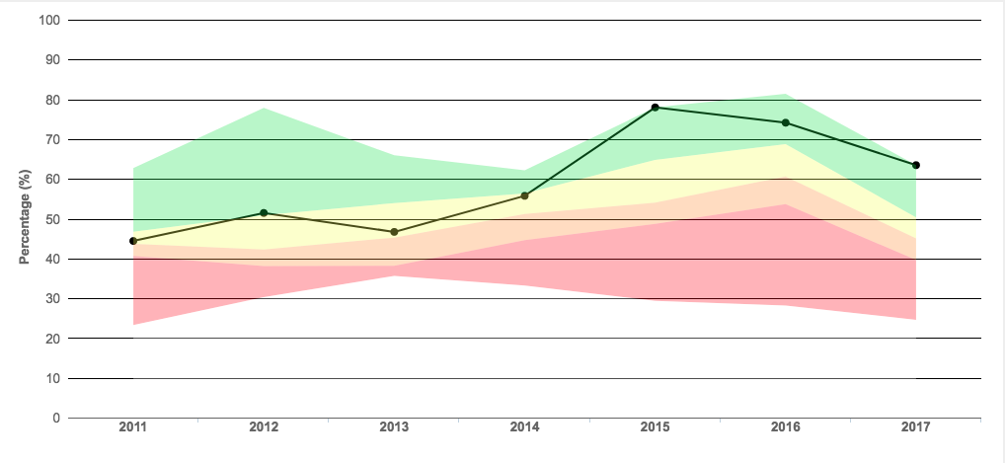

**English Performance**

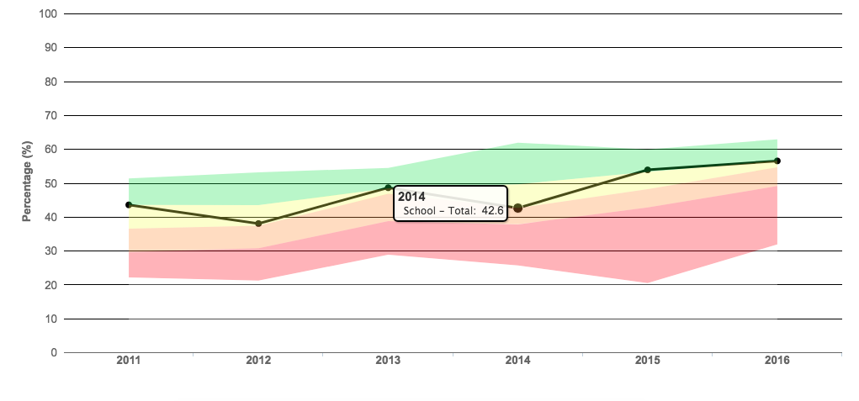

**Maths Performance**

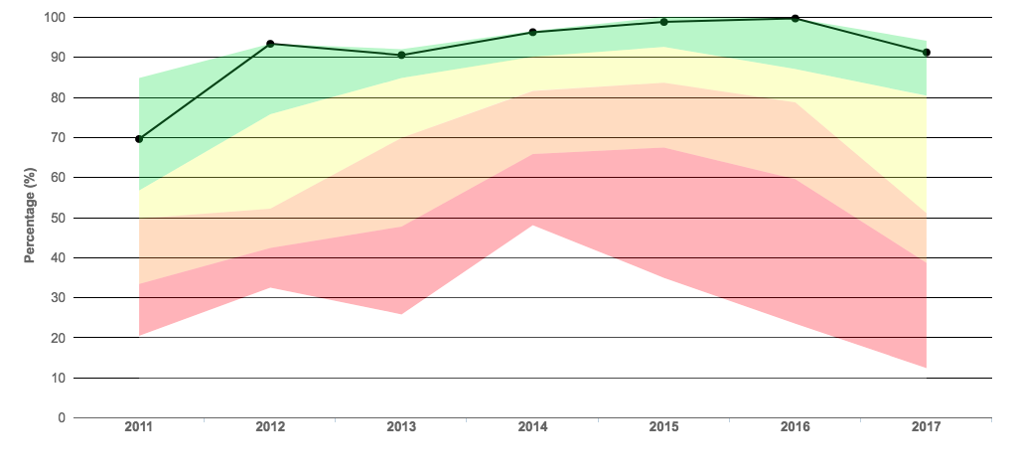

**Science Performance**

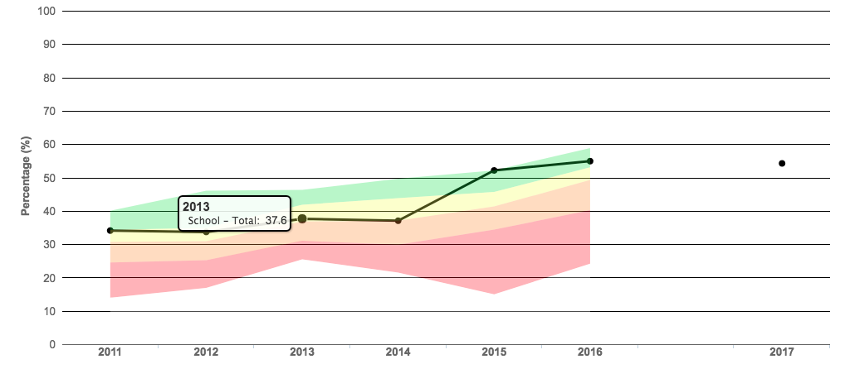

**Level 2 Performance**

**Fig.** The first three plots show the percentage of pupils at Fitzalan Secondary School achieving grade A*-C in English, Maths, and Science respectively. The coloured bars indicate quartile ranges for schools with a similar number of students on free school meals in the UK. The final plot shows the percentage of pupils achieving the level 2 threshold. This means they achieved the equivalent of five A*-C GCSE grades, including Maths and English/Welsh. Note that this indicator has been changed for 2017, so direct comparison to previous years is not possible. All of these indicators suggest that the school is performing very well given the level of deprivation in the area. (<http://mylocalschool.wales.gov.uk/School/6814042?lang=en> )

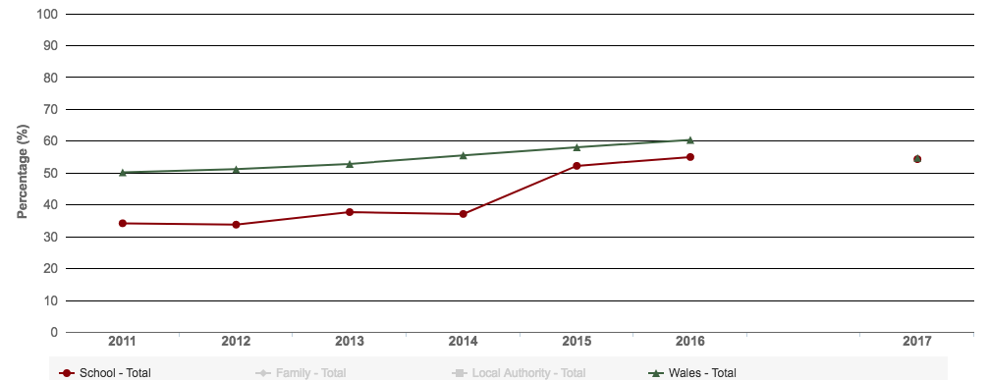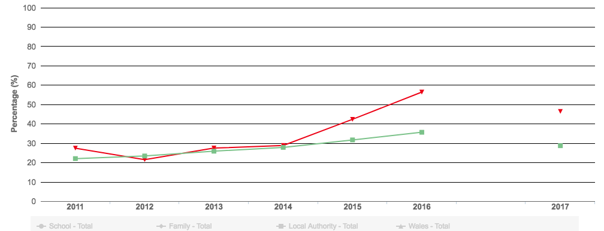

**Percentage of Pupils Achieving the Level 2 Threshold**

**Percentage of FSM Pupils Achieving the Level 2 Threshold**

**Fig.** The top plot is the percentage of students at Fitzalan Secondary School attaining the level 2 threshold (including a GCSE in English/Welsh and Maths). Below a plot showing the percentage of FSM students attaining the level 2 threshold. Red lines indicate the school, green lines indicate the Welsh average. As you can see, the school overall is below the Welsh average, but is performing very well for its FSM students. (Direct comparisons to 2017 cannot be made as the way the measure is calculated have changed). (<http://mylocalschool.wales.gov.uk/School/6814042?lang=en> )