NLP – HW2

Ido Shapira Yoav Rabinovich  
319021044 208275735

1a)

1b)

1d)

Perplexity = 113.313

2a)

2b)

3a)

We think that character-based models will have better understanding of gentle differences between words and sentences. This will contribute to the persistence of “small window” elements of the language prediction like grammar. On the other hand, using character-based models with compared to word-based models will achieve less expressive results and won’t be able to understand semantic meaning as good as word-based models duo to the small granularity which emphasize gentle differences and not “big picture” ideas of sentences.

4.a.

4.b

Question 1 model perplexity:

shakespeare perplexity : 5.770625170390506

wikipedia perplexity : 24.694984109600412

Question 3 model perplexity:

shakespeare perplexity: 7.334185113381366

wikipedia perplexity: 19.282856653181966

5. a.

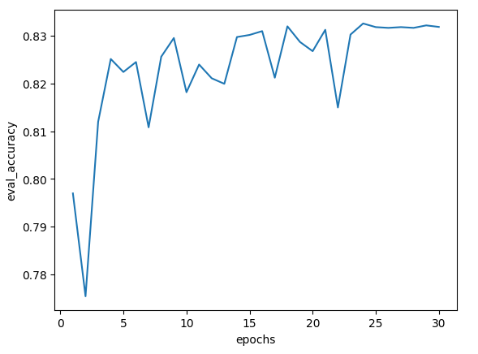

b.

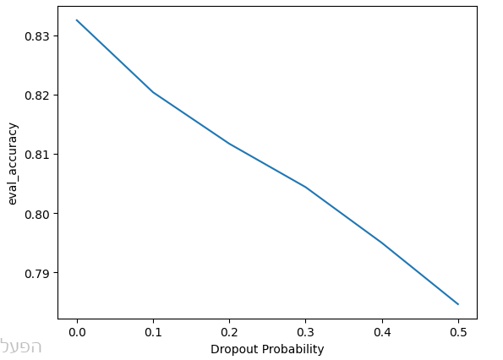

c.

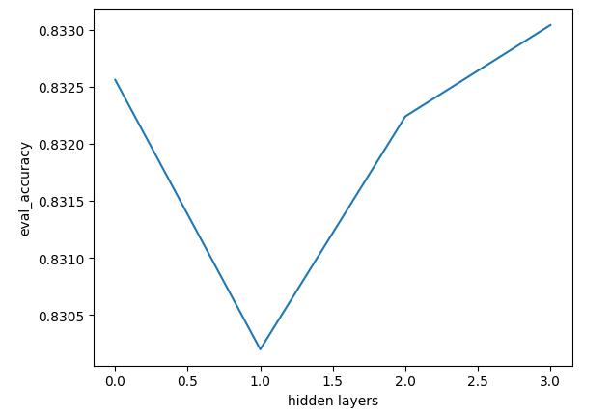

Before the experiment we expected to see better results for each added hidden layer. We didn’t expect that the model with one hidden layer will get worse results than with a linear model. We can see we still getting better results with 3 hidden layers but we expect that with more hidden layers we will reach the point where adding more hidden layers will have insignificant effect.

The linear models did not outperform the model with 3 hidden layers.

d.

ReLU:

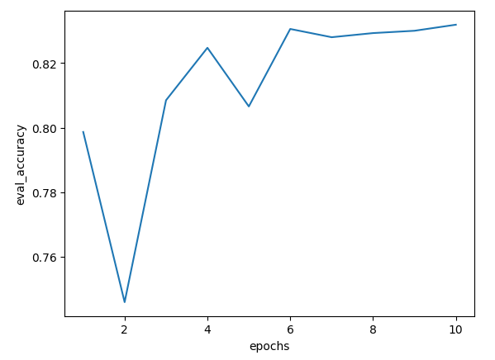

[Sigmoid:](https://pytorch.org/docs/stable/generated/torch.nn.Sigmoid.html#torch.nn.Sigmoid)

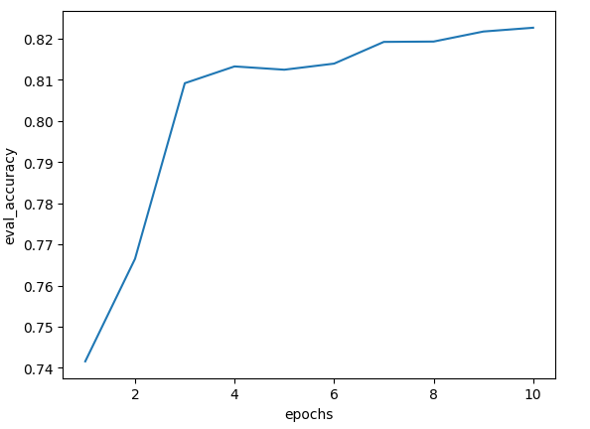

[Tanh](https://pytorch.org/docs/stable/generated/torch.nn.Tanh.html#torch.nn.Tanh):

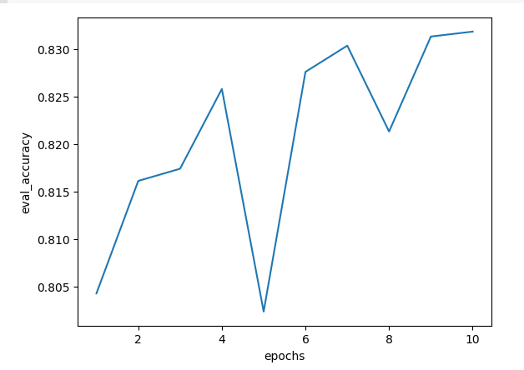

We can see that there are differences between models with different activation functions. The best activation for this model is ReLU. We can see that the sigmoid activation function achieved close to peak results faster than the 2 other functions and was the steadiest among the activation functions.

e)

**Example1:**

Input Text: This HAS to be my guilty pleasure. I am a HUGE fan of 80's movies that were designed to entertain and they didn't care if they offended anyone. This move has no meat, not substance, no deep thought provoking scenes. Just plain old college kids having fun and if a few breasts have to be shown, then so be it! This movie is for when you just want to relax and NOT think. Viva la nudity!

Predicted label: 0

real label: 1

**prediction explanation:** The reviewer actually liked the fact that the movie is stupid and pointless, usually these words will appear in bad review while the reviewer consider them as good.

**Example2:**

Input Text: This was a fantastically written screenplay when it comes to perceiving things from another perspective. The comedy was timely and not overdone, the acting was generally terrific, and the plot line served a greater purpose of generating misconception when we think about people solely based on their external appearance. The plot twists as the brother/sister character of Amanda Bynes tries to play soccer on the boys team finding instead a new love interest along the way. Tatum Channing is where the real misperception lies and he does a fine job of acting disinterested at first, later coming to realize the most important thing in life is friendship, not attitude.

Predicted label: 0

real label: 1

**prediction explanation:** again, bad considered sentences like “the acting was generally terrific” actually pointed as positive review.

**Example3:**

Input Text: I really enjoyed this movie. Yes there was disrespect throughout the movie, but Bruce Willis learned, from The Kid, that there is more value in repecting others, and his life of disrespect needs to change. This movie was a refreshing change from the trash that Hollywood is trying to shove down our throats. There are some very good lessons to be learned in this movie. I really believe this was one of Disneys best, even though a couple of things could have been left out. I was impressed with the lack of swearing and lack of sexual inuendos. It isn't perfect, but much better than most everything else out there.

Predicted label: 0

real label: 1

**prediction explanation:** Now the reader points negative arguments about the movie as counter to his good review which made the model wrong by taking it as the actual review.

**Example4:**

Input Text: An intense thriller about a mute movie make-up artist who witnesses a snuff film being made when she is working late in the studio one night. After she tries to get away from the murder scene, she realizes she is in for more than she bargained for when the entire mafia is out to kill her for being a witness. This movie leaves you on the edge of your seat.

Predicted label: 0

real label: 1

**prediction explanation:** Here the reviewer explains about scenes in the movie that can be interpreted as bad for example “After she tries to get away from the murder scene, she realizes she is in for more than she bargained for when the entire mafia is out to kill her for being a witness”. This made the model think this is a bad review while it actually a good one.

**Example5:**

Input Text: This is one of the worst Sandra Bullock movie since Speed 2 But not quite that bad. I really lost it with those out of the blue not so "special effect". Guys, If you're an insomniac go with your girl to see this movie. I give it three sleepies!

Predicted label: 1

real label: 0

**prediction explanation:** Here probably the sentence “Guys, If you're an insomniac go with your girl to see this movie” probably made the model not giving the word “insomniac” enough weight and consider it as a good review.

6.

Using bayes rule: