Stock Keeping Unit (SKU) Definition and How They’re Used in Retail

* 

By [Rachel Burns](https://www.shipbob.com/author/rachel-burns/)

* May 4, 2018

The world of order fulfillment can seem [full of confusing jargon](https://www.shipbob.com/blog/3pls-from-a-to-z-definitions-for-e-commerce-order-fulfillment/#.WuxpJtMvzBI), especially if you’re just starting your ecommerce business. Part of creating an ecommerce [order fulfillment strategy](https://www.shipbob.com/blog/order-fulfillment/) involves understanding all of the different parts of successful [fulfillment and inventory management](https://www.shipbob.com/blog/inventory-management/).

One important element to get familiar with is the SKU, or Stock Keeping Unit.

In this article, you will learn what a SKU is, how SKUs are used, and how to calculate the number of SKUs in your inventory.

**Don't Mess Up Holiday Logistics This Year**

Prepare your fulfillment and supply chain operations for a seamless Q4

[**Download The Guide**](https://resources.shipbob.com/9-ways-to-not-mess-up-your-holiday-logistics)

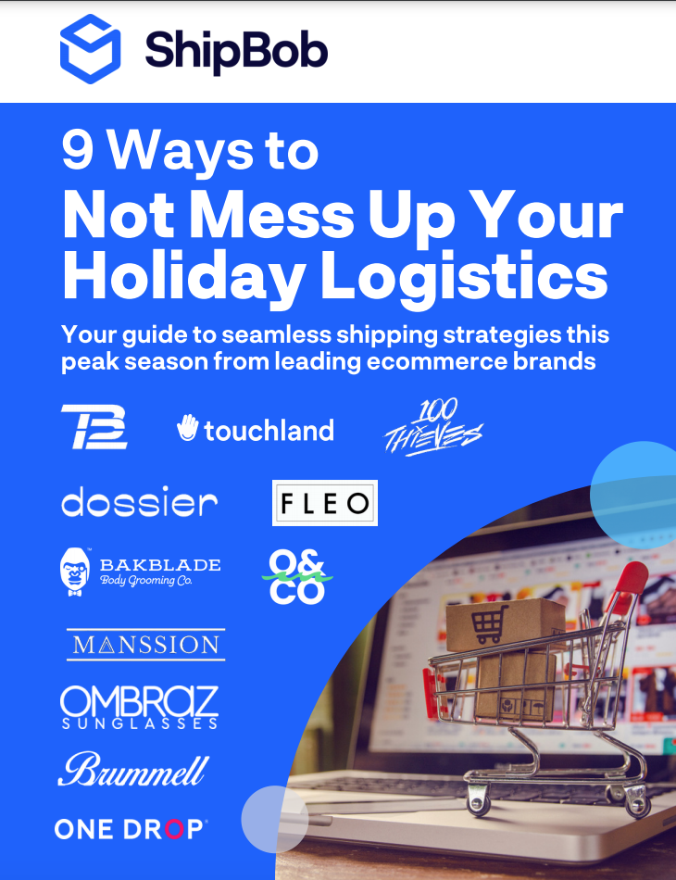

What is a Stock Keeping Unit (SKU)?

A Stock Keeping Unit, or SKU, is an alphanumeric code used by online or retail stores to identify a specific product. SKUs are often on scannable bar codes and represent different product characteristics such as color, size, and brand, and are used for inventory management.

Using a SKU and Barcodes

A SKU can be any series of numbers that you choose. Unlike a Universal Product Code (UPC), SKUs are not universal; instead, each retailer has its own set of SKUs.

There is no rule about creating SKUs, but make sure that everyone at your company understands your SKU system; SKUs are meant to be easily read, as opposed to [barcodes](https://www.shipbob.com/blog/shipping-barcode/) or UPCs that often need equipment or software to break down.

[Shopify](https://www.shopify.com/encyclopedia/stock-keeping-unit-sku) gives the following example for a SKU number:

A SKU for a pair of purple Ugg boots in the Bailey Bow style, size 7 might look something like this: UGG-BB-PUR-07.

The above example is easy to read, shares important information about the product, and follows a clear naming convention.

How SKUs are used in ecommerce

SKUs help you keep track of your inventory with regard to both [inbound and outbound logistics](https://www.shipbob.com/blog/inbound-and-outbound-logistics/), and are especially helpful when working with a third-party fulfillment provider.

When working with a new third-party logistics ([3PL](https://www.shipbob.com/blog/3pl/)) provider, you will likely be asked how many different SKUs you have in your inventory. This helps the 3PL know how much [warehousing and storage space](https://www.shipbob.com/blog/warehousing/) you will need in their fulfillment center, as well as how complex your orders may be.

Many 3PLs store each unique SKU in its own bin or shelf space to optimize [picking lists](https://www.shipbob.com/blog/picking-list/) to make the picking and packing process as accurate and efficient as possible.

A 3PL that offers a comprehensive [inventory management](https://www.shipbob.com/blog/inventory-management/#.Wux6RtMvzBI) solution may offer the following services, all of which are based on SKUs:

* Sync inventory by automatically pulling SKUs from your online store
* Show real-time inventory levels by SKU
* Set [reorder points](https://www.shipbob.com/blog/reorder-point-formula/) for each SKU based on the quantity at which you wish to be alerted to [restock inventory](https://www.shipbob.com/blog/restocking-inventory/)
* Bundling different SKUs for promotions
* Merging the same product across ecommerce platforms
* [Kitting SKUs to assemble them a certain way before they are shipped to customers](https://www.shipbob.com/kitting-assembly/)

Overall, 3PLs use SKUs to not only keep track of your inventory, but also to offer customized and in-depth analytics and services for your ecommerce business.

How to calculate the number of SKUs in your inventory

To calculate the number of SKUs in your inventory, you will need to consider all of the different product variations you offer. This includes variations in color, size, price, and more. The number of SKUs in your online store will be equal to the number of product variations.

If you are a small clothing retailer, your SKU calculations might look like this:

You have a t-shirt that comes in 2 styles, 2 colors, and 3 sizes. Red or blue; v-neck or crewneck; and small, medium, or large. Here are all of the possible product variations:

1. Red, V-neck, Small
2. Red, V-neck, Medium
3. Red, V-neck, Large
4. Red, Crewneck, Small
5. Red, Crewneck, Medium
6. Red, Crewneck, Large
7. Blue, V-neck, Small
8. Blue, V-neck, Medium
9. Blue, V-neck, Large
10. Blue, Crewneck, Small
11. Blue, Crewneck, Medium,
12. Blue, Crewneck, Large

2 colors x 2 styles x 3 colors = 12 variations; you will have 12 SKUs.

Conclusion

SKUs may seem confusing, but they don’t have to be! They are an integral part of inventory management, and successful inventory management is key to [ecommerce fulfillment](https://www.shipbob.com/ecommerce-fulfillment/) success.

If you are looking for an end-to-end fulfillment solution that includes inventory management, check out [ShipBob](https://www.shipbob.com/). See which of your SKUs are selling best, receive automatic reorder notifications based on inventory for each SKU, and access additional advanced reporting about your inventory. Request a pricing quote below to speak with a fulfillment expert.