What is Demand Forecasting? Importance and Benefits of Forecasting Customer Demand

* 

By [Kristina Lopienski](https://www.shipbob.com/author/klopienski/)

* June 27, 2019

Running a business is hard. You never really know how it will all turn out, yet you need to be able to answer questions like these:

How many units of inventory do you need to have on hand to be at full stock for each SKU?

How often do you project to [replenish inventory](https://www.shipbob.com/blog/inventory-replenishm)?

How will those projections change over time?

Where do you expect to be a year from now?

Okay, so maybe you only sort of have an understanding of demand for your products. That’s fine! Forecasting projections is one of the toughest things to get right.

And even when you’ve been doing it for a while and start to get the hang of it, your projections shift again.

Whether your brand is experiencing [gradual sales or is in high-growth mode](https://www.shipbob.com/blog/ecommerce-dtc-brand-growth-seasonal-sales-order-volume/), we’ll walk you through some tips to improve your ability to forecast demand.

**Don't Mess Up Holiday Logistics This Year**

Prepare your fulfillment and supply chain operations for a seamless Q4

[**Download The Guide**](https://resources.shipbob.com/9-ways-to-not-mess-up-your-holiday-logistics)

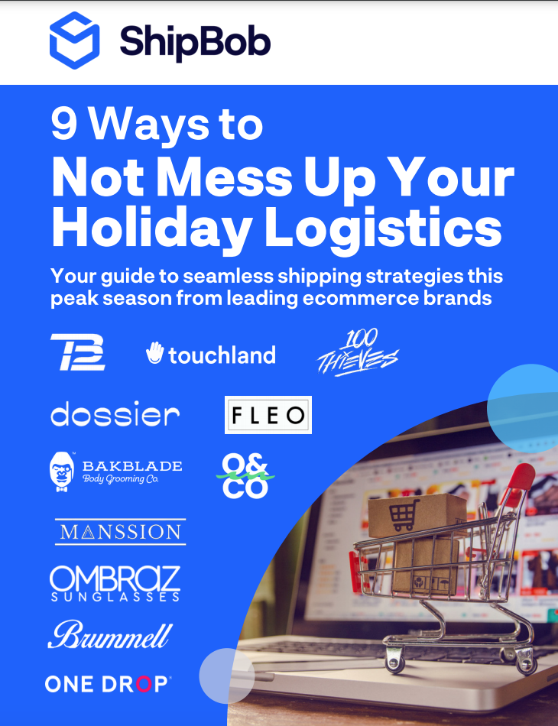

What is demand forecasting?

Demand forecasting is the process of using predictive analysis of historical data to estimate and predict customers’ future demand for a product or service. Demand forecasting helps the business make better-informed supply decisions that estimate the total sales and revenue for a future period of time.

Through demand forecasting, businesses can [optimize inventory](https://www.shipbob.com/blog/inventory-optimization/) by [predicting future sales](https://blog.mailshake.com/sales-playbook/) from analyzing historical sales data to make informed business decisions about everything from inventory planning and warehousing needs to [running flash sales](https://www.shipbob.com/blog/how-to-run-an-e-commerce-flash-sale/) and meeting customer expectations.

Importance of demand forecasting for ecommerce

Without demand, there is no business. And without a thorough understanding of demand, businesses aren’t capable of making the right decisions about marketing spend, production, staffing, and more.

Demand forecasting will never be 100% accurate, but there are steps you can take to [improve production lead times](https://www.shipbob.com/blog/how-to-cut-costs-and-production-lead-times/), increase operational efficiencies, save money, launch new products, and provide a better customer experience.

Preparing your budget

Demand forecasting helps reduce risks and make efficient financial decisions that impact profit margins, cash flow, allocation of resources, opportunities for expansion, [inventory accounting](https://www.shipbob.com/blog/inventory-accounting/), operating costs, staffing, and overall spend. All strategic and operational plans are formulated around forecasting demand.

Planning and scheduling production

Demand forecasting lets you provide the products your customers want, when they want them. Forecasting demand requires that [order fulfillment](https://www.shipbob.com/blog/order-fulfillment/) is synced up with your marketing prior to launching.

Nothing kills progress (or your reputation) faster than being sold out for weeks on end. Proper demand forecasting and [inventory control](https://www.shipbob.com/blog/inventory-control/) can help ensure a business doesn’t buy insufficient or excessive inventory.

*“Our B2C and B2B order volume changes month to month. Between shipping new collections for wholesale earlier in the year and Q4 madness for direct-to-consumer sales, we’ve been able to get through our heaviest seasons while staying ahead of production using ShipBob’s forecasting tools — even as order volume more than quadrupled in a year.”*

Ryan Casas, COO of [iloveplum](https://www.shipbob.com/blog/iloveplum/)

Storing inventory

Demand forecasting can help you spend less money on both inventory purchase orders and [warehousing](https://www.shipbob.com/blog/warehousing/) as the more inventory you carry, the more expensive it is to store. Good [inventory management](https://www.shipbob.com/blog/inventory-management/) involves having enough product on hand but not too much.

Closely [tracking inventory levels](https://www.shipbob.com/blog/inventory-tracking/) lets you easily restock and [forecast inventory](https://www.shipbob.com/blog/inventory-forecasting/) over time.

*“With ShipBob, we have access to live inventory management, knowing exactly how many units we have in each fulfillment center. This not only helps with our overall process in managing and making sure our inventory levels are balanced but also for tax purposes at the end of the year.”*

Matt Dryfhout, Founder & CEO of [BAKblade](https://www.shipbob.com/blog/bakblade/)

Developing a pricing strategy

Demand forecasting isn’t just about perfecting a business’s production schedule to supply demand, but it should also help price products based on the demand. Understanding the market and potential opportunities, businesses can grow, formulate [competitive pricing](https://blog.prisync.com/competitive-pricing-advantages-vs-disadvantages/), employ the right marketing strategies, and invest in their growth.

If you choose to slash prices or put an item on promotion, demand may temporarily increase for that product. Without that sale, you may not have experienced the boost.

If there is limited supply of a [high-demand product](https://www.shipbob.com/blog/high-demand-products/), you can use the scarcity principle to increase the price as an exclusive offer. You must keep an eye on new entrants though as supply may increase.

Examples of demand forecasting

A small business may be on a conservative growth plan, while another company may be scaling or diversifying with aggressive growth plans. The demand forecasting examples below walk through a couple different scenarios.

Example 1

A grocery store looks at sales trends from last year’s Thanksgiving week to prepare adequate [inventory levels](https://www.shipbob.com/blog/inventory-levels/) for the upcoming season. They look at sales leading into that week last year for seasonal products like turkeys, cranberries, and mashed potatoes.

It was a great holiday sale for them. But eight months ago, a competing grocery store opened four blocks away, so they’re unsure how Thanksgiving demand will be affected and if local customers will buy ingredients from their competitor.

At the same time, a lot of families continue to move into the neighborhood, and they’ve still grown an average of 1% month-over-month since the competing chain opened.

They plan to launch a few more ads than last year through channels that have proven a good ROI for them in the past, and also offer some new deals to position themselves as the go-to Thanksgiving destination. Their calculations project a 5% increase in sales from last year.

Example 2

An up-and-coming direct-to-consumer cosmetics brand is growing quickly. Currently, they are selling 10,000 orders per month. Based on their past sales data, upcoming ad campaigns, and general market conditions in the industry, they plan to be above 30,000 orders per month at this time next year.

Right now they’re stocking a total of 75,000 units, at varying levels across their 5 SKUs. Their order volume fluctuates quite a bit based on their replenishment cycle, and they [restock inventory](https://www.shipbob.com/blog/restocking-inventory/) by SKU level at a rate of about every 90 days.

The average units they store will grow quickly while the cadence will remain the same. The last run of their main SKU was 30,000 units. They’re about to ship in another 50,000 units, and their next run will be of 75,000 units.

They plan to continue to grow at that pace, so they are look into whether they should purchase land, lease a warehouse, or [outsource fulfillment](https://www.shipbob.com/ecommerce-fulfillment/outsourced-fulfillment/) to keep up with demand.

Types of demand forecasting

There are various ways businesses can forecast demand. All forecasting models leverage data and analytics over specific periods of time.

Macro-level

Macro-level demand forecasting looks at general economic conditions, external forces, and other broad things disrupting commerce. These factors keep a business in the know around portfolio expansion opportunities, market research intel, and other shifts in the market.

Micro-level

Demand forecasting at the micro-level can be specific to a particular industry, business, or [customer segment](https://supermetrics.com/blog/ecommerce-customer-segmentation) (e.g., examining demand for natural deodorant for millennial customers in Chicago, IL).

Short-term

Short-term demand forecasting is usually done for a time period of less than 12 months. It looks at demand for under a year of sales to inform the day-to-day (e.g., planning production needs for a Black Friday/Cyber Monday promotion).

Long-term

Long-term demand forecasting is done for greater than a year. This helps identify and plan for seasonality, annual patterns, production capacity, and expansion over a longer period of time. This drives long-term business strategy (e.g., plans to launch a facility or store internationally and expand into new markets).

Factors influencing the customer demand life cycle

Demand forecasting is where the supply chain side of business meets sales and marketing. Both sides must be in sync to succeed. Learn how different forces affect demand forecasting.

Seasonality

Seasonality refers to changes in order volume throughout a specific period of time. A [highly seasonal brand](https://www.shipbob.com/blog/ecommerce-dtc-brand-growth-seasonal-sales-order-volume/) may serve a specific time period, event, or season, causing varying demand levels throughout the year including large spikes during their peak season (e.g., shoppers looking for grilling equipment right before the summer or 4th of July).

The chart below shows a [ShipBob](https://www.shipbob.com/) customer that runs an extremely seasonal business.

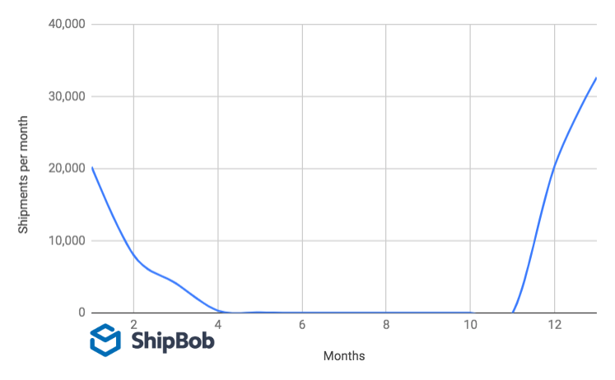

Seasonal demand often requires a business to reduce inventory on hand during the quiet months and then ramp up production and their operations workforce during peak season. That’s why many cyclical businesses outsource [retail fulfillment](https://www.shipbob.com/blog/retail-fulfillment/) to a third-party ([3PL](https://www.shipbob.com/blog/3pl/)) logistics company, who can store inventory, pick items, pack boxes, and ship orders for them.

Competition

Competition affects demand as there are more options for your customers to choose from and more companies vying for their attention.

When a competitive force comes into play — whether it’s a direct competitor or new kind of solution that forces your customer to choose between you or them — demand will be skewed. This can take you by surprise, so an agile demand forecasting model can help you respond quickly.

Types of goods

Demand forecasting will be very different for different products and services — from perishable goods that expire quickly to [subscription boxes](https://www.shipbob.com/ecommerce-fulfillment/subscription-box-fulfillment/) that come at the same time each month.

It’s important to know the lifetime value of your customers (the total purchases they buy from you across channels over time), your [average order value](https://www.shipbob.com/blog/average-order-value/) (how much they’re spending each time), and the combinations of products ordered to improve demand forecasting.

Using this data, you can understand how to group or bundle items, drive more recurring revenue, and see how one [SKU](https://www.shipbob.com/blog/fulfillment-basics-sku/) affects or drives demand for another (e.g., razor and blade cartridge refill sales).

Geography

The geography of where your customers reside and where you manufacture and ship orders from can greatly impact [inventory forecasting](https://www.shipbob.com/blog/inventory-forecasting/) and the speed at which you can fulfill customer orders.

The geographic locations of your [retail supply chain](https://www.shipbob.com/blog/retail-supply-chain/) can be very strategic. Using [fulfillment centers](https://www.shipbob.com/blog/differences-warehouse-fulfillment-center/) in locations near your customers can help you fulfill customer demand quickly and more affordably, so it ships from the warehouse closest to the customer.

This helps you monitor where your customers reside and store certain products in the regions where they are ordered most, so you don’t have to [ship to far away destinations](https://www.shipbob.com/blog/shipping-zones/).

*“Our favorite aspects of ShipBob’s fulfillment software are the algorithm and analytics. ShipBob’s analytics dashboard has a lot of valuable reports that show our top-selling states, order revenue and costs, units sold, sales by SKU, days of inventory, SKU velocity, sales vs. inventory distributions showing where our customers are and where we’re shipping from, and more.”*

Andrew Hardy, COO of [Nature’s Ultra](https://www.shipbob.com/blog/natures-ultra-cbd/)

How to forecast demand in 4 steps

Forecasting demand is an extremely challenging task. You want to be flexible enough to handle sporadic influxes but also take a long-term approach. Here are some tips for your business.

1. Set objectives

Demand forecasting should have a clear purpose. At its core, it predicts what, how much, and when customers will purchase. Choose your time period, the specific product or general category you’re looking at, and whether you’re forecasting demand for everyone or a specific subset of people.

Make sure it satisfies your financial planners, product marketing, logistics, and operations teams in a non-biased way.

You need to understand what your goals are for the right demand capacity planning which will allow you to use decision-making forecasting processes to understand consumer behavior better

2. Collect and record data

Integrating all of the data from your sales channels can provide a cohesive view of actual product demand and insight into sales forecasts.. Being able to see the time and date of orders, SKU(s) ordered, and sales channel will help you forecast growth and trend projection on a more granular level and look back to see how your forecasts matched up to reality.

You should also pay close attention to [ecommerce returns](https://www.shipbob.com/blog/ecommerce-returns/), which can be costly. Products with high return rates should be evaluated and adjusted based on the reasons for returns. If 10% of items are being returned, and you’re able to decrease that number, your production may need to be adjusted as well.

In addition to your historical sales data, you may also need to pull in other pieces of data like market conditions. To ensure reliability and accuracy, data must be properly prepared.

*“Another ShipBob integration I love is Inventory Planner. It saves me hours every week in Excel spreadsheets, and I can raise a PO in minutes when it used to take me hours. For every order I placed for years, I was ordering too much or not enough. Between inventory forecasting tools and the ability to auto-create WROs, we don’t have stockouts much anymore. I sleep better at night.”*

Wes Brown, Head of Operations at [Black Claw LLC](https://www.shipbob.com/blog/black-claw/)

3. Measure and analyze data

Whether done manually or using automation and predictive analytics, you’ll need a repeatable data analysis process. This requires comparing what you predicted to actual sales to help you adapt your next forecast.

The chart below shows four different ShipBob customers on the same timeline that have all shipped 60,000 total orders in the same year. Measuring this helps track demand for different products at different times. While they each ship an average of 5,000 orders per month, some months are much lighter than others.

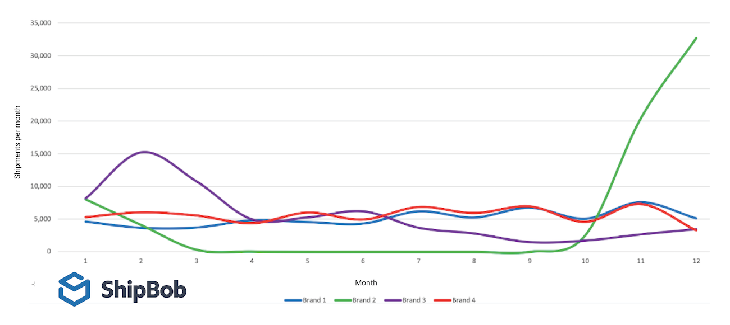

If the brands under-forecasted this volume, they wouldn’t have had enough inventory to ship orders out and there wouldn’t be enough staff to fulfill them all in a timely manner. If they over-forecasted the volume, they would have spent a lot of money on inventory that is just sitting and taking much longer than anticipated to generate revenue.

As you grow, you may find you need to start tracking additional pieces of information such as obsolete stock, frequency of [stockouts](https://www.shipbob.com/blog/stockout-costs/), and other order details you may need to improve.

4. Budget accordingly

Once you have a feedback loop, you can set your next forecast (hopefully more accurately) and update your budget to allocate funds where they should go based on growth goals. Demand forecasting helps you reduce [inventory carrying costs](https://www.shipbob.com/blog/inventory-carrying-costs/), plan marketing spend, future headcount, production and inventory needs, and even new products.

How ShipBob makes demand forecasting easier

ShipBob has a network of fulfillment centers across the United States, allowing ecommerce businesses to store their inventory and have ShipBob automatically pick, pack, and ship orders as soon as they are placed. ShipBob also has proprietary software with advanced analytics and [distribution metrics](https://www.shipbob.com/blog/distribution-metrics/) that inform business decisions.

*“We roll out new products and designs on our website 1-3 times a month and send new inventory to ShipBob each week. It’s really easy to create new SKUs and restock existing ones using ShipBob’s technology, which is especially important with high*[*inventory turnover*](https://www.shipbob.com/blog/inventory-turnover-rate/)*.”*

Carl Protsch, Co-Founder of [FLEO Shorts](https://www.shipbob.com/blog/fleo-shorts/)

ShipBob’s analytics show you the following at a glance:

* How quickly products are selling
* Which items are slow-moving
* How many days of inventory you have until you are expected to run out (based on SKU velocity)
* Where your customers are and where you’re shipping from (with the ability to compare current and ideal distribution)
* Profitability by order, how much you are spending on shipping, and the average order amount that customers are spending at your store
* Daily order status and performance
* How your current demand compares to previous time periods
* How your sales are affected by different seasons and months
* A breakdown of transit times and average cart value by shipping method (to see which shipping methods are most attractive to your customers)
* How much your customers are spending by shipping method (to help you test different pricing strategies)
* How much inventory you were holding at any ShipBob fulfillment centers at any point in the past
* Your best selling items and the percentage of your business they account for (and how they are performing compared to other periods)
* How many orders are held up, where they are located, and which items are driving a backlog (so you can prioritize the replenishment of stock that are affecting sales)

Conclusion

Demand forecasting helps businesses make informed decisions that affect everything from inventory planning to [supply chain optimization](https://www.shipbob.com/blog/supply-chain-optimization/). With customer expectations changing faster than ever, businesses need a method to accurately forecast demand.

*“So many 3PLs have either bad or no front-facing software, making it impossible to keep track of what’s leaving or entering the warehouse.*

*On the supply chain side, I just throw in what we placed at the factory into a WRO in the ShipBob dashboard, and I can see how many units we have on-hand, what’s incoming, what’s at docks, and so on. I can see all of those numbers in a few seconds, and it makes life so much easier.”*

Harley Abrams, Operations Manager of [SuperSpeed Golf, LLC](https://www.shipbob.com/blog/superspeed-golf/)

If you’re looking for an [ecommerce fulfillment](https://www.shipbob.com/ecommerce-fulfillment/) solution to help you improve demand forecasting, learn more about how ShipBob helps you replenish stock and deliver the experience that customers want. Request a pricing quote of our fulfillment services below.

### What is demand forecasting?

Demand forecasting is the process of predicting future sales by using historical sales data to make informed business decisions about everything from inventory planning to running flash sales. Demand forecasting helps estimate the total sales and revenue for a future period of time.

### Why is demand forecasting important?

Without a thorough understanding of demand, businesses aren’t capable of making the right decisions about marketing spend, production, staffing, and more. Through it will never be 100% accurate, forecasting demand can help you improve production lead times, increase operational efficiencies, save money, launch new products, and provide a better customer experience overall.

### How is demand forecasting done?

There are various ways businesses can forecast demand. All forecasting models leverage data and analytics over specific periods of time. For instance, you can forecast demand on the macro-level (e.g., economic conditions, external forces, and other broad things disrupting commerce) or micro-level (e.g., particular industry, business, or customer segment). Or, you can determine future demand by short-term or long-term, depending on how you’ll use the data.

### How do I build a demand forecasting model?

Forecasting demand is an extremely challenging task. You want to be flexible enough to handle sporadic influxes but also take a long-term approach. The first step is to set clear objectives, and make sure your objective satisfies your financial planners, product marketing, logistics, and operations teams in a non-biased way. You’ll also need a technology and systems in place to collect historical order accurately from your sales channels, so you can easily measure and analyze the data.

Forecasting demand can be a time-consuming task. By partnering with a 3PL like ShipBob, you can access advanced analytics and [distribution metrics](https://www.shipbob.com/blog/distribution-metrics/) to make the process much easier.