**Yaniv Malach 315902148**

**Ido Singer 207232257**

Garage logic explanation:

**Vehicle logic explanation:**

**1. Vehicle**: abstract class, representing a **Vehicle** in system.

**2. Car**: class extending a vehicle to be of **Car** in system.

**3. Motorcycle**: class extending a vehicle to be of **Motorcycle** in system.

**4.** **Truck**: class extending a vehicle to be of **Truck** in system.

**5.** **Engine:** abstract class, representing a **Engine** in system in system.

**6.** **FuelEngine**: class extending a Engine to be of **Engine** that runs on fuel in system.



**7.** **ElectricEngine:** class extending a vehicle to be of **Engine** that runs on electricity in system.

**8.** **Wheel:** class that representing a vehicle **Wheel** in system.

**Garage logic explanation:**

**1. Garage**: class that representing a garage in system.

**2.**  **GarageClient**: class that representing a client of the garage in system.

**Enum logic explanation:**

**1. eColor**: enum that representing valid car's color.

**2.** **eFuelType**: enum that representing valid FuelVehicle's fuel type.

**3.** **eMotorcycleLicenseType**: enum that representing valid option of motorcycle license type.

**4.** **eVehicleInSystem :** enum that representing valid option of vehicles in the system.

**5.** **eGarageVehicleStatus**: enum that representing valid option of vehicle status in the garage.

**6.** **eNumOfDoors**: enum that representing valid option of number of doors in a car.

**7. eEngineType** : enum that representing valid option of energy that engine can run on it.

**Vehicle creator logic explanation:**

**1. VehicleBuilder**: class that create new car by type that supported in system.

**Exception logic explanation:**

**1. ValueOutOfRangeException**: a class that inheriting from class Exception, this type of exception is given when a value from user is out of range.

**Vehicle Logic:**

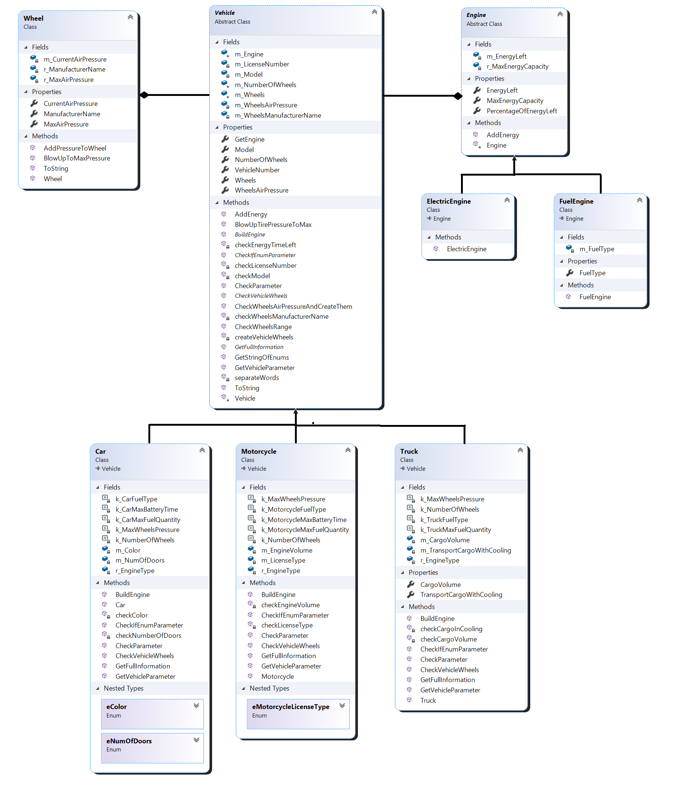

**Garage Logic:**

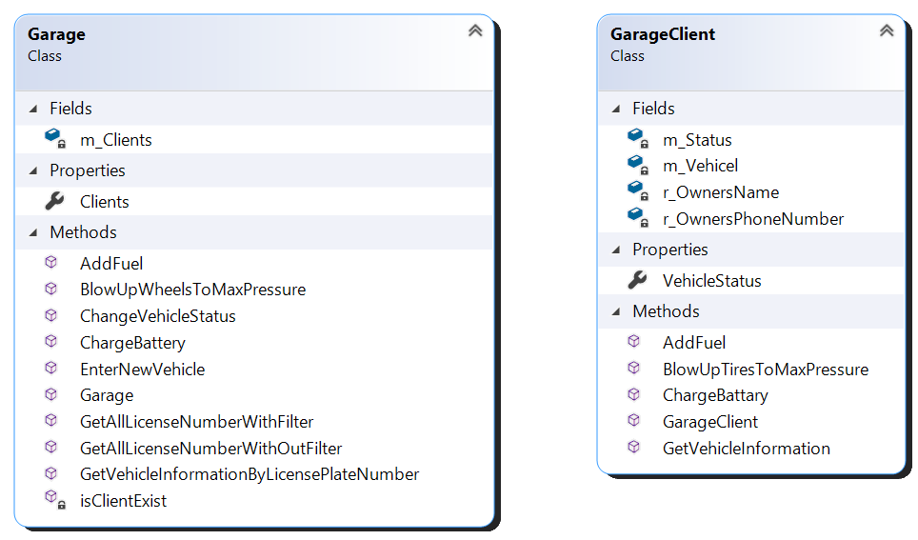



**Vehicle Creator Logic:**

**Enums Logic:**

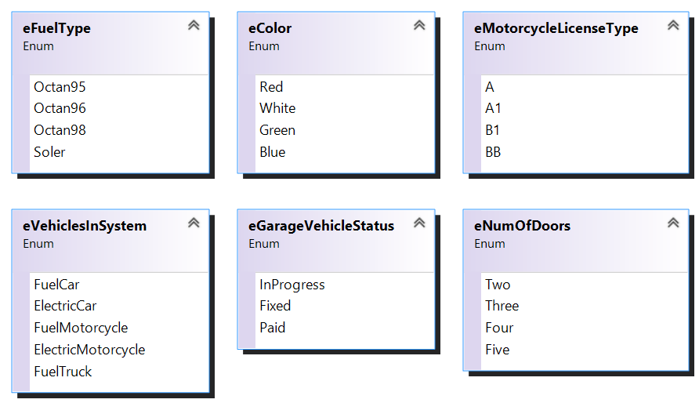

**Exception Logic:**

