This paragraph is above the first image. It is an introductory paragraph which states that we have some images of charts. It stands on its own and is not associated with any image in this document.

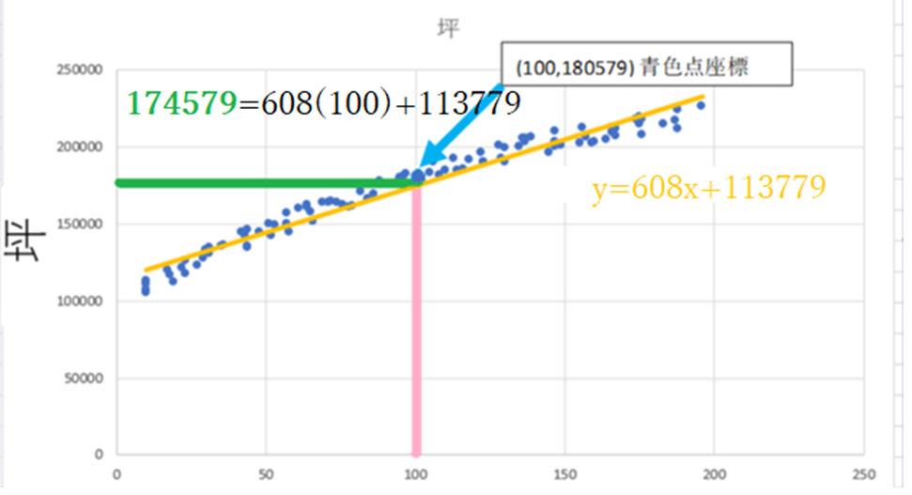

This paragraph is below the first image and above the second. It is describing the first image.

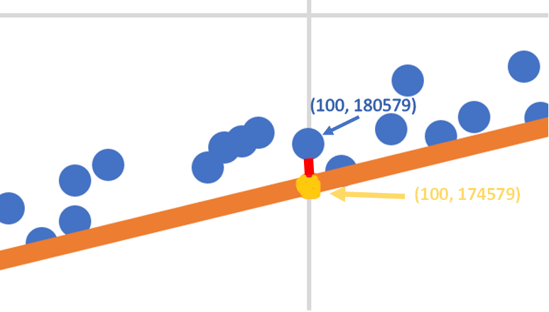 This paragraph is below the second image and above the third. It is describing the second image.

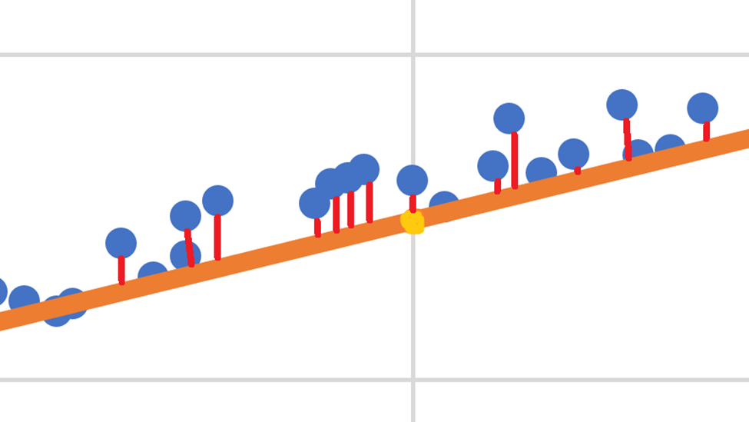

This paragraph is below the third image and above the fourth. It is describing the third image.

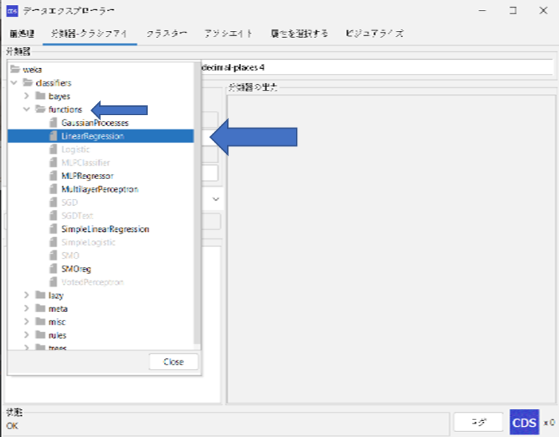

This paragraph is below the fourth image. It is describing the fourth image.

This is the concluding paragraph. It stands on its own and is not associated with any image in this document.