## Team: Hotaru

**Members:**

* Милан Друмев – [milan.drumev](http://telerikacademy.com/Users/milan.drumev)
* Георги Серев - [lockheed](http://telerikacademy.com/Users/lockheed)
* Васил Коларов - [vassilpk](https://telerikacademy.com/Users/vassilpk)
* Иван Дойчинов - [ivand](http://telerikacademy.com/Users/ivand)
* Ивайло Христов – [Ivaylo1987](http://telerikacademy.com/Users/Ivaylo1987)
* Генчо Разсилев – [gencho85](http://telerikacademy.com/Users/gencho85)

## Project explanation

The team has designed and implemented the client-side JavaScript application meeting all the general requirements for the project. We designed a game that presents an air battle between a player’s aircraft and enemy’s ones (see Picture1).

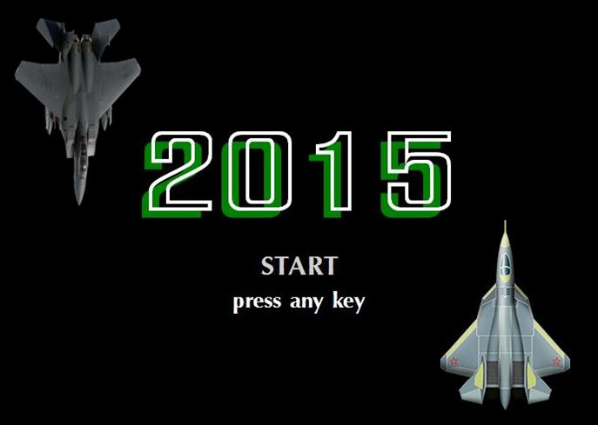

**Picture 1**. Start screen with game characters

The aim of the player is to stay alive as long as it is possible, shooting down enemy’s aircrafts. We have implemented the game obtaining wide range of functionality and possibility for easy further upgrade and improvement.   
We implemented the application following the best practices for object-oriented design and high-quality code. For the background and the characters graphics are used game purpose-made images. The rendering is done by the HTML5 canvas, using KineticJS framework. For a better visualization of the application structure we provide a SVG based [class diagram](https://github.com/drumev/Hotaru-JavaScript/tree/master/diagram).

Current functionality of the game :

* General
* Moving background objects;
* Collision detection for all the objects except background ones;
* Generation of background objects and enemy’s aircrafts;
* Option for pausing the game;
* Player’s character
* Different kinds of aircrafts depending on the level;
* Option for the aircraft to move in all directions;
* Different kinds of shooting manners depending on the level;
* Current score
* Current lives
* Damage levels
* Non player character
* Different kinds of aircrafts;
* Navigation by artificial intelligence;
* Shooting controlled by artificial intelligence;
* Damage levels

## The URL of the TFS repository

[**https://github.com/drumev/Hotaru-JavaScript**](https://github.com/drumev/Hotaru-JavaScript)