I. Task 1. Used tools

1. I’m using Tortoise Git for syncing with my GitHub account where I keep all my homework / teamwork projects. Also I have used both Tortoise SVN and Visual Studio TFS for previous projects hosted on Google Code and Microsoft TFS (VS Online) respectively.

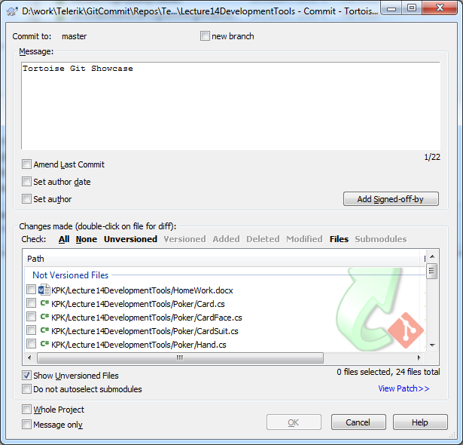

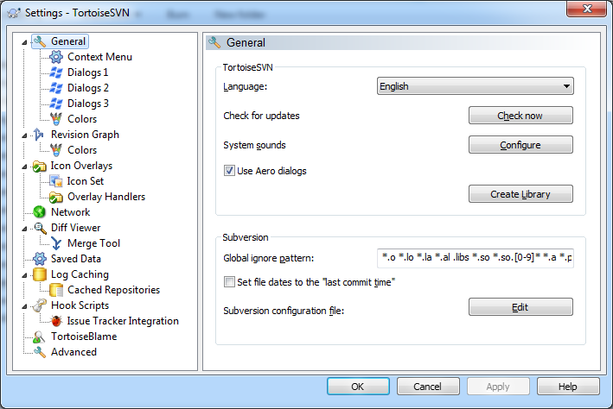

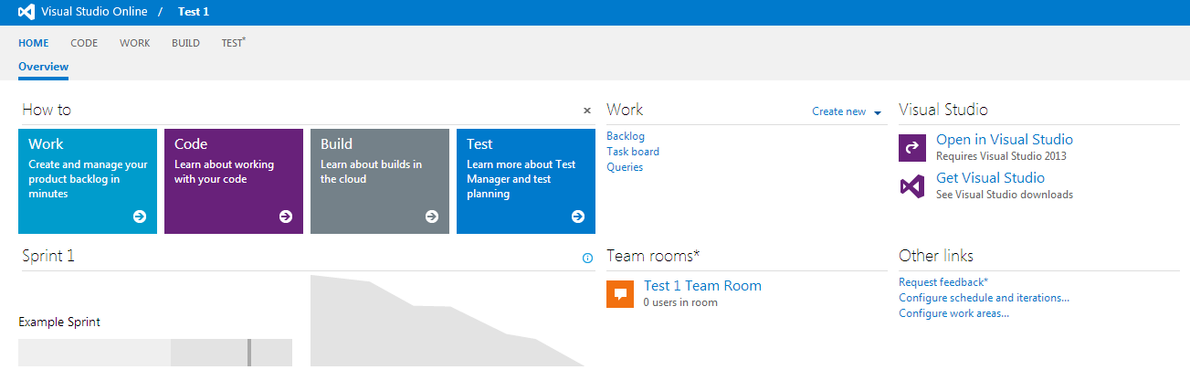

1. Log4Net

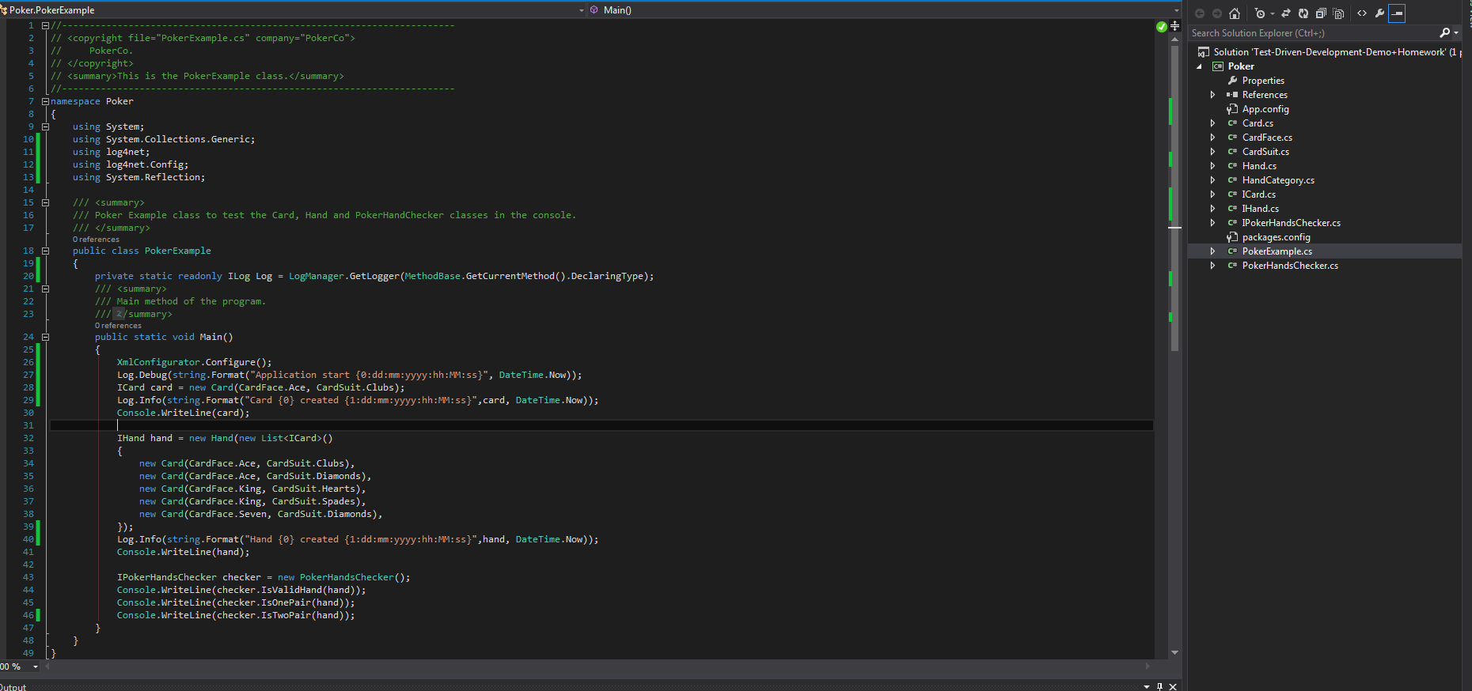

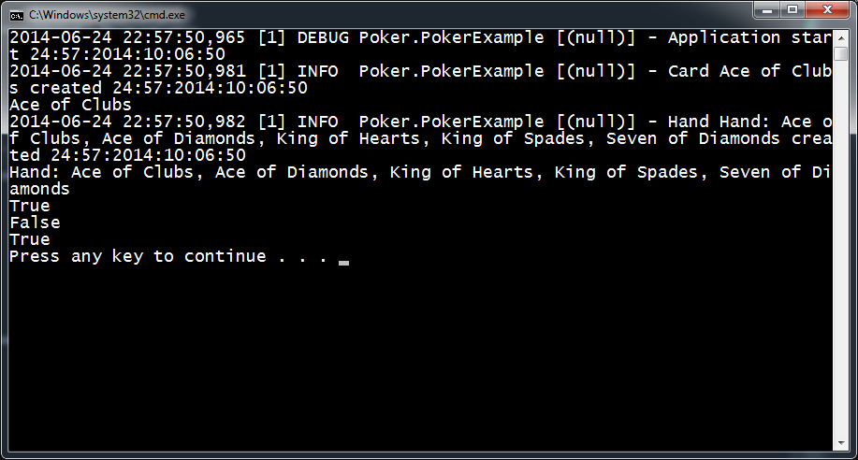

1. StyleCop and JustCode

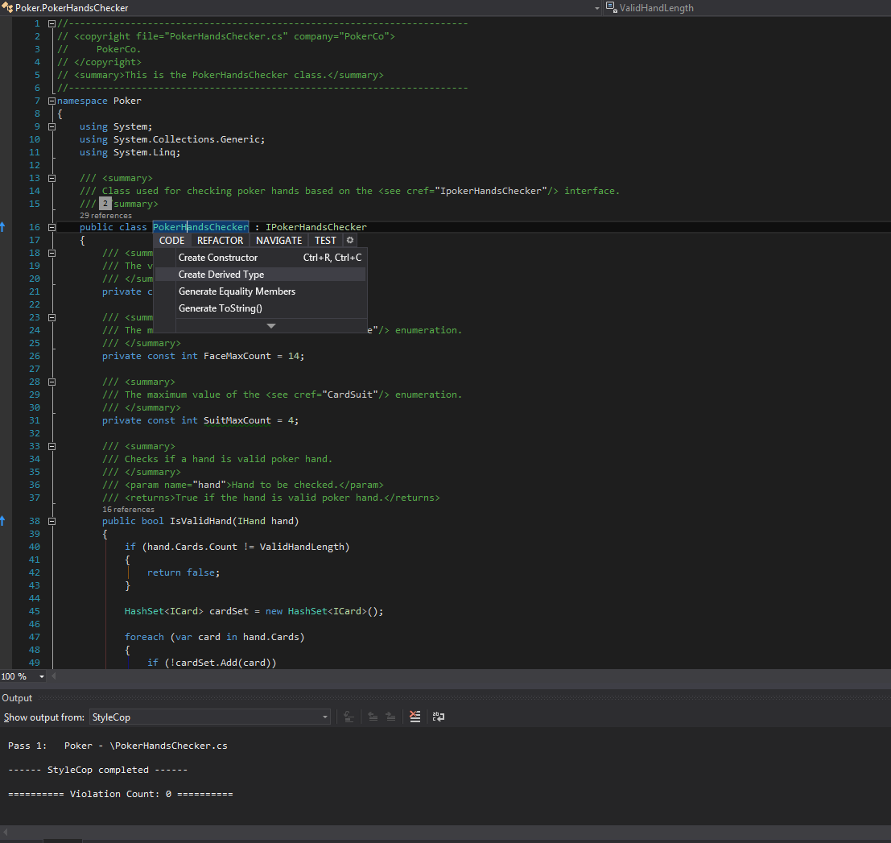

1. Just Decompile

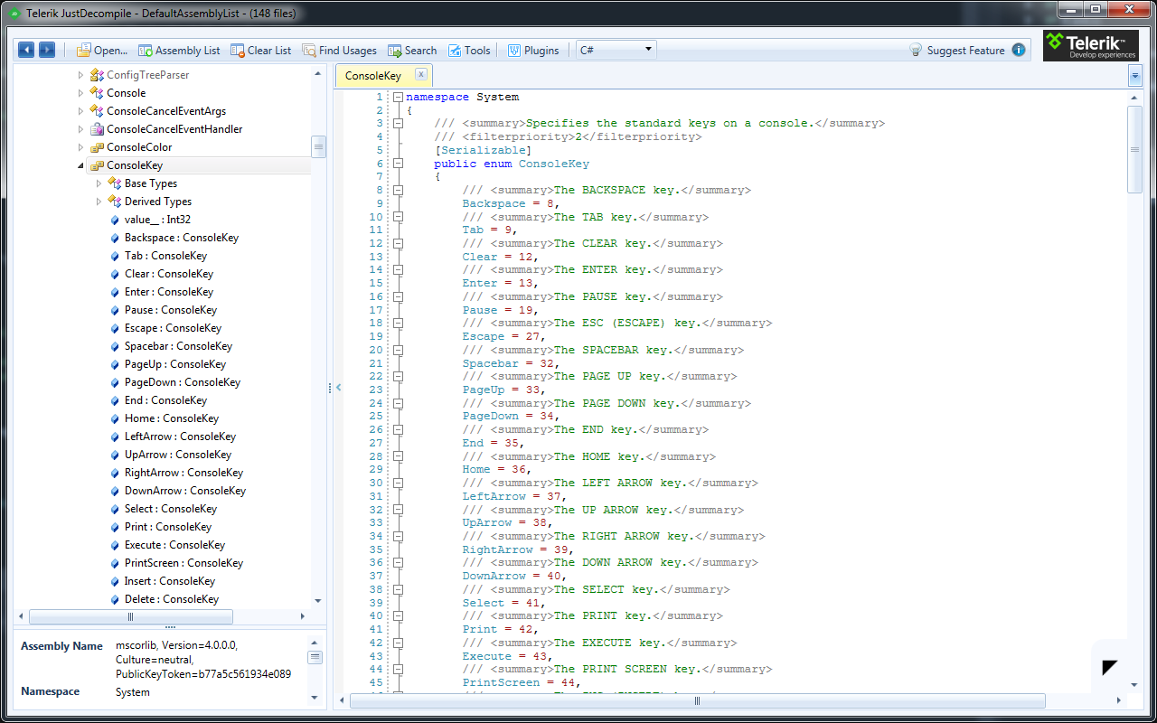

1. Sandcastle

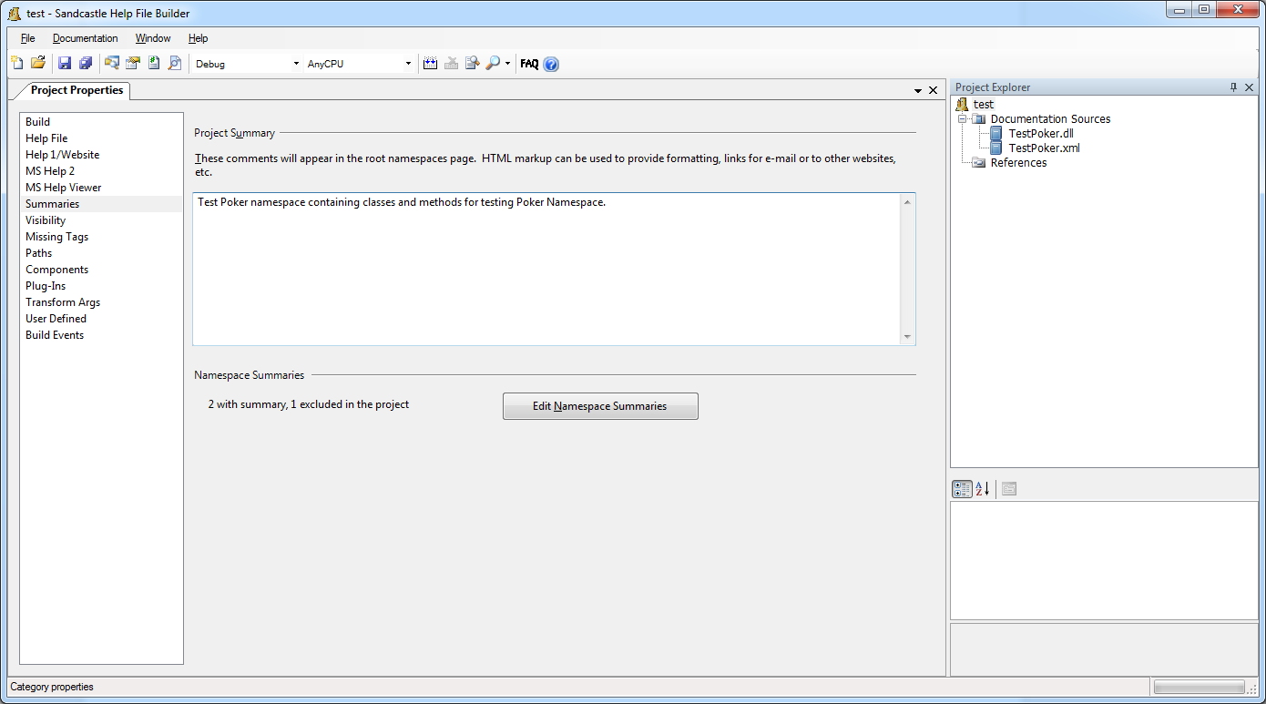

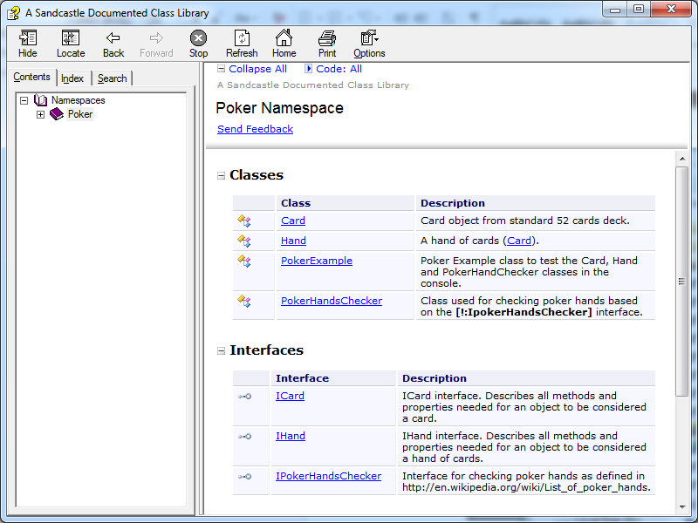

1. Obfuscator – Eazfuscator

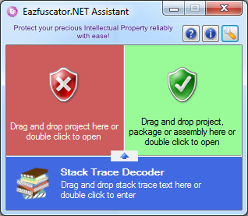

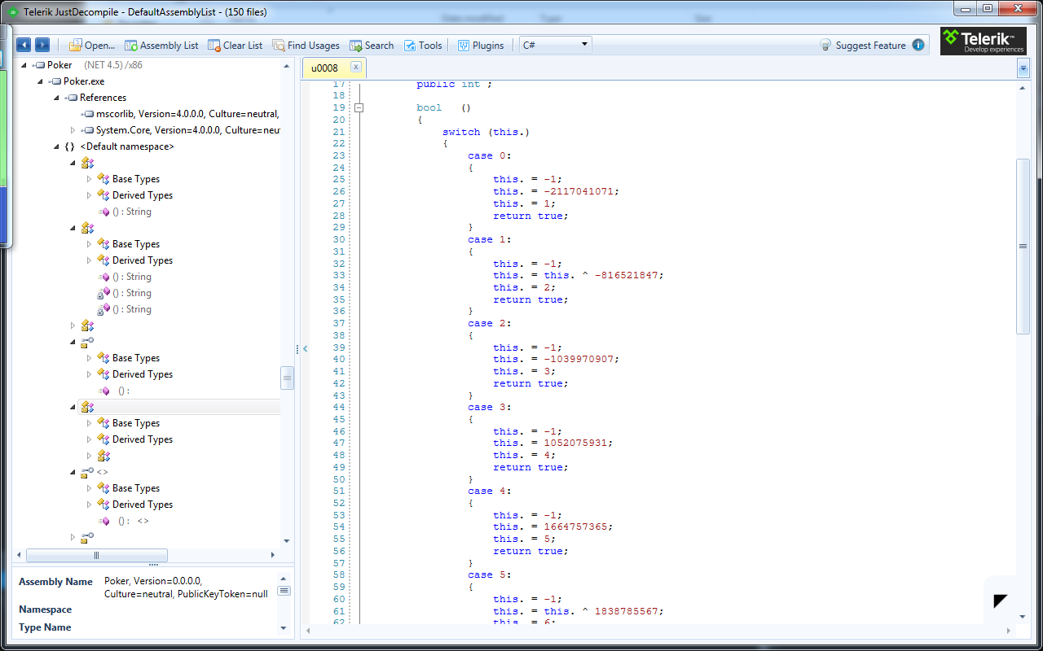

II.T4 Template is in the folder T4 Template

III. Couldn’t find anonymous upload to GitHub or Google Code