|  |  |
| --- | --- |
| הטכניון, מכון טכנולוגי לישראל | tech3 |

מבוא למערכות לומדות

236756

סמסטר אביב 2019

|  |  |
| --- | --- |
| תרגיל מספר: | 1 |

מגישים:

|  |  |  |  |  |  |  |  |  |  |  |
| --- | --- | --- | --- | --- | --- | --- | --- | --- | --- | --- |
| אמיר אביבי |  |  |  |  |  |  |  |  |  |  |
| 3 | 7 | 8 | 3 | 8 | 1 | 5 | 0 | 3 |
| שם מלא | מספר ת.ז. | | | | | | | | |  |

|  |
| --- |
|  |
| ציון |

Exercise 1 – Probability & Python

Question 1:  
P(Coin is forged| )=

Question 2:

We are being asked if the probability that the number of boys in a family is bigger than the number of girls.  
As we can see the number of girls in a family is distributed as a Geometric random variable meaning:

$The number of girls in a family \sim Geo\left(0.5\right)$, and the mean behavior of such random variable is $\frac{1}{p}$, which in our case equals 2, meaning that the **common** family will have 1 boy and 1 girl.  
  
For each family we calculate the following:P(Boys in the family > Girls in the family) = P( The first born baby was a boy) = 0.5 = P(Boys in the family <= Girls in the family)  
  
By using the law of large numbers , and defining the families to be an i.i.d series of random variables, we deduce that the number of males and females in the country converges to its average behavior which means, that in probability, half of the country are **males and half are females, so the answer to the question is: The number of boys and girls is equal.**

Question 3:  
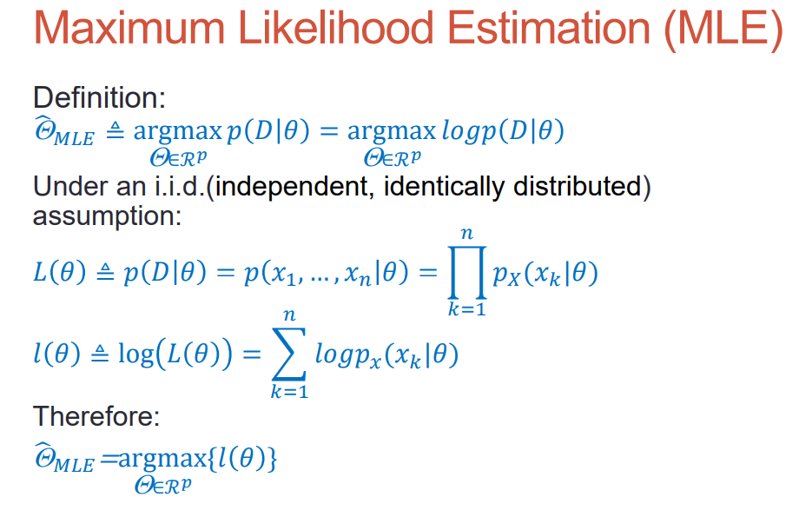  
**Binomial distribution: $${\hat{p}}_{MLE}=argmax (p\left(x_{1},x_{2},…,x_{n}\right|n,p))=argmax(\log{(p\left(x_{1},x_{2},…,x_{n}\right|n,p))})= \\ log\left(\prod_{k=1}^{n}{\left(\begin{matrix}n \\ x_{k}\end{matrix}\right)⋅p^{x_{k}}⋅{\left(1-p\right)}^{n-x_{k}}} \right)=\sum_{k=1}^{n}{log\left(\begin{matrix}n \\ x_{k}\end{matrix}\right)+x_{k}⋅\log{p}+\left(n-x_{k}\right)⋅\log\left(1-p\right)}$$**  
Finding the maximum: $$\frac{∂l}{∂p}=\sum_{k=1}^{n}{\frac{x_{k}}{p}-\frac{\left(n-x_{k}\right)}{\left(1-p\right)}} \\ \sum_{k=1}^{n}{\frac{x_{k}}{p}-\frac{\left(n-x_{k}\right)}{\left(1-p\right)}}=0⇒\sum_{k=1}^{n}{\frac{x_{k}-x_{k}⋅p-n⋅p+x_{k}⋅p}{p\left(1-p\right)}}= \sum_{k=1}^{n}{\frac{x_{k}-n⋅p}{p\left(1-p\right)}}=0⇒ \\ \sum_{k=1}^{n}{\frac{x_{k}}{p\left(1-p\right)}}-\frac{n^{2}}{\left(1-p\right)}=0⇒ \\ {\hat{p}}_{MLE}=\frac{\sum_{k=1}^{n}{x_{k}}}{n^{2}}$$

$${\hat{Θ}}_{MLE}=(\frac{\sum_{k=1}^{n}{x_{k}}}{n^{2}})$$

**Normal distribution: $${\hat{Θ}}_{MLE}=argmax (p\left(x_{1},x_{2},…,x_{n}\right|μ,σ))=argmax (\log{p\left(x_{1},x_{2},…,x_{n}\right|μ,σ)})= \\ l\left(θ\right)=\log{\prod_{k=1}^{n}{\frac{1}{\sqrt{2πσ^{2}}}\exp{\{-\frac{{\left(x_{k}-μ\right)}^{2}}{2σ^{2}}\}}}}=log({\frac{1}{{\left(2πσ^{2}\right)}^{\frac{n}{2}}}\exp{\{-\frac{1}{2σ^{2}}\sum_{k=1}^{n}{{\left(x_{k}-μ\right)}^{2}} \}}})=\log{\frac{1}{{\left(2πσ^{2}\right)}^{\frac{n}{2}}}}- \frac{1}{2σ^{2}}\sum_{k=1}^{n}{{\left(x_{k}-μ\right)}^{2}}$$**  
Finding the maximum: $$\frac{∂l}{∂μ}=- \frac{1}{σ^{2}}\sum_{k=1}^{n}{\left(x_{k}-μ\right)}=0⇒\hat{μ}=\frac{\sum{x_{k}}}{n}$$

$$\frac{∂l}{∂σ^{2}}=-\frac{n}{2}⋅\frac{1}{σ^{2}}+\frac{1}{σ^{4}}\sum_{k=1}^{n}{{\left(x_{k}-μ\right)}^{2}}=0⇒\hat{σ^{2}}=\frac{1}{n}\sum_{k=1}^{n}{{\left(x_{k}-μ\right)}^{2}}$$

$${\hat{Θ}}_{MLE}=(\frac{\sum{x_{k}}}{n}, \frac{1}{n}\sum_{k=1}^{n}{{\left(x_{k}-μ\right)}^{2}})$$

**Poisson distribution:**

$$l\left(θ\right)=\log{\prod_{k=1}^{n}{\frac{λ^{x_{k}}}{x_{k}!}⋅e^{-λ} }}=\sum_{k=1}^{n}{x_{k}\log{λ}}-\log{{(x}_{k}!)}-λ$$

Finding the maximum:

$$\frac{∂l}{∂λ}=\sum_{k=1}^{n}{\frac{x_{k}}{λ}-1}=0⇒ \hat{λ}=\frac{\sum{x_{k}}}{n} \\ {\hat{Θ}}_{MLE}=(\frac{\sum{x_{k}}}{n})$$

Question 4:  
a.

$$f_{x_{1}}\left(x_{1}\right)=\int_{-∞}^{∞}{\frac{1}{2πσ_{1}σ_{2}\sqrt{1-ρ^{2}}}⋅\exp\left\{-\frac{1}{2\left(1-ρ^{2}\right)}\left({\left(\frac{x_{1}-μ_{1}}{σ_{1}}\right)}^{2}-2ρ\left(\frac{x_{1}-μ_{1}}{σ_{1}}\right)\left(\frac{x_{2}-μ_{2}}{σ_{2}}\right)+{\left(\frac{x_{2}-μ_{2}}{σ_{2}}\right)}^{2}\right)\right\}}dx_{2}$$

$$let z_{2}=\frac{x_{2}-μ_{2}}{σ_{2}}⇒ dz_{2}=\frac{dx_{2}}{σ_{2}}⇒dx_{2}=dz_{2}⋅σ_{2}$$

$$f_{x_{1}}\left(x_{1}\right)=\int_{-∞}^{∞}{\frac{1}{2πσ_{1}\sqrt{1-ρ^{2}}}⋅\exp\left\{-\frac{1}{2\left(1-ρ^{2}\right)}\left({\left(\frac{x_{1}-μ_{1}}{σ_{1}}\right)}^{2}-2ρ\left(\frac{x_{1}-μ_{1}}{σ_{1}}\right)z_{2}+{z_{2}}^{2}\right)\right\}}dz_{2}= \\ \frac{1}{2πσ_{1}\sqrt{1-ρ^{2}}}\int_{-∞}^{∞}{\exp\left\{-\left(\frac{{\left(\frac{x_{1}-μ_{1}}{σ_{1}}\right)}^{2}}{2\left(1-ρ^{2}\right)}-\frac{2ρ\left(\frac{x_{1}-μ_{1}}{σ_{1}}\right)z_{2}}{2\left(1-ρ^{2}\right)}+\frac{{z_{2}}^{2}}{2\left(1-ρ^{2}\right)}\right)\right\}}dz_{2} \\ using the given integral solution we define:$$

$$a=\frac{1}{2\left(1-ρ^{2}\right)}, b=- \frac{ρ\left(\frac{x_{1}-μ_{1}}{σ_{1}}\right)}{\left(1-ρ^{2}\right)}, c= \frac{{\left(\frac{x_{1}-μ_{1}}{σ_{1}}\right)}^{2}}{2\left(1-ρ^{2}\right)}$$

$$f_{x_{1}}\left(x_{1}\right)=\frac{1}{2πσ_{1}\sqrt{1-ρ^{2}}}⋅{\left(\frac{π }{\frac{1}{2\left(1-ρ^{2}\right)}}\right)}^{\frac{1}{2}}\exp\left\{\frac{{\left(- \frac{ρ\left(\frac{x_{1}-μ_{1}}{σ_{1}}\right)}{\left(1-ρ^{2}\right)}\right)}^{2}}{4\left(\frac{1}{2\left(1-ρ^{2}\right)}\right)}-\left( \frac{{\left(\frac{x_{1}-μ_{1}}{σ_{1}}\right)}^{2}}{2\left(1-ρ^{2}\right)}\right)\right\}= \\ \frac{\sqrt{π⋅2\left(1-ρ^{2}\right)}}{2πσ_{1}\sqrt{1-ρ^{2}}}⋅\exp\left\{\frac{ρ^{2}{\left(\frac{x_{1}-μ_{1}}{σ_{1}}\right)}^{2}⋅2\left(1-ρ^{2}\right)}{4\left(1-ρ^{2}\right)}-\frac{{\left(\frac{x_{1}-μ_{1}}{σ_{1}}\right)}^{2}}{2\left(1-ρ^{2}\right)}\right\}= \\ \frac{1}{\sqrt{2πσ_{1}^{2}}}\exp\left\{\frac{ρ^{2}{\left(\frac{x_{1}-μ_{1}}{σ_{1}}\right)}^{2}-{\left(\frac{x_{1}-μ_{1}}{σ_{1}}\right)}^{2}}{2\left(1-ρ^{2}\right)}\right\}=\frac{1}{\sqrt{2πσ_{1}^{2}}}\exp\left\{-\frac{1}{2}{\left(\frac{x_{1}-μ_{1}}{σ_{1}}\right)}^{2}\right\}$$

$$⇒X_{1}\sim N(μ_{1},σ_{1}^{2}) \\ ∎$$

Question 4:  
b.

$$f_{X_{1}|X_{2}}\left(x_{1}|x_{2}\right)=\frac{f_{X_{1},X_{2}}\left(x_{1},x_{2}\right)}{f_{X_{2}}\left(x_{2}\right)}=$$

$$f_{X_{1}|X_{2}}\left(x_{1}|x_{2}\right)=\frac{\frac{1}{2πσ_{1}σ_{2}\sqrt{1-ρ^{2}}}⋅\exp\left\{-\frac{1}{2\left(1-ρ^{2}\right)}\left({\left(\frac{x_{1}-μ_{1}}{σ_{1}}\right)}^{2}-2ρ\left(\frac{x_{1}-μ_{1}}{σ_{1}}\right)\left(\frac{x_{2}-μ_{2}}{σ_{2}}\right)+{\left(\frac{x_{2}-μ_{2}}{σ_{2}}\right)}^{2}\right)\right\}}{\frac{1}{\sqrt{2πσ_{2}^{2}}}\exp\left\{-\frac{1}{2}{\left(\frac{x_{2}-μ_{2}}{σ_{2}}\right)}^{2}\right\}}=$$

$$\frac{1}{\sqrt{2π{(σ}_{1}^{2}(1-ρ^{2}))}}⋅\exp\left\{-\frac{1}{2\left(1-ρ^{2}\right)}\left({\left(\frac{x_{1}-μ_{1}}{σ_{1}}\right)}^{2}-2ρ\left(\frac{x_{1}-μ_{1}}{σ_{1}}\right)\left(\frac{x_{2}-μ_{2}}{σ_{2}}\right)+{\left(\frac{x_{2}-μ_{2}}{σ_{2}}\right)}^{2}\right)+\frac{1}{2}{\left(\frac{x_{2}-μ_{2}}{σ_{2}}\right)}^{2}\right\}$$

$$\frac{1}{\sqrt{2π{(σ}_{1}^{2}(1-ρ^{2}))}}⋅\exp\left\{-\frac{1}{2\left(1-ρ^{2}\right)}\left({\left(\frac{x_{1}-μ_{1}}{σ_{1}}\right)}^{2}-2ρ\left(\frac{x_{1}-μ_{1}}{σ_{1}}\right)\left(\frac{x_{2}-μ_{2}}{σ_{2}}\right)+{\left(\frac{x_{2}-μ_{2}}{σ_{2}}\right)}^{2}-\left(1-ρ^{2}\right){\left(\frac{x_{2}-μ_{2}}{σ_{2}}\right)}^{2}\right)\right\}=$$

$$\frac{1}{\sqrt{2π{(σ}_{1}^{2}(1-ρ^{2}))}}⋅\exp\left\{-\frac{1}{2\left(1-ρ^{2}\right)}\left({\left(\frac{x_{1}-μ_{1}}{σ_{1}}\right)}^{2}-2ρ\left(\frac{x_{1}-μ_{1}}{σ_{1}}\right)\left(\frac{x_{2}-μ_{2}}{σ_{2}}\right)+{ρ^{2}\left(\frac{x_{2}-μ_{2}}{σ_{2}}\right)}^{2}\right)\right\}=$$

$$\frac{1}{\sqrt{2π{(σ}_{1}^{2}(1-ρ^{2}))}}⋅\exp\left\{-\frac{1}{2\left(1-ρ^{2}\right)}{\left(\left(\frac{x_{1}-μ_{1}}{σ_{1}}\right)-ρ\left(\frac{x_{2}-μ_{2}}{σ_{2}}\right)\right)}^{2}\right\}=$$

$$\frac{1}{\sqrt{2π{(σ}_{1}^{2}(1-ρ^{2}))}}⋅\exp\left\{-\frac{1}{2}{\left(\frac{x_{1}-\left(μ_{1}+\frac{ρσ_{1}\left(x_{2}-μ_{2}\right)}{σ_{2}}\right)}{σ_{1}\sqrt{\left(1-ρ^{2}\right)}}\right)}^{2}\right\}$$

$$⇒X_{1}|X_{2}\sim N\left(μ_{1}+\frac{ρσ_{1}\left(x_{2}-μ_{2}\right)}{σ_{2}},σ_{1}^{2}\left(1-ρ^{2}\right) \right)$$

$$∎$$

Question 5: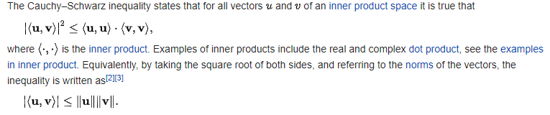

Let’s define the mean as the inner product in our inner product space (we can do it based on previous probability courses), we get:

$$<u,v>≜E\left[u⋅v\right]$$ By defining the vectors: $$u=\left(x{-μ}_{x}\right) \\ v=(y{-μ}_{y})$$

And thus

$$<\left(x-μ_{x}\right),\left(y-μ_{y}\right)> ≝cov\left(X,Y\right)$$

$$<\left(x-μ_{x}\right),\left(x-μ_{x}\right)> ≝var\left(X\right) \\ <\left(y-μ_{y}\right),\left(y-μ_{y}\right)> ≝var(Y)$$ We get the following result, based on the inequality: $${\left|cov\left(X,Y\right)\right|}^{2}≤var\left(X\right)⋅var\left(Y\right)$$*Reminder- $var\left(⋅\right)≥0$

$$\left|cov\left(X,Y\right)\right|≤σ_{x}σ_{y} \\ -σ_{x}σ_{y}≤ cov\left(X,Y\right)≤σ_{x}σ_{y} \\ -1≤\frac{cov\left(X,Y\right)}{σ_{x}σ_{y}}≤1$$

$$∎$$