1. **Exercises:**
   1. **Solving 8-Puzzle with Dijkstra's Algorithm:**
      1. The number of tiles configuration is . Although this is an enormous number because we want to solve the single pair shortest path problem there are some redundant sates which not belong to the requested path, therefore, we can crate the state online, during Dijkstra iteration, that way we will create only the required state to solve our problem.
      2. *Code is submitted.*
   2. **Solving 8-Puzzle with A*:**
      1. We define a Manhattan distance on a puzzle state by given examine the minimum number of movements to get from one state to another for example, if number "2" is on position (1,1) the Manhattan distance to move it to (2,3) is and sum for all numbers in the puzzle but "0" because if we arrange all 8 numbers 0 must be in its place.
      2. *Code is submitted.*
      3. Yes, **the heuristic is matter**, because it effects on the number of states the algorithm is going to create, the more it is close to real distance it is better. We change the heuristic to "Air distance heuristic", basically it is taking each coordinate delta power it by 2 sums for all coordinates and square root the sum. The heuristic is admissible because, its value is for sure less than Manhattan distance and the Manhattan distance is admissible because it is presenting the minimum changes that needed to be done from one state to another without blocking considerations.  
         For Manhattan distance A* evolves 222 states and for air distance: 327, therefore it is clearly that Manhattan distance is better, it is closer to real distance.
      4. Initial state is:

|  |  |  |
| --- | --- | --- |
| 8 | 7 | 6 |
| 1 | 0 | 5 |
| 2 | 3 | 4 |

Goal state is:

|  |  |  |
| --- | --- | --- |
| 1 | 3 | 4 |
| 8 | 2 | 0 |
| 7 | 6 | 5 |

Actions need to be done:  
d-> l-> u-> r-> r-> d-> l-> u-> u-> r-> d-> d-> l-> u-> u-> l-> d-> d-> r->   
u-> u-> l-> d-> r-> r

Dijkstra solving time: 10.768 seconds and 149,326 states.

A* solving time: 0.186000 seconds and 2,058 states.

* + 1. The parameter  effects the heuristic function in a way to get it closer to the real distance. For  the heuristic function is basically the constant zero, therefore, the algorithm behaves like Dijkstra.  
       For if the original heuristic is admissible therefore the weighted one is also admissible, but in that case the parameter has no contribution, in the contrary it makes the function less closer to real.  
       But for we can't claim any more that we hold with admissible heuristic. Notice that the heuristic might stays admissible for somevalues.  
       For the heuristic function value is infinity for all states and that makes it not admissible for sure.
    2. For , the heuristic is the constant zero, it doesn’t give any extra information to A* therefore the algorithm behaves lkike Dijkstra, will find the shortest path.  
       For if the original heuristic is admissible therefore the weighted one is also admissible, the algorithm will find the shortest path. Notice that if the original is admissible the weighting is making the algorithm to evolve more states, so it is no needed. But if the original is not admissible the weighting might help to make the heuristic admissible and therefore to find the shortest path.  
       As said before, the search algorithm assume that for any pair of states the distance between them is  therefore it will find some path and probably not the optimal, and also crate large number of states.
  1. **Solving Cart-Pole with LQR:**

**def** get_A**(**cart_pole_env**):**

'''

create and returns the A matrix used in LQR. i.e. x_{t+1} = A * x_t + B * u_t

:param cart_pole_env: to extract all the relevant constants

:return: the A matrix used in LQR. i.e. x_{t+1} = A * x_t + B * u_t

'''

g **=** cart_pole_env**.**gravity

pole_mass **=** cart_pole_env**.**masspole

cart_mass **=** cart_pole_env**.**masscart

pole_length **=** cart_pole_env**.**length

dt **=** cart_pole_env**.**tau

moment_of_inertia **=** pole_mass **\*** **(**pole_length **\*\*** 2**)**

A_bar **=** np**.**array**([[**0**,** 1**,** 0**,** 0**],**

**[**0**,** 0**,** **((**pole_mass **\*** g**)** **/** cart_mass**),** 0**],**

**[**0**,** 0**,** 0**,** 1**],**

**[**0**,** 0**,** **(**g **/** pole_length**)** **\*** **(**1 **+** **(**pole_mass **/** cart_mass**)),** 0**]])**

A **=** np**.**add**(**moment_of_inertia**,** np**.**multiply**(**dt**,** A_bar**))**

**return** A

**def** get_B**(**cart_pole_env**):**

'''

create and returns the B matrix used in LQR. i.e. x_{t+1} = A * x_t + B * u_t

:param cart_pole_env: to extract all the relevant constants

:return: the B matrix used in LQR. i.e. x_{t+1} = A * x_t + B * u_t

'''

g **=** cart_pole_env**.**gravity

pole_mass **=** cart_pole_env**.**masspole

cart_mass **=** cart_pole_env**.**masscart

pole_length **=** cart_pole_env**.**length

dt **=** cart_pole_env**.**tau

B_bar **=** np**.**array**([[**0**],**

**[**1 **/** cart_mass**],**

**[**0**],**

**[**1 **/** **(**cart_mass **\*** pole_length**)]])**

B **=** np**.**multiply**(**dt**,** B_bar**)**

**return** B

* + 1. We decided the Q matrix should be and R is 1, therefore it creates a cost function of. The motivation behind it is:
* Makes it more expansive to be in large angles, means make the controller to avoid large  values.
* We don’t take price of the x location because it doesn’t important in order to stabilize the mass on the pole.
* Because it is very delicate to stabilize to mass over the pole, we would like to make the changes over time, aka velocity and angular velocity, very costly in that way the controller should avoid moving the cart very fast.
  + 1. We found the for initial of the controller cannot stabilize the mass and it loses control, we think this happens because as we claimed before the controller doesn't want to pay for big changes but few small changes cannot stabilize it.

Plot for :

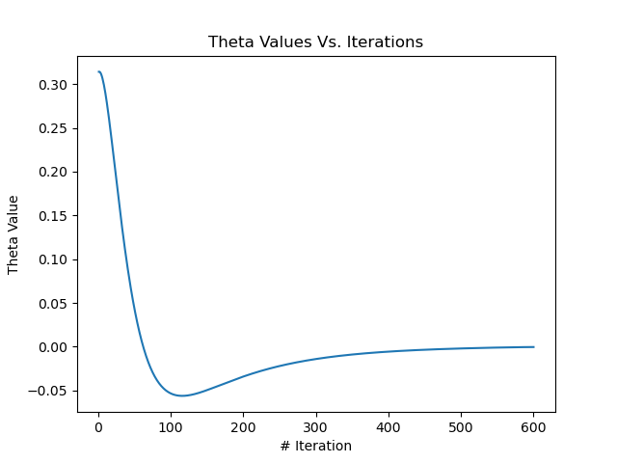

Plot for :

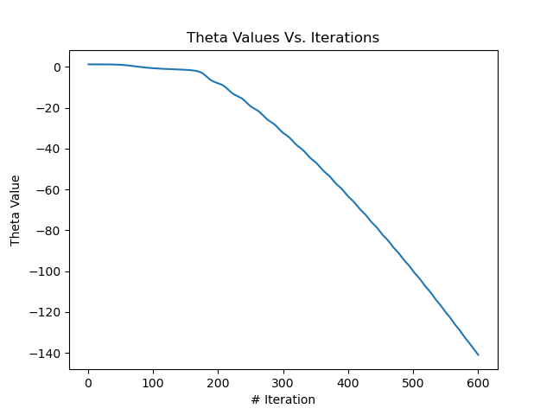

Plot for :



As we can see for  the value of theta is not going to zero but losing control because the controller is trying to stabilize it by moving the cart fast but when the cart moves fast it becomes more difficult to stabilize the mass. In the other graphs we can see that the controller decisions lead to stabilization of the mass.

* + 1. Plots for feedforward control:

Plot for :

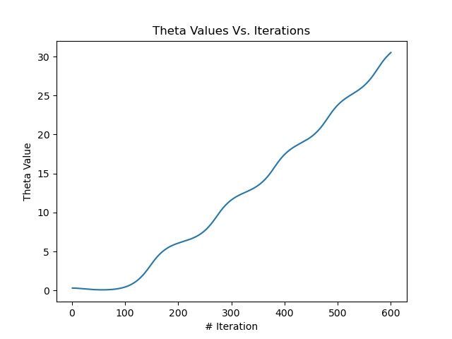

Plot for :

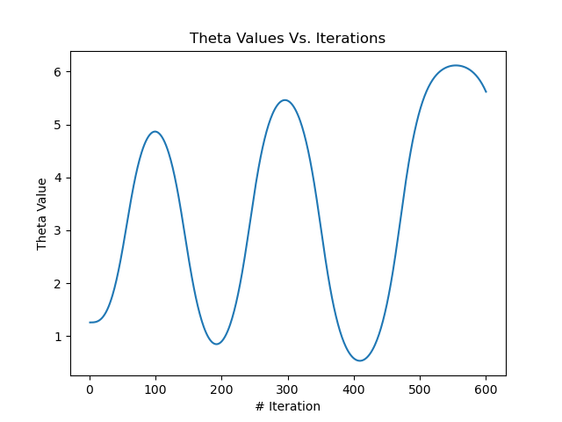

Plot for :

  
As we can see clearly the LQR feedback control is better than feedforward control, because in LQR we linearize the dynamic of the system to  around , but the dynamic is different in the simulator which calculate the change in state like the real physics of the system. Therefore, for a given action there is a delta(aka noise) between the next state the LQR calculates and the simulator calculates which means the paths of states is not the same.

* + 1. Force limitation:Plot for :

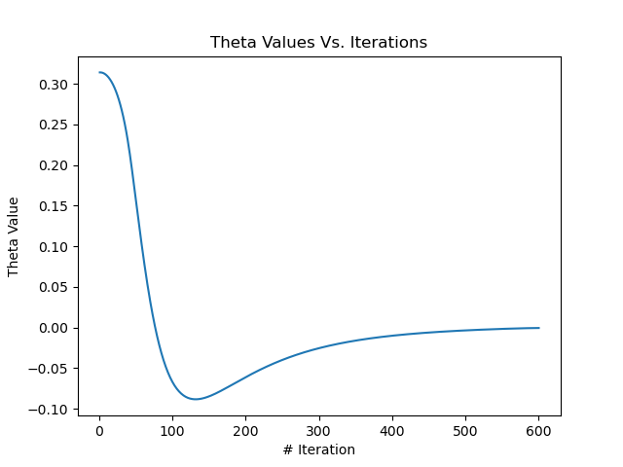

Plot for :

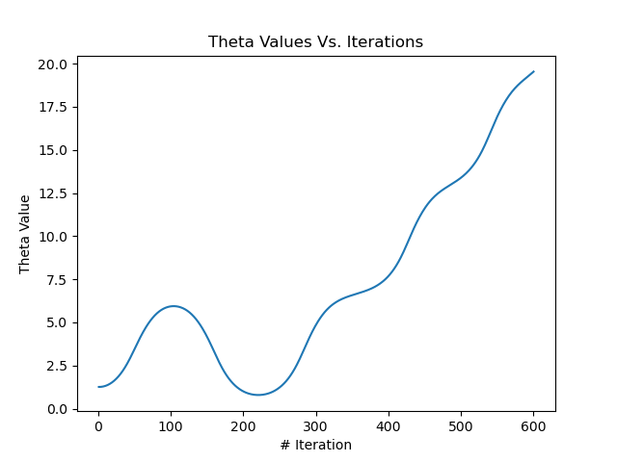

Plot for :

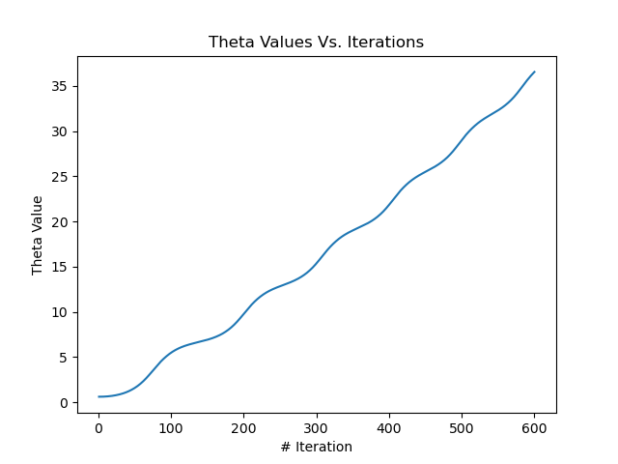

In order to stabilize the mass with initial we didn't need to change out Q or R matrices. Unlike before the controller doesn't success to stabilize the mass with initial , the explanation for that is that it might need more force which is now limited.