Development of Topics in Electrical Engineering 1 - "Learning to Route"  
Restoring Paper Results

**Report**

Written by:

**Ido Yehezkel 204397368**

Table of Contents

Introduction 3

Definition of the Model 4

Optimal Routing – Baseline 5

Optimal Oblivious Routing - Baseline 6

Restoring the Baseline Results 7

Evaluation 7

Restoring the Reinforcement Learning Results 12

Evaluation 12

References 18

# Introduction

This report is about restoring the achieved results from the paper: *Valadarsky, A., Schapira, M., Shahaf, D., & Tamar, A. (2017, November). Learning to route*. In *Proceedings of the 16th ACM workshop on hot topics in networks* (pp. 185-191).‏

The paper's writers interduce a new approach of how to use machine learning techniques in order to solve one of the fundamental network control problem, traffic routing.  
Two approaches were evaluated: traffic patterns predictions based on the history traffic using supervised learning and solving the routing control problem directly using reinforcement learning agent.  
The supervised learning models is a good start point but didn't achieve noticeable results, on the other hand, the reinforcement learning techniques achieved much better results and create new direction of research.

This report is focusing on restoring the presented results and conclusions using reinforcement learning techniques. The motivation is getting new knowledge about routing algorithms (Optimal Routing, Oblivious Routing), new heuristics methods, useful programming packages, but the main goal is to develop a new direction for a continue research.

# Definition of the Problem

Network topology- following the paper, for the control routing problem the network topology is represent by directional graph which is based on unidirectional graph with edges' capacity function (in Mb/s).  
The directional graph is simply made by considering each edge as independent bidirectional link.

Synthetic Traffic Generation – to examine the developed techniques a synthetic traffic generation is necessary.  
The traffic demands is represent by square matrix where the cell is the flow demand from node to node.  
Another property of the matrix is sparsity, which is the percentage of source, destination pairs that include traffic, for example, a topology with 10 nodes includes 90 difference pairs of source destination, with sparsity of 30% only 27 randomly chosen pairs are included in the traffic.  
Two different types of traffic are generated for evaluation:

* **Gravity** **Traffic**: traffic with correlation to the links' capacities connected to the source node and the destination node, calculated by the formula: 
* **Bimodal Traffic:** each flow demand of the traffic is sampled by some probability (biased coin flip) from two independent gaussian distributions. One distribution represents mice flows and the other elephants' flows.

For all the evaluations the gaussians distributions are: for elephant flows and  for mice flows.

# Baselines - Optimal Routing

To evaluate the models and techniques that were developed by the paper's writers they define a reference baseline which is based on **load balancing**.

The optimal routing criteria is defined as the **minimization of maximum link utilization**, minimize the most congested link, the mathematic expression is:  


These criteria can be formulated as an optimization problem as follow:



As this optimization problem define, all the constraints are linear expressions therefore, a linear programing solver (like "IBM – CPLEX" or "Gurobi") can be used to solve it, ("Gurobi" had been used).  
The linear programming problem includes  variables and constrains.

# Baseline - Optimal Oblivious Routing

Another baseline the writers used is **optimal oblivious routing**. As its name implies the oblivious routing **is not traffic patterns depended but only a topology depended**, this routing technique was represented in several papers in early 2000s.

The oblivious performance ratio of routing scheme  is define as follows:





Using the result of the paper *Applegate, D., & Cohen, E. (2006). Making routing robust to changing traffic demands: algorithms and evaluation. IEEE/ACM Transactions on Networking, 14(6), 1193-1206,* the optimal oblivious routing problem can be formulated as a single optimization problem as follow:  








As one can see, because all the constrains are linear, this also a linear programming problem with  variables and constrains, where is a variable that represent an exist weight that for every pair of edges : and  represent the length of the shortest path from node to node according the edge weights .

# Restoring the Baseline Results

Before restoring the results of the reinforcement learning agent all the baselines should be restored.  
Because the agent is taking a decision by observing the traffic history the writers created a similar reference baseline that also use traffic history, by observing the last matrices and calculate the average traffic matrix and route the next new traffic matrix by the optimal routing scheme of the average one.  
One of the critic challenges needed to be considered is that it can be happens that a flow exists in the current routed new matrix but not in the average one (based on history), the solution is to use an ECMP policy with equal weights, so those first appear flows are equally divided between all shortest paths between the source and destination.  
The result are normalized with the most congested link utilization when applying the optimal routing scheme.

Evaluation

Similar to the paper, a 12-node topology with 26 edges (the original topology includes duplicate edges, this represented as double the capacity for those edges) and constant link capacity of 10,000 Mb.  
20,000 traffic matrices dataset had been used in order to get the results.

(The dashed lines are approximations of the results from the paper).

**Gravity Traffic:**

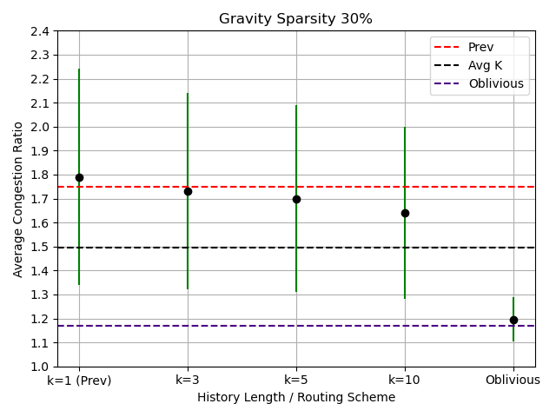

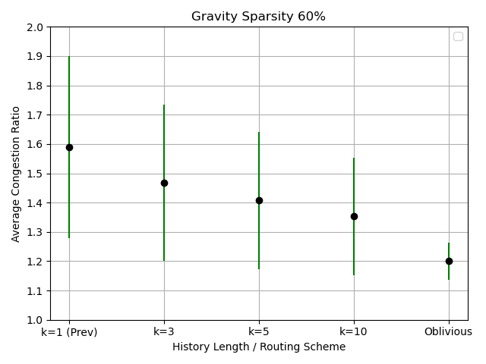

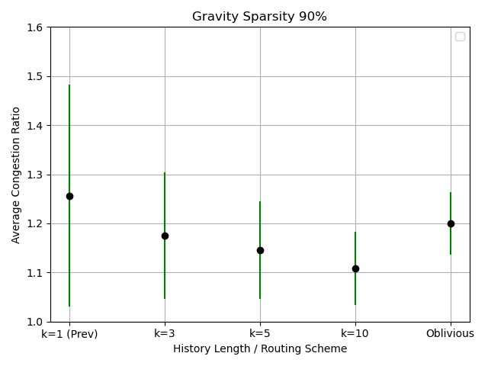

**Bimodal Traffic:**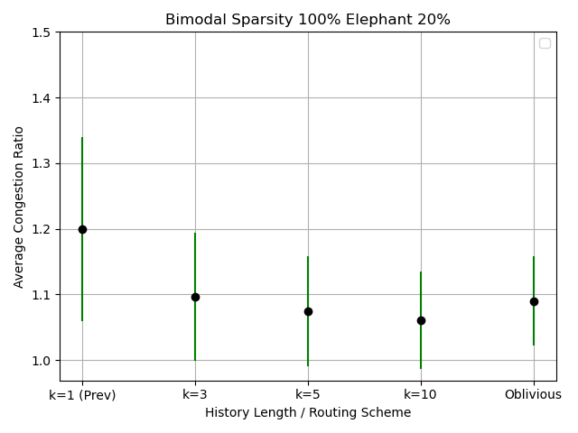

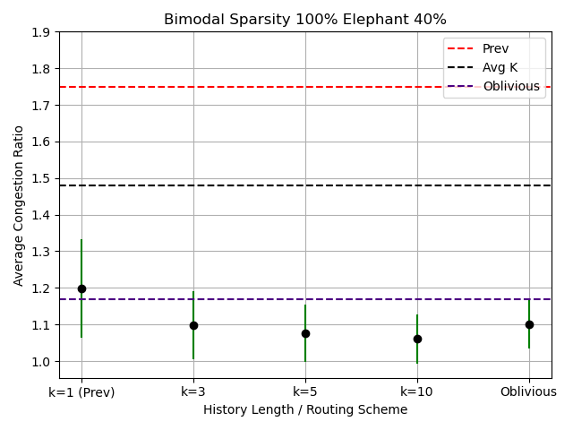

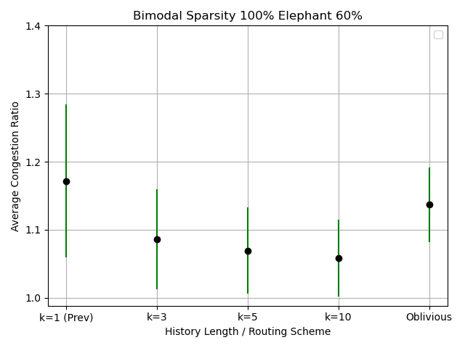

# Restoring the Reinforcement Learning Results

The outstanding result of the paper is the prove of concept that an RL agent can be useful to produce good routing scheme that minimize the congestion ratio.

The writers set up an environment that simulate the network nodes and links and every timestep a new traffic matrix with new demands is routed by the agent.

The goal of the process of learning is that the agent learns a map from the a history of traffic matrices to weights for each network link which used for routed the future traffic matrix, using that weight the environment calculate shortest path to each destination of demands from every other node. Finally, plug these costs and each edge weight to soft-min function to calculate for each node the percentage of flow carried by each leaving edge. The final step is to run each demand of flow around the network links until all of it reach to its destination and calculate the most congested edge for the final congestion ratio of the traffic matrix.

Evaluation

Similar to the paper, a 12-node topology with 26 edges (the original topology includes duplicate edges, this represented as double the capacity for those edges) and constant link capacity of 10,000 Mb.  
The evaluated agent parameters are: history length of 10 (as paper), discount factor equal to 0 and episode length of 1. Because flows are not continued more than one timestep, so I assume a myopic approach to minimize the congestion of the current traffic matrix is a good start because current agent decision has no effect on future ones.

**Gravity Traffic Paper results:**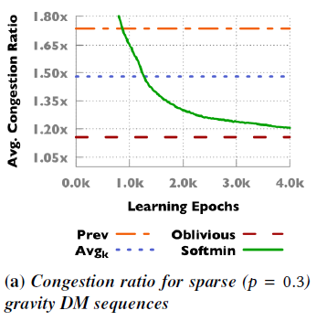

**Gravity Traffic with 350 different TMs:**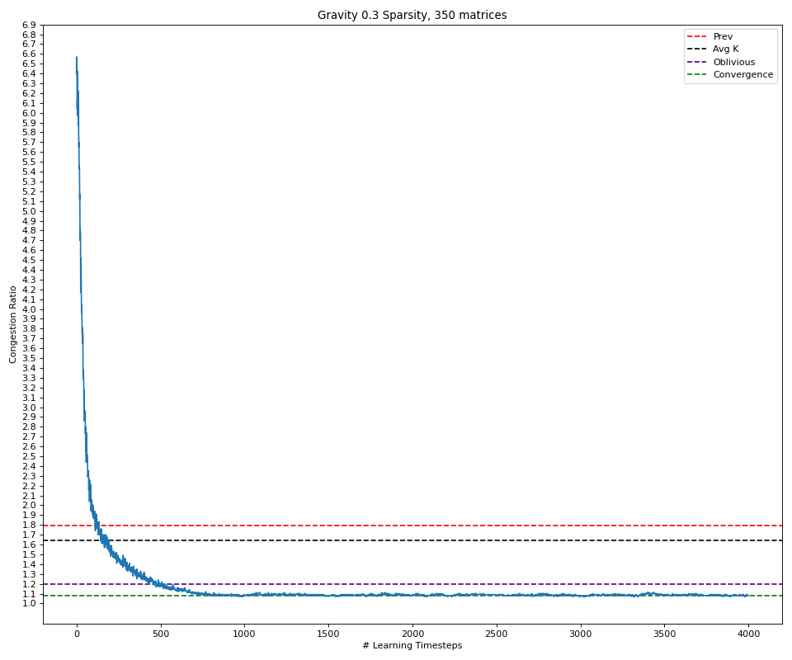

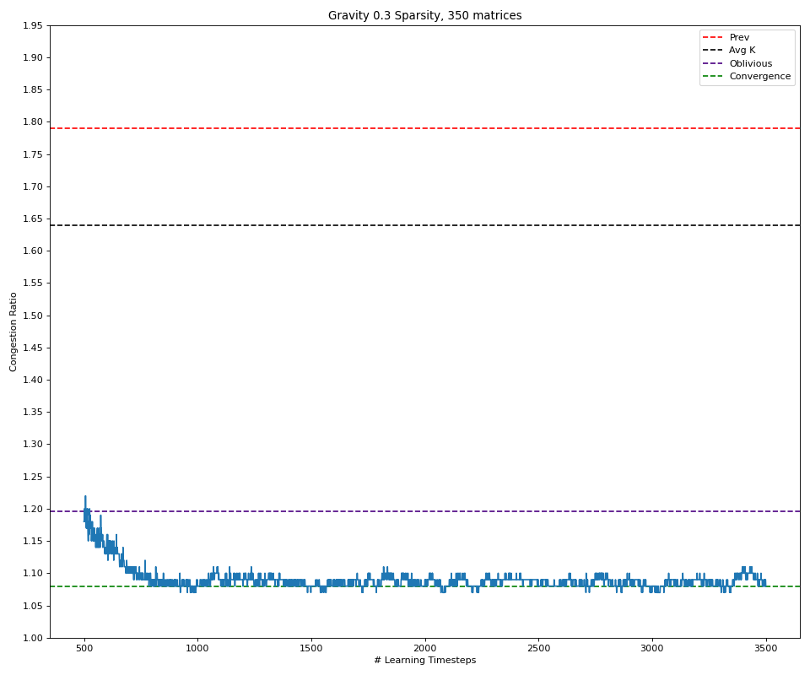

**Gravity Traffic with 10,500 different TMs:**

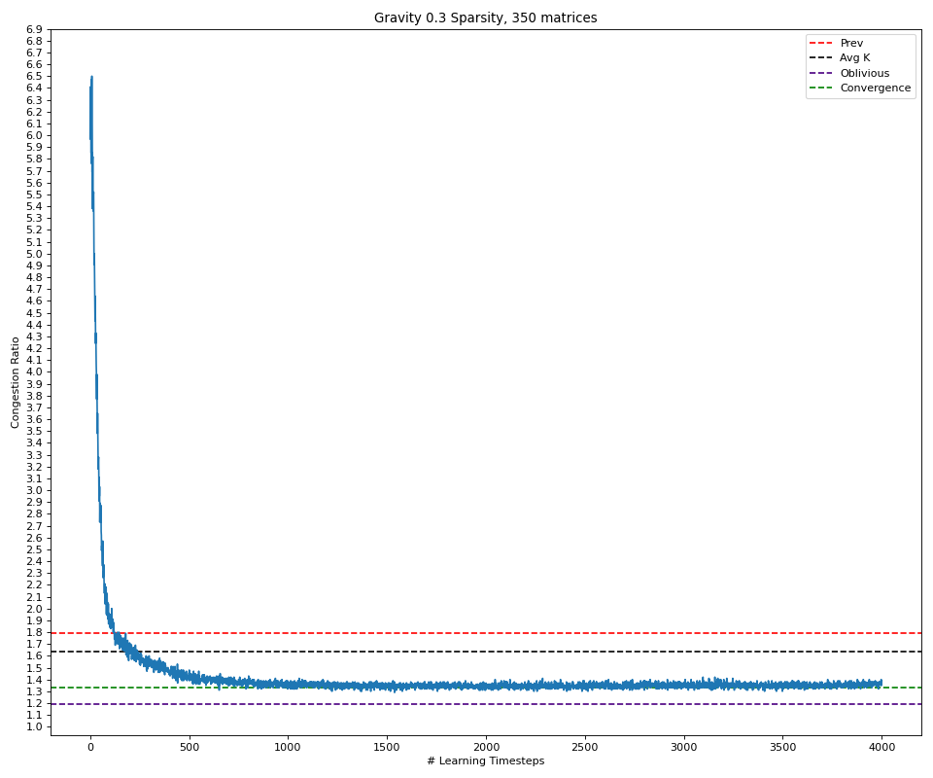

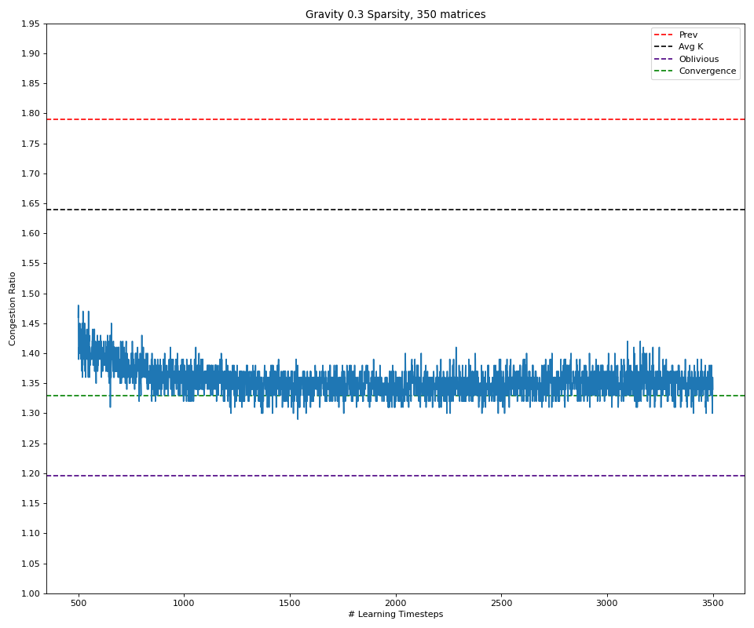

**Bimodal Traffic Paper results:**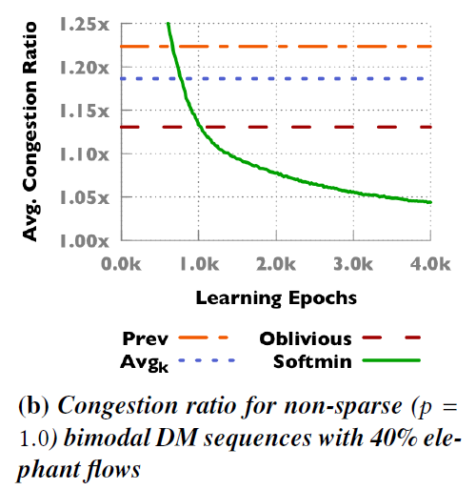

**Bimodal Traffic with 350 different TMs:**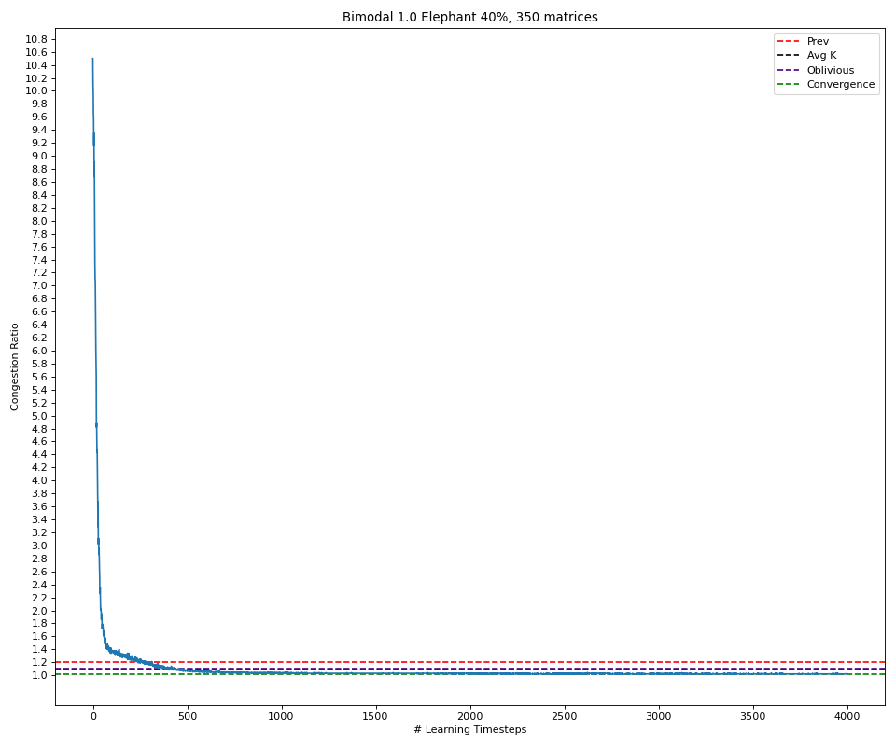

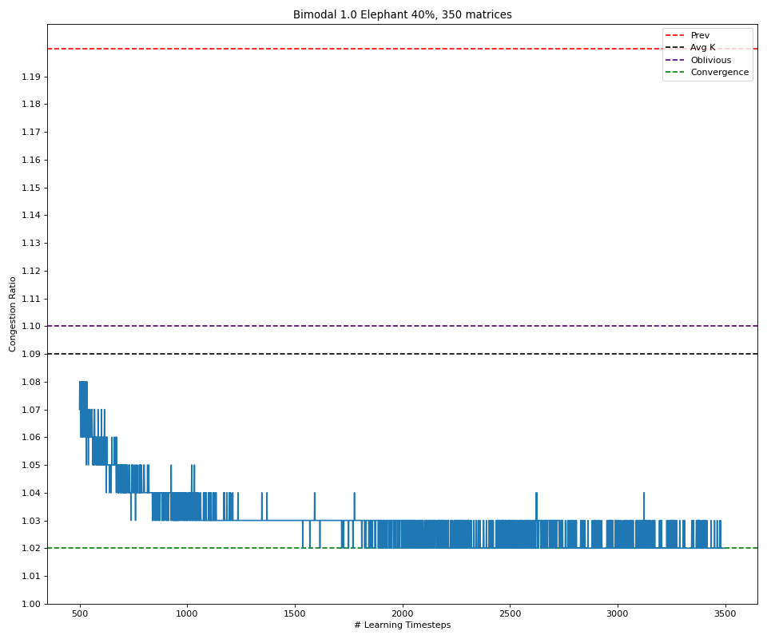

**Bimodal Traffic with 10,500 different TMs:**

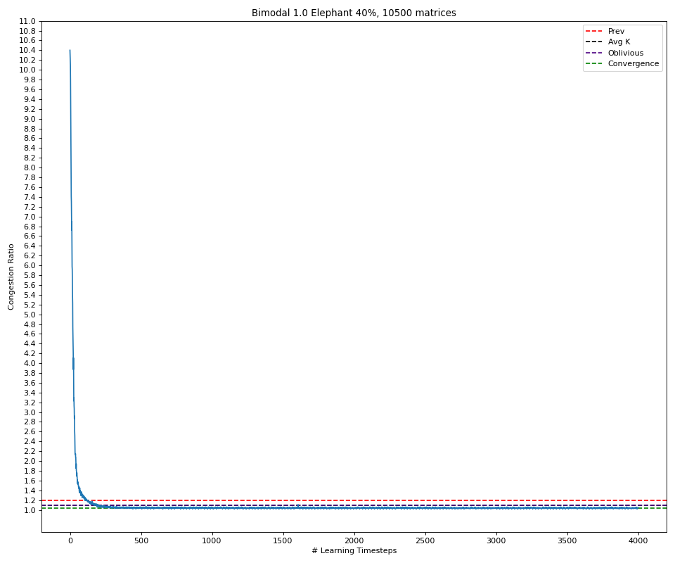

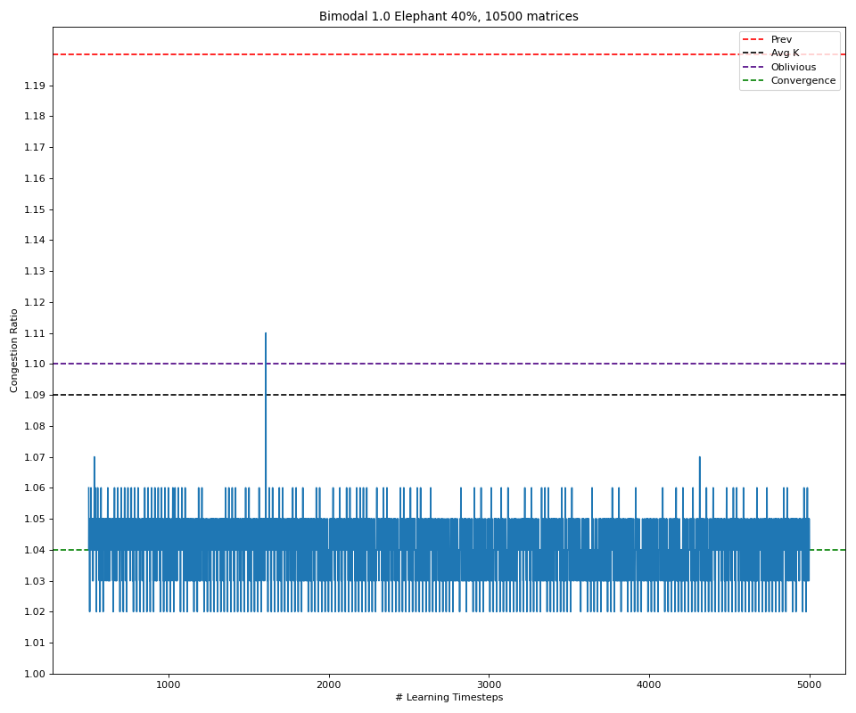

# References

* Valadarsky, A., Schapira, M., Shahaf, D., & Tamar, A. (2017, November). Learning to route. In Proceedings of the 16th ACM workshop on hot topics in networks (pp. 185-191).
* Applegate, D., & Cohen, E. (2006). Making routing robust to changing traffic demands: algorithms and evaluation. IEEE/ACM Transactions on Networking, 14(6), 1193-1206.‏
* Azar, Y., Cohen, E., Fiat, A., Kaplan, H., & Räcke, H. (2004). Optimal oblivious routing in polynomial time. Journal of Computer and System Sciences, 69(3), 383-394.‏