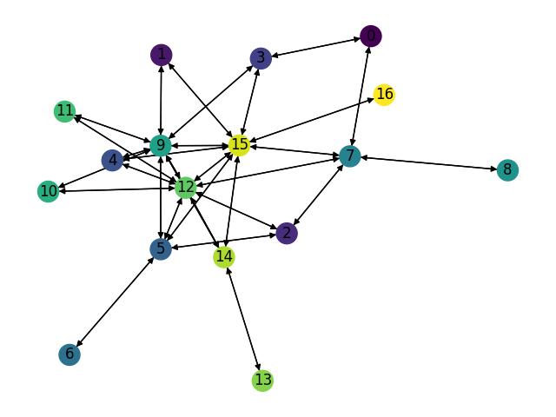Topology name: GoodNet.

Number of Nodes: 17.

Number of links: 62.

Train matrices: Gravity Traffic, 2048 TMs, 30% sparsity.

Test matrices: Gravity Traffic, 4096 TMs, 30% sparsity.

|  |  |  |  |
| --- | --- | --- | --- |
| Smart Nodes Set size | “Smart Nodes” by evaluating all hubs options | Expected Congestion  Baseline (1024 TMs) | Expected Congestion and Optimal Expected Congestion |
| -1 – no optimization at all | None | 1.24 | 1.165 |
| 0 | None | 1.185 | 1.11 |
| 1 | (12,) 1.173 | 1.171 | 1.10 |
| 2 |  |  |  |
| 3 |  |  |  |
| 4 |  |  |  |
| 5 | (5,7,9,12,15)1.103 | 1.119 | 1.05 |

Optimal Expected Congestion: 1.0645

Reduce source- destination to destination routing congestion: 1.30, Vs. optimal: 1.22

Oblivious Mean Congestion Result: 1.25, Vs. optimal: 1.17

Mean Traffic Matrix optimal routing scheme expected congestion: 1.5, Vs. optimal: 1.4

Smart node set: {5,7,9,12,15}

Topology name: GoodNet.

Number of Nodes: 17.

Number of links: 62.

Train matrices: Gravity Traffic, 512 TMs, 30% sparsity.

Test matrices: Gravity Traffic, 1024 TMs, 30% sparsity.

|  |  |  |  |
| --- | --- | --- | --- |
| Smart Nodes Set size | “Smart Nodes” by evaluating all hubs options | Expected Congestion  Baseline (1024 TMs) | Expected Congestion and Optimal Expected Congestion |
| -1 – no optimization at all | None | 1.25 | 1.22 |
| 0 | None | 1.196 | 1.17 |
| 1 | (12,)1.16 | 1.179 | 1.15 |
| 2 | (12, 15)1.14 | 1.169 | 1.14 |
| 3 | (9, 12, 15) 1.11954 | 1.16 | 1.13 |
| 4 | (9, 12, 15, 7) 1.09 | 1.15 | 1.12 |
| 5 | (5,7,9,12,15)1.076 | 1.14 | 1.11 |

Optimal Expected Congestion: 1.023

Reduce source- destination to destination routing congestion: 1.243, Vs. optimal: 1.21

Oblivious Mean Congestion Result: 1.25, Vs. optimal: 1.22

Mean Traffic Matrix optimal routing scheme expected congestion: 1.51, Vs. optimal: 1.48

Smart node set: {5,7,9,12,15}

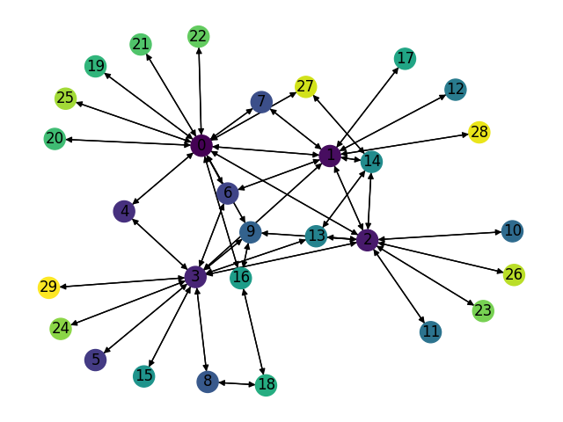Topology name: Scale Free 30 Nodes.

Number of Nodes: 30.

Number of links: 86.

Train matrices: Gravity Traffic, 512 TMs, 30% sparsity.

Test matrices: Gravity Traffic, 1024 TMs, 30% sparsity.

|  |  |  |  |
| --- | --- | --- | --- |
| Smart Nodes Set size | “Smart Nodes” by evaluating all hubs options | Expected Congestion  Baseline (1024 TMs) | Expected Congestion and Optimal Expected Congestion |
| -1 – no optimization at all | None | 1.636 | 1.26 |
| 0 | None | 1.52 | 1.18 |
| 1 | (0)1.47 | 1.486 | 1.15 |
| 2 | (0, 2)1.44 | 1.483 | 1.15 |
| 3 | (0, 2,3)1.4 | 1.46 | 1.13 |
| 4 | (0,1,2,3)1.37 | 1.46 | 1.13 |

Optimal Expected Congestion: 1.287

Reduce source- destination to destination routing congestion: 1.639, Vs. optimal: 1.27

Oblivious Mean Congestion Result: 1.675, Vs. optimal: 1.29

Mean Traffic Matrix optimal routing scheme expected congestion: 1.67975, Vs. optimal: 1.30

Smart node set: {0,1,2,3}

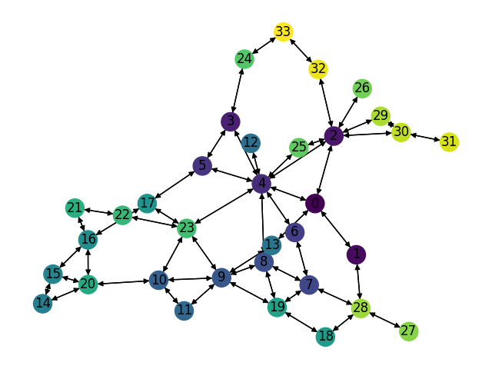Topology name: GEANT.

Number of Nodes: 34.

Number of links: 104.

Train matrices: Gravity Traffic, 512 TMs, 30% sparsity.

Test matrices: Gravity Traffic, 1024 TMs, 30% sparsity.

|  |  |  |  |
| --- | --- | --- | --- |
| Smart Nodes Set size | “Smart Nodes” by evaluating all hubs options | Expected Congestion  Baseline (1024 TMs) | Expected Congestion and Optimal Expected Congestion |
| -1 – no optimization at all | None | 2.785 | 1.66 |
| 0 | None | 1.95 | 1.16 |
| 1 | (4,) 1.87 | 1.94 | 1.15 |
| 2 | (4,23) 1.84 | 1.93 | 1.14 |
| 3 | (4, 9, 23) 1.81 | 1.926 | 1.14 |
| 4 | (2,4, 9, 23) 1.80 | 1.926 | 1.14 |

Optimal Expected Congestion: 1.681

Reduce source- destination to destination routing congestion: 58.98, Vs. optimal: 35.1

Oblivious Mean Congestion Result: 2.56, Vs. optimal: 1.52

Mean Traffic Matrix optimal routing scheme expected congestion: 2.91, Vs. optimal: 1.73

Smart node set: {2,4,9,23}

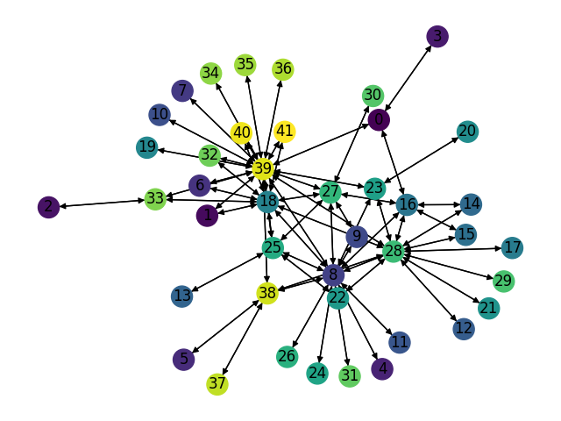Topology name: China Telecom.

Number of Nodes: 42.

Number of links: 132.

Train matrices: Gravity Traffic, 512 TMs, 30% sparsity.

Test matrices: Gravity Traffic, 1024 TMs, 30% sparsity.

|  |  |  |  |
| --- | --- | --- | --- |
| Smart Nodes Set size | “Smart Nodes” by evaluating all hubs options | Expected Congestion  Baseline (1024 TMs) | Expected Congestion and Optimal Expected Congestion |
| -1 – no optimization at all | None | 2.0 | 1.46 |
| 0 | None | 1.75 | 1.27 |
| 1 | (39,)1.69445 |  |  |
| 2 |  |  |  |
| 3 |  |  |  |
| 4 |  |  |  |
| 5 |  |  |  |

Optimal Expected Congestion: 1.37

Reduce source- destination to destination routing congestion: 2.2, Vs. optimal: 1.60

Oblivious Mean Congestion Result: 2.13, Vs. optimal: 1.55

Mean Traffic Matrix optimal routing scheme expected congestion: 2.30, Vs. optimal: 1.68

Smart node set: {8, 18, 27, 28, 39}