Networking Intro – Assignment 2
Ido Zeira – 322607177
Q.1:
Settings up the V0 communication analysis:
I’ve started wireshark sniffing on any network interface, with the filter query: “tcp.port=12345”, I set the destination (server) port to 12345 and the server IP to machine A’s IP, started the server.py script on machine A (192.168.1.21) And started the client.py script on machine B (192.168.1.13).

Communication is as shown (See traceV0.pcapng):
*The [Flag] in the info field represents a set flag in the packet. For example, [SYN] means SYNBit = 1.
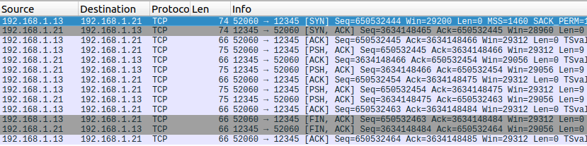
B -> A: Syn sent to server, client requests a connection.
Seq = X (650532444).

A -> B: Syn received by server, Sending SYNACK meaning the server accepts the connection request.
Seq = Y (3634148465), Ack = X+1.

B -> A: Client acknowledges that the connection is established. (SYNRCV)
Seq = X+1, Ack = Y+1.

B -> A: Client sends “Ido Zeira” (Len = 9).
Seq = X+1 (No change), Ack = Y+1 (No change).

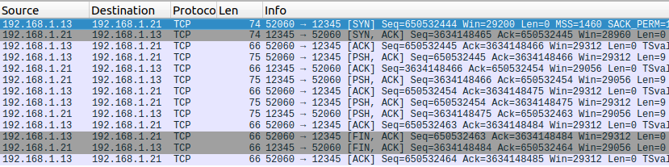
A -> B: Server acknowledges the received message.
Seq = Y+1, Ack = X+10 (Added the length of “Ido Zeira” - 9).

A -> B: Server sends “IDO ZEIRA” (Len = 9).
Seq = Y+1 (No change), Ack = X+10 (No change).

B -> A: Client acknowledges the received message.
Seq = X+10, Ack = Y+10 (Added the length of “IDO ZEIRA” - 9).
B -> A: Client sends “322607177” (Len = 9).
Seq = X+10 (No change), Ack = Y+10 (No change).

A -> B: Server received the message and immediately sends “322607177” (Len = 9).
Seq = Y+10, Ack = X+19 (Added the length of “322607177” - 9).
B -> A: Client acknowledges the received message.
Seq = X+19, Ack = Y+19 (Added the length of “322607177” - 9).
B -> A: Client sends a FIN signal to end the connection. (Ctrl + C)
Seq = X+19 (No change), Ack = Y+19 (No change).
A -> B: Server received signal and sends FIN back to confirm termination of session.
Seq = Y+19, Ack = X+20 (Added the length of FIN signal – 1).
B -> A: Client received signal and acknowledges end of connection.
Seq = X+20, Ack = Y+21 (Added the length of FIN signal – 1).

And the connection has been closed.

Q.2:
I’ve transported all server versions to A and all client versions to B.

V1:
V1/server.py binds a socket to the port specified by cli argument and the 0.0.0.0 IP, similar to the server.py in Q1 (‘V0’). In line 9 we see “s.listen(1)” as opposed to “server.listen(5)” in v0 (line 7). The difference is that this time we allow up to 1 connection to be queued simultaneously instead of 5. and from there they both run the exact same way.

V1/client.py binds the socket the same as the V0 client, except that this time it is provided with server IP and port via cli argument. The main difference is that client V1 connects, sends “Hello World!”, receives the server response and disconnects, while the V0 client sends and receives data until the user sends ‘quit’.

Settings up the V1 communication analysis:
I’ve started wireshark sniffing on any network interface, with the filter query: “tcp.port=12345”, Started V1/server.py on machine A with port 12345 and then Started V1/client.py on machine B with server-IP 192.168.1.21 and port 12345.

Communication between V1 Client and Server is as shown (See traceV1.pcapng):
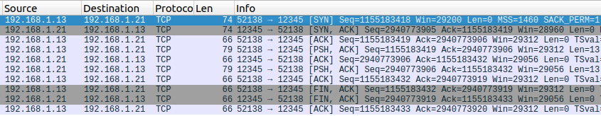
In this part, just as before, the client sends SYN, the server ACKs the SYN and responds with a SYN which is then ACKed by the client – The connection was established.

The client sends “Hello World!” (Len 13) to the server, and the server ACKs the message.

The server then sends his response “HELLO WORLD!” (Len 13) to the client, and the client ACKs it.

The client sends FIN, the server ACKs it and responds a FIN back, the client ACKs and the connection is closed.

V2:
V2/server.py is almost identical to v1, except that v2 only reads 5 characters of data each iteration, instead of 1024 in V1 and V0.

V2/client.py is almost identical to v1, except that v2 sends “World! Hello, World!” instead of “Hello World!” in V1.

Settings up the V2 communication analysis:
I’ve started wireshark sniffing on any network interface, with the filter query: “tcp.port=12345”, Started V2/server.py on machine A with port 12345 and then Started V2/client.py on machine B with server-IP 192.168.1.21 and port 12345.

Communication between V2 Client and Server is as shown (See traceV2.pcapng):
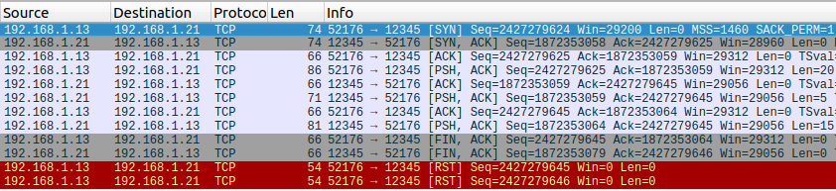
Same as V1, a connection is established between server and client, client sends “World! Hello, World!” (Len 20) and server ACKs it.
Server then captures the 5 letter prefix “World” and responds “WORLD” which is ACKed by client.
The server sends the remaining 3x5 letter responses together: “! HELLO, WORLD!”. Which were ultimately not expected by the client.
The client sends a FIN signal to the server (and expects a FIN response with
Sequence = Ack+1, because of the length of a FIN signal).
The server then sends a FIN signal back, with a Sequence that was increased by the length of his last message’s data (+15), and the client responds that he is missing the FIN-ACK response since it didn’t mach the sequence. client expected a different sequence so he throws a RST signal to try and retrieve ‘the lost data’.
Additionally, the client didn’t expect the FIN signal with Ack ending in 46 so he throws a RST to try and figure out the error.

V3:
V3/server.py is almost identical to V1, except that it responds with data.upper()*1000.

V3/client.py is almost identical to V1, except that is receives the data twice.

Settings up the V3 communication analysis:
I’ve started wireshark sniffing on any network interface, with the filter query: “tcp.port=12345”, Started V3/server.py on machine A with port 12345 and then Started V3/client.py on machine B with server-IP 192.168.1.21 and port 12345.

Communication between V3 Client and Server is as shown (See traceV3.pcapng):
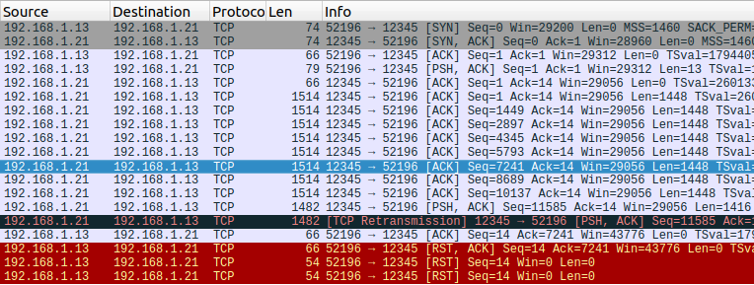
Same as previous versions, Server and Client establish a connection, client sends “Hello World!” (Len 13), and server ACKs it.

Server responds with “HELLO WORLD!”*1000, we see multiple ACKs probably because of MSS limiting the data to be 1448 each time.
Because we preformed multiple ACKs with the same acknowledgment number, the server preformed a re-transmission of the packet with the smallest Seq number (from the last three tries).
The Client acknowledges the packet with sequence 5793 and len 1448 (above the highlighted packet in screenshot 2), but the ACK could not be sent as another unexpected packet (Ack 7241) was received so it sent a RST.
Afterwards, the client tries twice to receive a response for the RST without success and the connection is unexpectedly terminated (was reset by client).

V4:
V4/server.py is the almost the same as V1, except it waits 5ms between message interception tries.

V4/client.py is almost as V1, except it sends 4 messages each containing data*10 separately.

Settings up the V4 communication analysis:
I’ve started wireshark sniffing on any network interface, with the filter query: “tcp.port=12345”, Started V4/server.py on machine A with port 12345 and then Started V4/client.py on machine B with server-IP 192.168.1.21 and port 12345.

Communication between V4 Client and Server is as shown (See traceV4.pcapng):
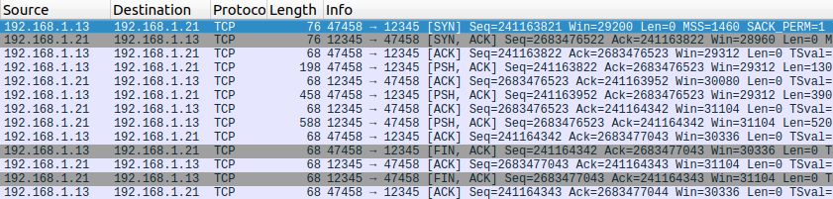
The client and the server established a connection, similar to what we’ve seen already.
(after sleeping for 5ms, Server.py is now at line 16, waiting for the first packet to be sent to it.)
Client sends the first “Hello World!”*10, and the server immediately receives it and queues a response appropriately. At the same time, the client queues another 3 messages of similar content sequentially, which are afterwards, captured by the server together at the next iteration.

The server then responds to all the 3 new messages as they were one and queues a message.toUpper() * 30 packet, which totals to 4 sequential packets each containing message.toUpper() *10, and since the client is yet to capture any packet sent previously, it captures them all together at client.py:14.

The client is then closing the connection, similar to previous versions, the server and the client both send FIN-ACK signals and the connection is terminated.

