TraderApp User Guide

Step 1: Open 5Paisa account and get the API keys. In API section you need to create an App which provides you with the following credentials:
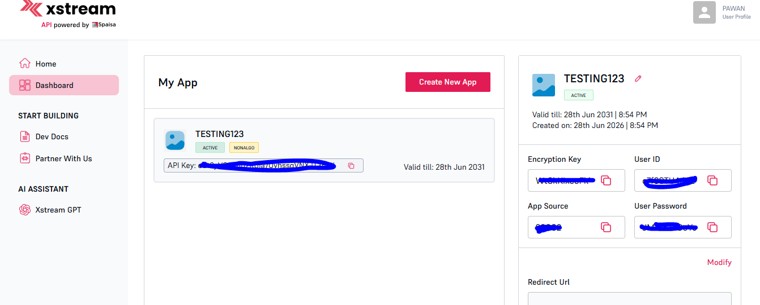

Step 2: Generate TOTP secrete for auto authentication. For this you need to goto Profile and Click on TOTP and generate TOTP secrate:
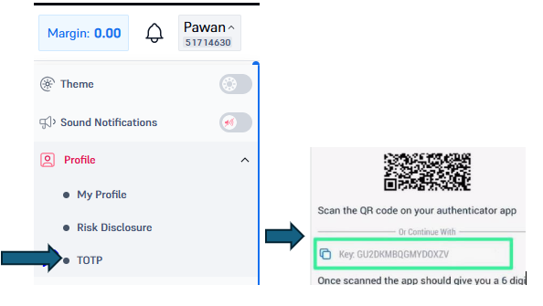
Step3: Now you need to update all required details in the cred.json file (Inside the TraderApp Folder)
Step4: App is compatible with Python 3.6 version so install Python 3.6 version.
Step5: Create libs folder in TraderApp folder and double click on install_libs.bat file to install all required liberary under libs folder
Step6: Double click on start_server.bat file. It will run the TraderApp on your web browser
You will see this page:
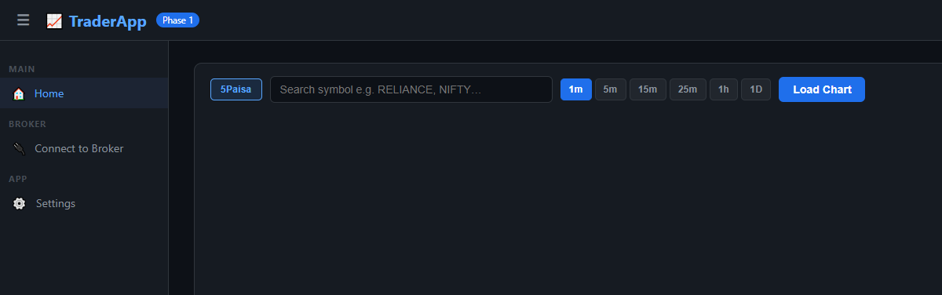
Step7: Goto Connect to Broker tab and click on Connect:
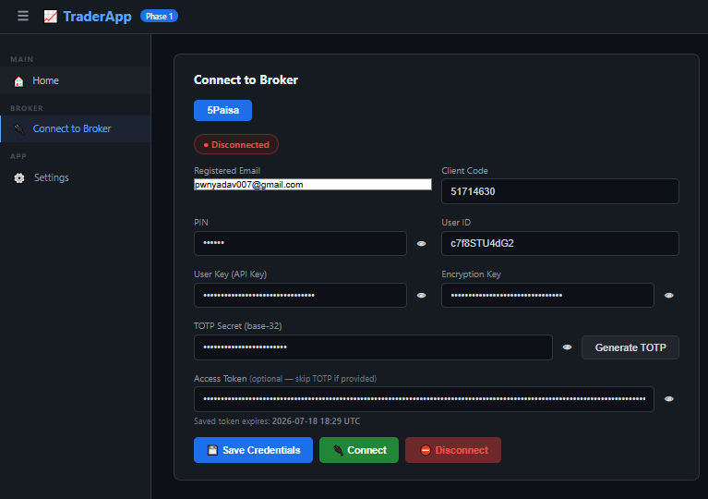

Step8: Once it is connected then you can goto Home tab and click on 5Paisa button and search instruments and click on load chart:
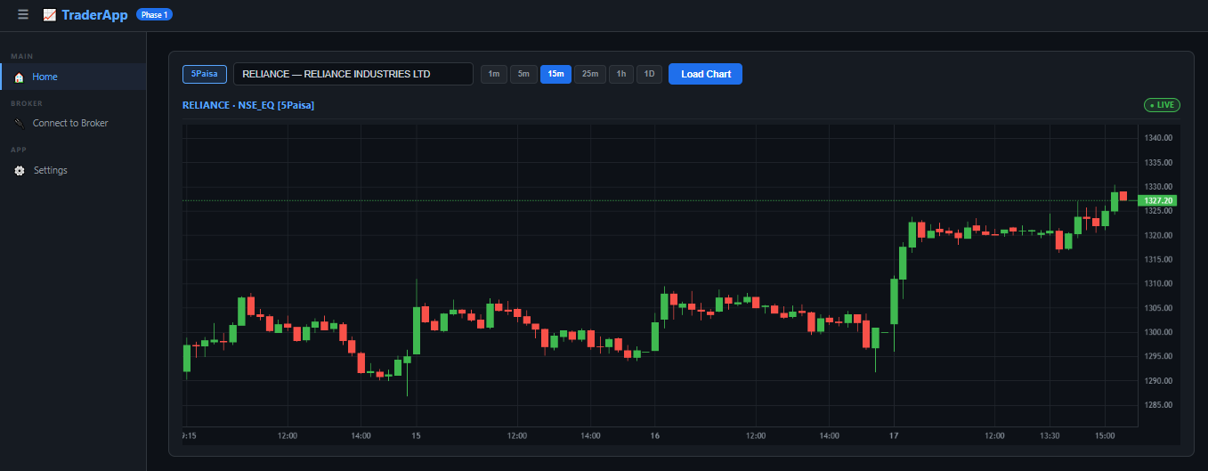

Step9: Under setting section you will see all settings.
- For Excel to retrieve data from 5Paisa you need to enable API access. That way you can retrive data in Excel.
- You can also retrieve Technical indicators data in Excel by enabling Technical Indicator option and add indicators as per your reqirement.

