**HTTP Representation**

Read runner with id 1

**GET** /runner/1/form-data

Database

**ER Diagram**

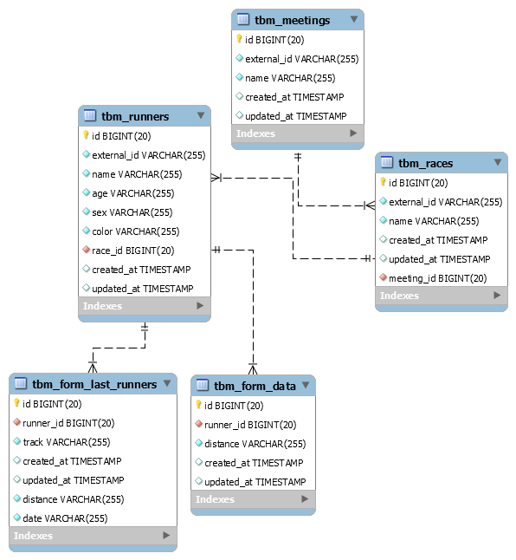

**Deployment**

1. Change database values of **.env** file.
2. Create database. (this app does not include automate database creation)
3. Execute this command to generate tables **php artisan migrate**
4. Populate fake data in the database **php artisan db:seed**
5. Start the server and run the application **php artisan serve**

**Endpoint**

**/api/v1/runner/2/form-data**

**Response**

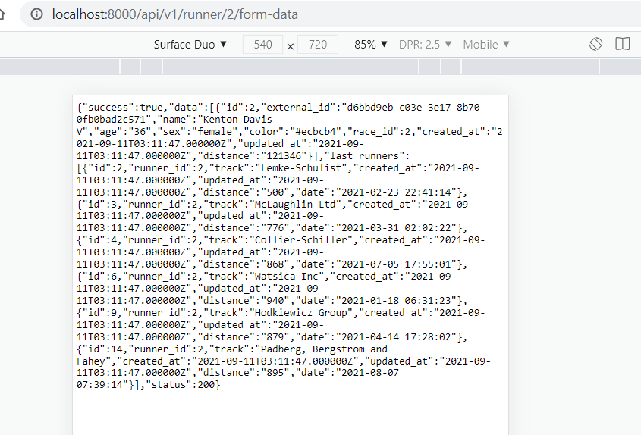

{

"success":true,

"data":[

{

"id":2,

"external_id":"d6bbd9eb-c03e-3e17-8b70-0fb0bad2c571",

"name":"Kenton Davis V",

"age":"36",

"sex":"female",

"color":"#ecbcb4",

"race_id":2,

"created_at":"2021-09-11T03:11:47.000000Z",

"updated_at":"2021-09-11T03:11:47.000000Z",

"distance":"121346"

}

],

"last_runners":[

{

"id":2,

"runner_id":2,

"track":"Lemke-Schulist",

"created_at":"2021-09-11T03:11:47.000000Z",

"updated_at":"2021-09-11T03:11:47.000000Z",

"distance":"500",

"date":"2021-02-23 22:41:14"

},

{

"id":3,

"runner_id":2,

"track":"McLaughlin Ltd",

"created_at":"2021-09-11T03:11:47.000000Z",

"updated_at":"2021-09-11T03:11:47.000000Z",

"distance":"776",

"date":"2021-03-31 02:02:22"

},

{

"id":4,

"runner_id":2,

"track":"Collier-Schiller",

"created_at":"2021-09-11T03:11:47.000000Z",

"updated_at":"2021-09-11T03:11:47.000000Z",

"distance":"868",

"date":"2021-07-05 17:55:01"

},

{

"id":6,

"runner_id":2,

"track":"Watsica Inc",

"created_at":"2021-09-11T03:11:47.000000Z",

"updated_at":"2021-09-11T03:11:47.000000Z",

"distance":"940",

"date":"2021-01-18 06:31:23"

},

{

"id":9,

"runner_id":2,

"track":"Hodkiewicz Group",

"created_at":"2021-09-11T03:11:47.000000Z",

"updated_at":"2021-09-11T03:11:47.000000Z",

"distance":"879",

"date":"2021-04-14 17:28:02"

},

{

"id":14,

"runner_id":2,

"track":"Padberg, Bergstrom and Fahey",

"created_at":"2021-09-11T03:11:47.000000Z",

"updated_at":"2021-09-11T03:11:47.000000Z",

"distance":"895",

"date":"2021-08-07 07:39:14"

}

],

"status":200

}